**Tutorial 08**

**Advanced Sort – Quick Sort**

1. Using Quick Sort binary tree, trace the execution of quick sort with the following list of numbers, and using the first element of the list/sublists as the pivot value:
   1. 4, 7, 1, 8, 3, 2, 6, 5 (in ascending order)

* 1. 5, 2, 7, 8, 1, 4, 6, 3 (in descending order)

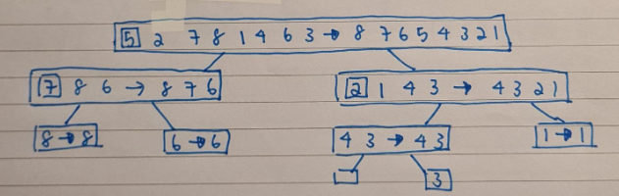

1. A stable sorting algorithm maintains the relative order of records with equal keys. That is, a sorting algorithm is stable if whenever there are two records R and S with the same key and with R appearing before S in the original list, R will appear before S in the sorted list.

For example:

Stable Sort

**Initial List**: 20 10 30 10

IT2153/IT2352/IT2553/IT2653/IT2852

Data Structures & Algorithms



|  |  |  |  |  |
| --- | --- | --- | --- | --- |
| **Sorted List**:      Unstable Sort | 10 | 10 | 20 | 30 |
| **Initial List**: | 20 | 10 | 30 | 10 |

**Sorted List**: 10 10 20 30

Are the sorting algorithms we have discussed so far i.e. bubble sort, selection sort, insertion sort, merge sort and quick sort stable algorithm?

**Stable Sort:** bubble sort, insertion sort, merge sort

**Unstable sort:** selection sort, quick sort

1. List one similarity and one difference between Merge Sort and Quick Sort.

**List one similarity and one difference between Merge Sort and Quick Sort.**

* **Similarity**
  + **Both of them are based on divide and conquer**
  + **Both are sorting algorithm based on recursion**
* **Difference**
  + **Merge sort is stable, whereas Quick sort is unstable**
  + **Quick is an in-place algorithm, whereas the standard Quick Sort implementation is not**
  + **Quick sort uses a pivot value for partitioning the elements, whereas Merge Sort does not**
  + **Quick Sort partition the list in any ratio, depending on the pivot value. Merge sort partition the list into 2 halves, ie n/2**

***-- End of Tutorial --***

AY2020/21 S1 Page 1