**Tutorial 10**

**Stacks**

1. Transform the following infix expressions to postfix and prefix:

* 1. (A * B) / C   
     ***Postfix:***

***STEP 1: ( ( A * B ) / C )***

***STEP 2: ( ( A B * ) C / )***

***STEP 3: A B * C /***

|  |  |  |  |  |  |
| --- | --- | --- | --- | --- | --- |
| ***Expression*** | ***A*** | ***B*** | ***\**** | ***C*** | ***/*** |
| ***Stack*** |  |  |  |  |  |
|  | ***B*** |  | ***C*** |  |
| ***A*** | ***A*** | ***A * B*** | ***A * B*** | ***AB / C*** |

***Prefix:***

***STEP 1: ( ( A * B ) / C )***

***STEP 2: ( / (* A B ) C)***

***STEP 3: / * A B***

* 1. A – (B * C) + D / E   
     ***Postfix:***

***STEP 1: ( ( A – ( B * C ) ) + ( D / E ) )***

***STEP 2: ( ( A ( B C * ) - ) ( D E / ) + )***

***STEP 3: A B C * - D E / +***

***Prefix:***

***STEP 1: ( ( A – ( B * C ) ) + ( D / E ) )***

***STEP 2: ( + ( - A ( * B C ) ) ( / D E) )***

***STEP 3: + - A * B C / D E***

* 1. (X – 5) + (7 * Z) / V   
     ***Postfix:***

***STEP 1: ( (X - 5) + ( (7 * Z) / V) )***

***STEP 2: ( ( X 5 - ) ( ( 7 Z * ) V / ) + )***

***STEP 3: X 5 – 7 Z * V / +***

***Prefix:***

***STEP 1: ( (X - 5) + ( (7 * Z) / V) )***

***STEP 2: ( + ( - X 5 ) ( / ( * 7 Z ) V)***

***STEP 3: + - X 5 / * 7 Z V***

* 1. V * W * 8 + Y - Z   
     ***Postfix:***

***STEP 1: ( ( ( (V * W) * 8 ) + Y ) – Z)***

***STEP 2: ( ( ( ( V W * ) 8 * ) Y + ) Z - )***

***STEP 3: V W * 8 * Y + Z -***

***Prefix:***

***STEP 1: ( ( ( (V * W) * 8 ) + Y ) – Z)***

***STEP 2: ( - ( + ( * ( * V W ) 8 ) Y ) Z )***

***STEP 3: - + * * V W 8 Y Z***

* 1. A / B * C – D + E   
     ***Postfix:***

***STEP 1: ( ( ( ( A / B ) * C ) – D ) + E)***

***STEP 2: ( ( ( ( A B / ) C * ) D - ) E + )***

***STEP 3: A B / C * D – E +***

***Prefix:***

***STEP 1: ( ( ( ( A / B ) * C ) – D ) + E)***

***STEP 2: ( + ( - ( * ( / A B) C ) D ) E )***

***STEP 3: + - * A B C D E***

1. Trace and evaluate the following postfix expressions:

* 1. 3 8 + 10 3 - *

|  |  |  |  |  |  |  |  |
| --- | --- | --- | --- | --- | --- | --- | --- |
| Expression: | 3 | 8 | + | 10 | 3 | - | * |
| Stack |  |  |  |  |  |  |  |
|  |  |  |  | 3 |  |  |
|  | 8 |  | 10 | 10 | 7 |  |
| 3 | 3 | 11 | 11 | 11 | 11 | 77 |

* 1. 2 3 ^ 4 ^

|  |  |  |  |  |  |
| --- | --- | --- | --- | --- | --- |
| Expression: | 2 | 3 | ^ | 4 | ^ |
| Stack |  |  |  |  |  |
|  |  |  |  |  |
|  | 3 |  | 4 |  |
| 2 | 2 | 8 | 6 | 4096 |

* 1. 8 2 + 10 - 10

|  |  |  |  |  |  |  |
| --- | --- | --- | --- | --- | --- | --- |
| Expression: | 8 | 2 | + | 10 | - | 10 |
| Stack |  |  |  |  |  |  |
|  |  |  |  |  |  |
|  | 2 |  | 10 |  | 10 |
| 8 | 8 | 8 + 2 = 10 | 10 | 10 – 10 = 0 | 0 |

***Invalid postfix expression! (too many values left on the stack)***

* 1. 15 3 / 5 10 – / 100 ^

|  |  |  |  |  |  |  |  |  |  |
| --- | --- | --- | --- | --- | --- | --- | --- | --- | --- |
| Expression: | 15 | 3 | / | 5 | 10 | - | / | 100 | ^ |
| Stack |  |  |  |  |  |  |  |  |  |
|  |  |  |  | 10 |  |  |  |  |
|  | 3 |  | 5 | 5 | -5 |  | 100 |  |
| 15 | 15 | 5 |  |  | 5 | -1 | -1 | 1 |

* 1. 25 4 * 20 15 - / 2 / 18 +

|  |  |  |  |  |  |  |  |  |  |  |  |
| --- | --- | --- | --- | --- | --- | --- | --- | --- | --- | --- | --- |
| Expression: | 25 | 4 | * | 20 | 15 | - | / | 2 | / | 18 | + |
| Stack |  |  |  |  |  |  |  |  |  |  |  |
|  |  |  |  | 15 |  |  |  |  |  |  |
|  | 4 |  | 20 | 20 | 5 |  | 2 |  | 18 |  |
| 25 | 25 | 100 | 100 | 100 | 100 | 20 | 20 | 10 | 10 | 28 |

IT2153/IT2352/IT2553/IT2653/IT2852

Data

Structures & Algorithms



1. Write a Python function – transfer(S, T) with no more than 3 lines of code, that transfers all elements from stack S to stack T, so that the element starts at the top of S is the first to be inserted onto T, and the element at the bottom of S ends up at the top or T.

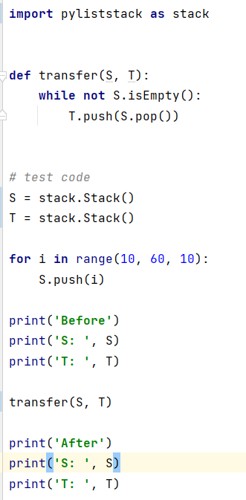

1. Write a recursive Python function – recEmptyStack(S) for removing all the elements from a stack S.

***-- End of Tutorial --***

AY2020/21 S1 Page 1