**Tutorial 11**

**Queues**

1. Write out the content of the resulting queue after the following code is executed:

|  |
| --- |
| myQueue = Queue() **for** i **in** range( 16 ):  **if** i % 3 == 0:  myQueue.enqueue(i) |

a.

the contents of the queue:

[0]: 0 [1]: 3 [2]: 6 [3]: 9 [4]: 12 [5]: 15

|  |
| --- |
| myQueue = Queue() **for** i **in** range( 16 ): **if** i % 3 == 0:  myQueue.enqueue(i) **elif** i % 4 == 0:  myQueue.dequeue() |

b.

The contents of the queue:

[0]: 6 [1]: 9 [2]: 12 [3]: 15

|  |
| --- |
| myQueue = Queue() **for** i **in** range( 16 ): **if** i % 3 == 0:  myQueue.enqueue(i)  myQueue.enqueue(i + 1)  **elif** i % 4 == 0:  myQueue.dequeue() |

c.

IT2153/IT2352/IT2553/IT2653/IT2852

Data Structures & Algorithms



The contents of the queue:

[0]: 3 [1]: 4 [2]: 6 [3]: 7 [4]: 9 [5]: 10 [6]: 12 [7]: 13 [8]: 15 [9]: 16

|  |
| --- |
| myQueue = Queue()  **for** i **in** range( 16 ):  **if** i % 4 == 0:  myQueue.dequeue()  **elif** i % 3 == 0:  myQueue.enqueue(i) |

d.

AssertionError: Cannot dequeue from an empty queue

1. Write a Python function – reverseQueue(Q) with no more than 6 lines of code, that reverses the order of the items in a queue. Your solution may only use the methods defined by the Queue ADT, but you are free to use other data structures if necessary

Diagram to help me understand better:

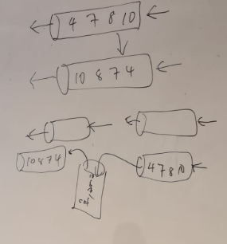

1. A double-ended queue, or **deque** (pronounced as “deck” to avoid confusion with the dequeue method of the regular Queue ADT) is a queue-like data structure that supports insertion and deletion at both the front and the back of the queue.

Define a Deque ADT by listing and describing the methods that should be supported by a Deque.

|  |  |
| --- | --- |
| Deque() | Creates a new empty deque, which is deque containing no items |
| isEmpty() | Returns a Boolean value indicating whether the dequeue is empty |
| length() | Returns the number of items currently in the deque |
| enqueue_front(item) | Adds the given item to the front of the deque |
| enqueue_back(item) | Adds the given item to the back of the deque |
| dequeue_front() | Removes and returns the front item from the deque. An item cannot be dequeued from an empty deque |
| dequeue_back() | Removes and returns the back item from the deque. An item cannot be dequeued from an empty deque. |

***-- End of Tutorial --***

AY2020/21 S1 Page 1