Status Report – Executive Summary
Project: eBest IT security enhancement | Period: 2 Nov – 9 Nov 2026

Achievements
- Investigated the inventory and delivery PDF document sharing process.
- Developed a mechanism to protect PDF documents by password and expiry date.
- Developed a new platform for PDF document sharing (admin upload, user download).
- Shared login credentials with warehouse personnel for testing.
Key screenshots:
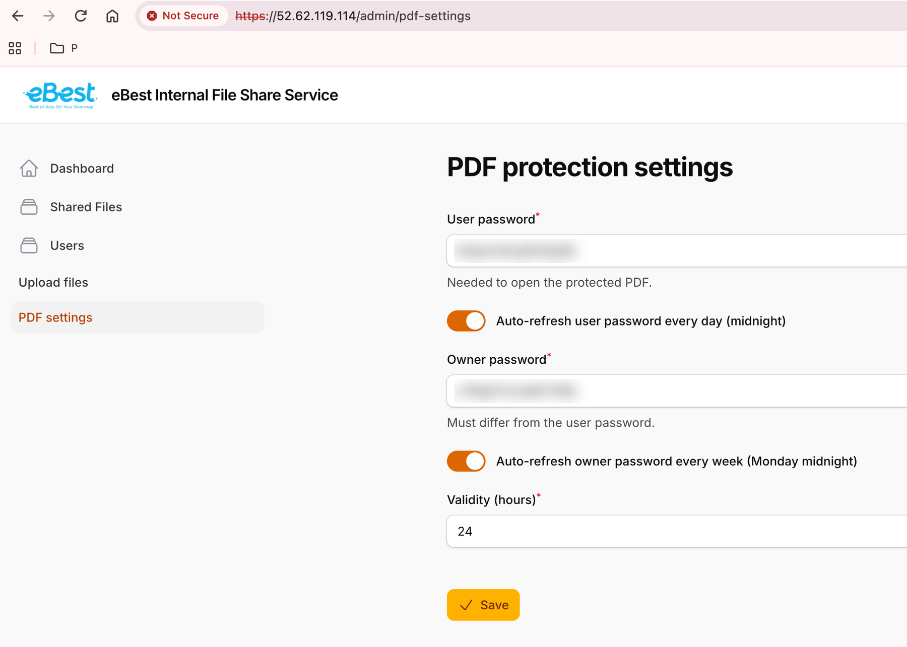  PDF password and expiry settings (admin) | 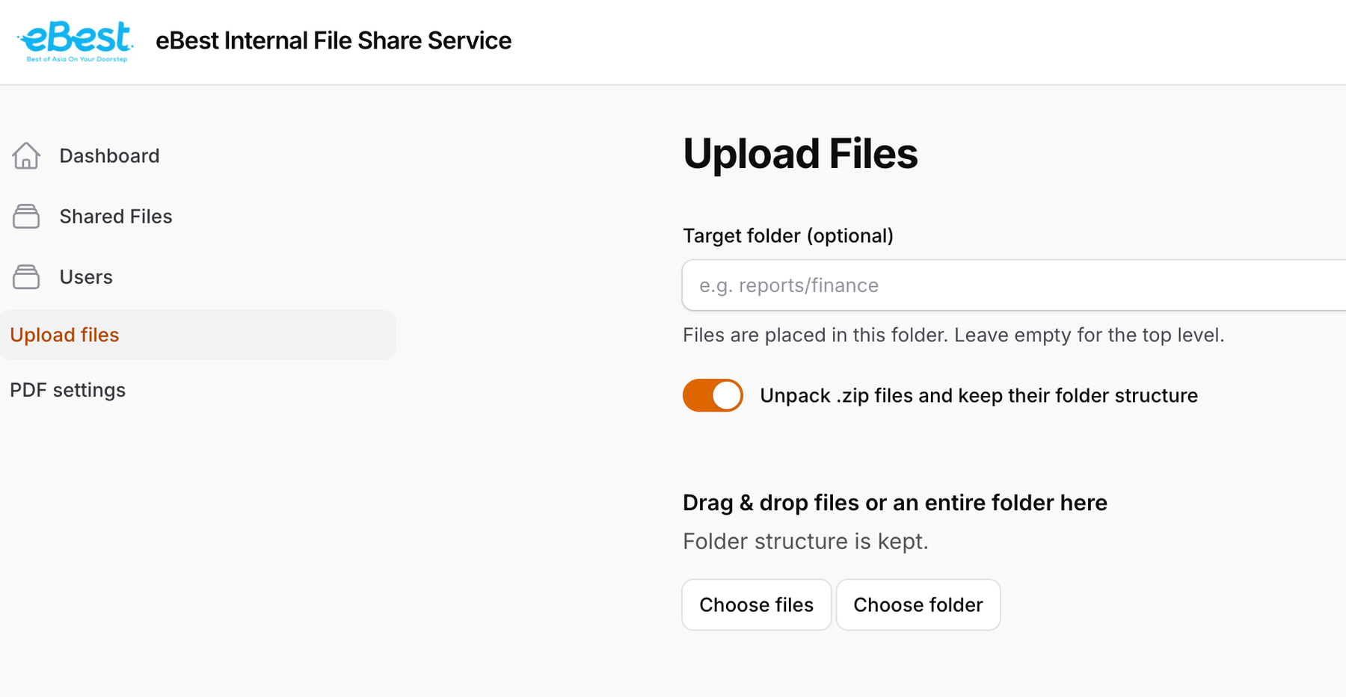  Admin file upload
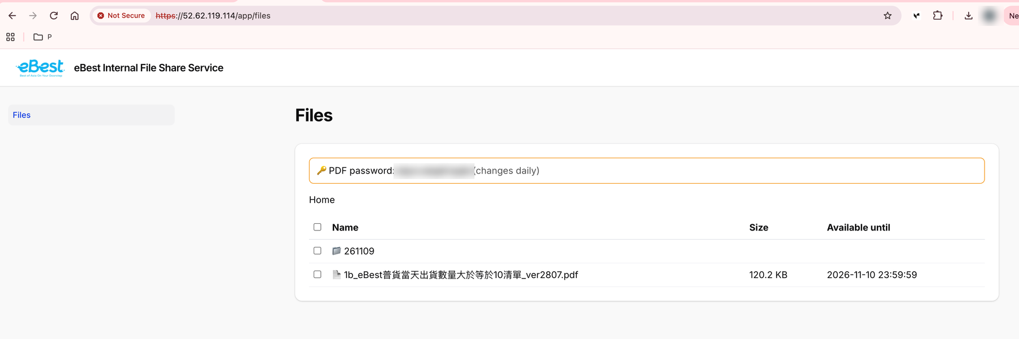  User file download page with PDF password | 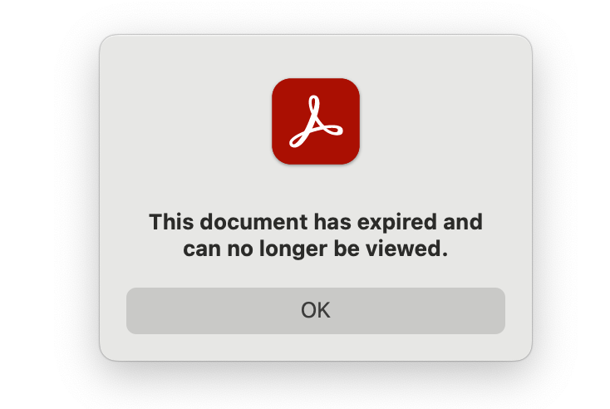  Expired PDF blocked in Adobe

Dependencies
Security improvement on API and data export is still blocked by the following five dependencies:
1. Source code of https://minimall.donkibuy.com/app/api/v1
2. LAB and Production environment access for https://minimall.donkibuy.com/app/api/v1
3. Source code of the latest iOS and Android eBest App
4. Source code of ERP (中台)
5. LAB and Production environment access to ERP
Recommendation: establish a weekly discussion with the development team.

Plan for next 5–7 days
- Continue investigation on white label.
- Continue investigation on Export menu security.
- Continue investigation on app/api/v1 security.

