CSIT115 Assignment 2 Test Cases

Name : Yong Qin Toh
Student No. : 7059073

General Instructions

1) Prepare the following :

(i) Setup / prepare the exact same version of your solution (that you submitted before deadline) to perform the test cases

- Open up Excel document ‘CSIT115_A2_Checklist.xls‘

2) Perform test cases SEQUENTIALLY on your program, do not skip steps / sequence!

3) FOR EACH test case :

  - Perform the test case using answers from your script

  - If your program ‘pass’ the test case

- Do screen capture, and paste the image in this document
(CSIT115_A2_Test_Cases.doc), where indicated

- Update CSIT115_A2_Checklist.xls (select ‘yes’) at the row corresponding to your test case

Else // i.e. program ‘fails’ the test case

- No need for screen capture (leave the section blank)

- Update CSIT115_A2_Checklist.xls (select ‘no’) at the
row corresponding to your test case

4) Note : Please RESIZE your screen capture, Adjust the Spacing such that each test case begins on a new page !!

Before you proceed ...

1) Login into your Ubuntu, MySQL Command Line, as ‘root’ user

2) Ensure your Assignment's script file (containing all your SQL answers) are on "stand-by" (i.e. readily available)

3) From MySQL Command Line, create a "blank" database which DO NOT have any tables in it!

(e.g.
mysql> create database A2TestDB;
mysql> use A2TestDB;
)

4) Initial setup for Task1 : run your *_Create.sql script to create all tables first!

5) Initial setup for Task2 : Execute the script files in the following order :

A2dbdrop.sql, A2dbcreate.sql, A2dbload.sql

Test Case #1a –

Person table created correctly?

- On the msql> prompt, type : show columns from Person;

- Expected Outcome :

+-----------------+-------------+------+-----+---------+-------+
| Field | Type | Null | Key | Default | Extra |
+-----------------+-------------+------+-----+---------+-------+
| passport_number | varchar(20) | NO | PRI | NULL | |
| first_name | varchar(30) | NO | MUL | NULL | |
| last_name | varchar(30) | NO | | NULL | |
| date_of_birth | date | NO | | NULL | |
| gender | char(1) | NO | | NULL | |
| address | varchar(50) | NO | | NULL | |
| tel_no | varchar(20) | YES | | NULL | |
| email | varchar(50) | NO | | NULL | |
+-----------------+-------------+------+-----+---------+-------+
Note => it is ok to :
- have slightly different column names, upper/lower case, as long as the MEANING of your attributes is the SAME as those in the figure above (e.g. passport_number, first_name, etc)
- have different order of rows presentation from the figure above

- Paste (and re-size) screen capture(s) of your Ubuntu terminal's output where indicated below, if:
  - the values in columns 'Type', 'Null', 'Key', 'Default', 'Extra' is exactly similar to its 'Field' (containing column names) for the corresponding, associated rows of data

- In CSIT115_A2_Checklist.xls, refer to the test case #1a, update the relevant cell in column C (select ‘Yes), if you accomplish step c) successfully

<Test Case #1a : Paste Screen Capture(s) below >

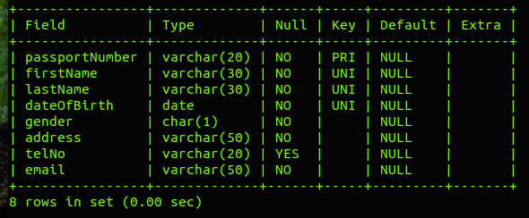

Test Case #1b –

Person table - can insert?

- On the msql> prompt, construct and execute INSERT statement(s), to insert the following values into your Person table :

+-----------------+-----------------------|-----------------------|-----------------------|
| Column | Value 1 | Value 2 | Value 3 |
+-----------------+-----------------------|-----------------------|-----------------------|
| passport_number | 'S1001001M' | 'S1001002F' | 'S1001003F' |
| first_name | 'Test-Person-01' | 'Test-Person-02' | 'Test-Person-03' |
| last_name | 'Lname-01' | 'Lname-02' | 'Lname-03' |
| date_of_birth | '13-08-1988' | '13-09-1989' | '13-10-1990' |
| gender | 'M' | 'F' | 'F' |
| address | 'Test-Addr-01' | 'Test-Addr-02' | 'Test-Addr-03' |
| tel_no | '65-10001234' | '65-10002234' | '65-10003234' |
| email | 'Test-Email-01@db.com | 'Test-Email-02@db.com | 'Test-Email-03@db.com |
+-----------------+-----------------------|-----------------------|-----------------------|

- On the msql> prompt, execute : SELECT * FROM Person;

- Paste (and re-size) screen capture(s) of your Ubuntu terminal's output where indicated below, if:
  - your output in step b), shows 3 rows of record, with the exact same values as those reflected in step a)'s sample data

- In CSIT115_A2_Checklist.xls, refer to the test case #1b, update the relevant cell in column C (select ‘Yes), if you accomplish step c) successfully

<Test Case #1b : Paste Screen Capture(s) below >

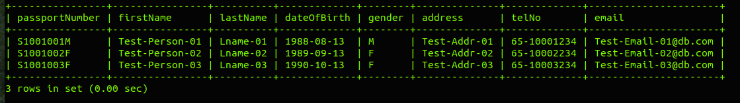

Test Case #1c –

Person table's PK works correctly?

- On the msql> prompt, construct and execute an INSERT statement, to insert the following values into your Person table :

+-----------------+-------------
| Column | Value
+-----------------+-------------
| passport_number | 'S1001001M'
| first_name | 'Test-Person-04'
| last_name | 'Lname-04'
| date_of_birth | '13-11-1991'
| gender | 'M'
| address | 'Test-Addr-04'
| tel_no | '65-10005678'
| email | 'Test-Email-04@db.com
+-----------------+-------------

- Paste (and re-size) screen capture(s) of your Ubuntu terminal's output where indicated below, if:
  - your insertion is UN-SUCCESSFUL, due to Primary Key constraint on passport_number!

- In CSIT115_A2_Checklist.xls, refer to the test case #1c, update the relevant cell in column C (select ‘Yes), if you accomplish step b) successfully

<Test Case #1c : Paste Screen Capture(s) below >

Test Case #1d –

Person table's CK (Unique Constraint) works correctly?

- On the msql> prompt, construct and execute an INSERT statement, to insert the following values into your Person table :

+-----------------+-------------
| Column | Value
+-----------------+-------------
| passport_number | 'S1001004M'
| first_name | 'Test-Person-01'
| last_name | 'Lname-01'
| date_of_birth | '13-08-1988'
| gender | 'F'
| address | 'Test-Addr-04'
| tel_no | '65-10004444'
| email | 'Test-Email-04@db.com
+-----------------+-------------

- Paste (and re-size) screen capture(s) of your Ubuntu terminal's output where indicated below, if:
  - your insertion is UN-SUCCESSFUL, due to Unique Key constraint on first_name, last_name, date_of_birth!

- In CSIT115_A2_Checklist.xls, refer to the test case #1d, update the relevant cell in column C (select ‘Yes), if you accomplish step b) successfully

<Test Case #1d : Paste Screen Capture(s) below >

Test Case #2a –

Chef table created correctly?

- On the msql> prompt, type : show columns from Chef;

- Expected Outcome :

+------------------+--------------+------+-----+---------+-------+
| Field | Type | Null | Key | Default | Extra |
+------------------+--------------+------+-----+---------+-------+
| passport_number | varchar(20) | NO | PRI | NULL | |
| culinary_certs | varchar(300) | NO | | NULL | |
| competition_expr | varchar(300) | YES | | NULL | |
+------------------+--------------+------+-----+---------+-------+

Note => it is ok to :
- have slightly different column names, upper/lower case, as long as the MEANING of your attributes is the SAME as those in the figure above (e.g. passport_number,, culinary_certs, etc)
- have different order of rows presentation from the figure above

- Paste (and re-size) screen capture(s) of your Ubuntu terminal's output where indicated below, if:
  - the values in columns 'Type', 'Null', 'Key', 'Default', 'Extra' is exactly similar to its 'Field' (containing column names) for the corresponding, associated rows of data

- In CSIT115_A2_Checklist.xls, refer to the test case #2a, update the relevant cell in column C (select ‘Yes), if you accomplish step c) successfully

<Test Case #2a : Paste Screen Capture(s) below >

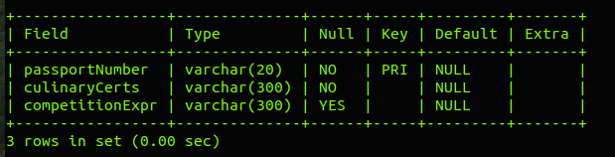

Test Case #2b –

Chef table - can insert?

- On the msql> prompt, construct and execute INSERT statement(s), to insert the following values into your Chef table :

+------------------+----------------
| Column | Value 1
+------------------+----------------
| passport_number | 'S1001003F'
| culinary_certs | 'BSc FoodSci, MA FoodArt'
| competition_expr | 'G. Ramsey Hells Kitchen'
+------------------+----------------
+------------------+----------------
| Column | Value 2
+------------------+----------------
| passport_number | 'S1001002F'
| culinary_certs | 'Shatec Diploma in Cooking'
| competition_expr | 'MasterChef Singapore'
+------------------+----------------

- On the msql> prompt, execute : SELECT * FROM Chef;

- Paste (and re-size) screen capture(s) of your Ubuntu terminal's output where indicated below, if:
  - your output in step b), shows 2 rows of record, with the exact same values as those reflected in step a)'s sample data

- In CSIT115_A2_Checklist.xls, refer to the test case #2b, update the relevant cell in column C (select ‘Yes), if you accomplish step c) successfully

<Test Case #2b : Paste Screen Capture(s) below >

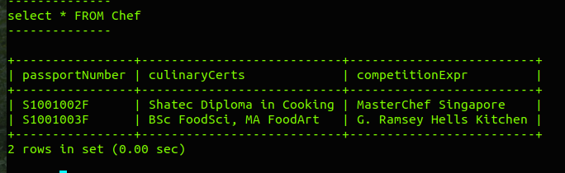

Test Case #2c –

Chef table's PK works correctly?

- On the msql> prompt, construct and execute an INSERT statement, to insert the following values into your Chef table :

+------------------+----------------
| Column | Value
+------------------+----------------
| passport_number | 'S1001003F'
| culinary_certs | 'University of Hawker Food'
| competition_expr | 'SIM Bakery Contest'
+------------------+----------------

- Paste (and re-size) screen capture(s) of your Ubuntu terminal's output where indicated below, if:
  - your insertion is UN-SUCCESSFUL, due to Primary Key constraint on passport_number!

- In CSIT115_A2_Checklist.xls, refer to the test case #2c, update the relevant cell in column C (select ‘Yes), if you accomplish step b) successfully

<Test Case #2c : Paste Screen Capture(s) below >

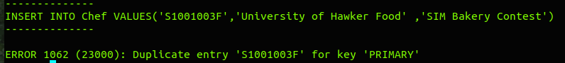

Test Case #2d –

Chef table's FK works correctly?

- On the msql> prompt, construct and execute an INSERT statement, to insert the following values into your Chef table :

+------------------+----------------
| Column | Value
+------------------+----------------
| passport_number | 'S1001007M'
| culinary_certs | 'University of Street Food'
| competition_expr | 'Starbux Cocktail Contest'
+------------------+----------------

- Paste (and re-size) screen capture(s) of your Ubuntu terminal's output where indicated below, if:
  - your insertion is UN-SUCCESSFUL, due to Foreign Key constraint on passport_number (linked to table : Person)

- In CSIT115_A2_Checklist.xls, refer to the test case #2d, update the relevant cell in column C (select ‘Yes), if you accomplish step b) successfully

<Test Case #2d : Paste Screen Capture(s) below >

Test Case #2e –

Client table created correctly?

- On the msql> prompt, type : show columns from Client;

- Expected Outcome :

+------------------------+--------------+------+-----+---------+-------+
| Field | Type | Null | Key | Default | Extra |
+------------------------+--------------+------+-----+---------+-------+
| passport_number | varchar(20) | NO | PRI | NULL | |
| preferred_cuisine | varchar(100) | YES | | NULL | |
| preferred_payment_type | varchar(20) | NO | | NULL | |
| credit_card_number | varchar(20) | YES | | NULL | |
| credit_card_type | varchar(20) | YES | | NULL | |
| issuing_bank | varchar(50) | YES | | NULL | |
+------------------------+--------------+------+-----+---------+-------+

Note => it is ok to :
- have slightly different column names, upper/lower case, as long as the MEANING of your attributes is the SAME as those in the figure above (e.g. passport_number, preferred_cuisine, etc)
- have different order of rows presentation from the figure above

- Paste (and re-size) screen capture(s) of your Ubuntu terminal's output where indicated below, if:

  - the values in columns 'Type', 'Null', 'Key', 'Default', 'Extra' is exactly similar to its 'Field' (containing column names) for the corresponding, associated rows of data

- In CSIT115_A2_Checklist.xls, refer to the test case #2e, update the relevant cell in column C (select ‘Yes), if you accomplish step c) successfully

<Test Case #2e : Paste Screen Capture(s) below >

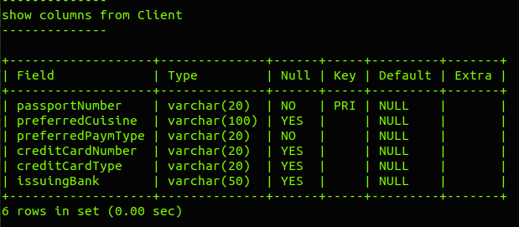

Test Case #2f –

Client table - can insert?

- On the msql> prompt, construct and execute INSERT statement(s), to insert the following values into your Client table :

+------------------------+-------------
| Column | Value 1
+------------------------+-------------
| passport_number | 'S1001001M'
| preferred_cuisine | 'Nonya Penang Laksa'
| preferred_payment_type | 'Cash'
| credit_card_number | NULL
| credit_card_type | NULL
| issuing_bank | NULL
+------------------------+-------------
+------------------------+-------------
| Column | Value 2
+------------------------+-------------
| passport_number | 'S1001002F'
| preferred_cuisine | 'Spicy Chilli Pepper Chicken'
| preferred_payment_type | 'Credit Card'
| credit_card_number | 'OCBC-12345678'
| credit_card_type | 'MasterCard'
| issuing_bank | 'OCBC'
+------------------------+-------------

- On the msql> prompt, execute : SELECT * FROM Client;

- Paste (and re-size) screen capture(s) of your Ubuntu terminal's output where indicated below, if:
  - your output in step b), shows 2 rows of record, with the exact same values as those reflected in step a)'s sample data

- In CSIT115_A2_Checklist.xls, refer to the test case #2f, update the relevant cell in column C (select ‘Yes), if you accomplish step c) successfully

<Test Case #2f : Paste Screen Capture(s) below >
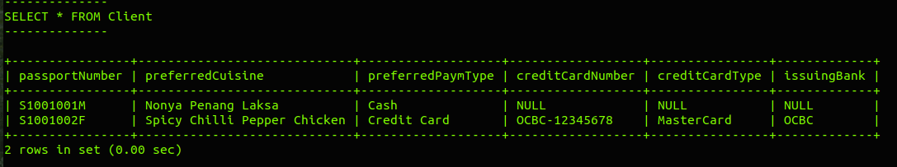

Test Case #2g –

Client table's PK works correctly?

- On the msql> prompt, construct and execute an INSERT statement, to insert the following values into your Client table :

+------------------------+-------------
| Column | Value
+------------------------+-------------
| passport_number | 'S1001001M'
| preferred_cuisine | 'Fragrant Seafood Fried Rice'
| preferred_payment_type | 'Cheque'
| credit_card_number | NULL
| credit_card_type | NULL
| issuing_bank | NULL
+------------------------+-------------

- Paste (and re-size) screen capture(s) of your Ubuntu terminal's output where indicated below, if:
  - your insertion is UN-SUCCESSFUL, due to Primary Key constraint on passport_number!

- In CSIT115_A2_Checklist.xls, refer to the test case #2g, update the relevant cell in column C (select ‘Yes), if you accomplish step b) successfully

<Test Case #2g : Paste Screen Capture(s) below >
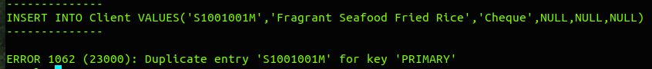

Test Case #2h –

Client table's FK works correctly?

- On the msql> prompt, construct and execute an INSERT statement, to insert the following values into your Client table :

+------------------------+-------------
| Column | Value
+------------------------+-------------
| passport_number | 'S1001444M'
| preferred_cuisine | 'French Snail Buffet'
| preferred_payment_type | 'Cash'
| credit_card_number | NULL
| credit_card_type | NULL
| issuing_bank | NULL
+------------------------+-------------

- Paste (and re-size) screen capture(s) of your Ubuntu terminal's output where indicated below, if:
  - your insertion is UN-SUCCESSFUL, due to Foreign Key constraint on passport_number (linked to table : Person)

- In CSIT115_A2_Checklist.xls, refer to the test case #2h, update the relevant cell in column C (select ‘Yes), if you accomplish step b) successfully

<Test Case #2h : Paste Screen Capture(s) below >

Test Case #3a –

Specialty table created correctly?

- On the msql> prompt, type : show columns from Specialty;

- Expected Outcome :

+------------------+---------------+------+-----+---------+-------+
| Field | Type | Null | Key | Default | Extra |
+------------------+---------------+------+-----+---------+-------+
| passport_number | varchar(20) | NO | PRI | NULL | |
| specialty_number | decimal(3,0) | NO | PRI | NULL | |
| description | varchar(100) | NO | | NULL | |
| ingredients | varchar(300) | NO | | NULL | |
| recipe | varchar(1000) | YES | | NULL | |
+------------------+---------------+------+-----+---------+-------+

Note => it is ok to :
- have slightly different column names, upper/lower case, as long as the MEANING of your attributes is the SAME as those in the figure above (e.g. passport_number, specialty_number, etc)
- have different order of rows presentation from the figure above

- Paste (and re-size) screen capture(s) of your Ubuntu terminal's output where indicated below, if:

  - the values in columns 'Type', 'Null', 'Key', 'Default', 'Extra' is exactly similar to its 'Field' (containing column names) for the corresponding, associated rows of data

- In CSIT115_A2_Checklist.xls, refer to the test case #3a, update the relevant cell in column C (select ‘Yes), if you accomplish step c) successfully

<Test Case #3a : Paste Screen Capture(s) below >
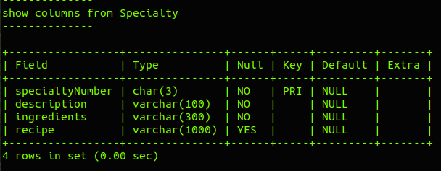

Test Case #3b –

Specialty table - can insert?

- On the msql> prompt, construct and execute INSERT statement(s), to insert the following values into your Specialty table :

+------------------+-------------
| Column | Value 2
+------------------+-------------
| passport_number | 'S1001003F'
| specialty_number | 303
| description | 'claypot tofu'
| ingredients | 'clay, pot, tofu'
| recipe | 'step1 - mix everything, step2 - cook'
+------------------+-------------
+------------------+-------------
| Column | Value 2
+------------------+-------------
| passport_number | 'S1001002F'
| specialty_number | 202
| description | 'lava cake'
| ingredients | 'lava, flour, eggs'
| recipe | 'step1 - mix everything, step2 - bake'
+------------------+-------------

- On the msql> prompt, execute : SELECT * FROM Specialty;

- Paste (and re-size) screen capture(s) of your Ubuntu terminal's output where indicated below, if:
  - your output in step b), shows 2 rows of record, with the exact same values as those reflected in step a)'s sample data

- In CSIT115_A2_Checklist.xls, refer to the test case #3b, update the relevant cell in column C (select ‘Yes), if you accomplish step c) successfully

<Test Case #3b : Paste Screen Capture(s) below >

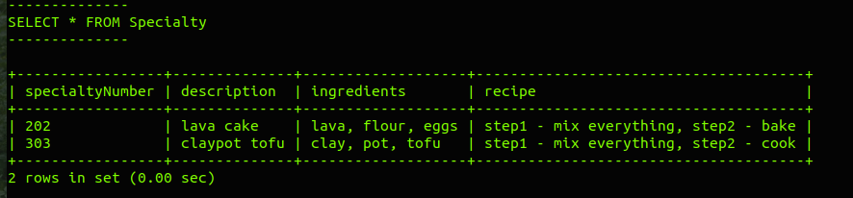

Test Case #3c –

Specialty table's PK works correctly?

- On the msql> prompt, construct and execute an INSERT statement, to insert the following values into your Specialty table :

+------------------+-------------
| Column | Value
+------------------+-------------
| passport_number | 'S1001003F'
| specialty_number | 303
| description | 'bbq stingray'
| ingredients | 'bbq sauce, charcoal, sting, ray'
| recipe | 'step1 - mix everything, step2 - grill'
+------------------+-------------

- Paste (and re-size) screen capture(s) of your Ubuntu terminal's output where indicated below, if:
  - your insertion is UN-SUCCESSFUL, due to Primary Key constraint on passport_number, specialty_number!

- In CSIT115_A2_Checklist.xls, refer to the test case #3c, update the relevant cell in column C (select ‘Yes), if you accomplish step b) successfully

<Test Case #3c : Paste Screen Capture(s) below >

Test Case #3d –

Specialty table's FK works correctly?

- On the msql> prompt, construct and execute an INSERT statement, to insert the following values into your Specialty table :

+------------------+-------------
| Column | Value 2
+------------------+-------------
| passport_number | 'S1002274F'
| specialty_number | 274
| description | 'popcorn chicken curry puff'
| ingredients | 'pop, corn, curry, puff'
| recipe | 'step1 - mix everything, step2 - fry'
+------------------+-------------

- Paste (and re-size) screen capture(s) of your Ubuntu terminal's output where indicated below, if:

  - your insertion is UN-SUCCESSFUL, due to Foreign Key constraint on passport_number (linked to table : Chef)

- In CSIT115_A2_Checklist.xls, refer to the test case #3d, update the relevant cell in column C (select ‘Yes), if you accomplish step b) successfully

<Test Case #3d : Paste Screen Capture(s) below >

Test Case #4a –

PartyEvent table created correctly?

- On the msql> prompt, type : show columns from PartyEvent;

- Expected Outcome :

+------------------------+--------------+------+-----+---------+-------+
| Field | Type | Null | Key | Default | Extra |
+------------------------+--------------+------+-----+---------+-------+
| event_id | char(10) | NO | PRI | NULL | |
| client_passport_number | varchar(20) | NO | MUL | NULL | |
| chef_passport_number | varchar(20) | NO | MUL | NULL | |
| party_size | decimal(3,0) | NO | | NULL | |
| cusine_pkg | varchar(100) | NO | | NULL | |
| event_date | date | NO | MUL | NULL | |
| event_time | char(5) | NO | | NULL | |
| event_venue | varchar(50) | NO | | NULL | |
+------------------------+--------------+------+-----+---------+-------+
Note => it is ok to :
- have slightly different column names, upper/lower case, as long as the MEANING of your attributes is the SAME as those in the figure above (e.g. event_id, client_passport_number, etc)
- have different order of rows presentation from the figure above

- Paste (and re-size) screen capture(s) of your Ubuntu terminal's output where indicated below, if:
  - the values in columns 'Type', 'Null', 'Key', 'Default', 'Extra' is exactly similar to its 'Field' (containing column names) for the corresponding, associated rows of data

- In CSIT115_A2_Checklist.xls, refer to the test case #4a, update the relevant cell in column C (select ‘Yes), if you accomplish step c) successfully

<Test Case #4a : Paste Screen Capture(s) below >
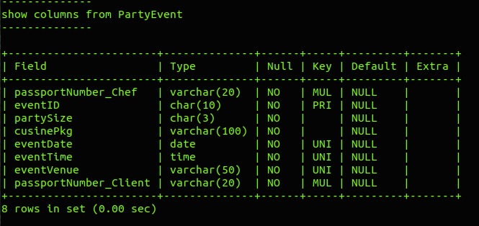

Test Case #4b –

PartyEvent table - can insert?

- On the msql> prompt, construct and execute INSERT statement(s), to insert the following values into your PartyEvent table :
+------------------------+--------------------|--------------------|
| Field | Value 1 | Value 2 |
+------------------------+--------------------|--------------------|
| event_id | '1000100001' | '1000100002' |
| client_passport_number | 'S1001001M' | 'S1001001M' |
| chef_passport_number | 'S1001003F' | 'S1001002F' |
| party_size | 138 | 88 |
| cusine_pkg | 'Halloween Horror' | 'Sweet 16 Partee' |
| event_date | '01-11-2019' | '02-12-2019' |
| event_time | '21:59' | '19:00' |
| event_venue | 'SIM Study Hall' | 'SIM Starbux' |
+------------------------+--------------------|--------------------|

+------------------------+--------------------|--------------------|
| Field | Value 3 | Value 4 |
+------------------------+--------------------|--------------------|
| event_id | '1000100003' | '1000100004' |
| client_passport_number | 'S1001002F' | 'S1001001M' |
| chef_passport_number | 'S1001003F' | 'S1001002F' |
| party_size | 168 | 8 |
| cusine_pkg | 'Slumber Parteee' | 'Stag Nite!' |
| event_date | '03-03-2020' | '08-08-2020' |
| event_time | '22:59' | '20:00' |
| event_venue | 'SIM Toilet' | 'SIM LT' |
+------------------------+--------------------|--------------------|

- On the msql> prompt, execute : SELECT * FROM PartyEvent;

- Paste (and re-size) screen capture(s) of your Ubuntu terminal's output where indicated below, if:

  - your output in step b), shows 4 rows of record, with the exact same values as those reflected in step a)'s sample data

- In CSIT115_A2_Checklist.xls, refer to the test case #4b, update the relevant cell in column C (select ‘Yes), if you accomplish step c) successfully

<Test Case #4b : Paste Screen Capture(s) below >

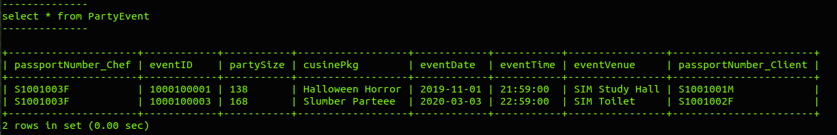

Test Case #4c –

PartyEvent table's PK works correctly?

- On the msql> prompt, construct and execute an INSERT statement, to insert the following values into your PartyEvent table :

+------------------------+--------------------
| Field | Value
+------------------------+--------------------
| event_id | '1000100001'
| client_passport_number | 'S1001001M'
| chef_passport_number | 'S1001003F'
| party_size | 666
| cusine_pkg | 'League of Evil Banquet'
| event_date | '06-06-2066'
| event_time | '23:59'
| event_venue | 'SIM Exam Hall'
+------------------------+--------------------

- Paste (and re-size) screen capture(s) of your Ubuntu terminal's output where indicated below, if:
  - your insertion is UN-SUCCESSFUL, due to Primary Key constraint on event_id!

- In CSIT115_A2_Checklist.xls, refer to the test case #4c, update the relevant cell in column C (select ‘Yes), if you accomplish step b) successfully

<Test Case #4c : Paste Screen Capture(s) below >

Test Case #4d –

PartyEvent table's FK works correctly (1)?

- On the msql> prompt, construct and execute an INSERT statement, to insert the following values into your PartyEvent table :

+------------------------+--------------------
| Field | Value
+------------------------+--------------------
| event_id | '1000100111'
| client_passport_number | 'S1001001M'
| chef_passport_number | 'S1001999F'
| party_size | 111
| cusine_pkg | 'Snails Strike Back'
| event_date | '11-01-2111'
| event_time | '23:59'
| event_venue | 'SIM Courtyard'
+------------------------+--------------------

- Paste (and re-size) screen capture(s) of your Ubuntu terminal's output where indicated below, if:

  - your insertion is UN-SUCCESSFUL, due to Foreign Key constraint on chef_passport_number (linked to table : Chef)!

- In CSIT115_A2_Checklist.xls, refer to the test case #4d, update the relevant cell in column C (select ‘Yes), if you accomplish step b) successfully

<Test Case #4d : Paste Screen Capture(s) below >

Test Case #4e –

PartyEvent table's FK works correctly (2)?

- On the msql> prompt, construct and execute an INSERT statement, to insert the following values into your PartyEvent table :

+------------------------+--------------------
| Field | Value
+------------------------+--------------------
| event_id | '1000100033'
| client_passport_number | 'S1001777M'
| chef_passport_number | 'S1001002F'
| party_size | 99
| cusine_pkg | 'Vegans Delight'
| event_date | '03-03-2133'
| event_time | '23:59'
| event_venue | 'SIM Koi Pond'
+------------------------+--------------------

- Paste (and re-size) screen capture(s) of your Ubuntu terminal's output where indicated below, if:

  - your insertion is UN-SUCCESSFUL, due to Foreign Key constraint on client_passport_number (linked to table : Client)!

- In CSIT115_A2_Checklist.xls, refer to the test case #4e, update the relevant cell in column C (select ‘Yes), if you accomplish step b) successfully

<Test Case #4e : Paste Screen Capture(s) below >

Test Case #5 –

Alter Table PartyEvent (on delete cascade) ok?

- On the msql> prompt, type and execute the following :
SELECT * FROM Client;
SELECT * FROM PartyEvent;

- Expected Outcome :

--------------
SELECT * FROM Client
--------------

+-----------------+-----------------------------+------------------------+--------------------
| passport_number | preferred_cuisine | preferred_payment_type | credit_card_number
+-----------------+-----------------------------+------------------------+--------------------
| S1001001M | Nonya Penang Laksa | Cash | NULL
| S1001002F | Spicy Chilli Pepper Chicken | Credit Card | OCBC-12345678
+-----------------+-----------------------------+------------------------+--------------------

------------------+--------------+
credit_card_type | issuing_bank |
------------------+--------------+
NULL | NULL |
MasterCard | OCBC |
------------------+--------------+

--------------
SELECT * FROM PartyEvent
--------------

+------------+------------------------+----------------------+------------+------------------+------------
| event_id | client_passport_number | chef_passport_number | party_size | cusine_pkg | event_date
+------------+------------------------+----------------------+------------+------------------+------------
| 1000100001 | S1001001M | S1001003F | 138 | Halloween Horror | 2019-11-01
| 1000100002 | S1001001M | S1001002F | 88 | Sweet 16 Partee | 2019-12-02
| 1000100003 | S1001002F | S1001003F | 168 | Slumber Parteee | 2020-03-03
| 1000100004 | S1001001M | S1001002F | 8 | Stag Nite! | 2020-08-08
+------------+------------------------+----------------------+------------+------------------+------------

------------+----------------+
event_time | event_venue |
------------+----------------+
21:59 | SIM Study Hall |
19:00 | SIM Starbux |
22:59 | SIM Toilet |
20:00 | SIM LT |
------------+----------------+

- Execute your (submitted) Assn2 SQL statements that implements the automatic deletion of (related) rows of record in PartyEvent table, when a row from Client table is deleted

- On the msql> prompt, type and execute the following :

DELETE FROM Client Where passport_number = 'S1001001M';

- Perform step a) again

- Expected Outcome :

--------------
select * from Client
--------------

+-----------------+-----------------------------+------------------------+--------------------
| passport_number | preferred_cuisine | preferred_payment_type | credit_card_number
+-----------------+-----------------------------+------------------------+--------------------
| S1001002F | Spicy Chilli Pepper Chicken | Credit Card | OCBC-12345678
+-----------------+-----------------------------+------------------------+--------------------

------------------+--------------+
credit_card_type | issuing_bank |
------------------+--------------+
MasterCard | OCBC |
------------------+--------------+

--------------
select * from PartyEvent
--------------

+------------+------------------------+----------------------+------------+-----------------
| event_id | client_passport_number | chef_passport_number | party_size | cusine_pkg
+------------+------------------------+----------------------+------------+-----------------
| 1000100003 | S1001002F | S1001003F | 168 | Slumber Parteee
+------------+------------------------+----------------------+------------+-----------------

------------+------------+-------------+
event_date | event_time | event_venue |
------------+------------+-------------+
2020-03-03 | 22:59 | SIM Toilet |
------------+------------+-------------+

- Paste (and re-size) screen capture(s) of your Ubuntu terminal's output from steps a) to f) where indicated below, if:
  - your screen captures shows same output as the Expected Outcomes

- In CSIT115_A2_Checklist.xls, refer to the test case #5, update the relevant cell in column C (select ‘Yes), if you accomplish step g) successfully

<Test Case #5 : Paste Screen Capture(s) below >

Test Case #6 –

Alter Table Chef (modify competition expr) ok?

- On the msql> prompt, type and execute the following :
show columns from Chef;

- Expected Outcome :

--------------
show columns from Chef
--------------

+------------------+--------------+------+-----+---------+-------+
| Field | Type | Null | Key | Default | Extra |
+------------------+--------------+------+-----+---------+-------+
| passport_number | varchar(20) | NO | PRI | NULL | |
| culinary_certs | varchar(300) | NO | | NULL | |
| competition_expr | varchar(300) | YES | | NULL | |
+------------------+--------------+------+-----+---------+-------+

- Execute your (submitted) Assn2 SQL statements that modify the maximum length of competition experiences to 1000 chars in Chef table

- Perform step a) again

- Expected Outcome :

--------------
show columns from Chef
--------------

+------------------+---------------+------+-----+---------+-------+
| Field | Type | Null | Key | Default | Extra |
+------------------+---------------+------+-----+---------+-------+
| passport_number | varchar(20) | NO | PRI | NULL | |
| culinary_certs | varchar(300) | NO | | NULL | |
| competition_expr | varchar(1000) | NO | | NULL | |
+------------------+---------------+------+-----+---------+-------+

- Paste (and re-size) screen capture(s) of your Ubuntu terminal's output from steps a) to e) where indicated below, if:
  - your screen captures shows same output as the Expected Outcomes

- In CSIT115_A2_Checklist.xls, refer to the test case #6, update the relevant cell in column C (select ‘Yes), if you accomplish step f) successfully

<Test Case #6 : Paste Screen Capture(s) below >

a)
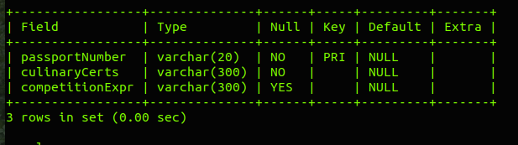

e)
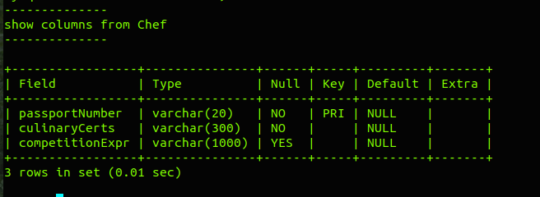

Test Case #7 –

Alter Table PartyEvent (add new column) ok?

- On the msql> prompt, type and execute the following :
show columns from PartyEvent;

- Expected Outcome :

--------------
show columns from PartyEvent
--------------

+------------------------+--------------+------+-----+---------+-------+
| Field | Type | Null | Key | Default | Extra |
+------------------------+--------------+------+-----+---------+-------+
| event_id | char(10) | NO | PRI | NULL | |
| client_passport_number | varchar(20) | NO | MUL | NULL | |
| chef_passport_number | varchar(20) | NO | MUL | NULL | |
| party_size | decimal(3,0) | NO | | NULL | |
| cusine_pkg | varchar(100) | NO | | NULL | |
| event_date | date | NO | MUL | NULL | |
| event_time | char(5) | NO | | NULL | |
| event_venue | varchar(50) | NO | | NULL | |
+------------------------+--------------+------+-----+---------+-------+

- Execute your (submitted) Assn2 SQL statements to add a new column ‘duration’ (fixed length, up to 2 digits) in PartyEvent table

- Perform step a) again

- Expected Outcome :

--------------
show columns from PartyEvent
--------------

+------------------------+--------------+------+-----+---------+-------+
| Field | Type | Null | Key | Default | Extra |
+------------------------+--------------+------+-----+---------+-------+
| event_id | char(10) | NO | PRI | NULL | |
| client_passport_number | varchar(20) | NO | MUL | NULL | |
| chef_passport_number | varchar(20) | NO | MUL | NULL | |
| party_size | decimal(3,0) | NO | | NULL | |
| cusine_pkg | varchar(100) | NO | | NULL | |
| event_date | date | NO | MUL | NULL | |
| event_time | char(5) | NO | | NULL | |
| event_venue | varchar(50) | NO | | NULL | |
| duration | decimal(2,0) | NO | | NULL | |
+------------------------+--------------+------+-----+---------+-------+

- Paste (and re-size) screen capture(s) of your Ubuntu terminal's output from steps a) to e) where indicated below, if:
  - your screen captures shows same output as the Expected Outcomes

- In CSIT115_A2_Checklist.xls, refer to the test case #7, update the relevant cell in column C (select ‘Yes), if you accomplish step f) successfully

<Test Case #7 : Paste Screen Capture(s) below >

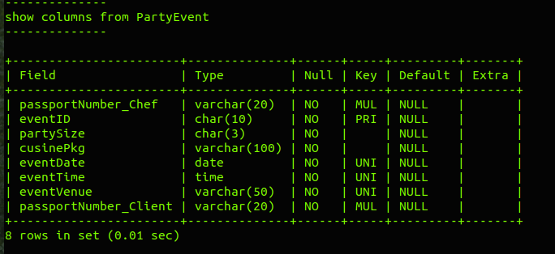

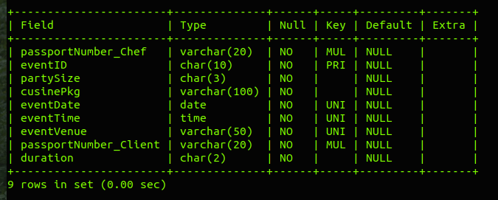

Test Case #8 –

Alter Table Client (add new columns) ok?

- On the msql> prompt, type and execute the following :
show columns from Client;

- Expected Outcome :

--------------
show columns from Client
--------------

+------------------------+--------------+------+-----+---------+-------+
| Field | Type | Null | Key | Default | Extra |
+------------------------+--------------+------+-----+---------+-------+
| passport_number | varchar(20) | NO | PRI | NULL | |
| preferred_cuisine | varchar(100) | YES | | NULL | |
| preferred_payment_type | varchar(20) | NO | | NULL | |
| credit_card_number | varchar(20) | YES | | NULL | |
| credit_card_type | varchar(20) | YES | | NULL | |
| issuing_bank | varchar(50) | YES | | NULL | |
+------------------------+--------------+------+-----+---------+-------+

- Execute your (submitted) Assn2 SQL statements that add new column 'country_of_origin' (variable length, up to 40 chars) into Client table

- Perform step a) again

- Expected Outcome :

--------------
show columns from Client
--------------

+------------------------+--------------+------+-----+---------+-------+
| Field | Type | Null | Key | Default | Extra |
+------------------------+--------------+------+-----+---------+-------+
| passport_number | varchar(20) | NO | PRI | NULL | |
| preferred_cuisine | varchar(100) | YES | | NULL | |
| preferred_payment_type | varchar(20) | NO | | NULL | |
| credit_card_number | varchar(20) | YES | | NULL | |
| credit_card_type | varchar(20) | YES | | NULL | |
| issuing_bank | varchar(50) | YES | | NULL | |
| country_of_origin | varchar(40) | NO | | NULL | |
+------------------------+--------------+------+-----+---------+-------+

- Paste (and re-size) screen capture(s) of your Ubuntu terminal's output from steps a) to e) where indicated below, if:
  - your screen captures shows same output as the Expected Outcomes

- In CSIT115_A2_Checklist.xls, refer to the test case #8, update the relevant cell in column C (select ‘Yes), if you accomplish step f) successfully

<Test Case #8 : Paste Screen Capture(s) below >

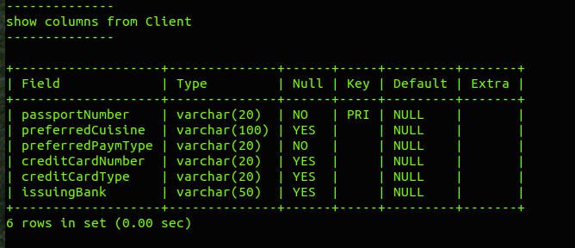

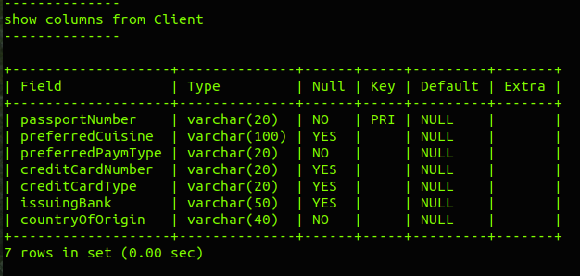

Test Case #9 –

SQL Select Statements (1)

- Execute your (submitted) Assn2 SQL statements to :

Find the employee id, first name, last name, job title and email of all employees working in Asia

- Expected Outcome :

+-------------+------------+------------+--------------------------------+----------+
| employee_id | first_name | last_name | job_title | email |
+-------------+------------+------------+--------------------------------+----------+
| 114 | Den | Raphaely | Purchasing Manager | DRAPHEAL |
| 115 | Alexander | Khoo | Purchasing Clerk | AKHOO |
| 116 | Shelli | Baida | Purchasing Clerk | SBAIDA |
| 117 | Sigal | Tobias | Purchasing Clerk | STOBIAS |
| 118 | Guy | Himuro | Purchasing Clerk | GHIMURO |
| 119 | Karen | Colmenares | Purchasing Clerk | KCOLMENA |
| 201 | Michael | Hartstein | Marketing Manager | MHARTSTE |
| 202 | Pat | Fay | Marketing Representative | PFAY |
| 203 | Susan | Mavris | Human Resources Representative | SMAVRIS |
+-------------+------------+------------+--------------------------------+----------+

- Paste (and re-size) screen capture(s) of your Ubuntu terminal's output where indicated below, if:
  - your screen captures shows same output as the Expected Outcome

- In CSIT115_A2_Checklist.xls, refer to the test case #9, update the relevant cell in column C (select ‘Yes), if you accomplish step c) successfully

<Test Case #9 : Paste Screen Capture(s) below >

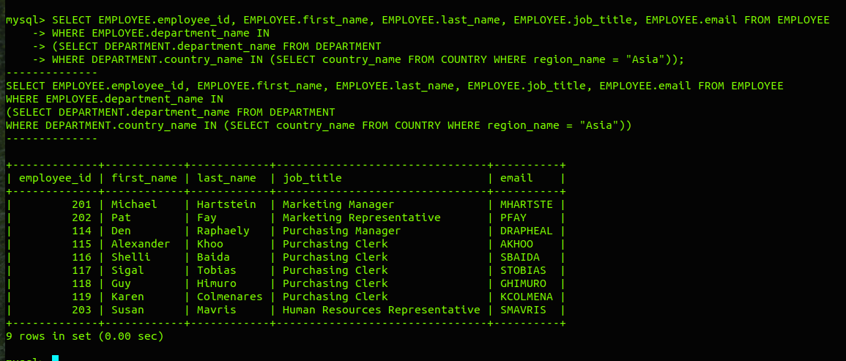

Test Case #10 –

SQL Select Statements (2)

- Execute your (submitted) Assn2 SQL statements to :

Find the employee id, first name, last name, job title and supervisor id of employees who had worked for more than 3 years and completed their jobs in the information technology department

- Expected Outcome :

+-------------+------------+-----------+-------------------------------+---------------+
| employee_id | first_name | last_name | job_title | supervisor_id |
+-------------+------------+-----------+-------------------------------+---------------+
| 102 | Lex | De Haan | Administration Vice President | 100 |
| 201 | Michael | Hartstein | Marketing Manager | 100 |
| 205 | Shelley | Higgins | Accounting Manager | 101 |
+-------------+------------+-----------+-------------------------------+---------------+

- Paste (and re-size) screen capture(s) of your Ubuntu terminal's output where indicated below, if:
  - your screen captures shows same output as the Expected Outcome

- In CSIT115_A2_Checklist.xls, refer to the test case #10, update the relevant cell in column C (select ‘Yes), if you accomplish step c) successfully

<Test Case #10 : Paste Screen Capture(s) below >

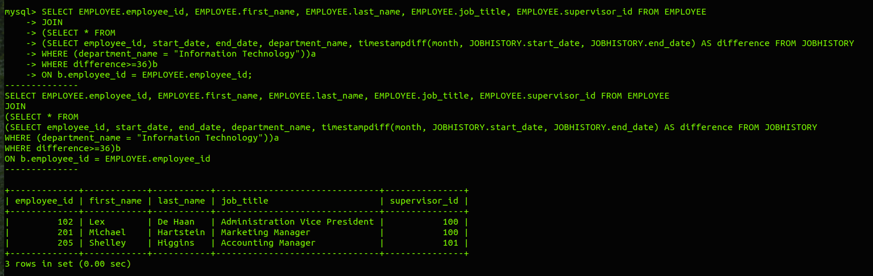

Test Case #11 –

SQL Select Statements (3)

- Execute your (submitted) Assn2 SQL statements to :

Find the employee id, first name, last name, hire-date, salary of supervisors, and the total number of employees directly supervised by each one of them. (Display only those records of supervisors who supervised 8 or more employees).

- Expected Outcome :

+-------------+------------+-----------+------------+----------+-------------+
| employee_id | first_name | last_name | hire_date | salary | TotNumOfEmp |
+-------------+------------+-----------+------------+----------+-------------+
| 100 | Steven | King | 1987-06-17 | 24000.00 | 14 |
| 120 | Matthew | Weiss | 1996-07-18 | 8000.00 | 8 |
| 121 | Adam | Fripp | 1997-04-10 | 8200.00 | 8 |
| 122 | Payam | Kaufling | 1995-05-01 | 7900.00 | 8 |
| 123 | Shanta | Vollman | 1997-10-10 | 6500.00 | 8 |
| 124 | Kevin | Mourgos | 1999-11-16 | 5800.00 | 8 |
+-------------+------------+-----------+------------+----------+-------------+

- Paste (and re-size) screen capture(s) of your Ubuntu terminal's output where indicated below, if:
  - your screen captures shows same output as the Expected Outcome

- In CSIT115_A2_Checklist.xls, refer to the test case #11, update the relevant cell in column C (select ‘Yes), if you accomplish step c) successfully

<Test Case #11 : Paste Screen Capture(s) below >

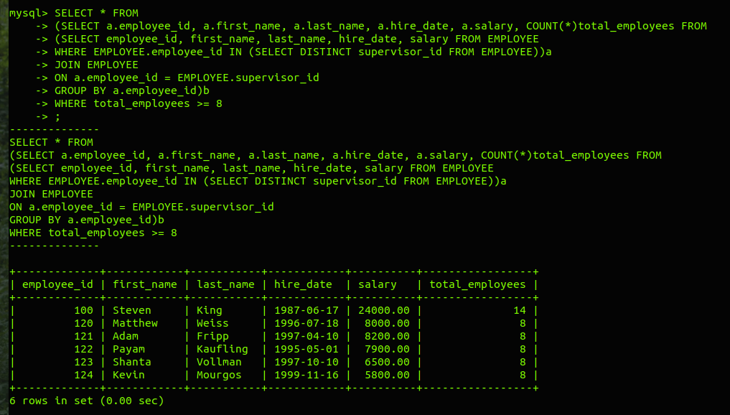

Test Case #12a –

SQL Statements (4)

- On the msql> prompt, type and execute the following :

SELECT first_name, last_name, job_title, supervisor_id
FROM EMPLOYEE
WHERE employee_id = 114;

- Expected Outcome :

// Who is employee_id = 114 and his supervisor's id ?

+------------+-----------+--------------------+---------------+
| first_name | last_name | job_title | supervisor_id |
+------------+-----------+--------------------+---------------+
| Den | Raphaely | Purchasing Manager | 100 |
+------------+-----------+--------------------+---------------+

- On the msql> prompt, type and execute the following :

SELECT employee_id, first_name, last_name, job_title, supervisor_id
FROM EMPLOYEE
WHERE employee_id =
(
SELECT supervisor_id
FROM EMPLOYEE
WHERE employee_id = 114
);

- Expected Outcome :

// Who is the boss of employee_id = 114 ?
+-------------+------------+-----------+-----------+---------------+
| employee_id | first_name | last_name | job_title | supervisor_id |
+-------------+------------+-----------+-----------+---------------+
| 100 | Steven | King | President | NULL |
+-------------+------------+-----------+-----------+---------------+

- On the msql> prompt, type and execute the following :

SELECT employee_id, first_name, last_name, job_title, supervisor_id
FROM EMPLOYEE
WHERE supervisor_id = 114;

- Expected Outcome :

// Who are the workers currently supervised by :
// the employee_id = 114 ?

+-------------+------------+------------+------------------+---------------+
| employee_id | first_name | last_name | job_title | supervisor_id |
+-------------+------------+------------+------------------+---------------+
| 115 | Alexander | Khoo | Purchasing Clerk | 114 |
| 116 | Shelli | Baida | Purchasing Clerk | 114 |
| 117 | Sigal | Tobias | Purchasing Clerk | 114 |
| 118 | Guy | Himuro | Purchasing Clerk | 114 |
| 119 | Karen | Colmenares | Purchasing Clerk | 114 |
+-------------+------------+------------+------------------+---------------+

- On the msql> prompt, type and execute the following :

SELECT employee_id, first_name, last_name, job_title, supervisor_id
FROM EMPLOYEE
WHERE supervisor_id =
(
SELECT E1.employee_id
FROM EMPLOYEE E1, EMPLOYEE E2
WHERE E2.employee_id = 114
AND E1.employee_id = E2.supervisor_id
);

- Expected Outcome :

// Who are the workers supervised by :
// the boss of employee_id = 114 ?
+-------------+------------+-----------+-------------------------------+---------------+
| employee_id | first_name | last_name | job_title | supervisor_id |
+-------------+------------+-----------+-------------------------------+---------------+
| 101 | Neena | Kochhar | Administration Vice President | 100 |
| 102 | Lex | De Haan | Administration Vice President | 100 |
| 114 | Den | Raphaely | Purchasing Manager | 100 |
| 120 | Matthew | Weiss | Stock Manager | 100 |
| 121 | Adam | Fripp | Stock Manager | 100 |
| 122 | Payam | Kaufling | Stock Manager | 100 |
| 123 | Shanta | Vollman | Stock Manager | 100 |
| 124 | Kevin | Mourgos | Stock Manager | 100 |
| 145 | John | Russell | Sales Manager | 100 |
| 146 | Karen | Partners | Sales Manager | 100 |
| 147 | Alberto | Errazuriz | Sales Manager | 100 |
| 148 | Gerald | Cambrault | Sales Manager | 100 |
| 149 | Eleni | Zlotkey | Sales Manager | 100 |
| 201 | Michael | Hartstein | Marketing Manager | 100 |
+-------------+------------+-----------+-------------------------------+---------------+

- Execute your (submitted) Assn2 SQL statements to :

Update the supervisor_id of employees (who were formerly supervised by employee id = 114) To employee id = 114's supervisor

- On the msql> prompt, type and execute the following :

SELECT employee_id, first_name, last_name, job_title, supervisor_id
FROM EMPLOYEE
WHERE supervisor_id = 114;

- Expected Outcome :

< Empty Set !!! >

- On the msql> prompt, type and execute the following :

SELECT employee_id, first_name, last_name, job_title, supervisor_id
FROM EMPLOYEE
WHERE supervisor_id = (
SELECT E1.employee_id
FROM EMPLOYEE E1, EMPLOYEE E2
WHERE E2.employee_id = 114
AND E1.employee_id = E2.supervisor_id
);

- Expected Outcome :

// Highlighted in green are all workers formerly supervised by employee_id = 114, now their
// supervisor_id is set to 100 (the boss of employee id = 114)

+-------------+------------+------------+-------------------------------+---------------+
| employee_id | first_name | last_name | job_title | supervisor_id |
+-------------+------------+------------+-------------------------------+---------------+
| 101 | Neena | Kochhar | Administration Vice President | 100 |
| 102 | Lex | De Haan | Administration Vice President | 100 |
| 114 | Den | Raphaely | Purchasing Manager | 100 |
| 115 | Alexander | Khoo | Purchasing Clerk | 100 |
| 116 | Shelli | Baida | Purchasing Clerk | 100 |
| 117 | Sigal | Tobias | Purchasing Clerk | 100 |
| 118 | Guy | Himuro | Purchasing Clerk | 100 |
| 119 | Karen | Colmenares | Purchasing Clerk | 100 |
| 120 | Matthew | Weiss | Stock Manager | 100 |
| 121 | Adam | Fripp | Stock Manager | 100 |
| 122 | Payam | Kaufling | Stock Manager | 100 |
| 123 | Shanta | Vollman | Stock Manager | 100 |
| 124 | Kevin | Mourgos | Stock Manager | 100 |
| 145 | John | Russell | Sales Manager | 100 |
| 146 | Karen | Partners | Sales Manager | 100 |
| 147 | Alberto | Errazuriz | Sales Manager | 100 |
| 148 | Gerald | Cambrault | Sales Manager | 100 |
| 149 | Eleni | Zlotkey | Sales Manager | 100 |
| 201 | Michael | Hartstein | Marketing Manager | 100 |
+-------------+------------+------------+-------------------------------+---------------+

- Paste (and re-size) screen capture(s) of your Ubuntu terminal's output from steps a) to m) where indicated below, if:
  - your screen captures shows same output as the Expected Outcomes, especially step m)

- In CSIT115_A2_Checklist.xls, refer to the test case #12a, update the relevant cell in column C (select ‘Yes), if you accomplish step n) successfully

<Test Case #12a : Paste Screen Capture(s) below >

b)
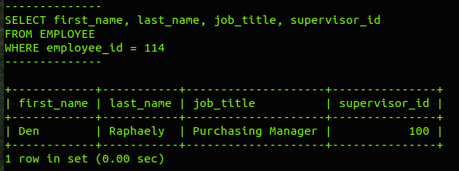

d)
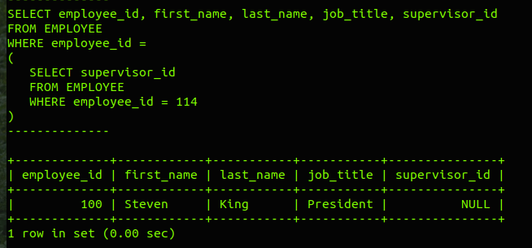

f)
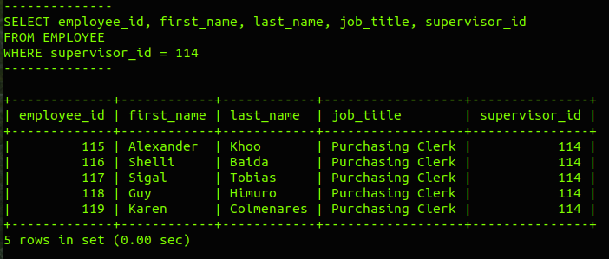

h)
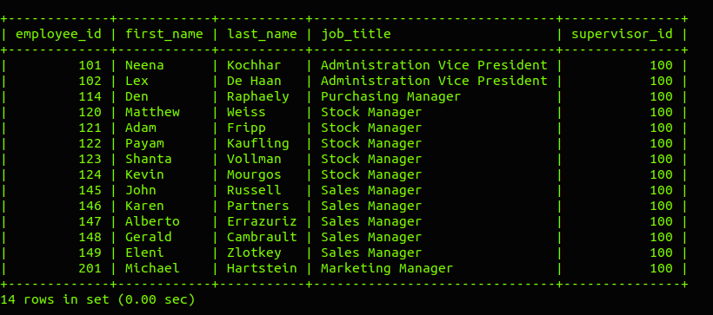
k)
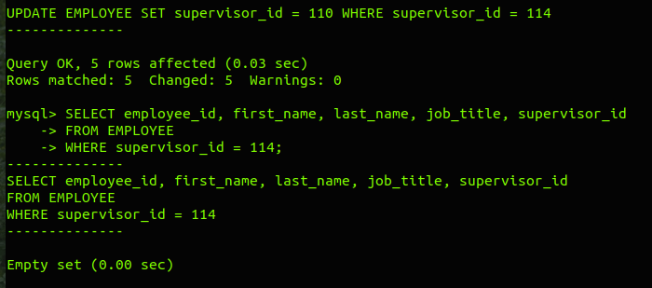

m)
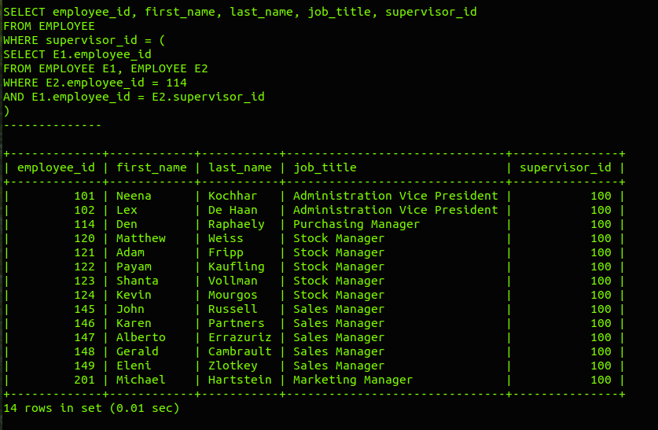

Test Case #12b –

SQL Statements (5)

- On the msql> prompt, type and execute the following :

SELECT * from JOBHISTORY WHERE employee_id = 114

- Expected Outcome :

// Job history of employee_id = 114
+-------------+------------+------------+-------------+-----------------+
| employee_id | start_date | end_date | job_title | department_name |
+-------------+------------+------------+-------------+-----------------+
| 114 | 1998-03-24 | 1999-12-31 | Stock Clerk | Purchasing |
+-------------+------------+------------+-------------+-----------------+

- Execute your (submitted) Assn2 SQL statements to :

Remove employee id = 114 from JOBHISTORY table

- Perform step a) again

- Expected Outcome :

< Empty Set !!! >

- Paste (and re-size) screen capture(s) of your Ubuntu terminal's output from steps a) to e) where indicated below, if:

  - your screen captures shows same output as the Expected Outcome

- In CSIT115_A2_Checklist.xls, refer to the test case #12b, update the relevant cell in column C (select ‘Yes), if you accomplish step f) successfully

<Test Case #12b : Paste Screen Capture(s) below >

b)

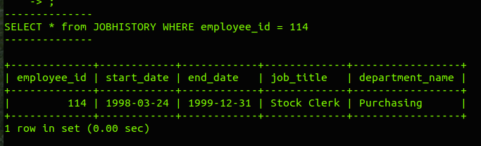

e)
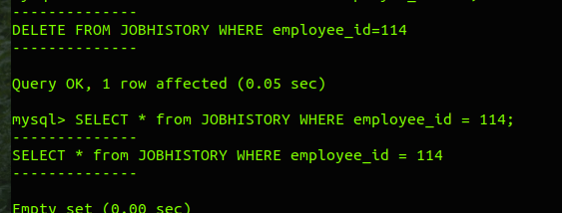

Test Case #12c –

SQL Statements (6)

- On the msql> prompt, type and execute the following :

SELECT * from DEPARTMENT WHERE manager_id = 114

- Expected Outcome :

// Department managed by manager_id = 114
+-----------------+---------------------+-------------+---------+--------------+------------+
| department_name | street_address | postal_code | city | country_name | manager_id |
+-----------------+---------------------+-------------+---------+--------------+------------+
| Purchasing | 40-5-12 Laogianggen | 190518 | Beijing | China | 114 |
+-----------------+---------------------+-------------+---------+--------------+------------+

- Execute your (submitted) Assn2 SQL statements to :

Remove manager id = 114 from DEPARTMENT table

- Perform step a) again

- Expected Outcome :

< Empty Set !!! >

- Paste (and re-size) screen capture(s) of your Ubuntu terminal's output from steps a) to e) where indicated below, if:
  - your screen captures shows same output as the Expected Outcome

- In CSIT115_A2_Checklist.xls, refer to the test case #12c, update the relevant cell in column C (select ‘Yes), if you accomplish step f) successfully

<Test Case #12c : Paste Screen Capture(s) below >
a)
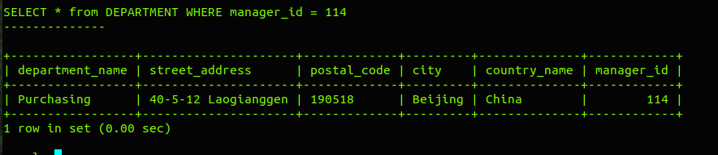

d)
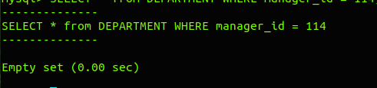

Test Case #12d –

SQL Statements (7)

- On the msql> prompt, type and execute the following :

SELECT * from EMPLOYEE WHERE employee_id = 114

- Expected Outcome :

// Finally, full details of employee_id = 114
+-------------+------------+-----------+----------+--------------+------------+------------------------------| employee_id | first_name | last_name | email | phone_number | hire_date | job_title +-------------+------------+-----------+----------+--------------+------------+------------------------------
| 114 | Den | Raphaely | DRAPHEAL | 515.127.4561 | 2000-01-01 | Purchasing Manager
+-------------+------------+-----------+----------+--------------+------------+------------------------------

-+----------+----------------+---------------+-----------------+
| salary | commission_pct | supervisor_id | department_name |
-+----------+----------------+---------------+-----------------+
| 11000.00 | NULL | 100 | Purchasing |
-+----------+----------------+---------------+-----------------+

- Execute your (submitted) Assn2 SQL statements to :

Remove employee id = 114 from EMPLOYEE table

- Perform step a) again

- Expected Outcome :

< Empty Set !!! >

- Paste (and re-size) screen capture(s) of your Ubuntu terminal's output from steps a) to e) where indicated below, if:
  - your screen captures shows same output as the Expected Outcome

- In CSIT115_A2_Checklist.xls, refer to the test case #12d, update the relevant cell in column C (select ‘Yes), if you accomplish step f) successfully

<Test Case #12d : Paste Screen Capture(s) below >
b)

e)

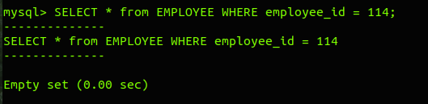

Test Case #13a –

SQL Select Statements (8)

- On the msql> prompt, type and execute the following :

SELECT * FROM JOB

- Expected Outcome :

// Existing types of jobs in Job table ...
+---------------------------------+------------+------------+
| job_title | min_salary | max_salary |
+---------------------------------+------------+------------+
| Accountant | 4200 | 9000 |
| Accounting Manager | 8200 | 16000 |
| Administration Assistant | 3000 | 6000 |
| Administration Vice President | 15000 | 30000 |
| Finance Manager | 8200 | 16000 |
| Human Resources Representative | 4000 | 9000 |
| Marketing Manager | 9000 | 15000 |
| Marketing Representative | 4000 | 9000 |
| President | 20000 | 40000 |
| Programmer | 4000 | 10000 |
| Public Accountant | 4200 | 9000 |
| Public Relations Representative | 4500 | 10500 |
| Purchasing Clerk | 2500 | 5500 |
| Purchasing Manager | 8000 | 15000 |
| Sales Manager | 10000 | 20000 |
| Sales Representative | 6000 | 12000 |
| Shipping Clerk | 2500 | 5500 |
| Stock Clerk | 2000 | 5000 |
| Stock Manager | 5500 | 8500 |
+---------------------------------+------------+------------+

- Execute your (submitted) Assn2 SQL statements to :

insert new job record for 'VIP Customer Relations'

- Perform step a) again

- Expected Outcome :

+---------------------------------+------------+------------+
| job_title | min_salary | max_salary |
+---------------------------------+------------+------------+
| Accountant | 4200 | 9000 |
| Accounting Manager | 8200 | 16000 |
| Administration Assistant | 3000 | 6000 |
| Administration Vice President | 15000 | 30000 |
| Finance Manager | 8200 | 16000 |
| Human Resources Representative | 4000 | 9000 |
| Marketing Manager | 9000 | 15000 |
| Marketing Representative | 4000 | 9000 |
| President | 20000 | 40000 |
| Programmer | 4000 | 10000 |
| Public Accountant | 4200 | 9000 |
| Public Relations Representative | 4500 | 10500 |
| Purchasing Clerk | 2500 | 5500 |
| Purchasing Manager | 8000 | 15000 |
| Sales Manager | 10000 | 20000 |
| Sales Representative | 6000 | 12000 |
| SEO Analyst | 8000 | 20000 |
| Shipping Clerk | 2500 | 5500 |
| Stock Clerk | 2000 | 5000 |
| Stock Manager | 5500 | 8500 |
| VIP Customer Relations | 6000 | 18000 |
+---------------------------------+------------+------------+

- Paste (and re-size) screen capture(s) of your Ubuntu terminal's output from steps a) to e) where indicated below, if:
  - your screen captures shows same output as the Expected Outcome

- In CSIT115_A2_Checklist.xls, refer to the test case #13a, update the relevant cell in column C (select ‘Yes), if you accomplish step f) successfully

<Test Case #13a : Paste Screen Capture(s) below >
b)
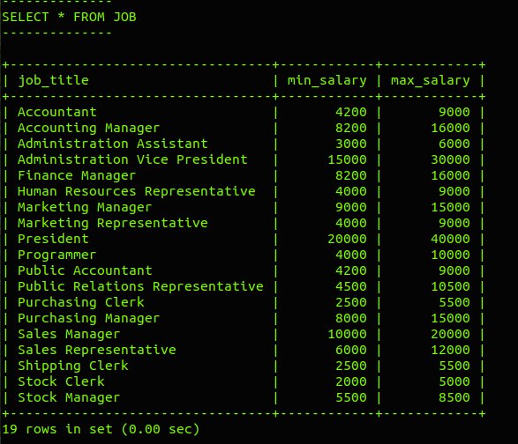

e)
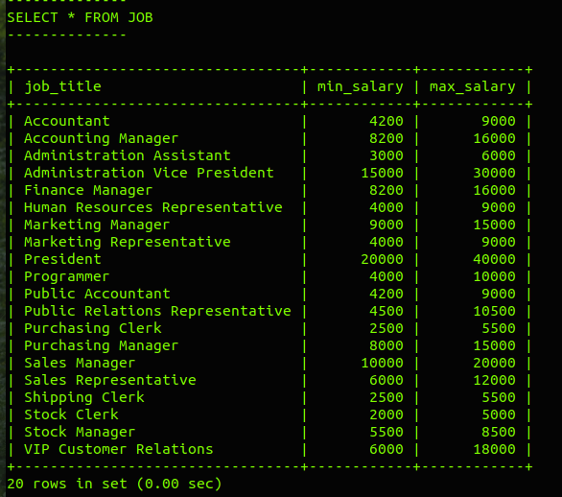

Test Case #13b –

SQL Select Statements (9)

- On the msql> prompt, type and execute the following :

SELECT * FROM EMPLOYEE WHERE employee_id = 888

- Expected Outcome :

< Empty Set !!! >

- Execute your (submitted) Assn2 SQL statements to :

insert new employee record for 'Pamela Anderson'

- Perform step a) again

- Expected Outcome :

+-------------+------------+-----------+-----------------------+--------------+------------+
| employee_id | first_name | last_name | email | phone_number | hire_date |
+-------------+------------+-----------+-----------------------+--------------+------------+
| 888 | Pamela | Anderson | pam.anderson@mail.com | NULL | 2018-10-18 |
+-------------+------------+-----------+-----------------------+--------------+------------+

------------------------+---------+----------------+---------------+------------------+
job_title | salary | commission_pct | supervisor_id | department_name |
------------------------+---------+----------------+---------------+------------------+
VIP Customer Relations | 8880.00 | NULL | 204 | Public Relations |
------------------------+---------+----------------+---------------+------------------+

- Paste (and re-size) screen capture(s) of your Ubuntu terminal's output from steps a) to e) where indicated below, if:
  - your screen captures shows same output as the Expected Outcome

- In CSIT115_A2_Checklist.xls, refer to the test case #13b, update the relevant cell in column C (select ‘Yes), if you accomplish step f) successfully

<Test Case #13b : Paste Screen Capture(s) below >
b)
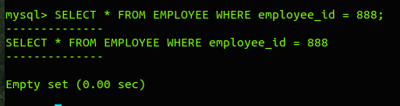

e)
