CSIT115 Assignment 3 Test Cases

Name : Yong Qin Toh
Student No. : 7059073

General Instructions

1) Prepare the following :

(i) Setup / prepare the exact same version of your solution (that you submitted before deadline) to perform the test cases

- Open up Excel document ‘CSIT115_A3_Checklist.xls‘

2) Perform test cases SEQUENTIALLY on your program, do not skip steps / sequence!

3) FOR EACH test case :

  - Perform the test case using answers from your script

  - If your program ‘pass’ the test case

- Do screen capture, and paste the image in this document
(CSIT115_A3_Test_Cases.doc), where indicated

- Update CSIT115_A3_Checklist.xls (select ‘yes’) at the row corresponding to your test case

Else // i.e. program ‘fails’ the test case

- No need for screen capture (leave the section blank)

- Update CSIT115_A3_Checklist.xls (select ‘no’) at the
row corresponding to your test case

4) Note : Please RESIZE your screen capture, Adjust the Spacing such that each test case begins on a new page !!

Before you proceed ...

1) Login into your Ubuntu, MySQL Command Line, as ‘root’ user

2) Ensure your Assignment's script file (containing all your SQL answers) are on "stand-by" (i.e. readily available)

3) From MySQL Command Line, create a "blank" database 'A3TestDB', all your test cases should be performed within this database!

(e.g.
mysql> create database A3TestDB;
mysql> use A3TestDB;
)

4) Initial setup for Task1 : Execute the script files in the following order :

A3drop.sql, A3create.sql, A3load.sql

5) Note:
For Task 1 – Part A test cases, the naming convention for the new user accounts to be created should be :

‘A3TestUser_1’, instead of <prefix of your UOW email account>_1
And

‘A3TestUser_2’, instead of <prefix of your UOW email account>_2
And

‘A3TestUser_3’, instead of <prefix of your UOW email account>_3

In the test cases below, when you are asked to " . . . Modify and execute your (submitted) Assn3 SQL solution statement . . ." , you are only allowed to change the user accounts and database name to the ones described above, no other changes are allowed unless explicitly stated!

Test Case #1 –

Create user accounts ok?

- Modify and execute your (submitted) Assn3 SQL solution statement for Task1 – Part A, to create the following :

 | New User Accounts | Password
1 | A3TestUser_1 | ‘A3TestUser_1’
2 | A3TestUser_2 | ‘A3TestUser_2’
3 | A3TestUser_3 | ‘A3TestUser_3’

- On the msql> prompt, execute : SELECT USER FROM mysql.user;

- Paste (and re-size) screen capture(s) of your Ubuntu terminal's output where indicated below, if:
  - your output in step b), shows the usernames listed in table in step a)

- In CSIT115_A3_Checklist.xls, refer to the test case #1, update the relevant cell in column C (select ‘Yes), if you accomplish step c) successfully

<Test Case #1 : Paste Screen Capture(s) below >

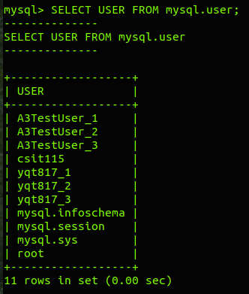

Test Case #2a –

Grant privileges for user 'A3TestUser_1' ok?

- On the msql> prompt, execute the following :

select user, db, create_priv, alter_priv, drop_priv, grant_priv from mysql.db where user in ('A3TestUser_1', 'A3TestUser_2', 'A3TestUser_3');

select user, db, select_priv, insert_priv, update_priv, delete_priv from mysql.db where user in ('A3TestUser_1', 'A3TestUser_2', 'A3TestUser_3');

- Expected Outcome :

< Empty Set !!! >

- Modify and execute your (submitted) Assn3 SQL solution statement(s) for Task1 – Part A, to grant the right for user ‘A3TestUser_1’ to alter, drop, select, insert, update, delete all objects on A3TestDB database

- Perform step a) again

- Expected Outcome :

+--------------+----------+-------------+------------+-----------+------------+
| user | db | create_priv | alter_priv | drop_priv | grant_priv |
+--------------+----------+-------------+------------+-----------+------------+
| A3TestUser_1 | A3TestDB | N | Y | Y | Y |
+--------------+----------+-------------+------------+-----------+------------+

+--------------+----------+-------------+-------------+-------------+-------------+
| user | db | select_priv | insert_priv | update_priv | delete_priv |
+--------------+----------+-------------+-------------+-------------+-------------+
| A3TestUser_1 | A3TestDB | Y | Y | Y | Y |
+--------------+----------+-------------+-------------+-------------+-------------+

- Paste (and re-size) screen capture(s) of your Ubuntu terminal's output where indicated below, if:
  - your screen captures shows same output as described in the Expected Outcomes

- In CSIT115_A3_Checklist.xls, refer to the test case #2a, update the relevant cell in column C (select ‘Yes), if you accomplish step c) successfully

<Test Case #2a : Paste Screen Capture(s) below >

b)
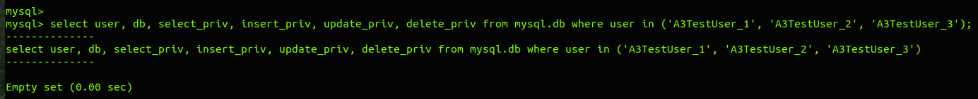

e)
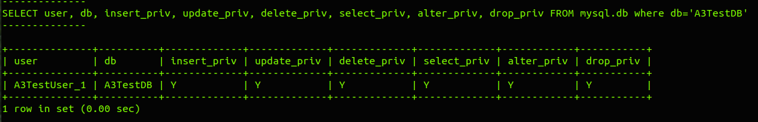

Test Case #2b –

Grant privileges for user 'A3TestUser_2' ok?

- On the msql> prompt, execute the following :

select db, user, table_name, table_priv from mysql.tables_priv where user in ('A3TestUser_1', 'A3TestUser_2', 'A3TestUser_3')

- Expected Outcome :

< Empty Set !!! >

- Modify and execute your (submitted) Assn3 SQL solution statement(s) for Task1 – Part A, to grant the right for user ‘A3TestUser_2’ to create views, and select from tables BOOK, AUTHOR in A3TestDB database, without option to grant other users the same privileges as well

- Perform step a) again

- Expected Outcome :

+----------+--------------+------------+--------------------+
| db | user | table_name | table_priv |
+----------+--------------+------------+--------------------+
| A3TestDB | A3TestUser_2 | AUTHOR | Select,Create View |
| A3TestDB | A3TestUser_2 | BOOK | Select,Create View |
+----------+--------------+------------+--------------------+

- Paste (and re-size) screen capture(s) of your Ubuntu terminal's output where indicated below, if:
  - your screen captures shows same output as described in the Expected Outcomes

- In CSIT115_A3_Checklist.xls, refer to the test case #2b, update the relevant cell in column C (select ‘Yes), if you accomplish step c) successfully

<Test Case #2b : Paste Screen Capture(s) below >

b)
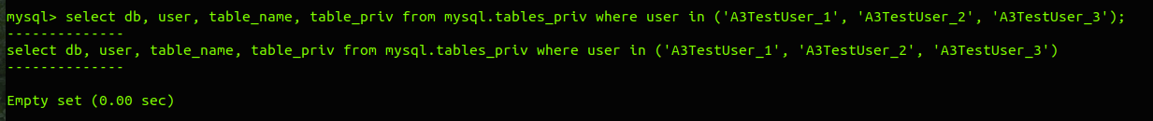

e)
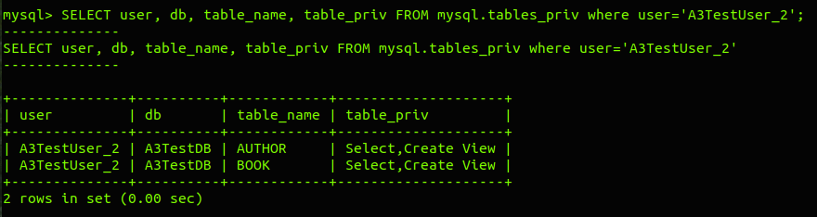

Test Case #3a –

Showing of privileges granted to A3TestUser_1 ok?

- Modify and execute your (submitted) Assn3 SQL solution statement(s) for Task1 – Part A, to list the privileges granted to user : A3TestUser_1

- Expected Outcome :

+--------------+----------+-------------+------------+-----------+------------+
| user | db | create_priv | alter_priv | drop_priv | grant_priv |
+--------------+----------+-------------+------------+-----------+------------+
| A3TestUser_1 | A3TestDB | N | Y | Y | Y |
+--------------+----------+-------------+------------+-----------+------------+

+--------------+----------+-------------+-------------+-------------+-------------+
| user | db | select_priv | insert_priv | update_priv | delete_priv |
+--------------+----------+-------------+-------------+-------------+-------------+
| A3TestUser_1 | A3TestDB | Y | Y | Y | Y |
+--------------+----------+-------------+-------------+-------------+-------------+

Note :
  - it is ok if you display MORE information on other privileges than the ones shown above in different format,
but ...
  - it is NOT OK if you omit any of the bare essential information above!

- Paste (and re-size) screen capture(s) of your Ubuntu terminal's output where indicated below, if:
  - your screen captures shows same output as described in the Expected Outcome

- In CSIT115_A3_Checklist.xls, refer to the test case #3a, update the relevant cell in column C (select ‘Yes), if you accomplish step c) successfully

<Test Case #3a : Paste Screen Capture(s) below >
b)

Test Case #3b –

Showing of privileges granted to A3TestUser_2 ok?

- Modify and execute your (submitted) Assn3 SQL solution statement(s) for Task1 – Part A, to list the privileges granted to user : A3TestUser_2

- Expected Outcome :

+----------+--------------+------------+--------------------+
| db | user | table_name | table_priv |
+----------+--------------+------------+--------------------+
| A3TestDB | A3TestUser_2 | AUTHOR | Select,Create View |
| A3TestDB | A3TestUser_2 | BOOK | Select,Create View |
+----------+--------------+------------+--------------------+

Note :
  - it is ok if you display MORE information on other privileges than the ones shown above in different format,
but ...
  - it is NOT OK if you omit any of the bare essential information above!

- Paste (and re-size) screen capture(s) of your Ubuntu terminal's output where indicated below, if:
  - your screen captures shows same output as described in the Expected Outcome

- In CSIT115_A3_Checklist.xls, refer to the test case #3b, update the relevant cell in column C (select ‘Yes), if you accomplish step c) successfully

<Test Case #3b : Paste Screen Capture(s) below >

Test Case #4 –

Setting values of resource limits for A3TestUser_3 ok?

- Modify and execute your (submitted) Assn3 SQL solution statement(s) for Task1 – Part A, to set the resource limits for user : A3TestUser_3

- Modify and execute your (submitted) Assn3 SQL solution statement(s) for Task1 – Part A, to display the resource limits for users : A3TestUser_1, A3TestUser_2 and A3TestUser_3

- Expected Outcome :

+--------------+---------------+-------------+------------------+
| user | max_questions | max_updates | password_expired |
+--------------+---------------+-------------+------------------+
| A3TestUser_1 | 0 | 0 | N |
| A3TestUser_2 | 0 | 0 | N |
| A3TestUser_3 | 100 | 10 | N |
+--------------+---------------+-------------+------------------+

Note :
  - it is ok if you display MORE information on other resource limits than the ones shown above in different format,
but ...
  - it is NOT OK if you omit any of the bare essential information above!

- Paste (and re-size) screen capture(s) of your Ubuntu terminal's output where indicated below, if:
  - your screen captures shows same output as described in the Expected Outcome

- In CSIT115_A3_Checklist.xls, refer to the test case #4, update the relevant cell in column C (select ‘Yes), if you accomplish step c) successfully

<Test Case #4 : Paste Screen Capture(s) below >

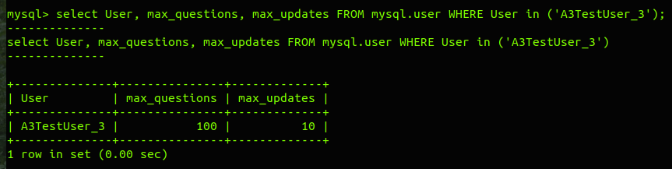

Test Case #5 –

Expiring the password of account for A3Test_User2 ok?

- Modify and execute your (submitted) Assn3 SQL solution statement(s) for Task1 – Part A, to expire the password for user : A3TestUser_2

- Modify and execute your (submitted) Assn3 SQL solution statement(s) for Task1 – Part A, to display the password expiry settings for users : A3TestUser_1, A3TestUser_2 and A3TestUser_3

- Expected Outcome :

+--------------+------------------+
| user | password_expired |
+--------------+------------------+
| A3TestUser_1 | N |
| A3TestUser_2 | Y |
| A3TestUser_3 | N |
+--------------+------------------+

Note :
  - it is ok if you display MORE information on other resource limits than the ones shown above in different format,
but ...
  - it is NOT OK if you omit any of the bare essential information above!

- Paste (and re-size) screen capture(s) of your Ubuntu terminal's output where indicated below, if:
  - your screen captures shows same output as described in the Expected Outcome

- In CSIT115_A3_Checklist.xls, refer to the test case #5, update the relevant cell in column C (select ‘Yes), if you accomplish step c) successfully

<Test Case #5 : Paste Screen Capture(s) below >

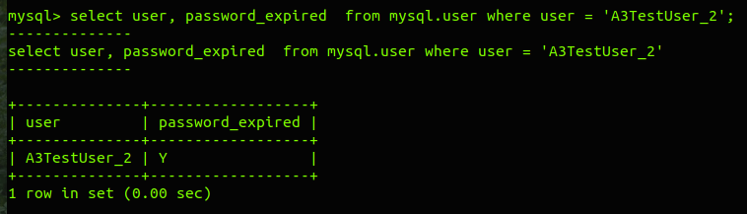

Test Case #6–

Command to create logical backup of BOOK table as
filename 'A3TestDB_BOOK.bak' ok?

- Connect to MySQL to command line interface mysql, login as user root.

- Switch to database 'A3TestDB'

- Execute a script file A3drop.sql and immediately after that the scripts A3create.sql and A3load.sql to refresh the contents of a database : A3TestDB.

- Exit command line interface mysql.

- Modify and Execute your (submitted) Assn3 solution for Task1 – Part B, to :

Create a logical backup of a relational table BOOK (from 'A3TestDB' database) and save it in a file as the following filename : A3TestDB_BOOK.bak

- Using gedit editor, open up the file 'A3TestDB_BOOK.bak' to display its contents

- Expected Outcome :

-- MySQL dump 10.13 Distrib 8.0.3-rc, for Linux (i686)
--
-- Host: localhost Database: A3TestDB
-- ------------------------------------------------------
-- Server version 8.0.3-rc-log

/*!40101 SET @OLD_CHARACTER_SET_CLIENT=@@CHARACTER_SET_CLIENT */;
/*!40101 SET @OLD_CHARACTER_SET_RESULTS=@@CHARACTER_SET_RESULTS */;
/*!40101 SET @OLD_COLLATION_CONNECTION=@@COLLATION_CONNECTION */;
SET NAMES utf8mb4 ;
/*!40103 SET @OLD_TIME_ZONE=@@TIME_ZONE */;
/*!40103 SET TIME_ZONE='+00:00' */;
/*!40014 SET @OLD_UNIQUE_CHECKS=@@UNIQUE_CHECKS, UNIQUE_CHECKS=0 */;
/*!40014 SET @OLD_FOREIGN_KEY_CHECKS=@@FOREIGN_KEY_CHECKS, FOREIGN_KEY_CHECKS=0 */;
/*!40101 SET @OLD_SQL_MODE=@@SQL_MODE, SQL_MODE='NO_AUTO_VALUE_ON_ZERO' */;
/*!40111 SET @OLD_SQL_NOTES=@@SQL_NOTES, SQL_NOTES=0 */;

--
-- Table structure for table `BOOK`
--

DROP TABLE IF EXISTS `BOOK`;
/*!40101 SET @saved_cs_client = @@character_set_client */;
SET character_set_client = utf8mb4 ;
CREATE TABLE `BOOK` (
`BookID` varchar(12) NOT NULL,
`Title` varchar(80) NOT NULL,
`Price` decimal(4,2) NOT NULL,
PRIMARY KEY (`BookID`)
) ENGINE=InnoDB DEFAULT CHARSET=utf8mb4;
/*!40101 SET character_set_client = @saved_cs_client */;

--
-- Dumping data for table `BOOK`
--

LOCK TABLES `BOOK` WRITE;
/*!40000 ALTER TABLE `BOOK` DISABLE KEYS */;

INSERT INTO `BOOK` VALUES
('20099','Taipei 101',20.99),
('20100','Bangkok 101',20.99),
('20101','Malaysia Travel',29.99),
('20102','Indonesia Travel',25.99),
('20103','Vietnam Travel',20.99),
('20104','Travel to USA',19.88),
('20105','Travel to Europe',25.88),
('20106','Travel to China',22.88),
('20107','Travel to Singapore',20.88),
('20108','Travel to Myanmar',21.88),
('20109','Travel to Japan',20.88),
('20200','Java for Beginner',30.00),
('20201','UML Bible',59.00),
('20202','SQL Make Simple',35.00),
('20203','MySQL Easy',45.00),
('20204','Microsoft SQL Server',59.00),
('20205','Database Fundamental',35.00),
('20206','ASP.NET Introduction',30.00),
('20207','Advance C++',50.00),
('20208','Network Security',50.00),
('20209','IOT and Big Data',30.00);
/*!40000 ALTER TABLE `BOOK` ENABLE KEYS */;
UNLOCK TABLES;
/*!40103 SET TIME_ZONE=@OLD_TIME_ZONE */;

/*!40101 SET SQL_MODE=@OLD_SQL_MODE */;
/*!40014 SET FOREIGN_KEY_CHECKS=@OLD_FOREIGN_KEY_CHECKS */;
/*!40014 SET UNIQUE_CHECKS=@OLD_UNIQUE_CHECKS */;
/*!40101 SET CHARACTER_SET_CLIENT=@OLD_CHARACTER_SET_CLIENT */;
/*!40101 SET CHARACTER_SET_RESULTS=@OLD_CHARACTER_SET_RESULTS */;
/*!40101 SET COLLATION_CONNECTION=@OLD_COLLATION_CONNECTION */;
/*!40111 SET SQL_NOTES=@OLD_SQL_NOTES */;

-- Dump completed on 2018-11-07 22:49:32

Note :
  - you ONLY need to verify the portions highlighted in yellow above, check that the output matches your own contents!

- Paste (and re-size) screen capture(s) of your Ubuntu terminal's output where indicated below, if:
  - your screen captures shows same output as described in the Expected Outcome

- In CSIT115_A3_Checklist.xls, refer to the test case #6 update the relevant cell in column C (select ‘Yes), if you accomplish step c) successfully

<Test Case #6 Paste Screen Capture(s) below >

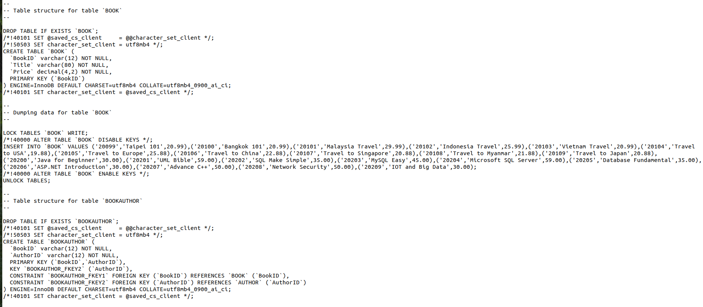

Test Case #7–

Command to load modified 'A3TestDB_BOOK.bak' file ok?

- Connect to MySQL to command line interface mysql, login as user root.

- Switch to database 'A3TestDB'

- Execute the script file A3change1b.sql (that came from your Assn3 files)

- Exit command line interface mysql.

- Using Ubuntu’s gedit editor, open up the file 'A3TestDB_BOOK.bak' (generated from earlier Test Case), to change its contents

- Edit the contents such that table 'BOOK', and all necessary references to it, is renamed as 'BOOK_v1', (instead of <prefix of your UOW email>_DOC) ! Save the changes to the same filename : 'A3TestDB_BOOK.bak'

- At Ubuntu terminal, please load the contents of (modified) 'A3TestDB_BOOK.bak' into database 'A3TestDB', using the user root.

- Login to command line interface mysql, as user root.

- Switch to database 'A3TestDB'

- Execute the command : SHOW TABLES;

- Expected Outcome :

+--------------------+
| Tables_in_A3TestDB |
+--------------------+
| AUTHOR |
| BOOK |
| BOOKAUTHOR |
| BOOK_v1 |
| CUSTOMER |
| ONLINEPURCHASE |
| PURCHASE |
| WALKINPURCHASE |
+--------------------+

- Paste (and re-size) screen capture(s) of your Ubuntu terminal's output where indicated below, if:
  - your screen captures shows same output as described in the Expected Outcome

- In CSIT115_A3_Checklist.xls, refer to the test case #7 update the relevant cell in column C (select ‘Yes), if you accomplish step c) successfully

<Test Case #7 Paste Screen Capture(s) below >

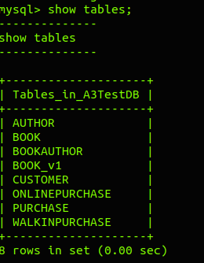

Test Case #8a –

SQL statement(s) to list rows added to BOOK table
(after executing 'A3change1b.sql') - ok?

- Modify and Execute your (submitted) Assn3 SQL solution statement(s) for Task1 – Part B, to display rows of records added to table : BOOK, since the execution of the script 'A3change1b.sql'

- Expected Outcome :

+--------+------------------+-------+
| BookID | Title | Price |
+--------+------------------+-------+
| 20110 | Taipei Summer | 20.88 |
| 20111 | Bangkok Wealther | 20.88 |
| 20112 | Najib influence | 29.88 |
| 20210 | 4G Singapore | 25.88 |
| 20211 | Rich and Poor | 20.88 |
+--------+------------------+-------+

Note :
  - it is ok if you display LESS information from the table, in different column sequence, as long as the main identifying columns like 'BookID' , 'Title' are included
  - it is NOT OK otherwise!

- Paste (and re-size) screen capture(s) of your Ubuntu terminal's output where indicated below, if:
  - your screen captures shows same output as described in the Expected Outcome

- In CSIT115_A3_Checklist.xls, refer to the test case #8a update the relevant cell in column C (select ‘Yes), if you accomplish step c) successfully

<Test Case #8a: Paste Screen Capture(s) below >
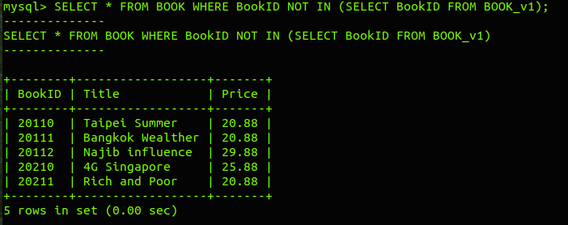

Test Case #8b –

SQL statement(s) to list rows deleted from BOOK table
(after executing 'A3change1b.sql') - ok?

- Modify and Execute your (submitted) Assn3 SQL solution statement(s) for Task1 – Part B, to display rows of records deleted from table : BOOK, since the execution of the script 'A3change1b.sql'

- Expected Outcome :

+--------+-----------------+-------+
| BookID | Title | Price |
+--------+-----------------+-------+
| 20101 | Malaysia Travel | 29.99 |
| 20104 | Travel to USA | 19.88 |
| 20207 | Advance C++ | 50.00 |
+--------+-----------------+-------+

Note :
  - it is ok if you display LESS information from the table, in different column sequence, as long as the main identifying columns like 'BookID' , 'Title' are included
  - it is NOT OK otherwise!

- Paste (and re-size) screen capture(s) of your Ubuntu terminal's output where indicated below, if:
  - your screen captures shows same output as described in the Expected Outcome

- In CSIT115_A3_Checklist.xls, refer to the test case #8b update the relevant cell in column C (select ‘Yes), if you accomplish step c) successfully

<Test Case #8b: Paste Screen Capture(s) below >
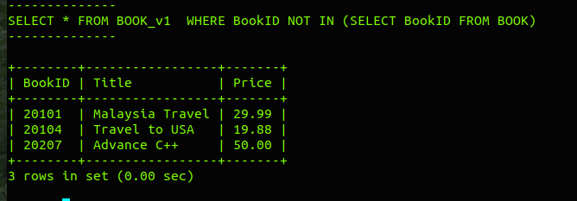

Test Case #8c –

SQL statement(s) to list rows changed in BOOK table
(after executing 'A3change1b.sql') - ok?

- Modify and Execute your (submitted) Assn3 SQL solution statement(s) for Task1 – Part B, to display rows of records changed in table : BOOK, since the execution of the script 'A3change1b.sql'

- Expected Outcome :

+--------+-----------------+-------+
| BookID | Title | Price |
+--------+-----------------+-------+
| 20108 | Myanmar Travel | 21.88 |
| 20201 | UML Bible | 60.00 |
| 20202 | SQL Make Simple | 40.00 |
+--------+-----------------+-------+

Note :
  - it is ok if you display LESS information from the table, in different column sequence, as long as the main identifying columns like 'BookID' , 'Title' are included
it is NOT OK otherwise!

- Paste (and re-size) screen capture(s) of your Ubuntu terminal's output where indicated below, if:
  - your screen captures shows same output as described in the Expected Outcome

- In CSIT115_A3_Checklist.xls, refer to the test case #8c update the relevant cell in column C (select ‘Yes), if you accomplish step c) successfully

<Test Case #8c: Paste Screen Capture(s) below >
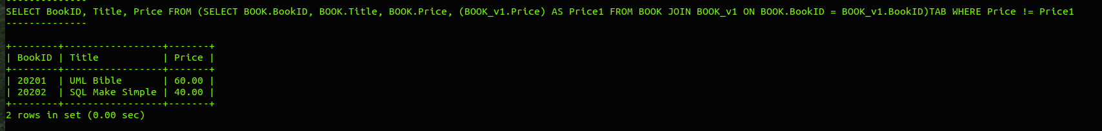

Test Case #9 –

Script to show consistency violation ok?

- Connect to MySQL to command line interface mysql, login as user root.

- Switch to database 'A3TestDB'

- Execute a script file A3drop.sql and immediately after that the scripts A3create.sql and A3load.sql to refresh the contents of a database : A3TestDB.

- Execute your (submitted) Assn3 SQL solution statement(s) for Task2 – Part A, to display all patients who violate the stated consistency constraint, in the following format :

... A purchase with the purchase ID of <PurchaseID> is an online purchase of type < OnlineType> and also a walk-in purchase of location <ShopLocation> ...

- Expected Outcome :

+-----------------------------------------------------------------------------------------------------------------------------------------------------------------------------------------------------------+
| concat('A purchase with the purchase ID of ', PURCHASE.PurchaseID, ' is an online purchase of type ', ONLINEPURCHASE.OnlineType, ' and also a walkin purchase of location ', WALKINPURCHASE.ShopLocation) |
+-----------------------------------------------------------------------------------------------------------------------------------------------------------------------------------------------------------+
| A purchase with the purchase ID of 50010 is an online purchase of type 1 and also a walkin purchase of location Jurong |
| A purchase with the purchase ID of 50011 is an online purchase of type 1 and also a walkin purchase of location Clementi |
| A purchase with the purchase ID of 50017 is an online purchase of type 2 and also a walkin purchase of location Clementi |
| A purchase with the purchase ID of 50018 is an online purchase of type 1 and also a walkin purchase of location Jurong |
| A purchase with the purchase ID of 50019 is an online purchase of type 2 and also a walkin purchase of location Clementi |
+-----------------------------------------------------------------------------------------------------------------------------------------------------------------------------------------------------------+

- Paste (and re-size) screen capture(s) of your Ubuntu terminal's output where indicated below, if:
  - your screen captures shows same output as described in the Expected Outcome

- In CSIT115_A3_Checklist.xls, refer to the test case #9 update the relevant cell in column C (select ‘Yes), if you accomplish step c) successfully

<Test Case #9: Paste Screen Capture(s) below >

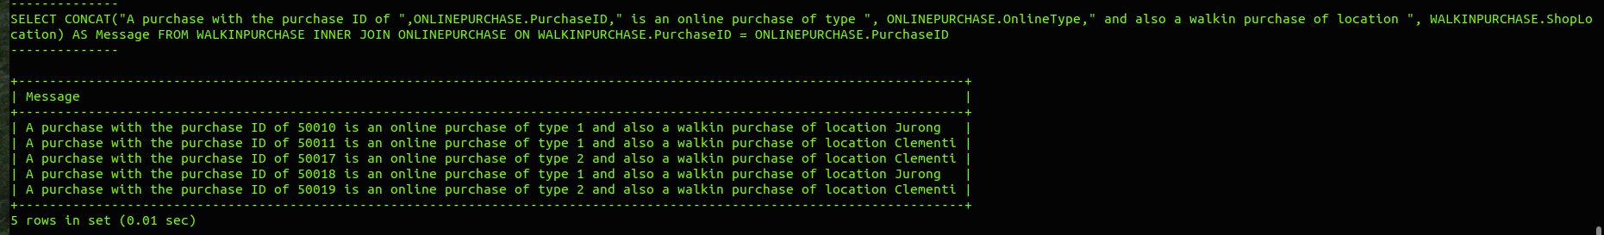

Test Case #10a –

SQL statement(s) to list no. of times DDL (Create, Alter, Drop) statements has been processed since general log started recording - ok?

- Connect to MySQL to command line interface mysql, login as user root.

- Switch to database 'A3TestDB'

- Execute a script file A3drop.sql and immediately after that the scripts A3create.sql and A3load.sql to refresh the contents of a database : A3TestDB.

- V. IMPT => Using the same database 'A3TestDB', execute your (submitted) Assn3 SQL solution statement(s) for Task2 – Part B, to perform the exact same steps (1) - (4) as described in your Assn3 Question paper.

- Execute your (submitted) Assn3 SQL solution statement(s) for Task2 – Part B, step (5) to :

... list the the DDL statements (CREATE, ALTER, DROP) processed in a period of time when a general log was recorded ...

- Expected Outcome :

+---------------------------------------------------------------------------------------------------+
| argument |
+---------------------------------------------------------------------------------------------------+
| CREATE TABLE A3 ( Description VARCHAR(30) NOT NULL, CONSTRAINT A3_PKEY PRIMARY KEY (Description)) |
| CREATE TABLE FUN ( Name VARCHAR(10) NOT NULL, CONSTRAINT A3_PKEY PRIMARY KEY (Name)) |
| ALTER TABLE A3 MODIFY Description VARCHAR(35) |
| DROP TABLE A3 |
| DROP TABLE FUN |
+---------------------------------------------------------------------------------------------------+

Note :
  - it is ok if you display MORE information from the general log table, in different column sequence, as long as it includes the above 'bare minimum' information
  - it is NOT OK otherwise!

- Paste (and re-size) screen capture(s) of your Ubuntu terminal's output where indicated below, if:
  - your screen captures shows same output as described in the Expected Outcome

- In CSIT115_A3_Checklist.xls, refer to the test case #10a update the relevant cell in column C (select ‘Yes), if you accomplish step c) successfully

<Test Case #10a: Paste Screen Capture(s) below >

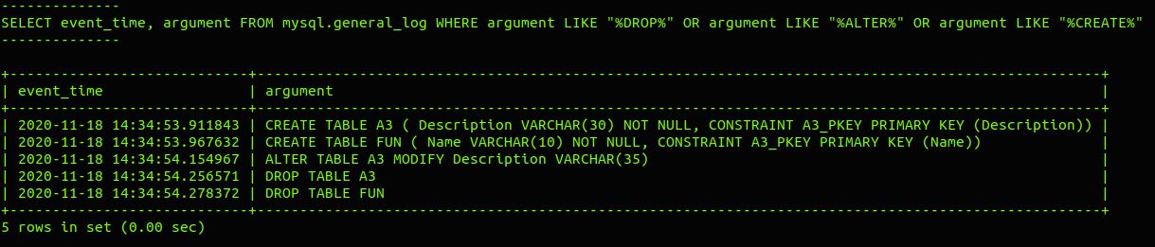

Test Case #10b –

SQL statement(s) to show all DML (Select, Insert, Delete, Update) statements that has been processed since general log started recording - ok?

- V. IMPT => Before you proceed, please ensure step a) to d), in earlier Test Case #10a, has been executed!

- Execute your (submitted) Assn3 SQL solution statement(s) for Task2 – Part B, step (6) to :

... list the DML statements (SELECT, INSERT, DELETE, UPDATE) that has been processed in the period of time since the general log was recorded. Sort the results in a descending order of the total number of times a DML statement has been processed ...

- Expected Outcome :

+------------------------+-------+
| substr(argument, 1, 6) | TIMES |
+------------------------+-------+
| DELETE | 21 |
| INSERT | 6 |
| UPDATE | 3 |
| SELECT | 2 |
+------------------------+-------+

Note :
  - it is ok if you display MORE information from the general log table, in different column sequence, as long as it includes the above 'bare minimum' information
  - it is NOT OK otherwise!

- Paste (and re-size) screen capture(s) of your Ubuntu terminal's output where indicated below, if:
  - your screen captures shows same output as described in the Expected Outcome

- In CSIT115_A3_Checklist.xls, refer to the test case #10b update the relevant cell in column C (select ‘Yes), if you accomplish step c) successfully

<Test Case #10b: Paste Screen Capture(s) below >

