Step 1: Creating classes of objects

“A client is described by his identification number, passport number, first name…”

“A lawyer is described by his identification number, passport number, first name…”

“Each specialty has an identification number, description. “

“Each case is described by a case number, case type, general description, (supporting) evidence description, and list of hearing dates…”

“Each court has a unique court name to it, and is described by a list of email addresses (for different types of cases…”

“Judges are described by their identification number, passport number, first name, last name, gender, date of birth…”

The classes are CLIENT, LAWYER, CASE, COURT, JUDGE. The quotes below show the evidence where the classes are extracted from.

Step 2: Creating associations and association classes

“In the event a citizen is too poor to afford a lawyer, a public lawyer will be assigned to him.”

“Based on a lawyer's experiences and exposure, a lawyer could have more than one specialty (e.g. family law, criminal law, business law, real estate law, etc).”

“A court case is assigned to one and only one court, and each court may handle many cases.”

“A lawyer can handle more than one case, and a client may be involved in more than one case as well.”

“Each court has between 1 to 5 judges assigned to it, and each judge is assigned to one court.”

“Each judge should have at least 1 specialty.”

Step 3: Creating attributes and link attributes

“A client is described by his identification number, passport number, first name, last name, gender, date of birth, residential address, tel. no. and email address.”

A lawyer is described by his identification number, passport number, first name, last name, gender, date of birth, specialty, company address, company tel. no. and email address.”

“Each specialty has an identification number, description

Step 4: Creating identifiers

“For each court case, a client is referred to, either as a "plaintiff" or "defendant". A system generated identification number is assigned to each client to uniquely identify him.”

“In a similar fashion, an identification number is generated for each lawyer (and judge) as well, so as to uniquely identify each individual.”

“Each court has a unique court name”

Step 5: Creating qualifications

Step 6: Generalisation

“In the event a citizen is too poor to afford a lawyer, a public lawyer will be assigned to him. Sometimes, a single lawyer could be employed to represent a group of people…”

“For each court case, a client is referred to, either as a "plaintiff" or "defendant".”

Step 1: **Multivalued attributes** are replaced with **classes of objects** and depending on the semantics of multivalued attribute either with **one-to-many** or **many-to-many** associations:

NIL

Step 2: **Associaton classes** and **link attributes** are replaced with the triples (**one-to-many association:class-of-objects :many-to-one-association**)

Step 4: **Qualifications** are replaced with **one-to-many associations** and **composite identifiers** in **object classes** on "many" side of **one-to-many** associations:

Before

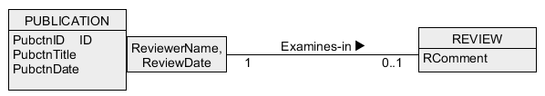

The attributes: ReviewerName and ReviewDate, are transferred to the REVIEW class and are turned into identifier in REVIEW CLASS. They are removed from qualification as well. The attribute PubctnID is tagged as a foreign key in REVIEW and is an identifier in REVIEW too. Also, a multiplicity on the REVIEW class side of qualified association has changed into 1..*.

After

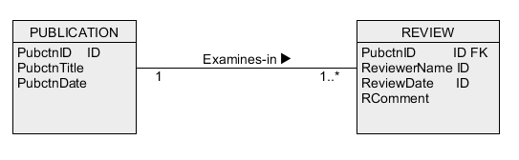

Step 5:  Selected **identifiers** are copied from **classes of objects** on "one" side of **association** to **class of objects** on "many" side of **association** and are tagged with **FKn** (an index "n" is used to distinguish between different **foreign keys**):

Before

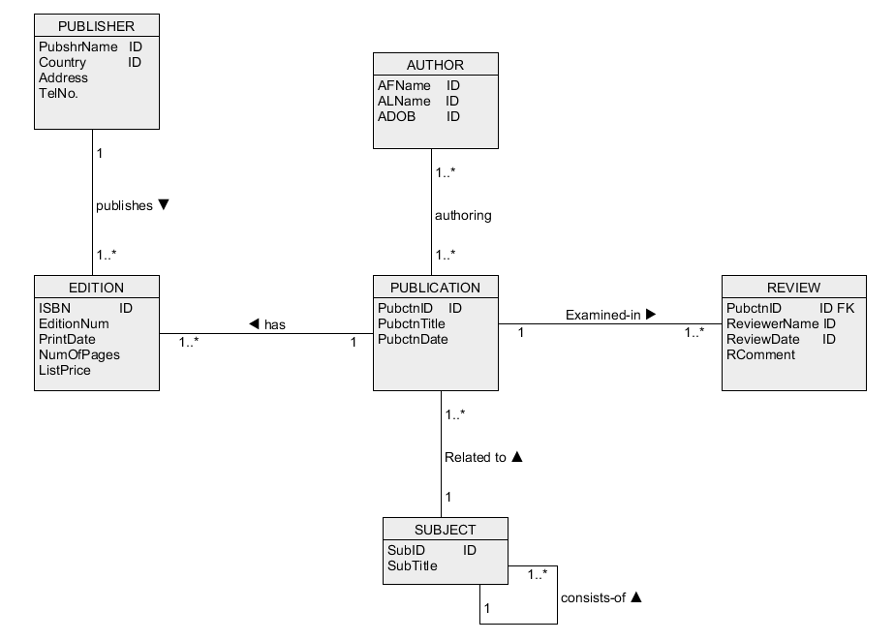

After

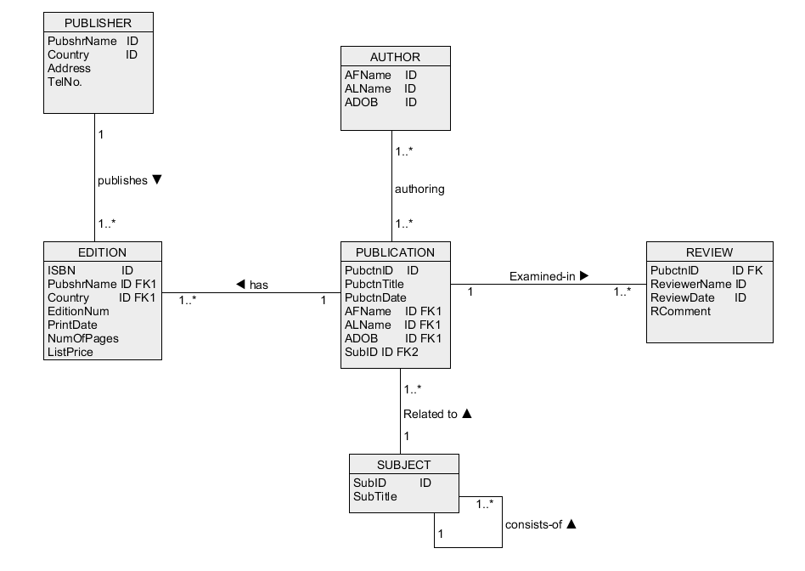

Step 8: **Primary** and **candidate keys** are created

Before



After