Modular Pulse Programme Generation for NMR Supersequences

Jonathan R. J. Yong,1 Ēriks Kupče,2 Tim D. W. Claridge1,*

1 Chemistry Research Laboratory, Department of Chemistry, University of Oxford, Mansfield Road, Oxford, OX1 3TA, United Kingdom

2 Bruker UK Ltd, R&D, Coventry CV4 9GH, United Kingdom

ABSTRACT: NOAH (NMR by Ordered Acquisition using 1H detection) supersequences allow multiple 2D NMR datasets to be acquired in greatly reduced experiment durations through the elision of recovery delays. In NOAH experiments, up to five “modules” can be combined (or more when parallel modules are employed), which means that there is a very large number of plausible supersequences (over 4000). This renders the traditional method of pulse program construction by hand wholly inadequate. We introduce here an online tool named GENESIS (GENEration of Supersequences In Silico), available via [https://nmr-genesis.co.uk](https://nmr-genesis.co.uk/), which systematically generates arbitrary NOAH supersequences compatible with Bruker spectrometers. This not only allows users to obtain customized supersequences for specific applications, but also enables us to rapidly and effortlessly disseminate new NOAH modules (e.g. PSYCHE, 2D J) as well as improvements to existing modules (e.g. 1H–13C HMBC, 1H–15N HMQC).

INTRODUCTION

The acceleration of NMR data acquisition has in recent years proven a fruitful area for NMR pulse sequence and method development, particularly for *n*‐dimensional (*n*D) NMR where raw data are acquired as a series of time increments. Developments in this area include (but are not limited to) ultrafast NMR,[1–3] non‐uniform sampling (NUS),[4–6] multiple‐FID experiments,[7–10] and the shortening or elision of recovery delays.[11–14] NOAH (NMR by Ordered Acquisition using 1H detection) experiments,[15–24] which fall under the last two categories, consist of a series of multiple 2D experiments (“modules”), combined into one single “supersequence” which uses only one recovery delay for all modules. This provides substantial (up to 4×) time savings compared to conventional acquisition, in which one recovery delay is used for each module (Figure 1).

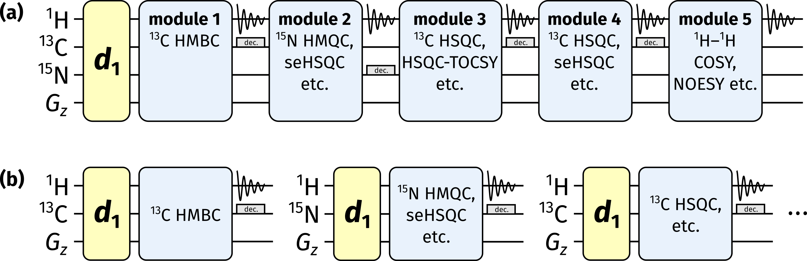

**Figure 1:** (a) Diagrammatic representation of a NOAH supersequence, where only one recovery delay (*d*1) is used for the entire experiment. (b) Conventional 2D NMR data acquisition, where one recovery delay is used per dataset.

Virtually all common 2D experiments employed for small molecule characterization have been implemented in NOAH supersequences to date, including HMBC, HSQC, HSQC‐TOCSY, HMQC, COSY, TOCSY, NOESY, and ROESY. Each module is given a unique abbreviation, usually one letter long (e.g. ‘B’ for HMBC, ‘S’ for HSQC, ‘M’ for HMQC, ‘C’ for COSY) and occasionally sub/superscripted (e.g. ‘ST’ for HSQC‐TOCSY or ‘S+’ for sensitivity‐enhanced HSQC). The combinatorial nature of NOAH experiments means that there are a very large number of conceivable supersequences ranging from NOAH‐2 to NOAH‐5 (where the suffix indicates the number of modules); the use of parallel supersequences[24] extends this maximum number even further.

For optimal data quality in terms of both sensitivity and artefact minimization, there are certain conditions on NOAH supersequences. Specifically, NOAH modules placed earlier in a supersequence should ideally only excite the magnetization it needs, leaving all other magnetization sources untouched. As an example, in the NOAH‐2 SC supersequence (comprising HSQC and COSY modules), the 1H–13C HSQC module is designed to excite only the 1H nuclei directly attached to the 1.1%‐natural abundance 13C, and leave all other proton magnetization (the “bulk magnetization”) in the equilibrium state (i.e. along the +*z*-axis).[13] A 1H–1H COSY module (or TOCSY, or NOESY, etc.) can then draw on this bulk magnetization, with almost no loss in sensitivity and without having to wait for the 12C‐bound protons to relax. Conversely, if the COSY module were placed first, the 13C‐bound proton magnetization would not survive for use in the HSQC: thus, the HSQC module in a NOAH‐2 CS would display severe sensitivity losses, as compared to in a NOAH‐2 SC. More subtle factors also abound, such as in the SBC sequence,[15] where COSY intensities are modulated by *T*2 relaxation and *J*HH evolution. The alternative BSC arrangement,[16] especially with isotropic “ASAP” mixing applied before the COSY, circumvents this issue and has become the preferred implementation for HMBC/HSQC combinations.[17]

Considerations such as these restrict the set of “viable” NOAH supersequences. Even so, the original NOAH paper alone suggests a figure of 285,[15] and the number of available modules has only grown since then. By our calculations, as of the time of writing, there are 4242 viable NOAH supersequences (Section S1, *Supporting Information*). Constructing every one of these supersequences “by hand” is clearly unreasonable. Consequently, it has not been possible to produce an exhaustive series of pulse programs: we have so far had to limit ourselves to a handful of “typical” supersequences, which may or may not be applicable to all users’ needs.

To solve this problem, we sought to *programmatically* generate NOAH pulse programs, an approach which we term GENESIS (GENEration of Supersequences In Silico). The implementation of this is a single web page (Figure 2), accessible via [https://nmr-genesis.co.uk](https://nmr-genesis.co.uk/), which can construct virtually any supersequence one might want and output a Bruker pulse program ready for download and execution. Apart from allowing users to download customized supersequences, this allows us to easily and rapidly disseminate new NOAH developments to users, independently of Bruker’s own release cycle and without needing a separate publication for each. Such developments may include either new modules or updates to existing modules, as detailed later in this article. Adopting a programmatic approach also ensures that the output is predictable and can be reasoned about; this eliminates many possibilities of user error during pulse program construction, a particularly acute problem for NOAH sequences which tend to have considerable length.

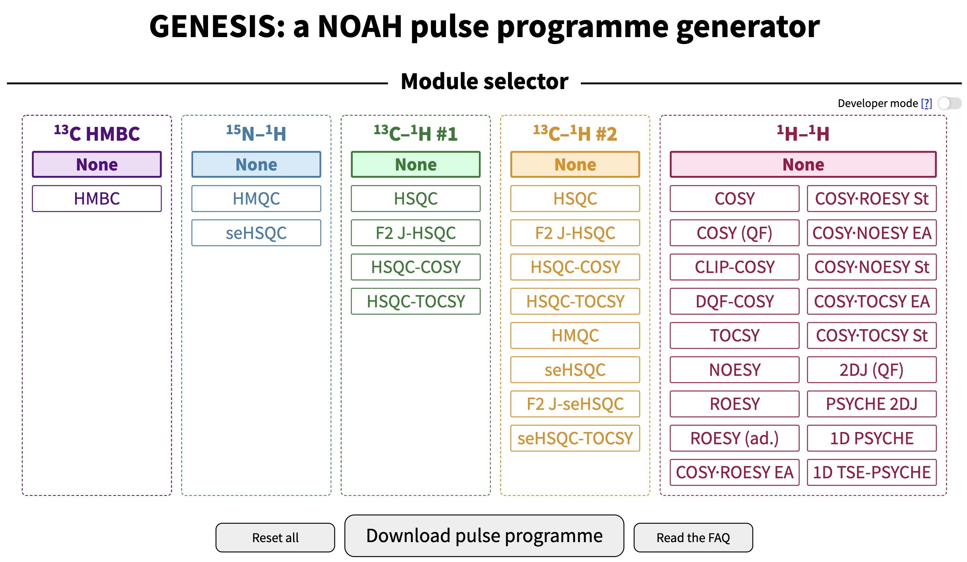

**Figure 2:** A screenshot of the GENESIS web interface. Visible here are the module choices, the “developer mode” toggle, and buttons for downloading the pulse program.

The regular GENESIS user interface is designed to only produce viable supersequences: thus, for example, it is not possible to create the CS or SBC supersequences discussed earlier. This is most useful for users who wish to follow established best practices. For more advanced usage, enabling “developer mode” will remove these limitations, allowing any arbitrary combination of modules to be created. The website further contains an extensive library of frequently asked questions about the implementation and practical details of NOAH experiments. It also offers download links for the AU scripts used for processing, as well as a new Python script used for toggling non‐uniform sampling on/off.

IMPLEMENTATION DETAILS

We begin with a brief discussion of how the GENESIS approach works. The pulse program generation code itself is written in TypeScript (version 4.2.3, Microsoft), which is compiled to JavaScript (formally ECMAScript 2015, or “ES6”) and then executed directly in a client’s browser; there is no server‐side code. The web browser shows a list of modules for users to choose from, using accessible and familiar names such as HMBC, HSQC, and so on (Figure 2). Internally, these are mapped to a series of *NOAHModule* objects, each of which contain module‐ specific information, such as its abbreviation, the requisite parameter definitions, the pulse program for the module itself, and the appropriate AU program to be used for processing.

Using this information, GENESIS then constructs the pulse program in several steps (Figure 3). The pulse program begins with header comments including information about the pulse program and constituent modules. Parameter definitions from each module are then collated, taking particular care to avoid duplicate definitions for parameters used in multiple modules. The main section, which contains the actual instructions for the pulse sequence, is then put together. This is done mostly by concatenating individual modules together, although there are also context-sensitive blocks placed *between* modules such as purge pulses, gradients, or ASAP mixing[17] in BSX-type supersequences (X being any homonuclear module). Appropriate looping and incrementation of parameters such as phase cycles, *t*1 delays, and gradient amplitudes for echo–antiecho selection is added at the end of the main section. Additional comments containing descriptive text for parameters (displayed in TopSpin's *ased* parameter setup screen), as well as gradient and shaped pulse information (which allow direct setup using the *gppp* and *wvm* commands), are added at this stage. Finally, we also specify the exact modules used in the pulse program, the GENESIS version number, and a timestamp. This is important for reproducibility purposes.

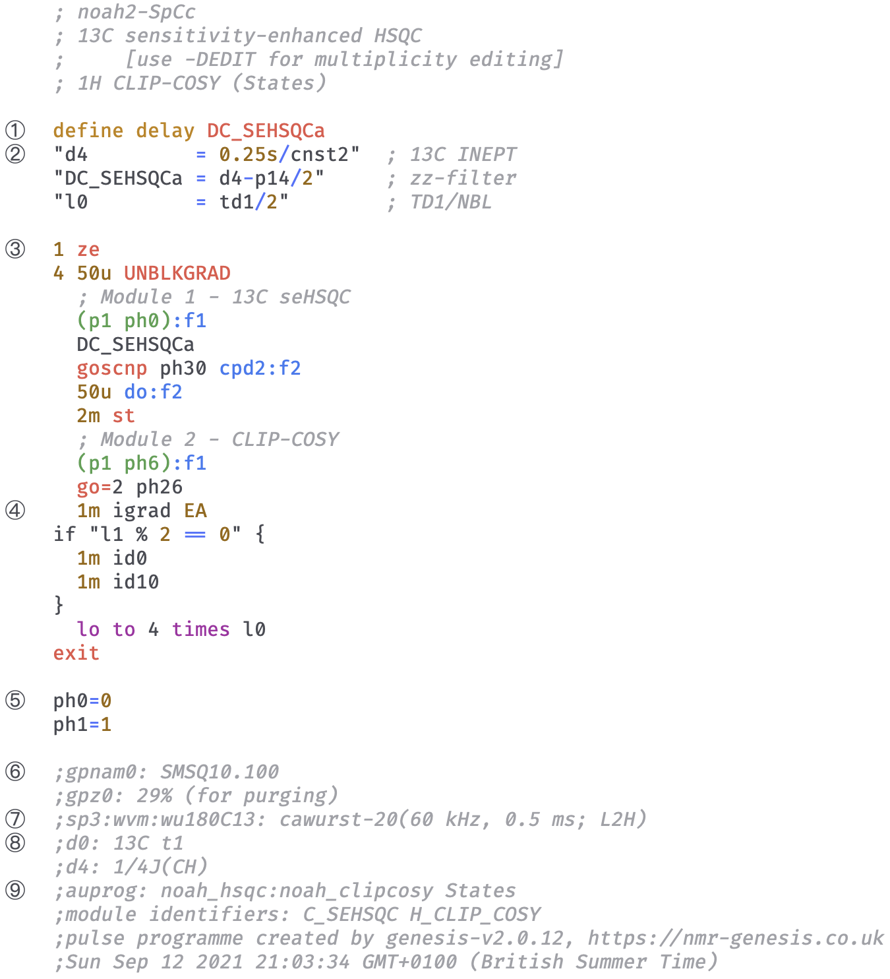

**Figure 3:** Abridged pulse program for a NOAH‐2 S+Cc supersequence (13C seHSQC + CLIP‐COSY). Specific sections of interest are numbered on the left. (1) Module‐specific delays are given unique identifiers to prevent clashes and to improve readability. (2) TopSpin parameters (delays such as *d4*) are standardized between modules. (3) The pulse program instructions themselves begin here. (4) *t*1 incrementation and echo–antiecho gradient inversion is carried out as necessary. (5) Pulse and receiver phase cycles are standardized between modules. (6) Comments for gradient pulses are compatible with the TopSpin *gppp* script. (7) Instructions for generating shaped pulses using TopSpin’s WaveMaker software. (8) Comments describing each parameter appear in the parameter setup screen. (9) Instructions for processing AU programs are encoded here, along with information about the specific modules used and a timestamp which ensures reproducibility.

An immediate problem of directly concatenating pulse program texts from different modules is that a given parameter in one module may take on a different meaning in another module. As a necessary step to prevent such clashes, we have fully standardized all parameters used in the GENESIS pulse programs. These include pulse widths (*p#*), delays (*d#*), constants (*cnst#*), *z*-gradient amplitudes (*gpz#*), and phase cycles (*ph#*), where *#* represents a non‐negative integer. Where possible, we have chosen meanings that are similar to those in the standard library of Bruker pulse programs, only deviating in order to avoid otherwise inevitable clashes between different modules. Furthermore, in place of module‐specific delays which are often called *DELTA#* in standard library sequences, we have chosen to define new identifiers with more human‐readable names inside the pulse program itself. Thus, the delays in a HSQC sequence might be called *DC_HSQC#*, where the first C indicates the indirect‐dimension nucleus (13C).

While this standardization was primarily implemented in order to facilitate pulse program construction, this also makes it far easier for users to set up NOAH experiments. Since the majority of these parameters are consistent with the standard Bruker library, many of them may be directly read in from the *prosol* relation tables and/or existing parameter sets in TopSpin. Furthermore, since every parameter has the same meaning in every NOAH supersequence, it also makes setting up multiple supersequences an almost trivial task: generally only the parameters *NBL*, *PULPROG*, and *TD1* need be changed.

Another potential issue is that different versions of a pulse sequence often exist. An example is the *zz*-HMBC, where the *zz*-filter element is used to retain 13C‐bound and/or 15N‐bound 1H magnetization.[16,18] Since the user only specifies that they want a HMBC module and not the exact details of the *zz*-filter, the GENESIS code must in effect make this choice for the user behind the scenes, in an adaptive fashion which changes depending on what other modules the user selects (Figure 4). Advanced users may, however, circumvent this and make their own choice by entering “developer mode”: each module version is assigned a different label *C_HMBC_...* (the labels are enumerated in more detail on the website). The sensitivity‐ enhanced HSQC (seHSQC, abbreviated ‘S+’/Sp) presents a similar case. If the seHSQC module is followed by one or more homonuclear modules such as a COSY or NOESY, then the ZIP‐seHSQC[22,23] is automatically chosen, as this preserves the requisite magnetization for the later modules. However, if the seHSQC module is used last in the sequence, then the original Cavanagh–Rance–Kay seHSQC[25,26] is chosen in order to maximize sensitivity.

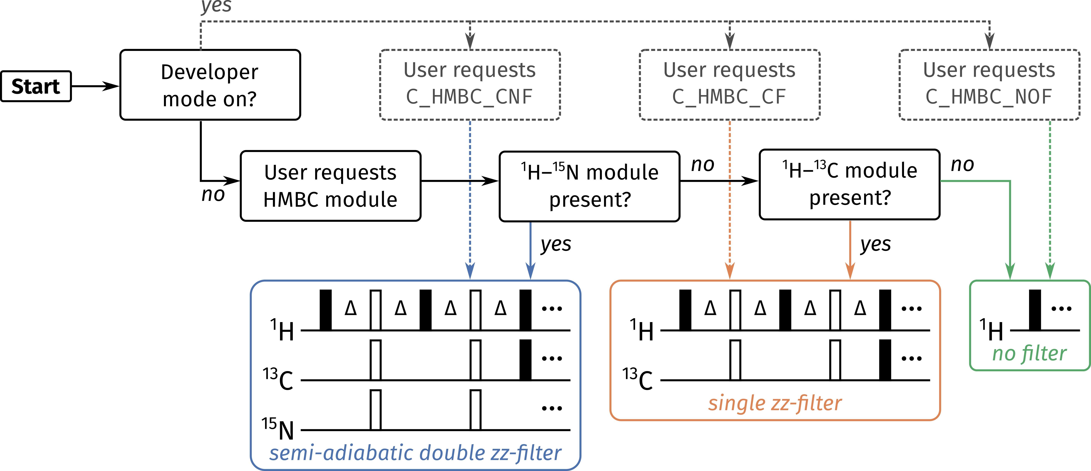

**Figure 4:** Flowchart illustrating how GENESIS decides the form of the *zz*-filter to be used in a 1H–13C HMBC module. Dotted lines represent the branch where developer mode is enabled, i.e. the user has full control over which form is used: these are labelled by alphabetical codes starting with C_HMBC (the website contains a full description of these codes). Solid lines represent the standard user mode, i.e. developer mode disabled: in this case, GENESIS automatically chooses the appropriate module based on what other modules are present in the supersequence.

The GENESIS pulse programs make substantial use of acquisition flags, a feature within TopSpin which allows for conditional compilation of pulse program segments. By defining one or more “symbols” inside the *zgoptns* TopSpin parameter, users may choose whether to include additional features in the pulse program, such as multiplicity editing in HSQC sequences, zero‐quantum suppression,[27] and solvent suppression. The benefit of this is that there is no need for users to store multiple different pulse sequences which only differ in isolated sections.

Reproducibility is a key consideration for scientific code, including GENESIS.[28] The primary aim of GENESIS is to release updates to NOAH supersequences in a timely fashion. However, it is also important that old releases of pulse sequences remain available so that scientific results using these pulse sequences may be reproduced. Furthermore, each release is accompanied by a suite of processing scripts; these may also be modified over time, and to ensure compatibility with the pulse sequences, old versions of the scripts must also be kept available.

To ensure that NMR experiments run with GENESIS pulse programs and scripts are always reproducible, each pulse program and script is marked with a version number (labelled (9) in Figure 3). Old versions of GENESIS may be obtained using the following formula: to access version X.Y.Z (where X, Y, Z are integers), navigate to the URL https://nmr-genesis.co .uk/X/Y/Z. For example, the release version that accompanies this paper is labelled v2.1.0; this can be accessed at <https://nmr-genesis.co.uk/2/1/0>. While earlier versions are also available and functional, these should be treated as “pre‐release” versions, to be used at the reader’s own risk. As an alternative, the GENESIS code can be obtained from GitHub at <https://github.com/yongrenjie/genesis>. Instructions on how to use this are provided in the repository description.

In its current form, GENESIS is not capable of creating arbitrary pulse sequences; its scope is limited to NOAH supersequences. However, this remains a viable target for the future: instead of combining NOAH modules to form a supersequence, one may instead consider combining pulse sequence elements (e.g. spin echoes, INEPT, zero‐quantum suppression, decoupling, or solvent suppression schemes) to form a pulse sequence. At an even more granular level, individual building blocks (e.g. pulses, delays, gradients) could be strung together to construct a pulse sequence in an interactive fashion.

NOAH IMPROVEMENTS WITHIN GENESIS

We now detail a few recent improvements to NOAH supersequences, which are already implemented in the live GENESIS webpage. It is worth noting that because of the modular nature of pulse program construction, changing the underlying code for a single NOAH module is sufficient to propagate changes to all supersequences containing that module.

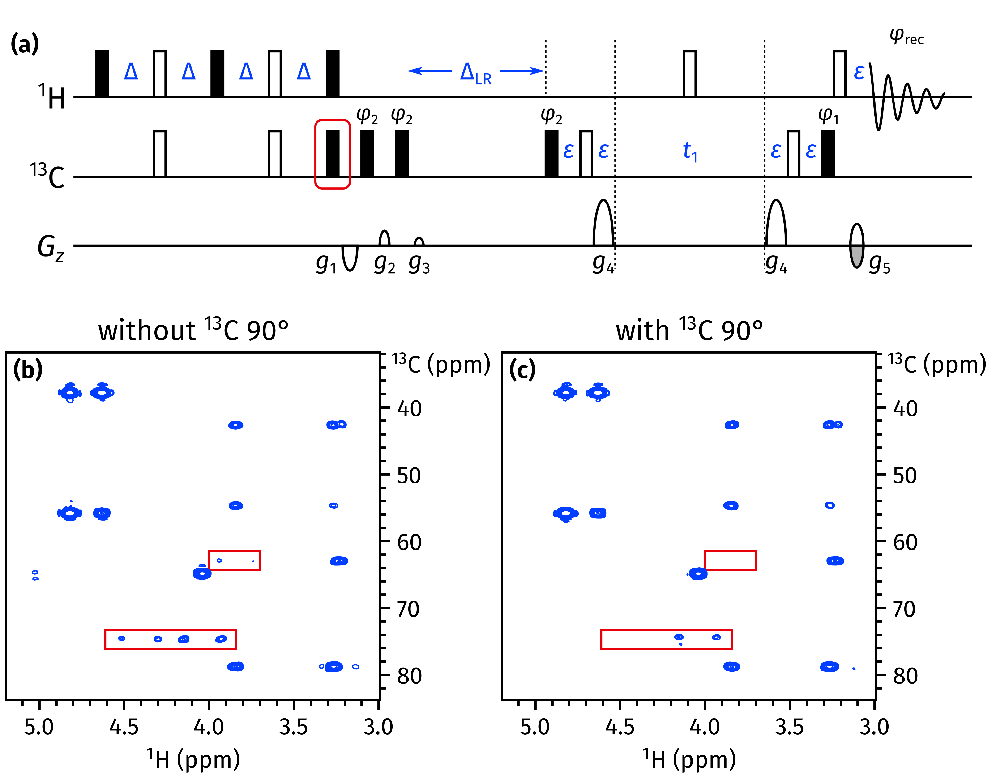

**Figure 5:** (a) The NOAH *zz*-HMBC pulse sequence, with the newly added 13C 90° pulse highlighted in red. The delays are Δ = 1 / (4 · 1*J*CH) and ΔLR = 1 / (2 · *nJ*CH); *ε* is the minimum time required for a gradient plus the subsequent recovery delay. Phase cycling is performed as follows: *φ*1 = *x*, −*x*; *φ*2 = *x*, *x*, −*x*, −*x*; *φ*rec = *x*, −*x*, −*x*, *x*. All gradients have duration 1 ms; amplitudes as a fraction of the maximum gradient strength (55.7 G/cm) are as follows: *g*1 = −15%; *g*2 = 10%; *g*3 = 5%; *g*4 = 80%; *g*5 = ±40.2%. (b) HMBC spectrum obtained using the original *zz*-HMBC module, i.e. without the added 90° pulse. 1*J*CH artefacts are highlighted in red boxes. (c) HMBC spectrum obtained with the added 90° pulse. Spectra were obtained on a 700 MHz Bruker AV III equipped with a TCI H/C/N cryoprobe; the sample used was 40 mM andrographolide in DMSO-*d*6.

**HMBC module.** The *zz*-HMBC module is ordinarily placed first in a supersequence, where the *zz*-filter element serves to preserve magnetization of protons directly coupled to 13C and/or 15N.[16,18] Specifically, the *zz*-filter acts as a 90° excitation pulse on 12C‐bound protons, while leaving 13C‐bound protons along +*z*. This is largely accomplished in practice, as evidenced by the fact that the intensities in subsequent HSQC‐type modules are barely perturbed. However, due to instrumental imperfections and/or J‐coupling mismatch, not all of the 13C–1H magnetization is perfectly retained: in particular, the *zz*-filter also generates a degree of antiphase magnetization of the form H*x*C*z*. This antiphase magnetization is later refocused during the low‐pass J‐filter (LPJF) to give in‐phase magnetization, eventually ending up as one‐bond correlation artefacts in the HMBC spectrum (Figure 5b).

A simple solution to this is to add a 13C 90° pulse at the end of the *zz*-filter (Figure 5a): this converts any antiphase magnetization to double‐ or zero‐quantum magnetization, which is subsequently dephased by the LPJF. This idea has previously been used by Luy and coworkers in CLIP‐HSQC experiments to remove antiphase contributions prior to FID detection.[29] In the event, this small modification proved to have a large impact, almost completely suppressing the 1*J*CH artefacts (Figure 5c). Further comparisons of artefact intensity are provided in Section S2 of the *Supporting Information*.

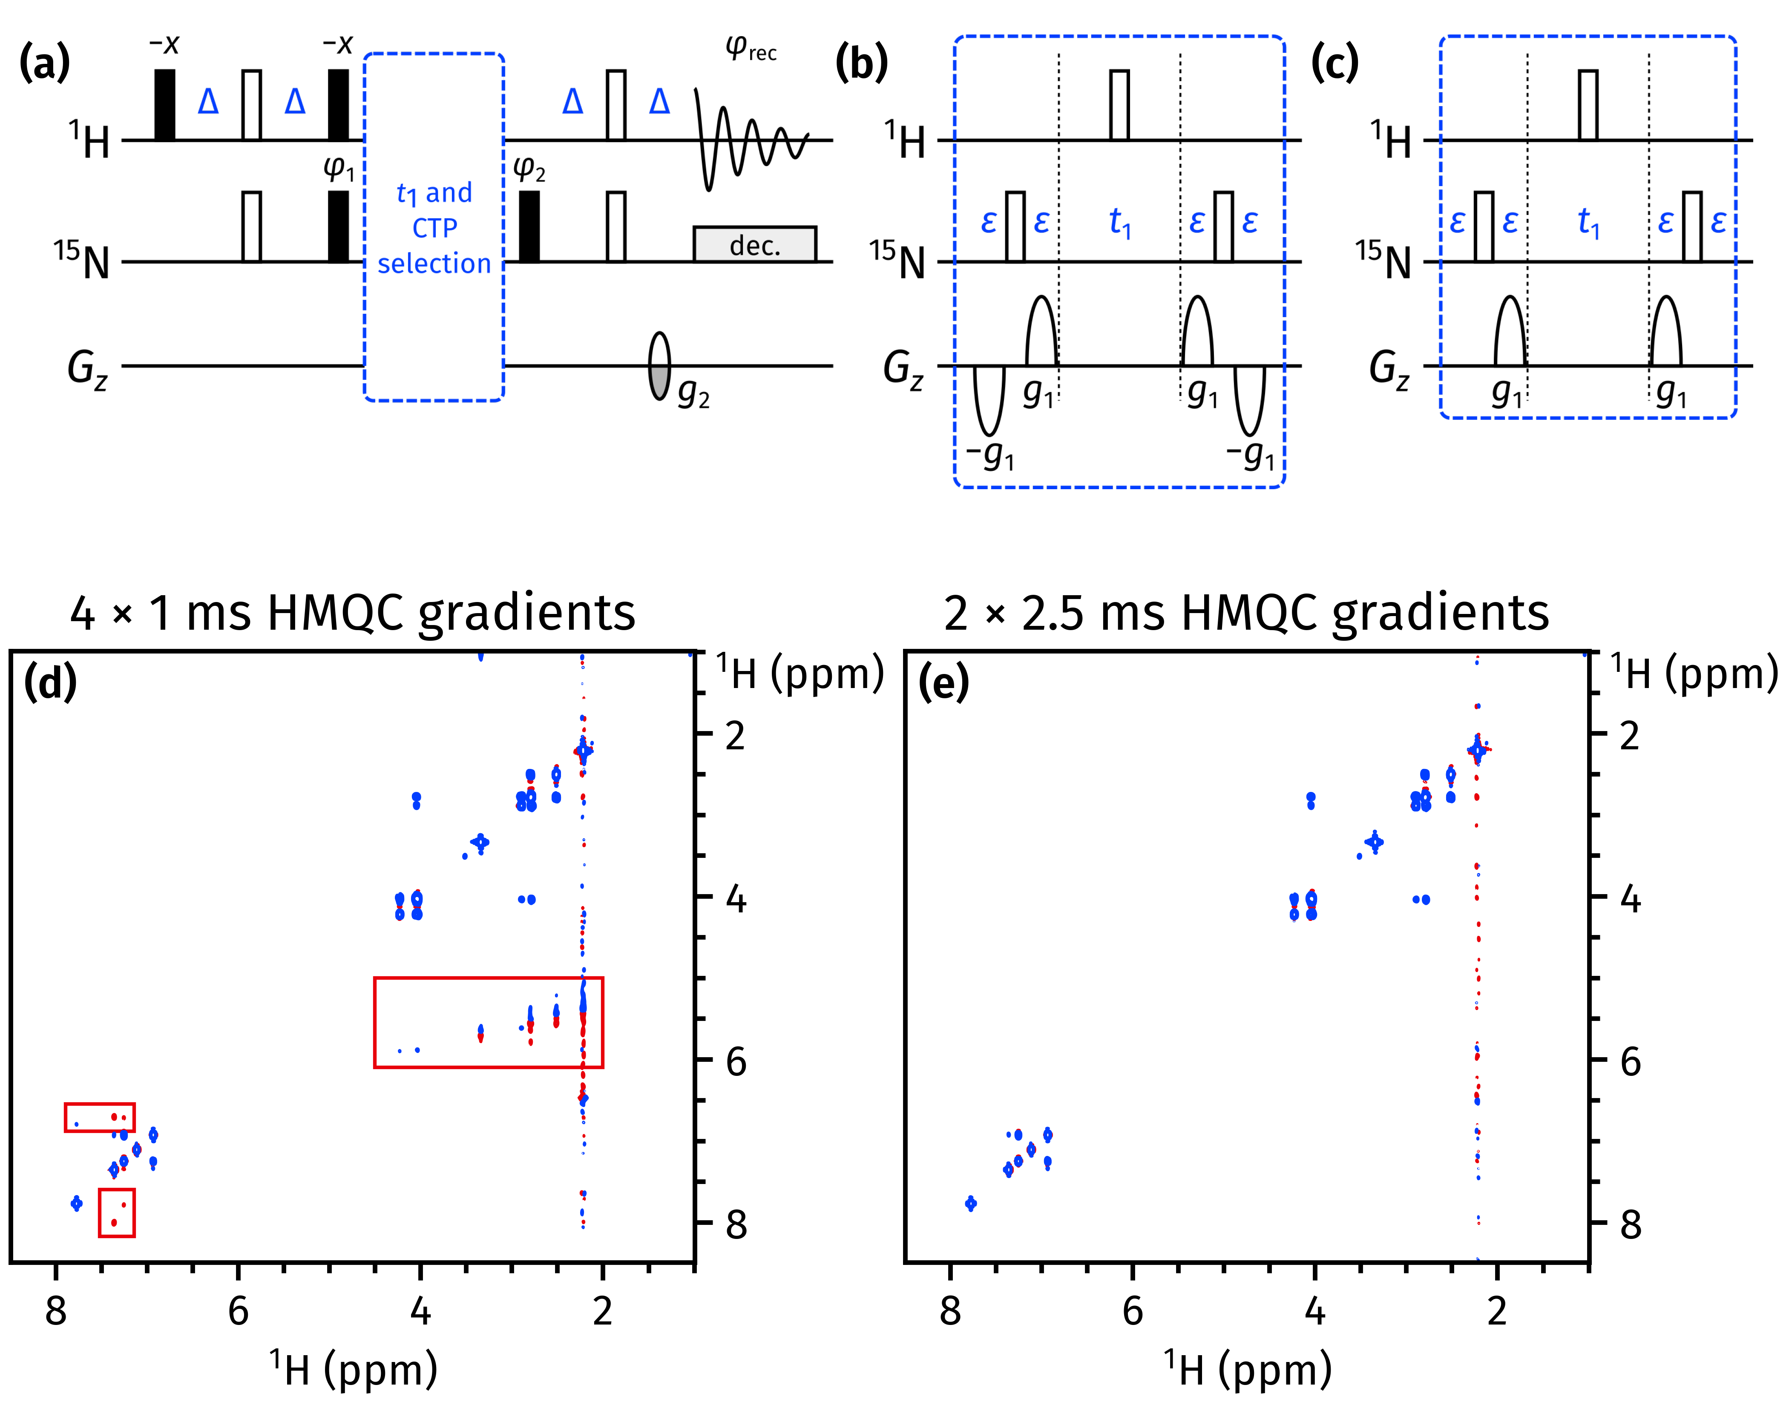

**Figure 6:** (a) A general outline of the NOAH 15N HMQC module. *g*2 has a duration which matches that of *g*1 (explained below), and an amplitude of ±*n* · 8.1%, where *n* is the number of CTP gradients bracketing the *t*1 period. *g*1 has an amplitude of 80% in all cases. All other symbols have the same meaning as in Figure 5. (b) The previously published coherence selection scheme for the HMQC module, with four gradients each of duration 1 ms. (c) The new coherence selection scheme for the HMQC module, with two gradients each of duration 2.5 ms. (d)–(e) CLIP‐COSY spectra obtained from a NOAH‐3 MS+Cc supersequence (15N HMQC + 13C seHSQC + CLIP‐COSY), acquired with the gradient schemes shown in (b) and (c) respectively. The wing artefacts in the former spectrum are highlighted in red boxes. Spectra were obtained on a 700 MHz Bruker AV III equipped with a TCI H/C/N cryoprobe; the sample used was 50 mM zolmitriptan in DMSO-*d*6.

**HMQC module.** We have recently described the occurrence of “wing artefacts” in homonuclear modules, which arise from bulk magnetization which evolves during either half of *t*1 in a preceding heteronuclear module.[23] These artefacts can be removed in an elegant manner by ensuring that each half of *t*1 in a HMQC/HSQC/seHSQC module contains coherence transfer pathway (CTP) gradients of equal sign and magnitude, which makes sure that any bulk magnetization undergoing net evolution during *t*1 is dephased.

At the same time, it is also important that the final gradient in the heteronuclear module have as large an amplitude as possible, since this gradient is responsible for dephasing bulk magnetization that is not returned to +*z* just prior to the detection period. In order to accomplish this, the previous 15N HMQC module used bipolar opposing gradients in either half of *t*1, a scheme which allows the final refocusing CTP gradient *g*2 to have an amplitude of 4*g*1*γ*N/*γ*H (Figure 6b). Although this leads to excellent artefact suppression in the 15N HMQC itself, wing artefacts are apparent in downstream modules (Figure 6d), because the opposing gradients cancel each other out and do not enforce any CTP selection on the bulk magnetization.

In order to suppress these “wing artefacts” in later modules, it proves better to only use two gradients during *t*1 (one in either half), and to lengthen their duration such that the final gradient *g*2 provides sufficient coherence selection in the HMQC itself (Figure 6c). This strategy was previously described for the 15N seHSQC;[23] here we have also applied it to the HMQC with success (Figure 6e). This change causes no significant difference in the sensitivity of the HMQC module itself (Figure S3).

**Pure shift and 2D J modules.** In previous work,[23] we described how 1H–15N modules could be implemented with optional “*k*-scaling”.[30] This entails a reduction in the number of *t*1 increments (by a factor of *k*), in return for a corresponding increase in the number of transients per increment, with no overall change in the experimental time. Particularly for the HMQC experiment, this allowed modest gains in sensitivity as *J*HH splittings were no longer resolved in the indirect dimension.

A simple extension of this protocol to homonuclear 1H–1H modules enables experiments such as 2D J‐resolved or pseudo‐2D pure shift spectroscopy to be incorporated into NOAH supersequences. In both cases, the number of *t*1 increments needed (16–32) is far smaller than the typical number required for a 2D experiment (128–256). In particular, at present, we have implemented a family of PSYCHE experiments, namely: the original pseudo‐2D PSYCHE (abbreviated “P”); the triple spin echo (TSE)‐PSYCHE experiment (“PT”), which provides improved robustness towards strong coupling; and the PSYCHE 2DJ experiment (“J”) which yields pure absorption‐mode lineshapes.[31–33] On top of this, there is also a magnitude‐mode 2D J module available (“Jqf”).

In PSYCHE spectra, the flip angle of the chirp or saltire pulses used in the J‐refocusing element provides the experimentalist with a choice: a larger flip angle provides greater sensitivity, but at the cost of increased artefacts.[33] One advantage of acquiring PSYCHE spectra in NOAH‐ type supersequences is that the increased number of transients compensates for the sensitivity losses inherent to PSYCHE and other pure shift techniques. Thus, the user can choose a smaller flip angle (ca. 10°) in order to maximize spectral purity instead, without losing any actual spectrometer time. An example of a NOAH‐3 supersequence with the TSE‐PSYCHE module is shown in Figure 7.

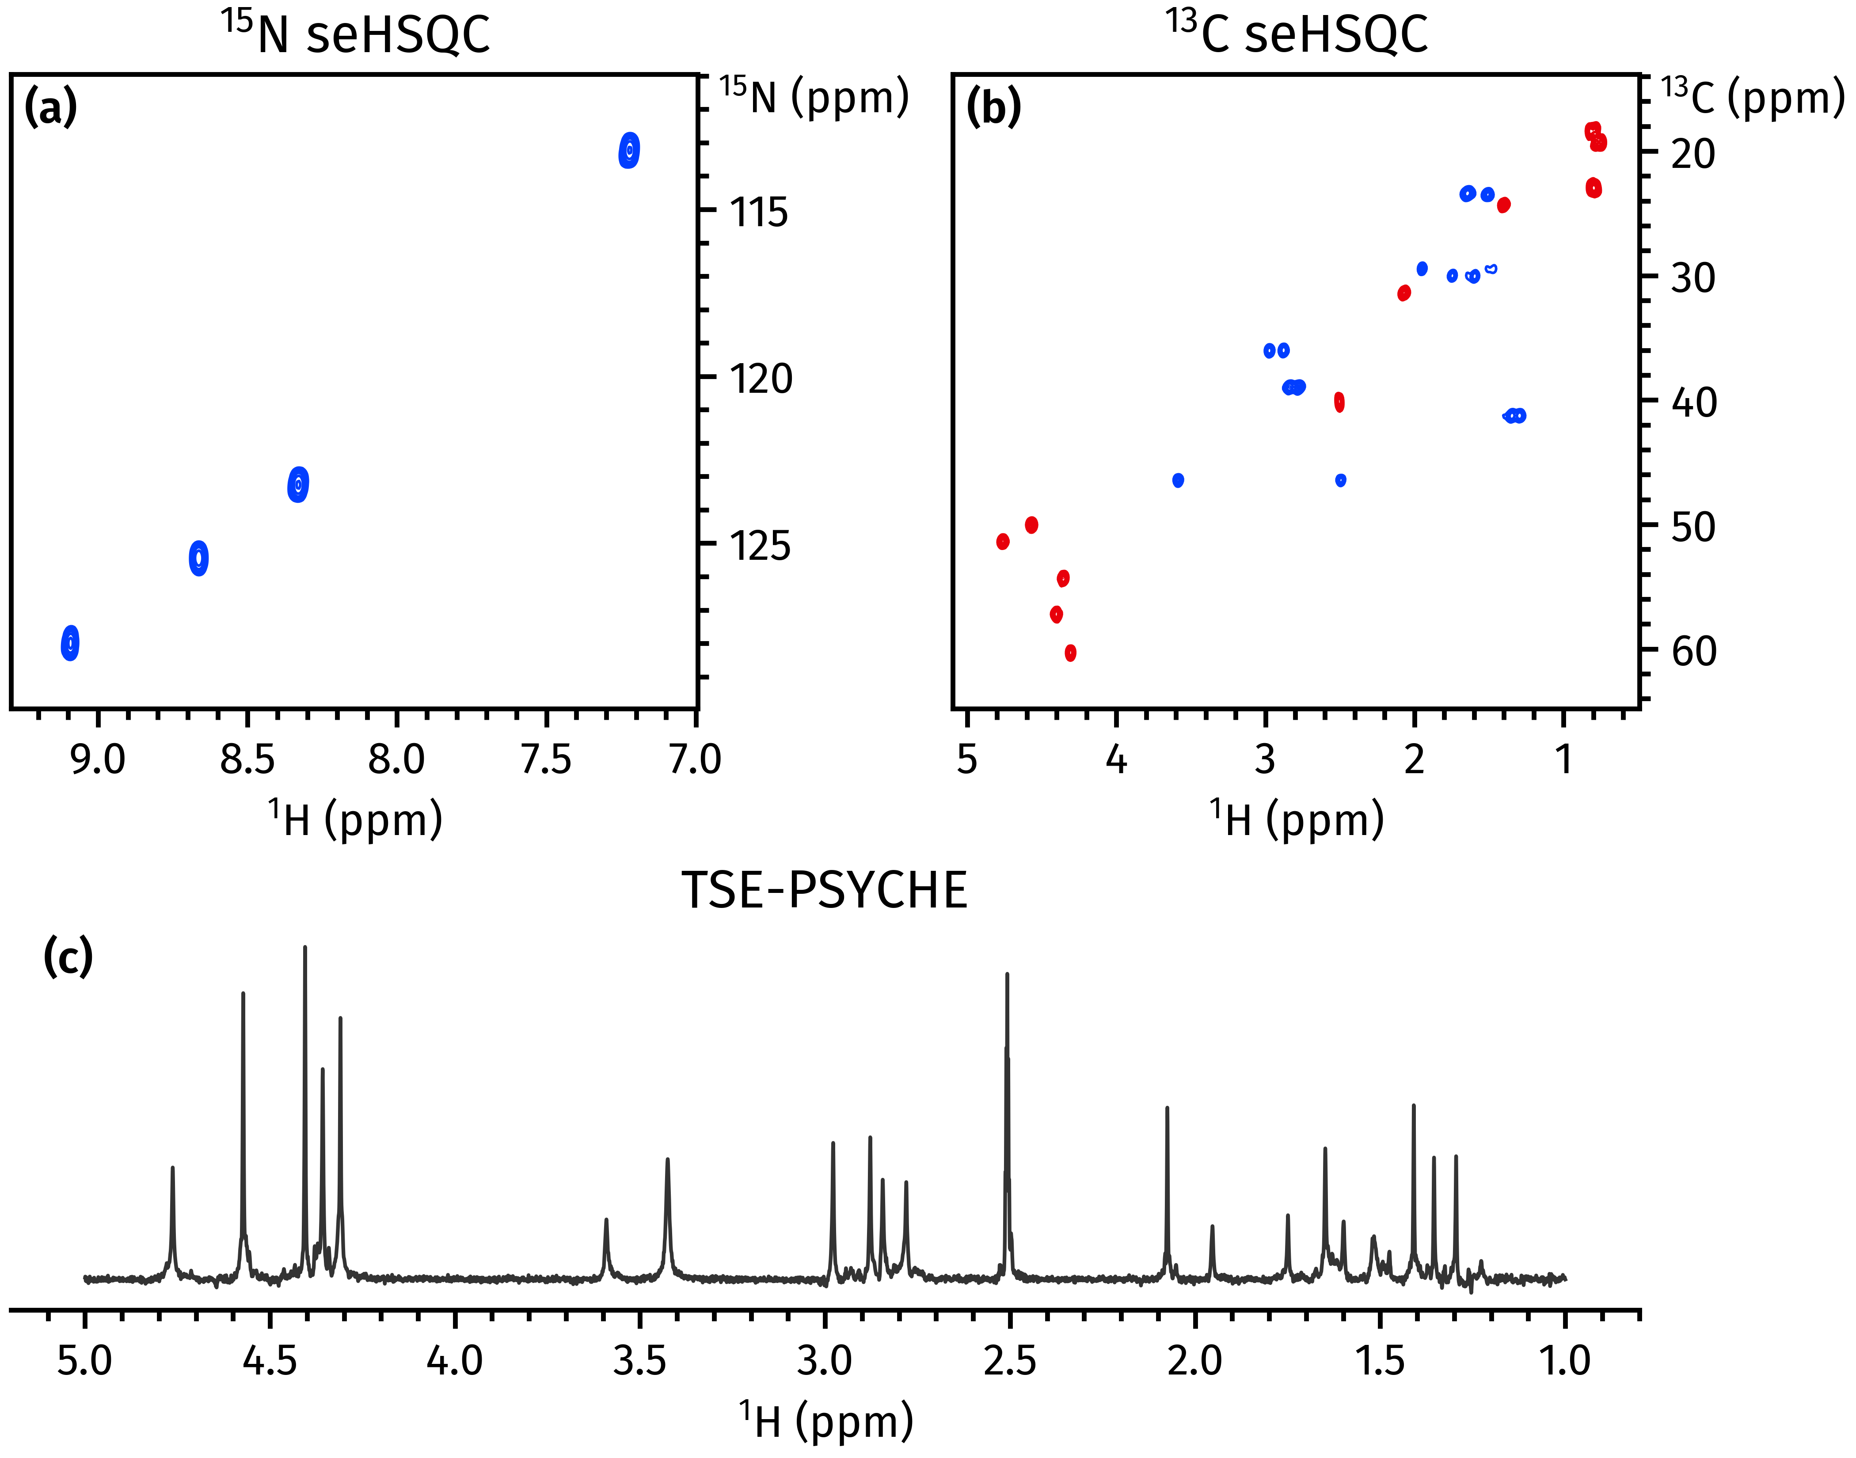

**Figure 7:** Spectra obtained from a NOAH‐3 S+NS+PT supersequence. (a) 15N sensitivity‐enhanced HSQC[23] (256 *t*1 increments, 2 scans per increment). (b) 13C sensitivity‐enhanced HSQC[22,23] (256 *t*1 increments, 2 scans per increment). (c) 1D TSE‐PSYCHE pure shift spectrum[31] (saltire flip angle of 10°, 32 chunks, 16 scans per chunk). Spectra were obtained on a 700 MHz Bruker AV III equipped with a TCI H/C/N cryoprobe; the sample used was 40 mM gramicidin in DMSO-*d*6.

**Solvent suppression.** The addition of solvent suppression to NOAH supersequences is more involved than for a typical NMR experiment, because the water signal must be adequately suppressed in all modules, ideally without affecting any other magnetization components. The HMQC‐ and HSQC‐type NOAH modules in fact provide good intrinsic solvent suppression, because the magnetization of all 1H spins not coupled to heteronuclei—including that of water—are returned to +*z* at the end of the sequence. However, other modules require the addition of specific solvent suppression techniques.

Two options are currently available, namely presaturation (during the recovery delay *d*1, as well as the mixing time in NOESY modules), and excitation sculpting placed just prior to acquisition in homonuclear (1H–1H) modules. The refocusing element used in the latter is a combination of a shaped and hard 180° pulse. Both presaturation and excitation sculpting can be independently turned on or off using acquisition flags in TopSpin.

***splitx_au* processing.** NOAH data processing is done using the *splitx_au* AU program; this is responsible for creating separate datasets containing the data for each module, defining any required processing parameters, and processing each dataset using module‐specific AU programs (e.g. *noah_hsqc* for 13C HSQC data). Previously, the names of the module‐specific AU programs had to be specified as the *USERP#* series of processing parameters. In contrast, with GENESIS pulse programs, this information is directly embedded within the pulse program itself; consequently, with a small modification to the *splitx_au* AU program, we can parse the pulse program to obtain the requisite list of AU programs. The user therefore does not have to specify it explicitly, which makes setting up multiple different supersequences a much smoother process. If necessary, it is possible to override these “default” AU programs by explicitly specifying the *USERP#* parameters, allowing for customized processing.

**Non-uniform sampling.** With the GENESIS pulse programs we also introduce a new and more user‐friendly implementation of non‐uniform sampling (NUS). NOAH experiments do not work “out of the box” with TopSpin’s conventional NUS setup routine: some special adjustments must be made by manually generating the list of increments to be sampled and adjusting the *t*1 delays accordingly within the pulse sequence looping. Previously, this was accomplished using a Python script which created a new pulse program for each supersequence, e.g. *noah3_BSC.nus*.[17] We have modified this approach such that the same pulse program can be used for both uniform and non‐uniform sampling, where NUS is controlled by an acquisition flag *-DNUS*. Although a (different) Python script is still required for initialization, this means that it is no longer necessary to keep two separate instances of the same pulse sequence in TopSpin, and simplifies turning NUS on and off.

CONCLUSION

Here, we have demonstrated how the systematic generation of NOAH pulse programs can be used to create any supersequence that users are interested in (of which there are potentially thousands). This provides ready access to a far greater range of supersequences tailored to users’ needs, reduces the likelihood of coding errors in new sequences, and allows newly implemented or improved modules to be easily disseminated to users. Several of these improvements to NOAH modules, along with the associated processing routines, have been described; these are already available via the GENESIS website ([https://nmr-genesis.co.uk](https://nmr-genesis.co.uk/)).

ASSOCIATED CONTENT

Supporting Information

The Supporting Information is available free of charge on the ACS Publications website.

Detailed analysis of NOAH combinations and comparisons of pulse sequences (PDF)

AUTHOR INFORMATION

Corresponding Author

Tim D. W. Claridge — *Chemistry Research Laboratory, Department of Chemistry, University of Oxford, 12 Mansfield Road, Oxford, OX1 3TA, United Kingdom*

Email: tim.claridge@chem.ox.ac.uk

Authors

Jonathan R. J. Yong — *Chemistry Research Laboratory, Department of Chemistry, University of Oxford, 12 Mansfield Road, Oxford, OX1 3TA, United Kingdom*

Ēriks Kupče — *Bruker UK Ltd, R&D, Coventry CV4 9GH, United Kingdom*

ACKNOWLEDGMENT

J.R.J.Y. thanks the Clarendon Fund (University of Oxford) and the EPSRC Centre for Doctoral Training in Synthesis for Biology and Medicine (EP/L015838/1) for a studentship, generously supported by AstraZeneca, Diamond Light Source, Defence Science and Technology Laboratory, Evotec, GlaxoSmithKline, Janssen, Novartis, Pfizer, Syngenta, Takeda, UCB, and Vertex.

REFERENCES

(1) Frydman, L.; Scherf, T.; Lupulescu, A. The acquisition of multidimensional NMR spectra within a single scan. *Proc. Natl. Acad. Sci. U. S. A.* **2002**, *99*, 15858–15862.

(2) Frydman, L.; Lupulescu, A.; Scherf, T. Principles and Features of Single‐Scan Two‐Dimensional NMR Spectroscopy. *J. Am. Chem. Soc.* **2003**, *125*, 9204–9217.

(3) Tal, A.; Frydman, L. Single‐scan multidimensional magnetic resonance. *Prog. Nucl. Magn. Reson. Spectrosc.* **2010**, *57*, 241–292.

(4) Mobli, M.; Hoch, J. C. Nonuniform sampling and non‐Fourier signal processing methods in multidimensional NMR. *Prog. Nucl. Magn. Reson. Spectrosc.* **2014**, *83*, 21–41.

(5) Kazimierczuk, K.; Orekhov, V. Non‐uniform sampling: post‐Fourier era of NMR data collection and processing. *Magn. Reson. Chem.* **2015**, *53*, 921–926.

(6) Gołowicz, D.; Kasprzak, P.; Orekhov, V.; Kazimierczuk, K. Fast time‐resolved NMR with non‐uniform sampling. *Prog. Nucl. Magn. Reson. Spectrosc.* **2020**, *116*, 40–55.

(7) Nolis, P.; Pérez‐Trujillo, M.; Parella, T. Multiple FID Acquisition of Complementary HMBC Data. *Angew. Chem., Int. Ed.* **2007**, *46*, 7495–7497.

(8) Kupče, Ē.; Freeman, R. Molecular Structure from a Single NMR Experiment. *J. Am. Chem. Soc.* **2008**, *130*, 10788–10792.

(9) Nagy, T. M.; Gyöngyösi, T.; Kövér, K. E.; Sørensen, O. W. BANGO SEA XLOC/HMBC–H2OBC: com‐ plete heteronuclear correlation within minutes from one NMR pulse sequence. *Chem. Commun.* **2019**, *55*, 12208–12211.

(10) Nagy, T. M.; Kövér, K. E.; Sørensen, O. W. Double and adiabatic BANGO for concatenating two NMR experiments relying on the same pool of magnetization. *J. Magn. Reson.* **2020**, *316*, 106767.

(11) Schanda, P.; Van Melckebeke, H.; Brutscher, B. Speeding Up Three‐Dimensional Protein NMR Experiments to a Few Minutes. *J. Am. Chem. Soc.* **2006**, *128*, 9042–9043.

(12) Kupče, Ē.; Freeman, R. Fast multidimensional NMR by polarization sharing. *Magn. Reson. Chem.* **2007**, *45*, 2–4.

(13) Schulze‐Sünninghausen, D.; Becker, J.; Luy, B. Rapid Heteronuclear Single Quantum Correlation NMR Spectra at Natural Abundance. *J. Am. Chem. Soc.* **2014**, *136*, 1242–1245.

(14) Nagy, T. M.; Kövér, K. E.; Sørensen, O. W. NORD: NO Relaxation Delay NMR Spectroscopy. *Angew. Chem., Int. Ed.* **2021**, *60*, 13587–13590.

(15) Kupče, Ē.; Claridge, T. D. W. NOAH: NMR Supersequences for Small Molecule Analysis and Structure Elucidation. *Angew. Chem., Int. Ed.* **2017**, *56*, 11779–11783.

(16) Kupče, Ē.; Claridge, T. D. W. Molecular structure from a single NMR supersequence. *Chem. Commun.* **2018**, *54*, 7139–7142.

(17) Claridge, T. D. W.; Mayzel, M.; Kupče, Ē. Triplet NOAH supersequences optimised for small molecule structure characterisation. *Magn. Reson. Chem.* **2019**, *57*, 946–952.

(18) Kupče, Ē.; Claridge, T. D. W. New NOAH modules for structure elucidation at natural isotopic abundance. *J. Magn. Reson.* **2019**, *307*, 106568.

(19) Rao Kakita, V. M.; Hosur, R. V. All‐in‐one NMR spectroscopy of small organic molecules: complete chemical shift assignment from a single NMR experiment. *RSC Adv.* **2020**, *10*, 21174–21179.

(20) Kupče, Ē.; Mote, K. R.; Webb, A.; Madhu, P. K.; Claridge, T. D. W. Multiplexing experiments in NMR and multi‐nuclear MRI. *Prog. Nucl. Magn. Reson. Spectrosc.* **2021**, *124‐125*, 1–56.

(21) Kupče, Ē.; Frydman, L.; Webb, A. G.; Yong, J. R. J.; Claridge, T. D. W. Parallel nuclear magnetic resonance spectroscopy. *Nat. Rev. Methods Primers* **2021**, *1*, 27.

(22) Hansen, A. L.; Kupče, Ē.; Li, D.‐W.; Bruschweiler‐Li, L.; Wang, C.; Brüschweiler, R. 2D NMR‐ Based Metabolomics with HSQC/TOCSY NOAH Supersequences. *Anal. Chem.* **2021**, *93*, 6112–6119.

(23) Yong, J. R. J.; Hansen, A. L.; Kupče, Ē.; Claridge, T. D. W. Increasing sensitivity and versatility in NMR supersequences with new HSQC‐based modules. *J. Magn. Reson.* **2021**, *329*, 107027.

(24) Kupče, Ē.; Yong, J. R. J.; Widmalm, G.; Claridge, T. D. W. Parallel NMR Supersequences: Ten Spectra in a Single Measurement. *JACS Au* **2021**, DOI: 10.1021/jacsau.1c00423.

(25) Palmer, A. G., III; Cavanagh, J.; Wright, P. E.; Rance, M. Sensitivity improvement in proton‐detected two‐dimensional heteronuclear correlation NMR spectroscopy. *J. Magn. Reson.* **1991**, *93*, 151–170.

(26) Kay, L. E.; Keifer, P.; Saarinen, T. Pure absorption gradient enhanced heteronuclear single quantum correlation spectroscopy with improved sensitivity. *J. Am. Chem. Soc.* **1992**, *114*, 10663–10665.

(27) Thrippleton, M. J.; Keeler, J. Elimination of Zero‐Quantum Interference in Two‐Dimensional NMR Spectra. *Angew. Chem., Int. Ed.* **2003**, *42*, 3938–3941.

(28) Perkel, J. M. Challenge to scientists: does your ten‐year‐old code still run? *Nature* **2020**, *584*, 656–658.

(29) Enthart, A.; Freudenberger, J. C.; Furrer, J.; Kessler, H.; Luy, B. The CLIP/CLAP‐HSQC: Pure absorptive spectra for the measurement of one‐bond couplings. *J. Magn. Reson.* **2008**, *192*, 314–322.

(30) Pérez‐Trujillo, M.; Nolis, P.; Bermel, W.; Parella, T. Optimizing sensitivity and resolution in time‐shared NMR experiments. *Magn. Reson. Chem.* **2007**, *45*, 325–329.

(31) Foroozandeh, M.; Adams, R. W.; Kiraly, P.; Nilsson, M.; Morris, G. A. Measuring couplings in crowded NMR spectra: pure shift NMR with multiplet analysis. *Chem. Commun.* **2015**, *51*, 15410–15413.

(32) Foroozandeh, M.; Adams, R. W.; Meharry, N. J.; Jeannerat, D.; Nilsson, M.; Morris, G. A. Ultrahigh‐Resolution NMR Spectroscopy. *Angew. Chem., Int. Ed.* **2014**, *53*, 6990–6992.

(33) Foroozandeh, M.; Morris, G. A.; Nilsson, M. PSYCHE Pure Shift NMR Spectroscopy. *Chem. Eur. J.* **2018**, *24*, 13988–14000.

Authors are required to submit a graphic entry for the Table of Contents (TOC) that, in conjunction with the manuscript title, should give the reader a representative idea of one of the following: A key structure, reaction, equation, concept, or theorem, etc., that is discussed in the manuscript. Consult the journal’s Instructions for Authors for TOC graphic specifications.

Insert Table of Contents artwork here