Diversifying NMR Supersequences with New HSQC-based
Modules
Jonathan R. J. Yong,^{[a]} Alexandar L. Hansen,^{[b]} Ēriks Kupče,^{[c]} and Tim D. W. Claridge*^{[a]}
[a] J. R. J. Yong, T. D. W. Claridge*
Chemistry Research Laboratory, Department of Chemistry
University of Oxford
Mansfield Road, Oxford, OX1 3TA, United Kingdom
E-mail: tim.claridge@chem.ox.ac.uk
[b] A. L. Hansen
Campus Chemical Instrument Center
The Ohio State University
460 W. 12th Avenue, Columbus, OH, 43210 United States
[c] Ē. Kupče
Bruker UK Ltd.
Banner Lane, Coventry, CV4 9GH, United Kingdom
Supporting information for this article is given via a link at the end of the document.

Abstract: The sensitivity-enhanced HSQC, as well as HSQC-TOCSY, experiments are incorporated into NOAH (NMR by Ordered Acquisition using ¹H detection) supersequences, adding diversity for ¹³C and ¹⁵N modules. Importantly, these heteronuclear modules are specifically tailored to preserve the magnetisation required for subsequent acquisition of homonuclear modules in a supersequence. In addition, we present protocols for optimally combining HSQC and HSQC-TOCSY elements within the same supersequences, yielding high-quality 2D spectra suitable for structure characterisation but with greatly reduced experiment durations.
Introduction
In recent years, there has been significant interest in the acceleration of multidimensional NMR data acquisition.^{[1–5]} In particular, some of the more readily implemented methods involve multiple-FID experiments which use either single or multiple receivers. Of these, one of the most versatile approaches is to utilise different “pools” of magnetisation available within a sample for the sequential collection of different spectra without an intervening recovery delay, as exemplified by the NOAH (NMR by Ordered Acquisition using ¹H detection) technique.^{[6]} Virtually all of the most common 2D experiments used in small molecule characterisation, such as HSQC, HMBC, COSY, TOCSY, NOESY, and ROESY, can be combined in a modular fashion to form supersequences which collectively use only one recovery delay (d₁) (Figure 1a). As the recovery delay accounts for the large majority of experiment time in 2D NMR, the NOAH approach can provide time savings of up to ∼4× compared to the conventional individual acquisition of each spectrum, where each constituent experiment would require its own recovery delay.
One-bond heteronuclear correlation experiments, namely HSQC and HMQC, play a central role in the structural elucidation of small organic molecules and biomolecules.^{[7]} These experiments are also a core component of many NOAH experiments, since the magnetisation they use (protons directly coupled to isotopically dilute X nuclei, i.e. ¹³C or ¹⁵N) can be efficiently differentiated from the “bulk” magnetisation of protons that are not directly attached to these NMR-active nuclei.^{[8]} Following the notation of Orts,^{[9]} we refer to these two magnetisation components (proton coupled to X and proton not coupled to X) as ¹H^{X} and ¹H^{!X} respectively. At the same time, due to the low natural abundance of these heteronuclei, these spectra are typically less sensitive than the homonuclear spectra that are placed towards the end of the supersequence. Consequently, for dilute samples, the minimum experimental time is generally dictated by these heteronuclear experiments, meaning any improvements in experiment sensitivity can be directly translated into greater time savings.
In the 1990s, Cavanagh, Rance, and Kay introduced the sensitivity-enhanced HSQC (seHSQC) experiment,^{[10]} which improves on the sensitivity of an ordinary echo–antiecho HSQC by up to a factor of 2 in the most ideal case. This is accomplished through the so-called preservation of equivalent pathways (PEP) scheme, which converts two magnetisation components that are cosine- and sine-modulated in t₁ into observable magnetisation prior to detection.^{[11]} Here, we show how the original seHSQC sequence can be modified such that it can be used as a NOAH module. We add further diversification by incorporating a HSQC-TOCSY module, derived from the ASAP-HSQC-TOCSY,^{[1g]} that is also compatible with the NOAH strategy. Both of these modules can be inserted either independently or together into NOAH supersequences, allowing large amounts of chemical information to be acquired in short times.
Results and Discussion
A typical example of a NOAH supersequence is the NOAH-4 MSCN experiment (Figure 1a), which yields ¹⁵N HMQC, ¹³C HSQC, COSY, and NOESY spectra in one single experiment.^{[6a]} The implementation of this supersequence relies on the fact that the output of any one module contains all the necessary magnetisation components required for downstream modules. For example, both the standard NOAH HMQC (Figure S1a)^{[1b,6a]} and HSQC (Figure S1b)^{[1e,6a]} modules return the bulk ¹H^{!X} magnetisation back to its equilibrium position (+z). In the MSCN sequence, this bulk magnetisation can therefore be used as the input to the COSY and NOESY homonuclear modules which follow. However, the original Cavanagh–Rance–Kay (CRK) seHSQC (Figure 1b) does not obey this principle: it causes bulk magnetisation to be dephased by coherence transfer pathway (CTP) gradients. Consequently, downstream modules can only utilise any bulk ¹H^{!X} magnetisation that has recovered during the HSQC FID acquisition, leading to drastic losses in signal intensity. This is illustrated using a NOAH-2 S⁺C^{c} (seHSQC + CLIP-COSY^{[12]}) supersequence: the CLIP-COSY is used in this work as a convenient module for which peaks can be easily integrated, but the conclusions drawn here are fully applicable to any other homonuclear module that is used in its place. While the CRK seHSQC implementation (Figure 2a) affords significant sensitivity gains (primarily for CH peaks, as predicted by theory^{[13]}), the COSY module which follows suffers from an almost complete (∼90%) loss of intensity. While one could argue that this is still tolerable for the COSY module, which is the most sensitive of all NOAH modules, these losses are not permissible for less inherently sensitive homonuclear modules such as NOESY and ROESY.
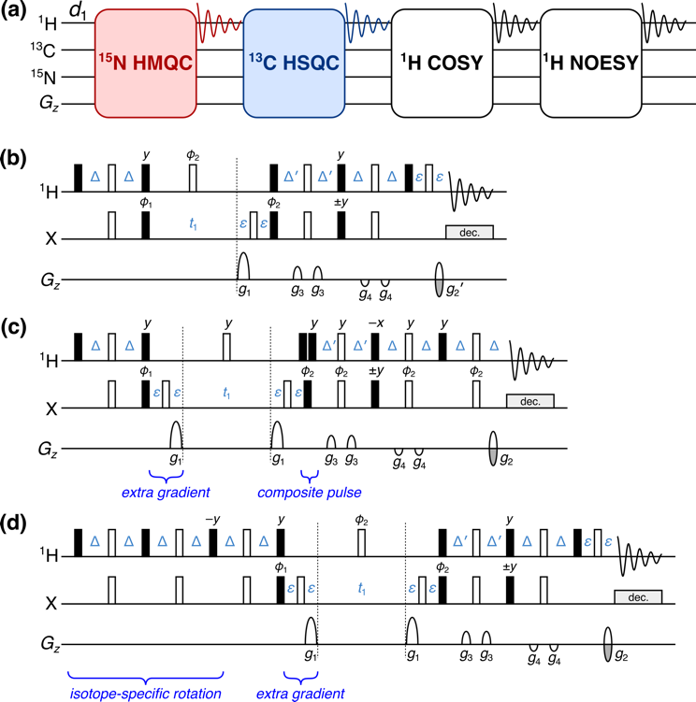
Figure 1. (a) Overview of a typical NOAH supersequence (MSCN, using the single-letter abbreviations previously defined^{[6a]}). The ¹⁵N–¹H HMQC and ¹³C–¹H HSQC modules are coloured; these may be replaced with the new seHSQC module proposed in this work. (b) Cavanagh–Rance–Kay (CRK) seHSQC.^{[10]} (c) Version 1 of the NOAH seHSQC module, abbreviated as “S⁺₁”. (d) Version 2 of the NOAH seHSQC module, abbreviated as “S⁺₂”. Filled and unfilled bars represent 90° and 180° pulses respectively; all 180° pulses on ¹³C are adiabatic (frequency-swept) pulses. All pulses are applied along +x unless otherwise noted. Phase cycling is performed with φ₁ = (x, −x) and φ₂ = (x, x, −x, −x). The delays are chosen as follows: Δ = 1/(4·¹J_{XH}), Δ′ = 1/(8·¹J_{CH}) or 1/(4·¹J_{NH}), and ε is the minimum time needed for a gradient pulse and subsequent recovery. All gradient pulses are 1 ms long, except for g₁ and g₂ in ¹⁵N experiments which are 2.5 ms long. Gradient amplitudes, as percentages of maximum gradient strength, are as follows: g₁ = 80%; g₂ = ±40.2% (¹³C) or ±16.2% (¹⁵N); g₂′ = g₂/2; g₃ = 11%; g₄ = −5%. The signs of g₂ and g₂′, as well as the phase of the 90° X pulse marked ±y, are alternated within each t₁ increment to provide echo–antiecho selection. Refer to Figure S1 for product operator analysis.
In this work, we compare two possible solutions to this, which form the basis of the NOAH seHSQC modules. In both cases, we require a pulse sequence element which performs a selective 90° rotation on ¹H^{X} magnetisation and leaves ¹H^{!X} magnetisation untouched. The first version of the NOAH seHSQC (Figure 1c, “S⁺₁”) uses a composite ¹H pulse immediately following t₁ to accomplish this aim, as both magnetisation components have already diverged by this point. On the other hand, the second (Figure 1d, “S⁺₂” or “ZIP-seHSQC”) actively differentiates the two components at the start of the sequence by prepending a double heteronuclear spin echo, a strategy recently reported by Hansen et al.^{[14]} This zz isotope-selective (ZIP) pulse element is based on the observation that the bulk ¹H^{!X} magnetisation in the seHSQC will be returned to +z if the phase of the initial ¹H 90°_{x} pulse in the CRK seHSQC is changed by 90° to +y. To generate the required HSQC signal, however, a ¹H 90°_{x} pulse must still be applied to ¹H^{X} magnetisation. Overall, what is required is therefore a pulse sequence element which simultaneously acts as a 90°_{x} (or 90°_{−x}) pulse on protons coupled to spin-X, and as a 90°_{y} pulse on uncoupled protons. The resulting ZIP element is similar to the zz-filter, which has previously been used in the NOAH zz-HMBC module to retain the magnetisation of directly coupled protons for a subsequent HSQC module.^{[6b,6d]} However, the ZIP element has different pulse phases to this and consequently leads to a different overall outcome, i.e. 90°_{−x} on ¹H^{X} and 90°_{y} on ¹H^{!X}.
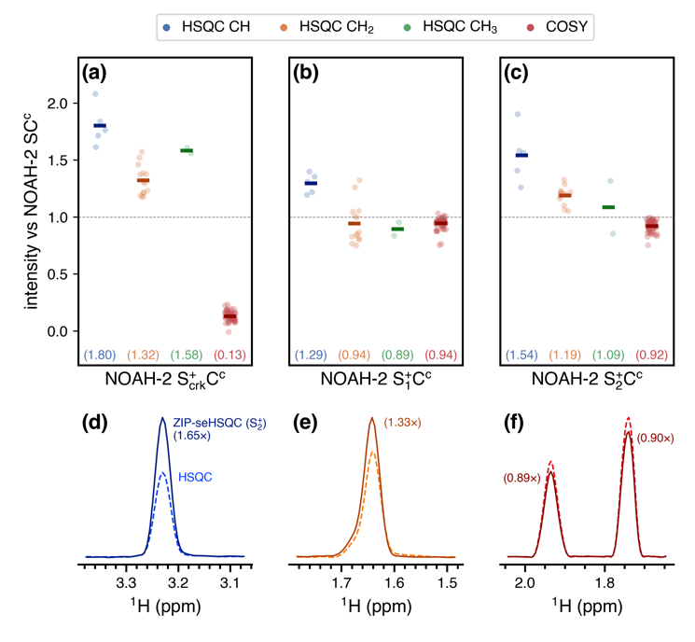
Figure 2. Sensitivity comparisons for NOAH-2 S⁺C^{c} (seHSQC + CLIP-COSY) supersequences, using the CRK and NOAH seHSQC implementations. The delay Δ′ was set to 1/(8·¹J_{CH}). All intensities are normalised against the NOAH-2 SC^{c} (HSQC + CLIP-COSY) supersequence, without HSQC sensitivity enhancement. HSQC intensities are further grouped by multiplicity. Circles represent the relative intensities of individual peaks; solid bars, as well as the numbers in parentheses, indicate averages over all peaks of a given type. (a) Using the original CRK seHSQC (Figure 1b). The CRK seHSQC does not preserve the bulk ¹H^{!X} magnetisation, leading to severely reduced COSY intensities. (b) Using the S⁺₁ module (Figure 1c). (c) Using the S⁺₂ module (Figure 1d). (d)–(e) Slices of the NOAH HSQC (dashed line) and NOAH ZIP-seHSQC (S⁺₂) spectra (solid line) through f₁ = 78.9 ppm (a CH peak, (d)) and f₁ = 28.5 ppm (a CH₂ peak, (e)). (f) Slices of the CLIP-COSY module from the NOAH-2 SC^{c} (dashed line) and S⁺₂C^{c} (solid line) supersequences, through f₁ = 1.36 ppm. Spectra were obtained on a 700 MHz Bruker AV III equipped with a TCI H/C/N cryoprobe; the sample used was 40 mM andrographolide in DMSO-d₆.
In addition to the aforementioned modifications, both NOAH seHSQC modules also contain a CTP gradient prior to the t₁ period (highlighted in Figures 1c and 1d). In the S⁺₁ module, the ¹H^{!X} magnetisation is in the xy-plane during t₁ (see Figure S1 for product operator analysis), and would simply be dephased if this gradient were not present, making its presence mandatory. Alternatively, the S⁺₂ module places the ¹H^{!X} magnetisation on ±z in t₁. This gradient is therefore not used for rephasing, but instead serves to suppress artefacts in downstream modules, which would otherwise arise from bulk magnetisation that (due to pulse imperfections) is not longitudinal and can therefore evolve during either half of the HSQC t₁ period (Figures S2 to S4). This magnetisation then evolves again in the t₁ period of a later homonuclear module (e.g. COSY), resulting in each COSY peak with indirect-dimension frequency f₁ = Ω_{H} being accompanied by a pair of “wing” artefacts at f₁ = Ω_{H} ± (Ω_{H}·SW_{COSY})/(2·SW_{HSQC}), where Ω_{H} and SW refer to the proton offset and indirect-dimension spectral width respectively (both in Hz). Importantly, the artefacts arising from diagonal peaks can have intensities that are comparable to genuine crosspeaks (Figure S2), which highlights the importance of suppressing these artefacts. Apart from the “wing” artefacts in downstream modules, we also briefly note here that the presence of two CTP gradients inside the seHSQC t₁ period allows the final CTP gradient (g₂) to have twice its usual amplitude, thereby providing additional artefact suppression in the seHSQC itself. This is particularly important in the ¹⁵N–¹H seHSQC, as will be explained below.
Both NOAH seHSQC modules provide clear sensitivity gains over the NOAH HSQC module for CH peaks (Figures 2b to 2d), though for CH₂ and CH₃ peaks, when the delay Δ′ is set to 1/(8·¹J_{CH}) as done here, the gains achieved via sensitivity enhancement are more modest (the case where Δ′ = 1/(4·¹J_{CH}) is explored in Figure S5).^{[13a]} Furthermore, the modifications present in the NOAH seHSQC invariably make them less efficient as compared to the original CRK implementation. Consequently, in this example, the use of the S⁺₁ module does not provide any sensitivity enhancement for CH₂ and CH₃ peaks, whilst the S⁺₂ module yields on average 1.19× increased sensitivity for CH₂ peaks (Figure 2e). The new seHSQC modules, however, bring about dramatic improvements in the homonuclear module which follows. In contrast to the CRK seHSQC, which largely destroys the requisite bulk magnetisation, both seHSQC modules preserve the majority of it, performing >90% as well as the original HSQC module (Figure 2f). We note that the BIG-BIRD element reported by Briand and Sørensen,^{[8d]} which independently excites ¹H^{X} and ¹H^{!X} magnetisation with arbitrary flip angles and phases, is also capable of performing the same role as the ZIP element in the S⁺₂ module. However, we find that the ZIP provides greater signal-to-noise in both the seHSQC itself as well as downstream modules (Figure S7).
Multiplicity editing^{[15]} can be easily incorporated into both NOAH seHSQC modules (Figure S8) by introducing a J-evolution period in the spin echo immediately following t₁. As described previously, the S⁺₁ module places the bulk magnetisation in the xy-plane during the editing period; the same is true of the unenhanced NOAH HSQC. In these modules, the bulk ¹H^{!X} magnetisation is therefore subject to homonuclear coupling (J_{HH}) evolution, leading to a small decrease in the sensitivity of later homonuclear modules when multiplicity editing is introduced. Since homonuclear experiments typically have a greater inherent sensitivity than the (se)HSQC, this minor loss is rarely a problem, and is far outweighed by the benefits of incorporating multiplicity editing in the HSQC. Nevertheless, the fact that the S⁺₂ module does not suffer from such a penalty is a welcome benefit. As a result, when editing is included, the S⁺₂ module slightly outperforms both the S and S⁺₁ modules by around 10% in terms of preserving bulk magnetisation (Figure S9).
The proposed seHSQC modules can be similarly implemented for ¹⁵N experiments. Currently, in NOAH supersequences, ¹⁵N–¹H correlations are primarily obtained using the HMQC module;^{[1b,6a]} compared to this, the new S⁺₂ module can provide greater than 4× enhanced sensitivity (Figure 3). This arises partly because the PEP sensitivity enhancement scheme can be optimised for NH peaks by setting the reverse INEPT transfer delay Δ′ to be equal to 1/(4·¹J_{NH}). However, there is also a significant improvement due to the fact that peaks in the ¹⁵N seHSQC are not broadened in the indirect dimension by J_{HH}, unlike in the ¹⁵N HMQC. Although the S⁺₂ module retains a slightly smaller amount of ¹H^{!N} magnetisation (~70%, versus ~80% for the HMQC (Figure S10)), this is unlikely to be problematic, since it is the ¹⁵N module which typically has the lowest intrinsic sensitivity in a supersequence.
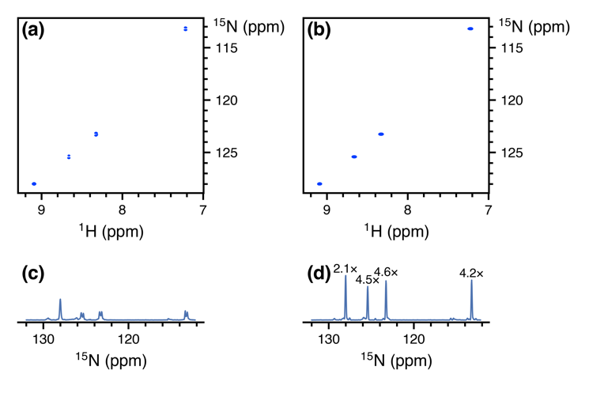
Figure 3. Comparison of the ¹⁵N–¹H seHSQC module (S⁺_{N}) with the standard NOAH HMQC module (M), taken from NOAH-3 XS⁺₂C^{c} supersequences (¹⁵N experiment + ¹³C ZIP-seHSQC + CLIP-COSY). The ¹⁵N S⁺₁ module is not included here as it causes line broadening downstream modules (see text). (a) ¹⁵N HMQC spectrum. (b) ¹⁵N seHSQC spectrum. (c) Projection of HMQC onto the f₁ axis. Splitting due to J_{HH} is clearly visible for three of the four peaks. (d) Projection of seHSQC onto the f₁ axis. Signal-to-noise improvements relative to the HMQC spectrum are indicated over each peak. The largest gains are observed for peaks where the multiplet structure is collapsed; however, even in the absence of that, a ~2× gain is still obtained. Spectra were obtained on a 700 MHz Bruker AV III equipped with a TCI H/C/N cryoprobe; the sample used was 40 mM gramicidin in DMSO-d₆.
Although the S and S⁺₁ modules also provide sensitivity gains versus the HMQC, they both come with other drawbacks. As previously discussed, these two modules place bulk ¹H^{!N} magnetisation in the xy-plane during the t₁ period. Consequently, the amount of bulk magnetisation that is retained decreases as t₁ is lengthened, leading to line broadening in the indirect dimensions of all downstream modules (Figure S11). Whilst this is not a problem with the ¹³C HSQC where typical ¹³C indirect dimension acquisition times are relatively short, the smaller spectral widths in ¹⁵N experiments can mean downstream modules suffer moderate losses in both sensitivity and resolution. The S⁺₂ module avoids this issue entirely, making it especially well-suited to obtaining ¹⁵N correlations; we henceforth refer to it as the S⁺_{N} module.
One remaining potential issue in the S⁺_{N} module arises from the cumulative effects of pulse imperfections, which cause a portion of bulk ¹H^{!N} magnetisation to be transverse just prior to detection of the seHSQC signal. Although this only represents a small fraction of the bulk magnetisation, if left uncontrolled, the resulting artefacts typically have intensities that are comparable to the seHSQC crosspeaks (Figure S12). The key to suppressing these artefacts efficiently lies in the final CTP gradient g₂ (Figure 1d), which dephases any transverse bulk magnetisation. The S⁺_{N} module therefore greatly benefits from having two CTP gradients g₁ within the t₁ period, as this means that g₂ will have twice its usual amplitude. For optimal performance, however, one further modification proves beneficial: the CTP gradients g₁ and g₂ should all be lengthened from their typical duration of 1 ms, in order to provide more effective dephasing. In practice, we find that gradient durations of 2 to 2.5 ms provide excellent artefact suppression whilst not causing any appreciable difference in the intensity of the desired crosspeaks (Figure S12). These extended gradients are not required in the ¹³C seHSQC for two reasons: firstly, the amplitude of g₂ in the 13C seHSQC is larger by a factor of γ_{C}/γ_{N} ≈ 2.5; and secondly, the greater natural abundance of ¹³C (1.1% versus 0.36% of ¹⁵N) leads to an intrinsically larger signal intensity, which makes any residual artefacts less apparent.
In scenarios where high resolution in the ¹⁵N dimension is not required, it can prove useful to reduce the number of t₁ increments and in its place increase the number of transients acquired.^{[3d,3e]} In new versions of the NOAH pulse programmes (including those provided in the Supporting Information), this feature can be enabled by specifying a factor k by which to perform this scaling. Note that the scaling is only applied to the ¹⁵N module; all other modules are left untouched. In our hands, setting k = 2 or 4 for the original ¹⁵N HMQC can lead to significant sensitivity gains of up to ~2×, since J_{HH} splitting in the indirect dimension tends not to be resolved (Figure S13). This point is not relevant to the seHSQC, and here k-scaling employed in isolation has only a tiny effect on peak height (and signal-to-noise), since any sensitivity gained from the extra transients is typically offset by the broadening (Figure S14). However, the later t₁ increments which were not acquired can be reconstructed using linear projection^{[16]} to mitigate this line broadening. The resulting spectra display sensitivity gains of up to a factor of k, although the fidelity of the reconstruction can suffer for large k, particularly with the HMQC (Figures S15 and S16).
Next, we note that the HSQC module (though not the new seHSQC modules) allows an arbitrary amount of ¹H^{C} magnetisation to be excited, with the remainder returned to +z.^{[1b,1d,1e,1f]} In order to excite a proportion f of ¹H^{C} magnetisation (0 < f ≤ 1), the initial INEPT delay must be shortened by a factor of sin⁻¹ f (Figure 4a). The remaining (1 − f) of the magnetisation, plus any that relaxes during the HSQC FID, can then be used for a second HSQC-based module in the same supersequence. Such a scheme proves to be useful for simultaneously collecting ¹³C-decoupled and coupled HSQC spectra, or HSQC spectra with different spectral widths. This has previously been accomplished in a multi-FID acquisition (MFA) scheme by keeping the two CTPs in the CRK seHSQC separate, with the cosine- and sine-modulated CTPs each contributing to one spectrum.^{[17]} With the present NOAH strategy, for values of f that are close to 1, the amount of ¹H^{C} magnetisation regained through relaxation can reach almost 50%. Consequently, by setting f ≈ 0.8, we can obtain two HSQC spectra with sensitivities that are comparable to the existing MFA approach. Furthermore, the sensitivity of the second HSQC can be boosted by using the new seHSQC modules in its place, in particular the S⁺₂ module (Figure S17).
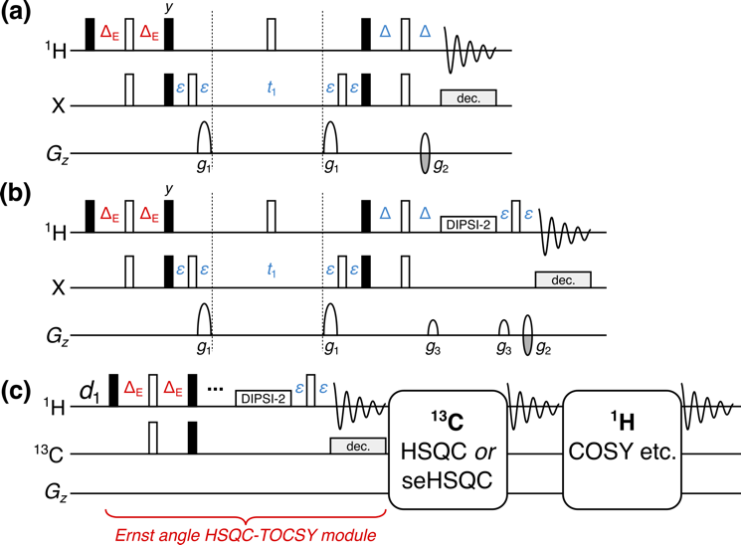
Figure 4. (a) NOAH HSQC module with modified INEPT delay Δ_{E} = (sin⁻¹ f)/(4·¹J_{CH}), where f is the fraction of ¹H^{C} magnetisation excited. (b) NOAH HSQC-TOCSY module (“S^{T}”), modified from the ASAP-HSQC-TOCSY.^{[1g]} The gradients g₃ are 1 ms long, and are set to 19% of the maximum gradient amplitude. (c) Overview of a NOAH-3 S^{T}SX or S^{T}S⁺X supersequence. The ¹H^{C} magnetisation is partly used by the initial HSQC-TOCSY module, with a subsequent HSQC or seHSQC using the remaining ¹H^{C} magnetisation. The bulk ¹H^{!C} magnetisation is retained for one or more homonuclear modules at the end. All other symbols have the same meanings as in Figure 1.
By adding a period of isotropic mixing prior to detection, the NOAH HSQC module may be converted to a HSQC-TOCSY module (denoted by “S^{T}”, Figure 4b). This is similar to the previously reported ASAP-HSQC-TOCSY,^{[1g]} the key difference being that in the present NOAH context, unused ¹H^{C} as well as bulk ¹H^{!C} magnetisation is preserved for use in other modules, instead of later t₁ increments as in the ASAP experiment. Compared to the existing MFA HSQC-TOCSY/HSQC experiment,^{[17a]} our approach has several characteristics which make it particularly amenable to use in NOAH supersequences. Firstly, the vast majority of ¹H^{!C} magnetisation is preserved, as required for homonuclear module(s) to be appended in a NOAH supersequence (Figure 4c); in practice, we observe small ¹H^{!C} losses of ca. 10% due to pulse imperfections. In contrast, the MFA sequence, much like the original CRK seHSQC on which it is based, dephases ¹H^{!C} magnetisation and causes a 80–90% sensitivity loss in downstream spectra. Secondly, since each NOAH module is independently executed, the NOAH approach allows multiplicity editing to be selectively enabled for only the HSQC and not the HSQC-TOCSY, where accidental overlap may lead to crosspeaks being lost unexpectedly. Lastly, the sensitivity of both spectra in a NOAH experiment can be optimised through the value of f; this allows a larger amount of ¹H^{C} magnetisation to be used for the inherently less sensitive HSQC-TOCSY. In our experience, setting f = 0.9 provides a good balance for S^{T}S combinations: the sensitivity in the HSQC is boosted not only by relaxation during the HSQC-TOCSY FID, but also by the isotropic mixing in the HSQC-TOCSY module, which effects a degree of ¹H^{!C} → ¹H^{C} polarisation transfer (Figure S18). Alternatively, the signal intensity of the HSQC-TOCSY can be maximised by replacing it with the seHSQC-TOCSY module, derived from the S⁺₂ module.^{[14]} The sole drawback of the seHSQC-TOCSY is that it does not allow for variable ¹H^{C} excitation and therefore cannot preserve any magnetisation for HSQC modules that follow it (Figure S19).
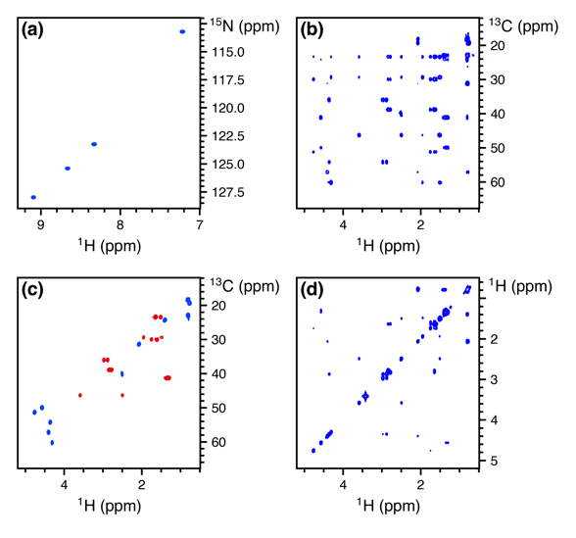
Figure 5. Spectra obtained from the NOAH-4 S⁺_{N}S^{T}S⁺₂C^{c} supersequence. 256 t₁ increments were used, with 2 scans per increment. The total experiment time was 17 minutes and 35 seconds. (a) ¹⁵N seHSQC. (b) ¹³C HSQC-TOCSY (30 ms mixing, f = 0.9). (c) Multiplicity-edited ¹³C ZIP-seHSQC. Notice that having the edited seHSQC removes the need for the less desirable HSQC-TOCSY editing. (d) CLIP-COSY. Spectra were obtained on a 700 MHz Bruker AV III equipped with a TCI H/C/N cryoprobe; the sample used was 40 mM gramicidin (a cyclic decapeptide; (Val–Orn–Leu–D-Phe–Pro)₂) in DMSO-d₆.
There exist many ways in which the new modules discussed above can be included in practical experiments for structure characterisation. Here, we illustrate this with the NOAH-4 S⁺_{N}S^{T}S⁺₂C^{c} (¹⁵N seHSQC, ¹³C HSQC-TOCSY, ¹³C seHSQC, and CLIP-COSY) supersequence (Figure 5). While individual collection of the four spectra above required 57 minutes and 8 seconds, the NOAH-4 supersequence took only 17 minutes and 35 seconds; this is 30.8% of the original duration, or equivalently a 3.25× speedup. For typical organic molecules, new supersequences such as the NOAH-4 S^{T}S⁺₂CT allow the rapid and complete collection of C–H and H–H correlations (Figure S20). Experiment times can be further reduced through the use of non-uniform sampling^{[18]} (Figure S21), which is compatible with nearly all of the supersequences shown here (the only exceptions being when k-scaling is employed in ¹⁵N modules, or when COSY modules are recorded without phase-sensitive detection). One can also prepend the NOAH zz-HMBC module (“B”);^{[6d]} this uses the semi-adiabatic zz-filter to preserve both ¹H^{C} and ¹H^{N} magnetisation, which can then be sampled in the HSQC-based modules presented here (Figure S22).
The benefits of the time savings afforded by NOAH supersequences are manifold. Apart from the enabling of greatly increased sample throughput, the combination of multiple modules in a single experiment also ensures that all constituent spectra are recorded under the same experimental conditions, such as temperature. This avoids the need for separate chemical shift referencing in each spectrum, and also makes the real-time monitoring and characterisation of reactive intermediates possible, especially when combined with non-uniform sampling. It is also of note that time savings may be directly translated into increases in sensitivity per unit time. The relative sensitivity per unit time, ε_{t}, of a given module is the product of an amplitude factor R_{S} indicating the intrinsic sensitivity of a module with respect to a reference experiment, and the square root of a time-saving factor ρ_{t}, which reflects the decrease in time needed for collection of all spectra.
We demonstrate this with the NOAH-4 S⁺_{N}S⁺₂CT supersequence (experimental time of 17 minutes and 28 seconds), choosing individually acquired versions of the four constituent modules as the reference spectra (total experimental time of 58 minutes and 42 seconds), which gives ρ_{t} = 3.36. The amplitude factor R_{S} starts off at 1 for the first module, with a slight decrease as the supersequence progresses due to imperfections in magnetisation preservation. Nevertheless, ε_{t} remains well above 1 for all four modules (Figure 6), which clearly illustrates the attainable gains in sensitivity per unit time in NOAH sequences where R_{S} is not significantly compromised: this is especially important for the heteronuclear modules which are naturally less sensitive. Comparisons against “standard” experiments (such as the CRK seHSQC) lead to similar conclusions (Figure S23).
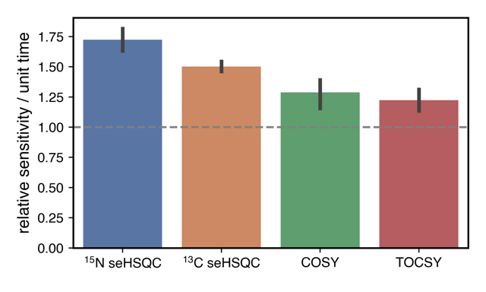
Figure 6. Relative sensitivities per unit time (ε_{t}) for the four modules in the S⁺_{N}S⁺₂CT supersequence (using a TOCSY mixing time of 35 ms). Error bars indicate 95% confidence intervals. The four NOAH modules, individually acquired, were used as the reference spectra (ρ_{t} = 3.36). Spectra were obtained on a 700 MHz Bruker AV III equipped with a TCI H/C/N cryoprobe; the sample used was 50 mM zolmitriptan in DMSO-d₆.
Conclusion
The new seHSQC and HSQC-TOCSY implementations add to the preexisting variety of NOAH modules, expanding the number of plausible NOAH supersequences tailored for small molecule characterisation. The controlled manipulation of all proton magnetisation reservoirs present within a sample is required for the success of these modules within nested experiments. We have demonstrated the optimisation of the individual HSQC-based modules and their combinations to further enhance the diversity of NOAH supersequences for efficient data collection.
Experimental Section
All spectra were recorded on a Bruker AV III NMR spectrometer operating at 700 MHz ¹H frequency equipped with a TCI H/C/N cryoprobe. Unless otherwise specified, spectra were recorded with 16 dummy scans, 2 scans per t₁ increment, 256 t₁ increments per module, and a 1.5 s recovery delay. 1024 points were recorded in each FID, leading to an acquisition time of 60.8–73.1ms depending on the ¹H spectral width (10–12 ppm). The delays in the HSQC sequences were optimised for ¹J_{CH} = 145 Hz and ¹J_{NH} = 90 Hz respectively, and the CLIP-COSY mixing delay (denoted by Δ in the original work^{[12]}) was set to 16.7 ms, corresponding to a nominal J_{HH} value of 30 Hz). DIPSI-2 mixing in the HSQC-TOCSY and TOCSY was applied with a B₁ amplitude of 10 kHz.
All NOAH data were processed using the splitx_au AU programme, available in the standard Bruker TopSpin software, which separates the individual modules into different datasets; these were then individually processed with noah_EXPT AU programmes, which define other processing parameters such as window functions. All datasets were linear predicted up to 512 complex points in f₁, then zero-filled to 1024 and 2048 complex points in f₁ and f₂ respectively. NUS experiments, such as that in Figure S21, can be set up using a new noah_nus2.py Python script. The pulse sequences used here, all AU processing scripts, as well as the NUS Python script are available from the authors upon request, and will also be made available via the online Bruker User Library.
Acknowledgements
J.R.J.Y. thanks the Clarendon Fund (University of Oxford) and the EPSRC Centre for Doctoral Training in Synthesis for Biology and Medicine (EP/L015838/1) for a studentship, generously supported by AstraZeneca, Diamond Light Source, Defence Science and Technology Laboratory, Evotec, GlaxoSmithKline, Janssen, Novartis, Pfizer, Syngenta, Takeda, UCB, and Vertex. Other acknowledgements?
Keywords: NMR spectroscopy • Analytical methods • keyword 3 • keyword 4 • keyword 5
[1] a) P. Schanda, Ē. Kupče, B. Brutscher, J. Biomol. NMR 2005, 33, 199–211; b) Ē. Kupče, R. Freeman, Magn. Reson. Chem. 2007, 45, 2–4; c) J. Furrer, Chem. Commun. 2010, 46, 3396–3398; d) D. Schulze-Sünninghausen, J. Becker, B. Luy, J. Am. Chem. Soc. 2014, 136, 1242–1245; e) D. Schulze-Sünninghausen, J. Becker, M. R. M. Koos, B. Luy, J. Magn. Reson. 2017, 281, 151–161; f) M. R. M. Koos, B. Luy, J. Magn. Reson. 2019, 300, 61–75; g) J. Becker, M. R. M. Koos, D. Schulze-Sünninghausen, B. Luy, J. Magn. Reson. 2019, 300, 76–83.
[2] a) L. Frydman, T. Scherf, A. Lupulescu, Proc. Natl. Acad. Sci. U. S. A. 2002, 99, 15858–15862; b) P. Pelupessy, J. Am. Chem. Soc. 2003, 125, 12345–12350; c) L. Frydman, A. Lupulescu, T. Scherf, J. Am. Chem. Soc. 2003, 125, 9204–9217; d) M. Gal, M. Mishkovsky, L. Frydman, J. Am. Chem. Soc. 2006, 128, 951–956; e) P. Giraudeau, Y. Shrot, L. Frydman, J. Am. Chem. Soc. 2009, 131, 13902–13903; f) A. Herrera, E. Fernández-Valle, R. Martínez-Álvarez, D. Molero, Z. D. Pardo, E. Sáez, M. Gal, Angew. Chem. Int. Ed. 2009, 48, 6274–6277; g) Z. D. Pardo, G. L. Olsen, M. E. Fernández-Valle, L. Frydman, R. Martínez-Álvarez, A. Herrera, J. Am. Chem. Soc. 2012, 134, 2706–2715; h) K. J. Donovan, Ē. Kupče, L. Frydman, Angew. Chem. Int. Ed. 2013, 52, 4152–4155; i) J.-N. Dumez, Prog. Nucl. Magn. Reson. Spectrosc. 2018, 109, 101–134; j) B. Gouilleux, L. Rouger, P. Giraudeau, Annu. Rep. NMR Spectrosc. 2018, 75–144.
[3] a) M. Sattler, M. Maurer, J. Schleucher, C. Griesinger, J. Biomol. NMR 1995, 5, 97–102; b) P. Nolis, M. Pérez, T. Parella, Magn. Reson. Chem. 2006, 44, 1031–1036; c) P. Nolis, M. Pérez-Trujillo, T. Parella, Angew. Chem. Int. Ed. 2007, 46, 7495–7497; d) M. Pérez-Trujillo, P. Nolis, W. Bermel, T. Parella, Magn. Reson. Chem. 2007, 45, 325–329; e) T. Parella, P. Nolis, Concepts Magn. Reson. 2010, 36A, 1–23; f) P. Nolis, K. Motiram-Corral, M. Pérez-Trujillo, T. Parella, J. Magn. Reson. 2019, 298, 23–30.
[4] a) Ē. Kupče, R. Freeman, B. K. John, J. Am. Chem. Soc. 2006, 128, 9606–9607; b) Ē. Kupče, R. Freeman, J. Am. Chem. Soc. 2008, 130, 10788–10792; c) Ē. Kupče, R. Freeman, J. Magn. Reson. 2010, 206, 147–153; d) Ē. Kupče, R. Freeman, Magn. Reson. Chem. 2010, 48, 333–336; e) S. M. Pudakalakatti, A. Dubey, G. Jaipuria, U. Shubhashree, S. K. Adiga, D. Moskau, H. S. Atreya, J. Biomol. NMR 2014, 58, 165–173; f) S. M. Pudakalakatti, A. Dubey, H. S. Atreya, J. Chem. Sci. 2015, 127, 1091–1097; g) H. Kovacs, Ē. Kupče, Magn. Reson. Chem. 2016, 54, 544–560.
[5] a) K. Motiram-Corral, M. Pérez-Trujillo, P. Nolis, T. Parella, Chem. Commun. 2018, 54, 13507–13510; b) V. M. R. Kakita, K. Rachineni, M. Bopardikar, R. V. Hosur, J. Magn. Reson. 2018, 297, 108–112; c) T. M. Nagy, T. Gyöngyösi, K. E. Kövér, O. W. Sørensen, Chem. Commun. 2019, 55, 12208–12211; d) P. Nolis, K. Motiram-Corral, M. Pérez-Trujillo, T. Parella, ChemPhysChem 2019, 20, 356–360; e) P. Nolis, K. Motiram-Corral, M. Pérez-Trujillo, T. Parella, J. Magn. Reson. 2019, 298, 23–30; f) P. Nolis, T. Parella, Magn. Reson. Chem. 2019, 57, S85–S94; g) V. M. R. Kakita, R. V. Hosur, RSC Adv. 2020, 10, 21174–21179; h) T. M. Nagy, K. E. Kövér, O. W. Sørensen, J. Magn. Reson. 2020, 316, 106767.
[6] a) Ē. Kupče, T. D. W. Claridge, Angew. Chem. Int. Ed. 2017, 56, 11779–11783; b) Ē. Kupče, T. D. W. Claridge, Chem. Commun. 2018, 54, 7139–7142; c) T. D. W. Claridge, M. Mayzel, Ē. Kupče, Magn. Reson. Chem. 2019, 57, 946–952; d) Ē. Kupče, T. D. W. Claridge, J. Magn. Reson. 2019, 307, 106568.
[7] a) T. D. W. Claridge, High-Resolution NMR Techniques in Organic Chemistry, 3rd ed., Elsevier, Amsterdam, 2016; b) J. Cavanagh, Protein NMR Spectroscopy: Principles and Practice, 2nd ed., Academic Press, Burlington, Mass., 2007.
[8] a) J. R. Garbow, D. P. Weitekamp, A. Pines, Chem. Phys. Lett. 1982, 93, 504–509; b) S. Wimperis, R. Freeman, J. Magn. Reson. 1984, 58, 348–353; c) D. Uhrin, T. Liptaj, K. E. Kövér, J. Magn. Reson. 1993, 101, 41–46; d) J. Briand, O. W. Sørensen, J. Magn. Reson. 1997, 125, 202–206; e) J. Briand, O. W. Sørensen, J. Magn. Reson. 1998, 135, 44–49.
[9] J. Orts, A. D. Gossert, Methods 2018, 138–139, 3–25.
[10] a) A. G. Palmer, J. Cavanagh, P. E. Wright, M. Rance, J. Magn. Reson. 1991, 93, 151–170; b) L. Kay, P. Keifer, T. Saarinen, J. Am. Chem. Soc. 1992, 114, 10663–10665.
[11] a) J. Cavanagh, M. Rance, J. Magn. Reson. 1990, 88, 72–85; b) J. Cavanagh, M. Rance, Annu. Rep. NMR Spectrosc. 1993, 27, 1–58.
[12] M. R. M. Koos, G. Kummerlöwe, L. Kaltschnee, C. M. Thiele, B. Luy, Angew. Chem. Int. Ed. 2016, 55, 7655–7659.
[13] a) J. Schleucher, M. Schwendinger, M. Sattler, P. Schmidt, O. Schedletzky, S. J. Glaser, O. W. Sørensen, C. Griesinger, J. Biomol. NMR 1994, 4, 301–306; b) G. Kontaxis, J. Stonehouse, E. D. Laue, J. Keeler, J. Magn. Reson. 1994, 111, 70–76.
[14] A. L. Hansen, Ē. Kupče, D.-W. Li, L. Bruschweiler-Li, C. Wang, R. Brüschweiler, “2D NMR-based Metabolomics with HSQC/TOCSY NOAH Supersequences”, submitted for publication, 2021.
[15] T. Parella, F. Sánchez-Ferrando, A. Virgili, J. Magn. Reson. 1997, 126, 274–277.
[16] a) D. Tufts, R. Kumaresan, IEEE Trans. Acoust. Speech Signal Process. 1982, 30, 671–675; b) P. Koehl, Prog. Nucl. Magn. Reson. Spectrosc. 1999, 34, 257–299.
[17] a) P. Nolis, K. Motiram-Corral, M. Pérez-Trujillo, T. Parella, ChemPhysChem 2019, 20, 356–360; b) P. Nolis, K. Motiram-Corral, M. Pérez-Trujillo, T. Parella, J. Magn. Reson. 2019, 298, 23–30.
[18] a) K. Kazimierczuk, J. Stanek, A. Zawadzka-Kazimierczuk, W. Koźmiński, Prog. Nucl. Magn. Reson. Spectrosc. 2010, 57, 420–434; b) M. Mobli, J. C. Hoch, Prog. Nucl. Magn. Reson. Spectrosc. 2014, 83, 21–41; c) K. Kazimierczuk, V. Orekhov, Magn. Reson. Chem. 2015, 53, 921–926; d) D. Gołowicz, P. Kasprzak, V. Orekhov, K. Kazimierczuk, Prog. Nucl. Magn. Reson. Spectrosc. 2020, 116, 40–55.

Entry for the Table of Contents

Insert graphic for Table of Contents here. ((Please ensure your graphic is in one of following formats))
((max. width: 5.5 cm; max. height: 5.0 cm))

Please delete this box prior to submission
((max. width: 11.5 cm; max. height: 2.5 cm))

Please delete this box prior to submission

Insert text for Table of Contents here. ((The Table of Contents text should give readers a short preview of the main theme of the research and results included in the paper to attract their attention into reading the paper in full. The Table of Contents text should be different from the abstract and should be no more than 450 characters including spaces.))
Institute and/or researcher Twitter usernames: ((optional))

