Multivariate Lesion-Symptom Mapping Using Support Vector Regression
(SVR-LSM) toolbox
(August 9, 2014)

Yongsheng Zhang
Perelman School of Medicine,
University of Pennsylvania
yozhang@mail.med.upenn.edu
yongsheng.zhang.cn@gmail.com@gmail.com

Contents
1. Introduction 3
1.1 Theory and background 3
1.2 Software and hardware requirement 3
1.3 Image format 3
1.4 License 4
2. Download and setup 5
2.1 Download SVR-LSM toolbox 5
2.2 Setup SVR-LSM toolbox 5
2.2.1 Unzip SVR-LSM toolbox 5
2.2.2 Setup working directories and parameters 5
2.3 Compile libsvm 7
3. Runtime screen information 8
4. Output results 9
4.1 output directories structure 9
4.2 Analysis reports 10
4.2.1 Report for beta-map with AAL atlas 11
4.2.2 Report for beta-map with Brodmann atlas 11
4.2.1 Report for permutation test p-map with AAL atlas 12
4.2.4 Report for Brodmann atlas 12
5. Acknowledgement 12

1. Introduction

1.1 Theory and background
Lesion analysis is a classic approach to study brain functions. Because brain function is a result of coherent activations of a collection of functionally related voxels, lesion-symptom relations are generally contributed by multiple voxels simultaneously. Although voxel-based lesion-symptom mapping (VLSM) has made substantial contributions to the understanding of brain-behavior relationships, a better understanding of the brain-behavior relationship contributed by multiple brain regions needs a multivariate lesion-symptom mapping (MLSM). The purpose of this artilce was to develop an MLSM using a machine learning-based multivariate regression algorithm: support vector regression (SVR). In the proposed SVR-LSM, the symptom relation to the entire lesion map as opposed to each isolated voxel is modeled using a nonlinear function, so the intervoxel correlations are intrinsically considered, resulting in a potentially more sensitive way to examine lesion-symptom relationships.
Please refer to the following paper for detailed information about the SVR-LSM method:
Yongsheng Zhang, Daniel Y. Kimberg, H. Branch Coslett, Myrna F. Schwartz, Ze Wang, "Multivariate Lesion-Symptom Mapping Using Support Vector Regression", Human Brain Mapping, 2014.

1.2 Software and hardware requirement
Software
- MATLAB (The MathWork, Inc., Natick, MA), version 7.12 or higher;
- SPM (Wellcome Institute of Imaging Neuroscience, London, UK), version SPM8 or SPM12b
- libSVM(http://www.csie.ntu.edu.tw/~cjlin/libsvm/), version 3.18
Hardware
Depending on the dimension and number of lesion images, the toolbox may require large memory to run smoothly. For 100 lesion image with dimension of 181x217x181, about 1GB free memory space is required.

1.3 Image format
The lesion image for each subject should be stored in a 3D NIfTI file with value ‘1’ representing the lesion regions. The file name should be the subject’s registry code.
The behavioral scores should be stored in a “.csv” file with each column represents one score. The first row stores the name of score.

1.4 License
The University of Pennsylvania reserves all rights regarding SVR-LSM toolbox. SVR-LSM toolbox is free for academic users. You can redistribute it and/or modify it under the terms of the GNU General Public Licenses as published by the Free Software Foundation, either version 3 or later.
SVR-LSM toolbox is distributed in the hope that it will be useful, but WITHOUT any warranty; without even the implied warranty of MERCHANTABILITY or fitness for a particular purpose. See the GNU General Public License for more details.
You should have received a copy of the GNU General Public Licnese along with SVR-LSM toolbox. If not, see http://www.gnu.org/licenses/

2. Download and setup

2.1 Download SVR-LSM toolbox
SVR-LSM toolbox can be request from authors’ email address (Yongsheng.zhang.cn@gmail.com, zewang@mail.med.upenn.edu).

2.2 Setup SVR-LSM toolbox

2.2.1 Unzip SVR-LSM toolbox
Extract the zip file to a directory, for example, “/home/yongsheng/LesionAnalysis”, the main script for the toolbox will be located at “/home/yongsheng/LesionAnalysis/SVR_LSM_toolbox/SVR_LSM_toolbox.m”.

2.2.2 Setup working directories and parameters
The working parameters and directories should be specified at the beginning of the main script “SVR_LSM_toolbox.m”.

Setup working directories
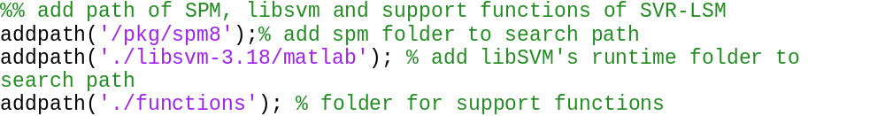
Temporary adding path of the SPM directory, libSVM directory and the SVR-LSM functions directory to the searching directories of Matlab.

Setup parameters
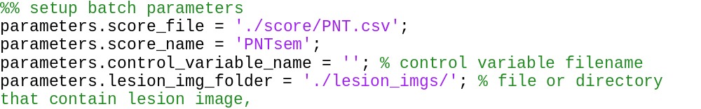
parameters.score_file contains all the scores that may be used in analysis. It should be scored in a “.csv” file with the following format; where the first column is the Registry code of each subject (each subject should use the SAME registry code as the lesion image filename), each other columns represent one behavioral score.
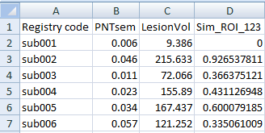
parameters.score_name is the name of the behavior score, i.e., the first row of the column of interest.
parameters.control_variable_name is the variable that need be regressed out from the behavior score. Usually, it is the total lesion volume to control the total lesion volume effect. It should be leave blank, as shown in the above example, if no variable will be controlled in the analysis.
Parameters.lesion_img_folder indicates the location where the lesion images are stored. Each subject’s lesion image should be stored in a separate file with the registry code as the filename. The registry codes must match with that in parameters.score_file.

parameters.cost and parameters.gamma are two parameters for SVR with RBF kernel. Different parameters can produce results with different smoothness. The parameters we used in our paper is cost = 30 and gamma = 5 for real behavior score, and cost = 30 and gamma = 2 for simulation score.

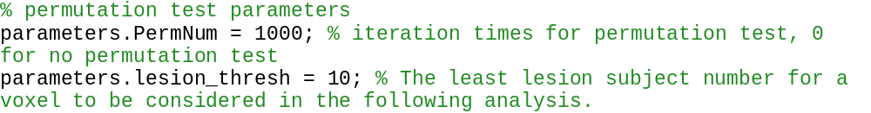
parameters.PermNum sets the iteration times in the permutation analysis. No permutation analysis will be performed if it is set to 0.
Parameters.lesion_thresh defines the minimum number of subjects with lesion at a voxel. Voxels with less lesion subjects than this number will not be included in the following analysis.

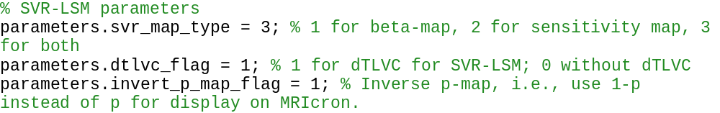
parameters.svr_map_type indicates the type of SVR map that will be generated: 1 for only generating beta-map only using the method in our Zhang et al. 2014 paper; 2 for only generating the sensitivity-map using Rasmussen et al. 2011’s method; 3 for generating both the beta-map and sensitivity map.
parameters.dtlvc_flag defines whether the direct total lesion volume control (dTLVC) will be used in the analysis, 1 for performing dTLVC in the analysis, 0 for not.
Note: dTLVC and the regressing variable specified in parameters.control_variable_name should not be used in the same analysis. Since they are both total lesion volume control methods, the total lesion volume effect will be over-corrected if both of them were performed in a same analysis.
parameters.invert_p_map_flag will flip the p-map from permutation test, i.e., p-value of 0.05 will be changed to 0.95 for the purpose of display. Since it is inconvenient to show voxels with value less than a threshold in some software, e.g., MRcroN, we offer this option. If you are using some software that can easily show voxels with value between 0 and 0.05, you can set it to 0, then what you get is a normal p-map.

The following two parameters are used to generate a quantitative analysis report for the SVR-LSM results.
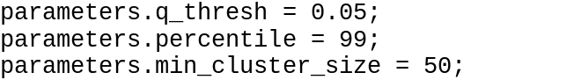
parameters.q_thresh is the FDR threshold for permutation analysis result.
parameters.percentile is the threshold for beta-map and/or sensitivity-map. The value is the percentile of voxels with number of lesion subjects no less than the predefined value parameters.lesion_thresh. Value 99 in the example means we are interested in the top 1% voxels.
parameters.min_cluster_size defines the minimum cluster size after thresholding, all isolated small clusters with less voxels than this threshold will be discarded.

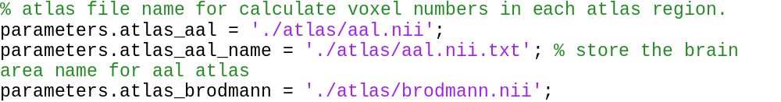
parameters.atlas_aal, parameters.atlas_aal_name and parameters.atlas_brodmann specify the location of atlas files used to generate an analysis report. Detailed information about the generated analysis report will be explained in Section 4. The dimension of the atlases come along with the toolbox is 181x217x181. Please make sure the dimension of the lesion image is identical to the dimension of the atlases, otherwise, the analysis report will be erroneous.

2.3 Compile libsvm
To compile libsvm, please go to directory “./libsvm-3.18/matlab” and type “make” in Matlab command window. More details please refer to file “./libsvm-3.18/matlab/README”.

2.4 Simulation
ROIs used to generate the pseudo-score for simulation analysis are stored in file “./atlas/ SimulationROIs.nii”.

3. Runtime screen information
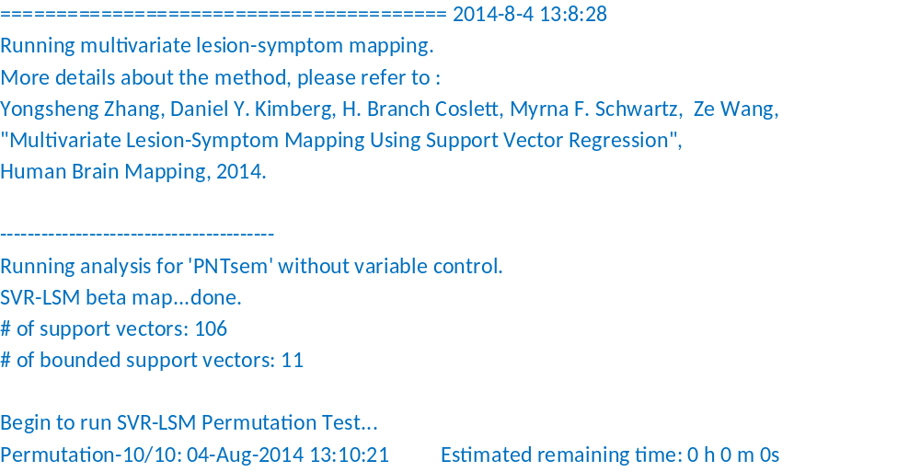
Above is an example of the runtime screen output of the toolbox.
First line is the current time, and a folder with the name of current date will be created to store all the output files. After that is the paper related to this toolbox. More information and analysis can be found in this paper.
When producing the SVR-LSM beta-map, the number of support vectors and the number of bounded support vectors are also shown.
During the permutation test, the estimated remaining time is also shown.

4. Output results

4.1 output directories structure
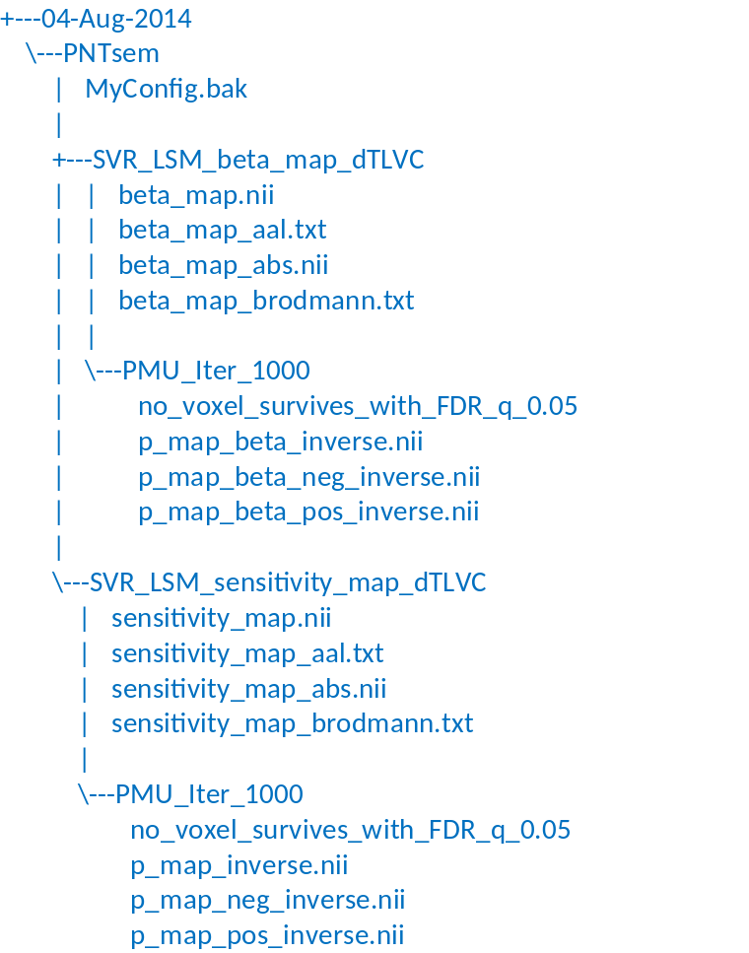
All the output files are under the directory named with the date when the script was run, “04-Aug-2014” in this example. Within this directory, a directory named with the score name is also created to differentiate results from different scores.
Within the directory named after the score name, a file named by “MyConfig.bak” will be created. It is a copy of the main script “SVR_LSM_toolbox.m” for your current run. It is saved here for your future reference. One or two directories with name starting with “SVR_LSM_” will be created according to the setting of parameters.svr_map_type. The created directory is named with the SVR-map type (beta-map or sensitivity-map) and the selected total lesion volume control method (either “Ctrl_”+parameters.control_var_name, or “dTLVC”) to separate different settings. For example, directory name “SVR_LSM_beta_map_dTLVC” means that this directory contains results of SVR beta-map with direct total lesion volume control.
Within the directory of each SVR-map type (e.g., “SVR_LSM_beta_map_dTLV” in this example), the SVR-map is generated with name “beta_map.nii” and “beta_map_abs.nii”, where “beta_map_abs.nii” is just the absolute value version of the “beta_map.nii”. There are also two text files named by “beta_map_aal.txt” and “beta_map_brodmann.txt”, these files contain the analysis report according to atlas AAL and Brodmann. Details about these analysis report file will be discussed in Section 4.2.
Within directory “SVR_LSM_beta_map_dTLV”, there is a subdirectory named [“PMU_Iter_” + permutation times]. For example, “PMU_Iter_1000” means results with 1000 times of permutation. Within this subdirectory, there are three NIfTI files named by “p_map_beta_inverse.nii”, “p_map_beta_neg_inverse.nii” and “p_map_beta_pos_inverse.nii”. The postfix “_inverse” means parameters.invert_p_map_flag was set to 1 to flip the permutation test results, e.g., value 0.95 in this map means p-value of 0.05. The meaning of each file is shown as follow:
“p_map_beta_inverse.nii”: the probability that the absolute value of permutation tests exceeds the absolute value in the original beta_map with the genuine ordering.
“p_map_beta_neg_inverse.nii”: for voxels in the original beta-map with negative value, the probability that the value from permutation tests is less than that from the original beta-map with the genuine ordering.
“p_map_beta_pos_inverse.nii”: for voxels in the original beta-map with positive value, the probability that the value from permutation tests is greater than that from the original beta-map with the genuine ordering.
A file named by “no_voxel_survives_with_FDR_q_0.05” will be created if no voxel survives the given FDR correction, where “0.05” is the specified FDR threshold and can be changed by changing parameters.q_thresh. When some voxels survive the FDR correction, two analysis report files are created with name “PMU_map_aal.txt” and “PMU_map_brodmann.txt”.

4.2 Analysis reports
According to configuration, analysis reports may be created for the derived beta-map and/or the significant-map, as well as their permutation test results.

4.2.1 Report for beta-map with AAL atlas
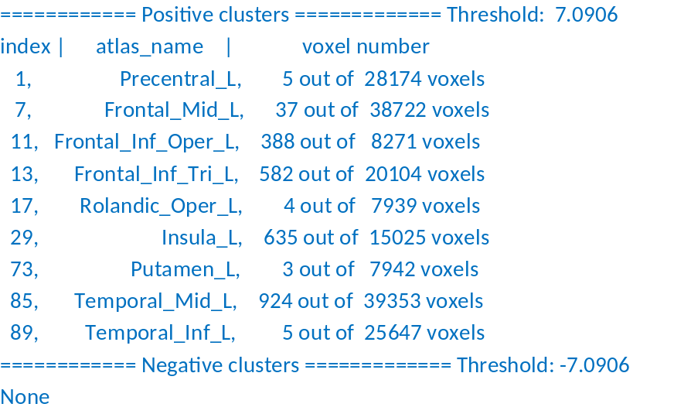
In this file, the first row shows the threshold used to generate this result. The threshold was determined according to the specific percentile in parameters.percentile. The first column are the index of atlas region, the second column are the name of the highlighted AAL regions, the third column give voxel number exceed the threshold as well as the total voxel number in each atlas region.

4.2.2 Report for beta-map with Brodmann atlas
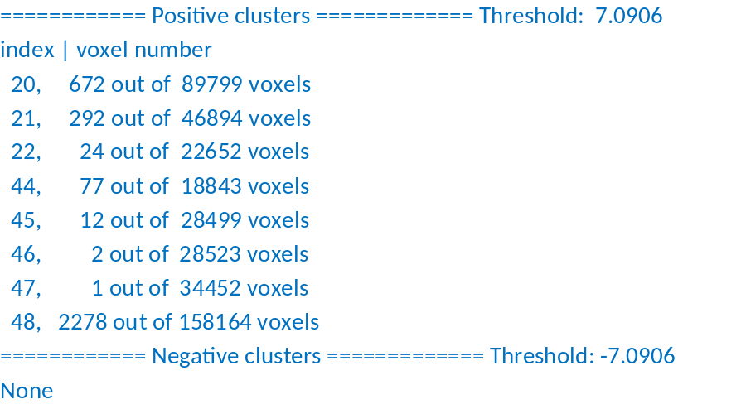
Same as in AAL report, the first row shows the threshold used to generate this result. The first column are the index of Brodmann area, the second column are voxel number exceed the threshold as well as the total voxel number in each atlas region.

4.2.1 Report for permutation test p-map with AAL atlas
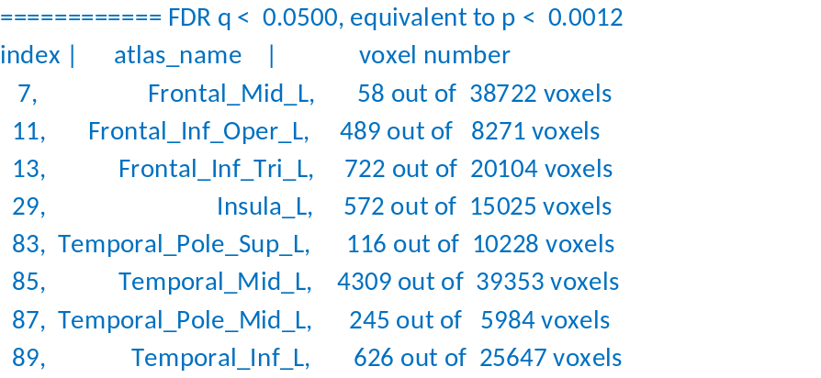
In this file, the first row shows the threshold used to generate this result. The threshold was determined according to the specific FDR parameter parameters.q_thresh for permutation test. The first column are the index of atlas region, the second column are the name of the highlighted AAL regions, the third column give voxel number exceed the threshold as well as the total voxel number in each atlas region.

4.2.4 Report for Brodmann atlas
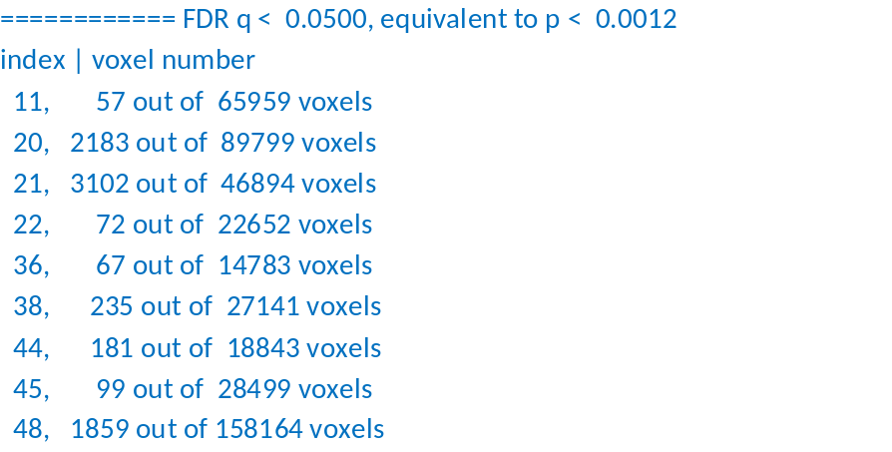
Same as in AAL report, the first row shows the threshold used to generate this result. The first column are the index of Brodmann area, the second column are voxel number exceed the threshold as well as the total voxel number in each atlas region.

5. Acknowledgement
I would thank Ze Wang, my postdoc supervisor, who has helped a lot for developing the method, experiments validation, as well as parameter training (will be included in future version). I would also thank all the coworkers, especially Myrna F. Schwartz, H. Branch Coslett, Dan Mirman and Olufunsho Faseyitan, for their comments and help during developing this toolbox as well as the journal paper.

