王詠婷
Document Name ： Weekly Report 2015/08/17-21

Progress this week: Logic design lab1
Lab1-1: Design and implement a full adder. (s+cout=x+y+cin).
1.Design Specification
(1)Specification of my design:
設計及實現加法器。
2.Design Implementation
(1) Write the logic equation:
s=x♁y♁cin & cout=(x˙y)+(y˙cin)+(x˙cin)
(2) Draw the related logic diagram:
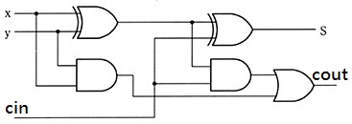
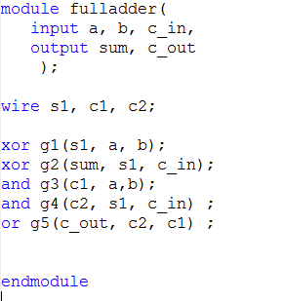
(3) Verilog RTL representation with verification:
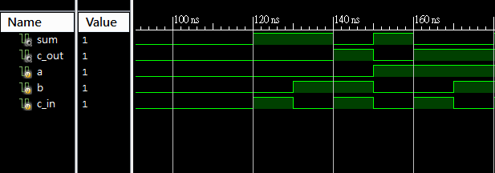

Lab1-2: Design a single digit decimal adder.
1.Design Specification
(1)Specification of my design:
設計一個十進制的加法器，input A(a3a2a1a0), B(b3b2b1b0), Cin(ci), and output S(s3s2s1s0) and Cout(co) 。
2.Design Implementation
由於，十進制數字為1-9，轉成2bit表示需要4個bits，再利用lab1_1的全加器重複四組，即可運算十進制的加法。
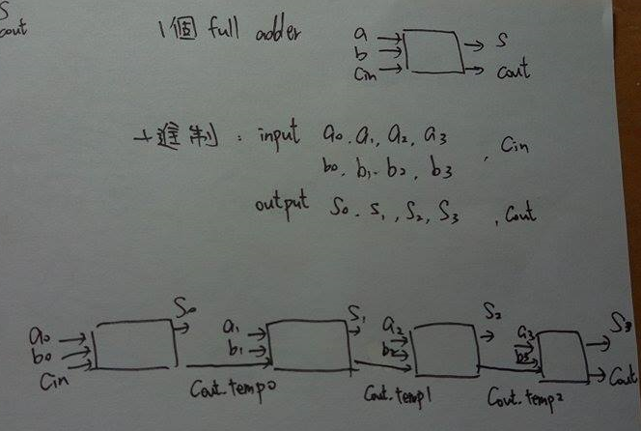
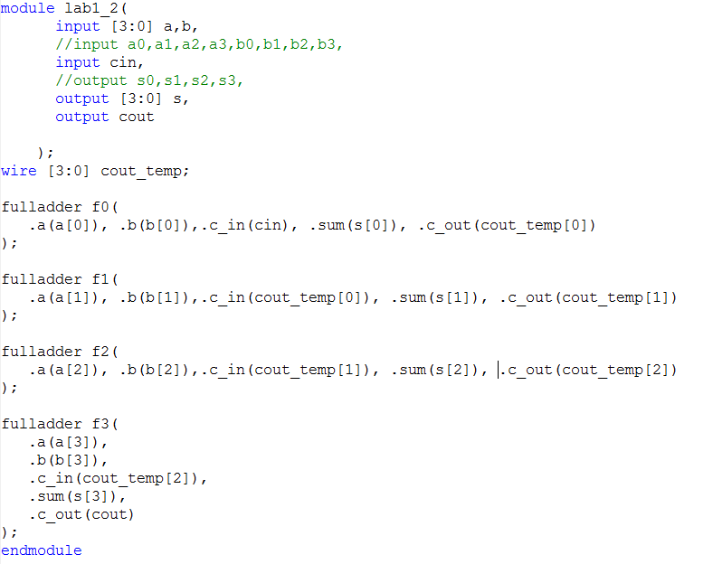
Lab1-3: Design a 2-to-4-line decoder with enable.
1.Design Specification
(1)Specification of my design:
設計一個2-to-4-line decoder，with input [1:0] in，en，and output [3:0]d。
2.Design Implementation
(1) Write the logic equation:
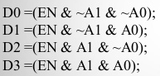
(2) Draw the related logic diagram:
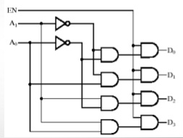
(3) Verilog RTL representation with verification:
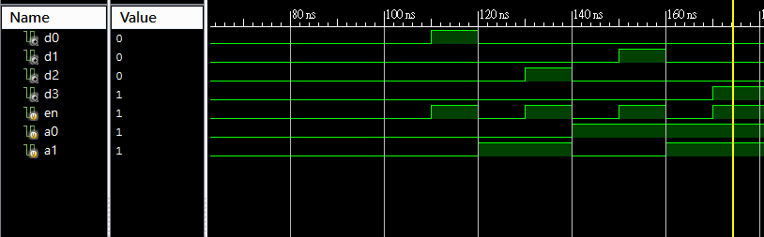
3.Discussion& Conclusion
Lab1算比較簡單，熟悉邏輯閘的使用，以及接線的處理。
4.References
[1] His-Pin Ma, “Logic Design Lab”, 2014
[2] Chih-Tsun Huang, “VLSI system design and implementation”, 2014

