Two missing sections, plus the numbering they change
Rubric items 2 (Research Background, 10 marks) and 3 (Methodology, 10 marks) had no matching section in the report. These are those sections, written for the position they should occupy.
Target structure: 1.0 Introduction · 2.0 Research Background · 3.0 Methodology · 4.0 Pseudocode · 5.0 Algorithm Analysis · 6.0 Coding · 7.0 Results · 8.0 Discussion and Conclusion · 9.0 References.
Move Figure 1 (the architecture diagram) out of the Introduction and into §3.1, where the rubric looks for it. The separate fix list covers the renumbering.

2.0 Research Background
The Part A proposal surveyed this field before anything was built. This section restates the background that bears on the system as delivered, and — where the project has since produced evidence — records which of the literature's expectations held and which did not. The second half of each subsection is the part that could not have been written before implementation.

2.1 Code-switching is not solved by language identification alone
Early work on code-switched text treated language identification as a prerequisite: tag each word's language, then route it to a monolingual model. Sitaram et al. (2020), surveying the field, expose the weakness of that pipeline — word-level identification is itself unreliable on romanised, informally spelled text, and its errors cascade. Winata et al. (2021) take the opposing position: skip explicit identification and let massively multilingual pretrained models absorb code-switching implicitly. Their models outperform monolingual ones on code-switched benchmarks while still trailing on pure-language tasks, which is evidence that pretraining alone does not close the gap. Closer to this project, Lim et al. (2021) propose a framework for Malay–English mixed-language question answering, confirming both the demand and the difficulty, but the contribution stops at framework level.
What this project found. The survey's warning held, and at a level it did not anticipate. Whisper predicts one language token per segment, which is language identification by another name, and it was the dominant error source in Stage 1 — not the acoustic model. Separating identification from transcription across two checkpoints reduced Word Error Rate from 0.398 to 0.349 (§5.4). What remains is calibration rather than deafness: the detector assigns English-dominant clips a median English probability of 0.234 against a 0.5 threshold, while still detecting English in all eight (§5.5). A cutoff that is sensible for monolingual audio is simply the wrong scale for utterances that are English sentences carrying Malay particles by design.

2.2 Malaysian resources: rule-based normalisation against regionally pretrained models
Two generations of Malaysian NLP resources coexist with complementary limitations. The Malaya toolkit (Zolkepli, 2018) offers informal-Malay normalisation that directly addresses the orthographic noise Sitaram et al. identify, but its normaliser is dictionary- and rule-driven: it handles catalogued abbreviations and cannot generalise to novel slang. Khalip et al. (2025) find that even large models degrade on noisy Malay input. The newer generation — Mesolitica's Malaysian checkpoints among them — is pretrained on regional text including Manglish, so slang is learned rather than listed; the inverse weakness is that a generative model offers no guarantee of controlled output.
What this project found. Part A planned to layer the two, cleaning input with Malaya before generation. Measurement made that untenable. 371 of 506 training inputs, 73%, contain informal rojak markers, so expanding shortforms before generation would hand the model text unlike anything it was fitted on, spending the improvement it was fine-tuned to deliver (§5.18). Stage 2 was rewritten to repair transcription errors and leave the register alone. The regionally pretrained speech checkpoint did earn its place — 0.398 against 0.447 for base Whisper at equal prompt conditions (§5.3). The regionally pretrained language model did not: on out-of-scope probes it fabricated a JPJ regulation and offered legal advice, and was rejected on that evidence (§5.11). Regional pretraining bought fluency, not control.

2.3 Chatbot architecture, and what a generative answer costs
Chen et al. (2017) set out the standard taxonomy. Rule-based systems are predictable but brittle to paraphrase, and rojak's spelling variance multiplies the pattern space past maintainability. Retrieval-based systems are controllable but robotic and cannot rephrase into the user's language mix. Generative systems are fluent and handle paraphrase, at the price of hallucination and knowledge fixed at training time. Lewis et al. (2020) reduce that price with retrieval augmentation, but reduce is not eliminate, and the added infrastructure exceeds what this assignment requires alongside speech integration.
What this project found. A fine-tuned generative model was adopted with refusal trained from 130 corpus examples rather than filtered at the output. It works, but only when measured correctly, and the correct measurement is not the one the literature reports. Both the tuned and untuned models decline roughly 82% of out-of-scope questions; the untuned one reaches that figure by declining 67% of the questions it should have answered. The quantity that describes a boundary is the gap between the two rates, and it moved from 15 percentage points to 80 (§5.16). The cost did not vanish: one out-of-scope probe in eleven still drew legal advice, the same failure that disqualified the alternative base model (§5.17).

2.4 Adapting a large model on free hardware
LoRA (Hu et al., 2021) changed the economics of adaptation by training low-rank adapters over frozen weights, and QLoRA (Dettmers et al., 2023) went further by quantising the frozen base to 4-bit while training those adapters, cutting memory requirements by roughly two-thirds at negligible quality cost. LLaMA-Factory (Zheng et al., 2024) lowered the engineering barrier again with YAML-driven configuration and native QLoRA support.
What this project found. The economics hold. A 3B-class model was adapted in 160 optimiser steps and 45 minutes on a free T4, producing a 24 MB adapter over a 6 GB base, and perplexity on the held-out split fell from 23.75 to 3.65 (§5.14). Less expected was that the standard training heuristic misleads here. Validation loss reached its minimum at step 100 and rose 13% by the end of the run, which on an ordinary supervised task means stop early. The objective was memorisation of a fixed knowledge base with no retrieval at inference, so held-out loss measures paraphrase robustness on facts already seen — a proxy, not the goal — and the behavioural check justified training on: over-refusal collapsed and fallback accuracy rose across exactly the epochs in which validation loss was deteriorating (§5.13).

2.5 Synthetic data where no corpus exists
No public Manglish dialogue corpus exists; Malaysian corpus work has concentrated on sentiment, and Shamsuddin et al. (2024) document how automated labelling of Malay–English data produces skewed and partly false labels. Model-generated instruction data (Wang et al., 2023; Taori et al., 2023) is the pragmatic alternative, and the literature is clear about its failure modes — distributional narrowing, style contamination, self-reinforcement.
What this project found. Distributional narrowing appeared in a specific form the general warning does not describe: the generator padded by reusing one question frame across sixteen different facts, changing only the quoted term. Sixteen distinct strings, one question — invisible to exact-match deduplication, and detectable only by comparing question shapes after stripping the variable. A second finding is arithmetic: facts stating a single value support five to seven genuinely distinct questions, not ten, so the proposal's target of 165 facts by ten paraphrases assumed a uniform yield that does not exist. The corpus was gated by a validator, sampled by both members, and its generation prompt committed as the provenance record.

2.6 Correction from users, and why it is not applied automatically
A system that learns from user corrections inherits whatever it is told. The proposal took the position from the literature on human correction that an unmoderated loop is worse than no loop at all, and specified periodic, team-reviewed batches with no automatic write path into the training data.
What this project found. The design was vindicated in use rather than in argument. The first correction the system ever logged was a negative verdict on a correct refusal: it had properly declined to explain photosynthesis, a topic outside its domains by three separate definitions, and the tester supplied an answer for it. Appended automatically, that one correction would have taught the model to answer science questions and eroded the boundary the evaluation exists to measure (§5.20).

2.7 The research gap
Read column-wise, the matrix below exposes the gap. Code-switching research stops at classification benchmarks; dialogue and retrieval research stops at English; Malaysian NLP research stops at sentiment and annotation; and no study combines them into an implemented, evaluated, speech-enabled mixed-language dialogue system with a moderated correction loop.
Study | Context | What it established | What it left open, and this project's answer
Sitaram et al. (2020) | Code-switched speech and language, survey | Language-identification errors cascade into every downstream stage | Evaluated on classification benchmarks. Here the cascade is shown in a deployed pipeline: Whisper's per-segment language token, not its acoustic model, was the dominant Stage 1 error source (§5.4)
Winata et al. (2021) | Multilingual pretrained models on code-switching | Implicit multilingual handling outperforms monolingual models | Not conversational, and no Malay–English speech. This project keeps the implicit approach but adds utterance-level routing, worth 5 WER points (§5.4)
Lim et al. (2021) | Malay–English mixed-language question answering | A conceptual framework for the task | Never implemented or measured. This project implements and evaluates one
Zolkepli (2018) | Malay language toolkit | Rule-based normalisation of informal Malay | Dictionary-bound, and no account of when normalisation harms. Measured here: with 73% of training inputs in informal rojak, expanding shortforms moves input off the fitted distribution (§5.18)
Khalip et al. (2025) | Noisy Malay text, LLM prompting | Large models degrade on noisy Malay input | Understanding only. This project generates in rojak as well as reading it
Radford et al. (2023) | Weakly supervised multilingual ASR | One language token is predicted per 30-second segment | The consequence for intra-sentential switching is named but not quantified. Quantified here: forced Malay scores 0.788 on English-dominant clips against 0.106 under the correct token (§5.4)
Chen et al. (2017); Lewis et al. (2020) | Dialogue system taxonomy; retrieval-augmented generation | Architecture trade-offs; retrieval reduces hallucination | English-only, and hallucination is treated as a rate. This project measures it as the gap between out-of-scope and in-domain refusal, which moved from 15 to 80 points (§5.16)
Hu et al. (2021); Dettmers et al. (2023); Zheng et al. (2024) | Parameter-efficient fine-tuning | LoRA and QLoRA make 3B-class adaptation feasible on free-tier hardware | No low-resource code-switched dialogue case study. Supplied here: 160 steps, 45 minutes, a 24 MB adapter, perplexity 23.75 to 3.65
Wang et al. (2023); Taori et al. (2023); Shamsuddin et al. (2024) | Synthetic instruction data; Malay–English annotation | Generation is viable where no corpus exists; quality risks are documented | Failure modes uncharacterised for fact-grounded code-switched corpora. Two are characterised here: template reuse across facts, invisible to exact-match deduplication, and a paraphrase yield that falls to five per single-value fact
Table 1: Related work, and what each left open. The right-hand column states this project's answer and where the evidence for it appears.
BorakBot occupies that intersection. Every design decision described in §3.0 is traceable to a limitation named in this table rather than to preference, and §5.0 reports the measurement that settled it.

3.0 Methodology

3.1 System overview and workflow
BorakBot is a four-stage pipeline with an offline preparation track. The runtime path executes on every user turn; the preparation track runs before deployment and produces the adapter the runtime path loads. Neither the corpus nor any retrieval step is consulted at inference — the knowledge lives in the model's weights, which is the design decision the rest of this methodology follows from.
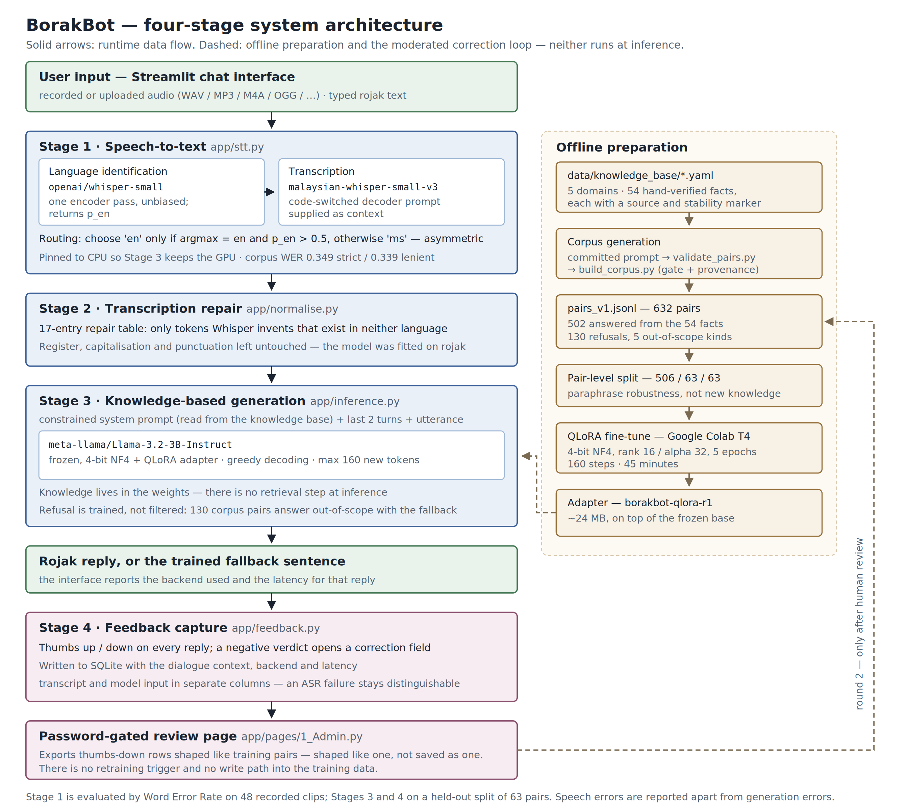
Figure 1: BorakBot system architecture. The runtime path (left) runs on every user turn; offline preparation (right) and the moderated correction loop are dashed because neither executes at inference.
Stage 1 — speech-to-text with language routing. The user types rojak or speaks, recording in the browser or uploading a file. Audio is passed to base Whisper for a single encoder pass that yields an English probability, and that probability selects the language token the Malaysian checkpoint will transcribe with. Transcription runs on mesolitica/malaysian-whisper-small-v3 with a short code-switched sample supplied as decoder context.
Stage 2 — transcription repair. The transcript passes through a seventeen-entry repair table covering only tokens Whisper invents that exist in neither language. Register, capitalisation and punctuation are left untouched.
Stage 3 — knowledge-based generation. The repaired utterance, the last two dialogue turns and a constrained system prompt read from the knowledge base are passed to Llama-3.2-3B-Instruct loaded in 4-bit with the QLoRA adapter applied. Decoding is greedy and capped at 160 new tokens. Questions outside the curated domains receive a trained fallback sentence rather than an invented answer.
Stage 4 — feedback capture. Every reply carries a verdict control. A negative verdict opens a correction field, and the exchange is written to SQLite with its dialogue context, the backend that produced it and its latency. A password-gated review page exports thumbs-down rows shaped like training pairs; a person decides which become training data.

3.2 Data collection
No public Bahasa Rojak corpus exists for either speech or dialogue, so all three datasets were built by the team.
The knowledge base. 54 facts across five domains — JPJ vehicle licensing, JPN identity documents, Immigration passports, Malaysian slang, and small talk — written as YAML, each carrying a source and a stability marker, 39 verified against official agency portals and 15 from secondary sources. Facts rather than conversations are the unit, because a fact can be checked against an agency portal and a conversation cannot. Verification was not ceremonial: every aggregator reports RM120 for non-citizen driving licence renewal, while the official JPJ table gives that as the trial licence rate and the competent driving licence as RM60.
The speech test set. 48 utterances across six switch-type categories — Malay-dominant, English-dominant, balanced intra-sentential, discourse particles, numerals, and Malaysian named entities — eight per category, 387 reference words. Reference transcripts were written before recording, because transcribing our own audio afterwards would have biased the references toward whatever was actually said. Speakers were balanced within each category rather than across the corpus, so that a poor category score cannot be confounded with one speaker's voice.
The training corpus. 632 question–answer pairs generated from the 54 facts by a prompted large language model: 502 answering from the knowledge base, and 130 answering an out-of-scope question with the fallback sentence, across five refusal categories. Refusal pairs are not padding — refusal is the hallucination control the proposal specifies, and a model learns it from examples like anything else. Generation is declared in Appendix A and the prompt is committed as the provenance record.

3.3 Preprocessing
Audio. Phone recordings are converted to 16 kHz mono WAV and paired to their manifest rows by filename rather than by position, because copying files off a phone rewrites modification times.
Text at inference. Only transcription repair, for the reason established by measurement in §5.18. The substitution table produced by the WER evaluation cannot be reversed into a repair table: it records what each reference word turned into, not what each mistake came from, and Whisper wrote saya for can, do, i, balance and my. What can be repaired is the residue that is not a word in either language.
Text for scoring. Both reference and hypothesis are lowercased, stripped of punctuation and whitespace-collapsed before alignment. Two scores are reported: strict, which counts orthographic variants as errors, and lenient, which canonicalises a small documented set of same-word spelling variants first. Translations are excluded from the lenient map, because a transcript rendered in formal Malay is still wrong for the stage that follows it.

3.4 NLP techniques and models
Each choice below was settled by measurement reported in §5.0, not by preference.
Language identification — openai/whisper-small. One encoder pass, used only to choose a language token. Base Whisper rather than the Malaysian checkpoint, because the latter pins Malay in its generation configuration and its detector is the defect being worked around.
Transcription — mesolitica/malaysian-whisper-small-v3. Same architecture and parameter count as openai/whisper-small, distilled on Malaysian speech including Manglish. Selected on 0.398 against 0.447 at equal prompt conditions.
Generation — meta-llama/Llama-3.2-3B-Instruct. Chosen over a Malaysian-pretrained candidate that read as more fluent, because its failure mode was over-refusal from ignorance, which fine-tuning repairs, while the alternative's was fabrication, which nothing in the training plan removes.
Adaptation — QLoRA. 4-bit NF4 with double quantisation over frozen weights, rank 16 and alpha 32, adapters on all attention and MLP projections, five epochs at a 2e-4 cosine schedule. Configuration and reasoning in §5.12.
Evaluation — two metric families. Word Error Rate computed as corpus totals for speech; perplexity, BLEU, chrF, ROUGE-L and BERTScore for generation, with BERTScore using a multilingual encoder because the references are code-switched. chrF is included specifically as a character-level cross-check on word-level BLEU over short answers.

3.5 Implementation and environment
The application is five Python modules plus a Streamlit interface and a password-gated review page. Feedback is stored in SQLite; the adapter is published to the Hugging Face Hub and never committed to the repository, as with all weights and audio.
Training runs on Google Colab with a free T4, checkpointing to Drive so a run survives disconnection. This is a deviation from the proposal, which named Kaggle Notebooks: Kaggle gates notebook networking behind phone verification the team account could not complete, and without networking pip, git and the Hub are all unreachable. The change is environmental and affects no reported figure.
The demonstration machine carries 4 GB of video memory, which the two models cannot share. The language model receives the GPU because it is thirteen times larger and runs once per reply rather than once per clip; the speech model is pinned to the CPU, where it costs a few seconds that are invisible beside generation and where the transcript is bit-identical because the computation is float32 on either device.

3.6 Evaluation design
Two independent harnesses were built and their results are never combined. A wrong answer to a misheard question is a different failure from a wrong answer to an understood one, and merging them would make neither diagnosable.
Speech. Nine configurations across two factors — model and decoder prompt — plus the language token, evaluated over all 48 clips. Word Error Rate is reported as total errors divided by total reference words across the corpus, not as the mean of per-clip rates, because averaging per-clip rates over-weights short utterances.
Generation. The corpus is split 506 / 63 / 63 at the level of the pair rather than the fact. A fact-level split would ask whether a model with no retrieval component generalises to facts it was never taught, which has a known answer and would produce a number with no decision attached. The pair-level split measures whether a fact learned from one phrasing survives being asked in another, and every generation figure in this report should be read as paraphrase robustness on that basis. The comparison holds everything constant except the adapter: same base model, tokenizer, test split, greedy decoding and 4-bit load. Refusal is measured separately, because all refusal items share one gold answer and including them in similarity metrics would score a model that declines everything as accurate.

