

**RGBD slam with octomap**

**Technische Informatica**

**Robot Operating System**

**Eindhoven 21-06-2012**

**Auteur(s):**

***Alex Ruijs***

# Summary

The RGBD slam and octomap package are used for making a map of a room in 3d.

# Installation

#### Rgbd slam

First we need to get 2 svn parts we get them with these commands:

svn co <http://alufr-ros-pkg.googlecode.com/svn/trunk/rgbdslam_freiburg/rgbdslam> ~/ros/rgbdslam

svn co <https://code.ros.org/svn/ros-pkg/stacks/vslam/trunk/g2>o ~/ros/g2o

after we have these 2 are on the computer we can build the package with this command:

rosmake --rosdep-install rgbdslam

if it does not compile right than we miss some libarys, we can get them with this command:

sudo apt-get install libglew1.5-dev libdevil-dev libsuitesparse-dev

sudo apt-get install gsl-bin libgsl0-dev

now we rebuild it and it should be installed in the right way.

#### Octomap

For octomap we have only 1 command to install it:

sudo apt-get install ros-electric-octomap-mapping

ros-electric-octomap-visualization

# RGBD slam

We start the rgbdslam with the kinect with this command:

roslaunch rgbdslam kinect+rgbdslam.launch

now we get a screen with 4 sections in it.

rosrun rgbdslam rgbdslam

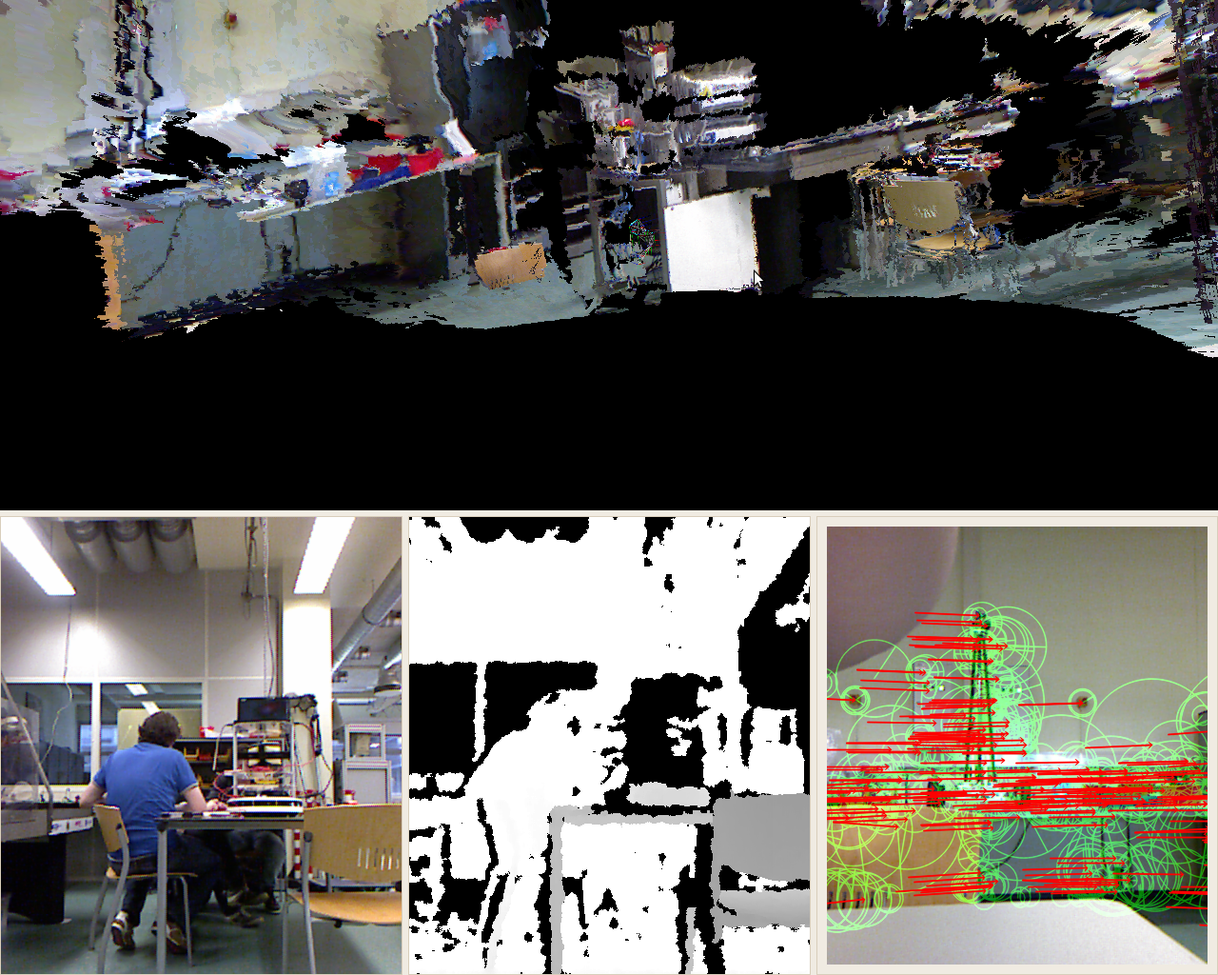

Main screen

Match points

view

Depth

#### Main screen

In this screen we see the pictures taken during the program put togher. This will form a depth map after enough pictures taken.

#### View

This screen shows what the camera view that is seen this moment.

#### Depth

This screens shows the depth map from the view screen

#### Match points

In this screen shows the recognition points and what movement it made during the last screen.

# Octomap

To use octomap we first need to save a map from rgbdslam. Afterthat we need to run the program. The following steps are needed for this.

* start rgbdslam as described above, capture a scene
* Execute roslaunch rgbdslam octomap_server.launch
* In rgbdslam select *Graph->Send Model* (or press Ctrl+M)
* Execute rosrun octomap_server octomap_saver <filename.bt>
* rosrun octovis octovis <filename.bt>

now we see the map we just made in rgbd slam and can move it around and look into it.

# Links

<http://www.ros.org/wiki/rgbdslam>

for the rgbd slam package

<http://octomap.sourceforge.net/>

official octomap site

<http://www.ros.org/wiki/octomap_mapping>

for the octo map package