Title page

Title of your report (e.g., Assessing impacts of climate and human factors on the vegetation change using a spatial machine learning model)

Name
ID
Email
Date

Table of Contents

1 Introduction (one paragraph)
(background and aim of the study)
Vegetation variations are increasingly affected by global climate change and human activities. Rising temperature and extreme hot weathers increase the risk of vegetation damage. Meanwhile, human activities such as socio-economic development and mining activities may worsen this risk of vegetation changes together with climate variations. This study develops a geographically optimal zones-based heterogeneity (GOZH) model in assessing the impacts of climate and human variables on the vegetation change. GOZH is a spatial machine learning model that combines a decision tree-based learning approach and a spatial stratified heterogeneity model in the spatial driver analysis. Decision tree is a machine learning for regression and classification using tree-based learning. Geographical detectors (GD) is used for spatial stratified heterogeneity modelling and spatial driver analysis.

2 Methods
Steps
2.1 Individual variable analysis
2.2 Contributions of all variables
(1) Decision tree for identifying the optimal zones
(2) Spatial power of determinants (contributions) of all variables explored by GD model

3 Results
3.1 individual variables’ contributions

A paragraph of explanation (Figure or table)
Figure or table

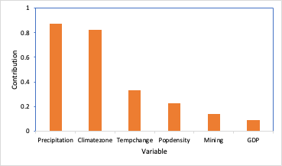
Figure 1. Contributions of individual variables on vegetation change explored by GOZH model

3.2 Contributions of all variables

A paragraph of explanation (Figure or table)
Figure or table
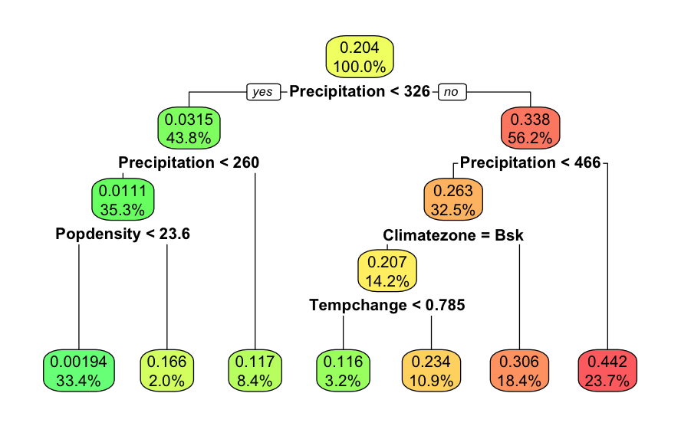
Figure 2. xxxxx

Total contribution is 91%.

