1 Introduction
(background and aim)
The importance of spatial prediction of soil heavy metals.
The soil heavy metals (trace elements) can lead to soil and water pollution and affect human health. Lead of one of the primary trace elements in soil affecting the agriculture production. However, there are still challenges in predicting the distribution maps of soil trace elements. This study aims at developing a Kriging model for the spatial prediction of trace elements in the soil.

2 Methods
Kriging model for predicting the spatial distributions of soil trace elements
Steps
2.1 fitting a variogram using samples

2.2 Kriging prediction
Equation:

3 Results

3.1 fitted variogram
Findings: In the fitted variogram, the range is 463 m. Threshold to evaluate the relationship between difference and distance of any two samples. When the distance is lower than 463 m, the variance of data values are increased with the increase of distance.
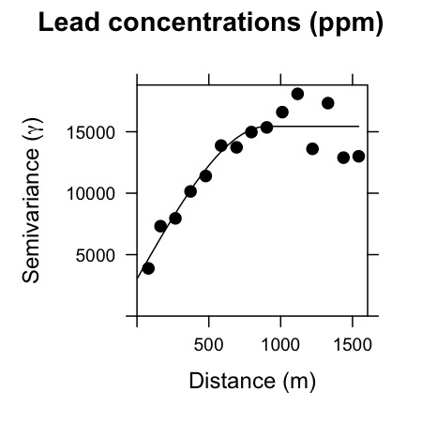

3.2 Kriging prediction
Maps
The maps include spatial distributions of predictions and prediction errors. For examples, in the western part of the map, the prediction values are around 410 and error is about 70. In the eastern part of the map, the prediction values are 100, and corresponding prediction error is about 110.

