Title: Assessing urbanization using geocomplexity patterns of drivers

1 Introduction
(Background and aim)
Background = reasons why you conduct the research
Aim = what methods are developed to address the issue

Why we need to analyze factors of urbanization? Why spatial patterns can improve the contributions of factors in explaining urbanization?

Understanding the factors of urbanization can support the identification of the strong and weak industry sectors and improve the strategies for urbanization. Spatial patterns improve the contributions of urbanization drivers through the regional analysis of spatial data, such as spatial dependence, clusters, heterogeneity, scale, and geocomplexity. This study develops geocomplexity patterns of spatial variables and an optimal parameters-based geographical detector (OPGD) model to explain the drivers of urbanization.

2 Methods
Steps in the code

2.1 Calculating geocomplexity patterns of explanatory variables

2.2 Calculating contributions of variables and their geocomplexity to urbanization

3 Results
Tables and Figure

3.1 Geocomplexity patterns of explanatory variables
Map

Write a paragraph to explain Figure 1.

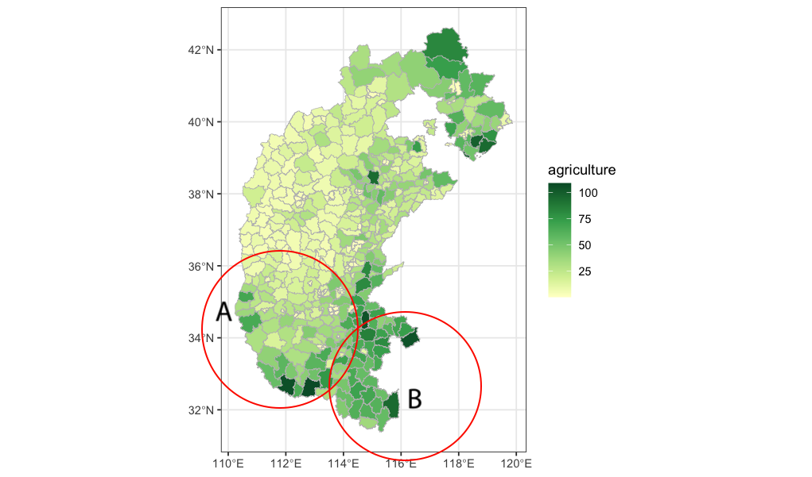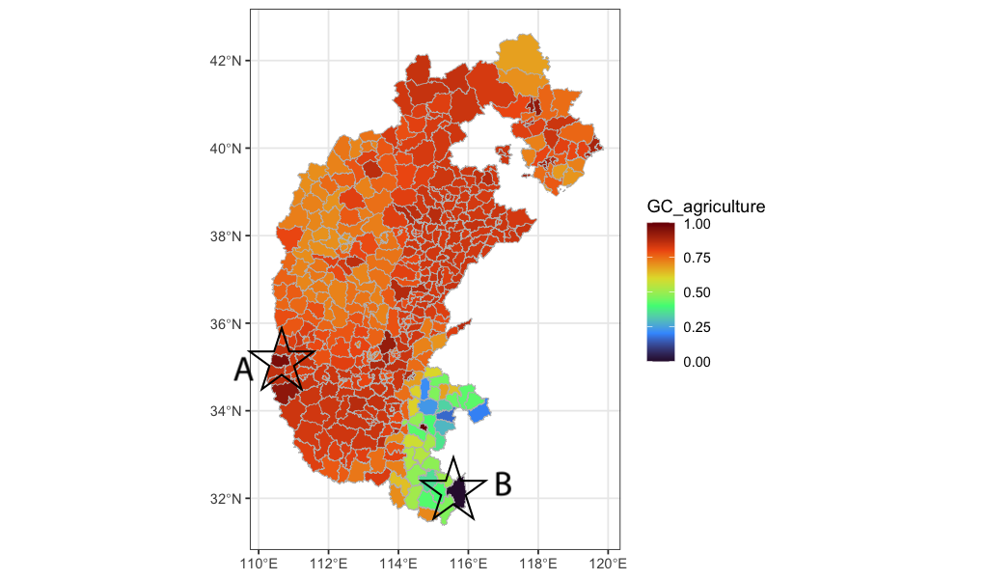
Figure 1. spatial distributions of agriculture production (a) and its geocomplexity pattern (b) in the study area.

Write a paragraph to explain the curve

Curve of the relationship between a variable and its geocomplexity pattern
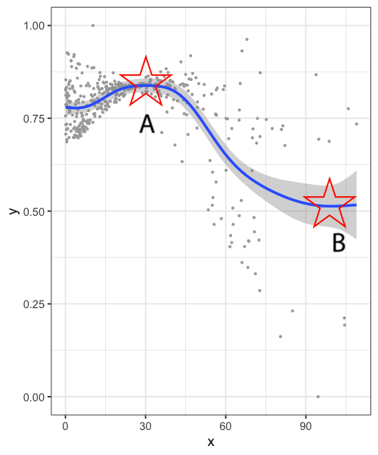
Figure caption here xxxxx

3.2 Contributions of variables and their geocomplexity to urbanization
OPGD: individual, interactions, total of all

