Spatial stratified random sampling for identifying sample location for measuring temperature

1 Introduction
Background and aim

The importance of temperature observation in Europe.

Global climate change affects European agriculture, industries, and human health. Temperature observations are used for mapping distributions of temperature related variables. This study develops a spatial stratified random sampling approach for identifying the sample locations for measuring and mapping temperature in Europe.

2 Methods
Steps

3 Results

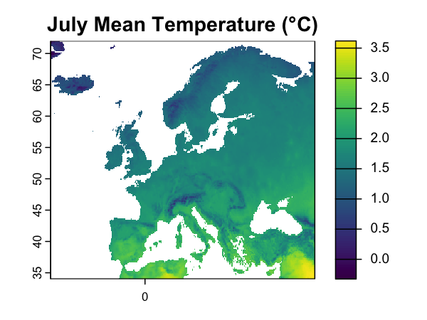
Figure 1. Spatial distribution of average temperature in July in Europe

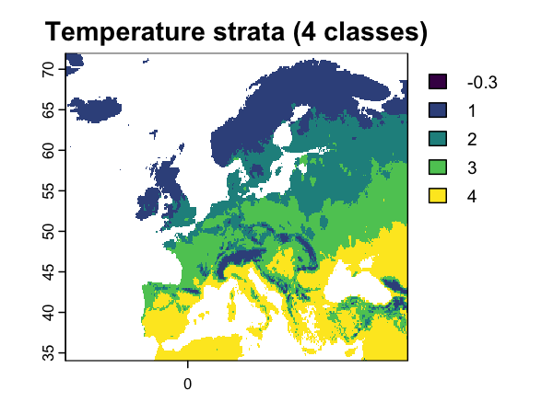
Figure 2. Spatial distributions of four classes of temperature strata

Table 1. Statistical summary of temperature monitoring samples
Temperature class | No of samples | Mean T | SD of T
Cool | 18 | 0.992 | 0.321
Mild | 24 | 1.91 | 0.127
Warm | 27 | 2.33 | 0.134
Hot | 31 | 2.77 | 0.116

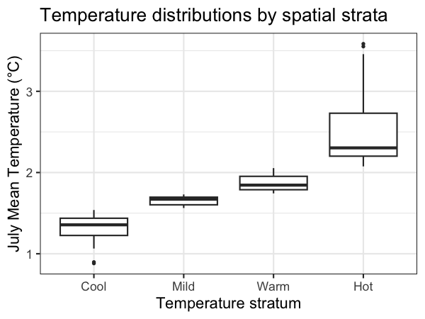
Figure 3. Temperature distributions by four categories of spatial strata

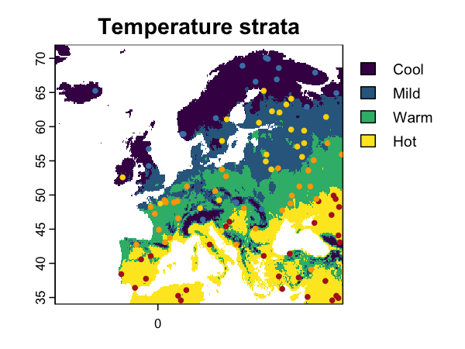
Figure 4. Identified samples for measuring temperature in Europe using the spatial stratified random sampling approach

