Analyzing the urbanization using a spatial decision making approach

1 Introduction
Background and aim

Why we need to develop an indicator analyze the urban development? Why an indicator based on socioeconomic, natural environment, and infrastructure is required by industry practice?

Urban development can be measured by various factors, criteria and indicators, such as population, economic, social well being, environment, and ecosystems. Urbanization index is required to understand the spatial distributions of geographically varied indicators and strategies for urban management. The industry and planning authorities need specific indicators of urban socioeconomic development, natural environment, and infrastructure to take actions for the urban management. This study develops a spatial decisions making model to examine the urbanization process and spatial distributions of urban development. The spatial decision making model employs normalization analysis and entropy weighting approach.

2 Methods
Brief descriptions of steps
2.1 normalization
2.2 entropy weighting

3 Results

3.1 Two categories of normalized urbanization variables

Data with various units and ranges are normalized to the range with values from 0 to 1. The normalized data ensures the fair comparison between various indicators.

3.2 weights of variables and urbanization index

The weights of the two categories of variables are calculated using the entropy weighting process. In the first category of socioeconomic urban development indicators, the GDP (weight is 24%) and revenue (weight is 23%) contribute more to urbanization than other socioeconomic factors. In the second category of natural environment and infrastructure variables, the vegetation contributes 15% and road density contributes 85%.

The spatial decision making derived urbanization index is mapped in Figure 1. The spatial distribution of urbanization index shows that the eastern regions that are closed to the major cities and ocean areas have relatively higher urban development levels than that in the western regions that are located far from major cities and located in the mountainous areas.

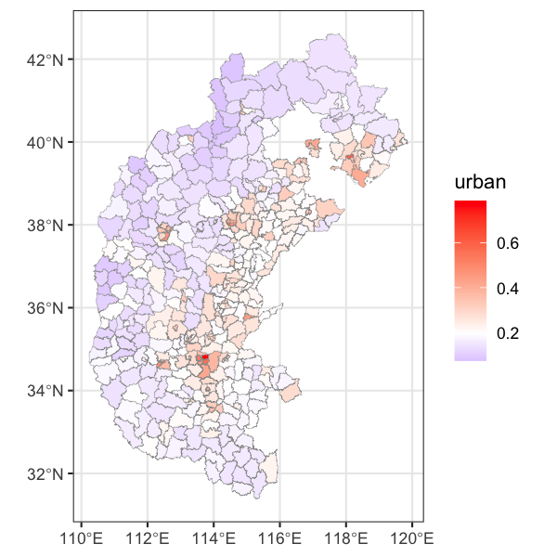
Figure 1. Spatial distribution of urbanization index calculated using the spatial decion making approach

