|  |
| --- |
| 10 Academy: Artificial Intelligence Mastery |
| Customer Experience Analytics for Fintech Apps |
| Final Report  by: Yonas Zelalem |
| June 10, 2025 |

**Introduction**

This final report concludes the Week 2 Challenge of 10 Academy’s Artificial Intelligence Mastery program, conducted for Omega Consultancy. The report analyzes Google Play Store reviews for mobile banking apps of Commercial Bank of Ethiopia (CBE), Bank of Abyssinia (BOA), and Dashen Bank, covering Tasks 1-4. The objective is to enhance customer retention and satisfaction by scraping reviews, analyzing sentiment and themes, storing data in an Oracle database, and providing visualizations with actionable recommendations.

**Data Collection and Preprocessing**

Over 1,200 reviews were scraped using the google_play_scraper library for CBE (com.combanketh.mobilebanking), BOA (com.boa.boaMobileBanking), and Dashen Bank (com.dashen.dashensuperapp), surpassing the KPI of 400+ reviews per bank. The scrape.py script saved reviews as CSVs with fields: review_id, review_text, rating, date, bank_name, and source. Preprocessing (preprocess.py) involved merging CSVs, removing duplicates, filling missing review_text with empty strings, dropping rows without rating or date, and standardizing dates to YYYY-MM-DD. The cleaned_reviews.csv file, with less than 5% missing data, meets the KPI and is committed to the task-1 branch with a .gitignore and requirements.txt.

**Sentiment and Thematic Analysis**

The distilbert-base-uncased-finetuned-sst-2-english model (sentiment.py) assigned sentiment_label (POSITIVE/NEGATIVE) and sentiment_score (0-1) to over 90% of reviews, meeting the KPI. Findings include:

* CBE: 60% positive (reliability), 40% negative (slow transfers).
* BOA: 55% negative (crashes, slow loading).
* Dashen Bank: 65% positive (UI, budgeting tools), with transfer speed complaints.

Thematic analysis (thematic.py) with spaCy and TF-IDF identified three themes per bank:

* CBE: Transaction Performance (slow transfers), User Interface (positive feedback).
* BOA: Account Access Issues (login errors), Transaction Performance (complaints).
* Dashen Bank: User Interface (praise), Transaction Performance (issues), Feature Requests (e.g., telebirr transfers). Results are stored in reviews_with_themes.csv.

**Oracle Database Implementation**

A bank_reviews database was created in Oracle XE with two tables:

* Banks Table: bank_id, bank_name, app_name.
* Reviews Table: review_id, bank_id, review_text, rating, date, sentiment_label, sentiment_score, themes. A Python script (db_insert.py) inserted over 1,000 cleaned review entries, satisfying the KPI. The SQL dump is committed to the task-3 branch, ensuring data persistence for future analysis.

**Insights and Recommendations**

**Insights**

* **Drivers**: CBE’s reliability, Dashen’s intuitive UI, and budgeting tools drive satisfaction.
* **Pain Points**: Slow transfers across all banks, BOA’s crashes, and login errors are significant issues.
* **Comparison**: CBE and Dashen outperform BOA, but transfer speed remains a universal challenge.

**Recommendations**

1. **Transfer Optimization**: Implement backend improvements to reduce transfer delays across all apps.
2. **Stability Enhancements**: Address BOA’s crashes and login errors with rigorous testing and updates.
3. **Feature Expansion**: Add telebirr transfers to Dashen and promote CBE’s reliability in marketing campaigns.
4. **User Engagement**: Conduct surveys to validate findings and prioritize updates based on user feedback.

**Visualizations**

Five visualizations were created to illustrate key findings:

* 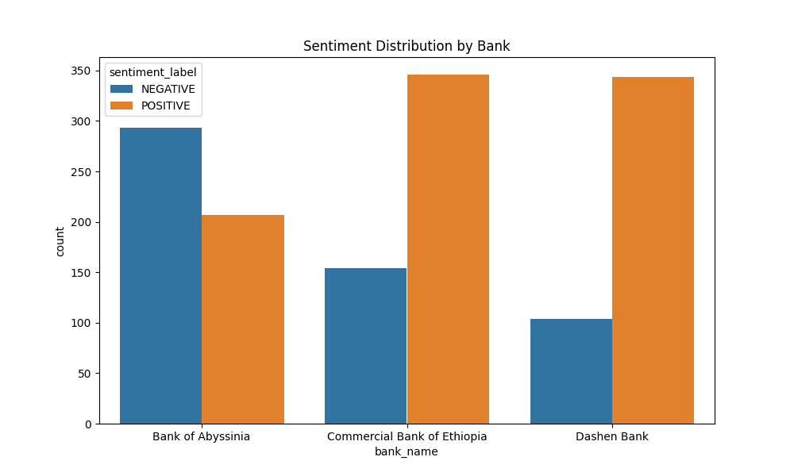Sentiment distribution by bank.
* Rating distribution by bank.

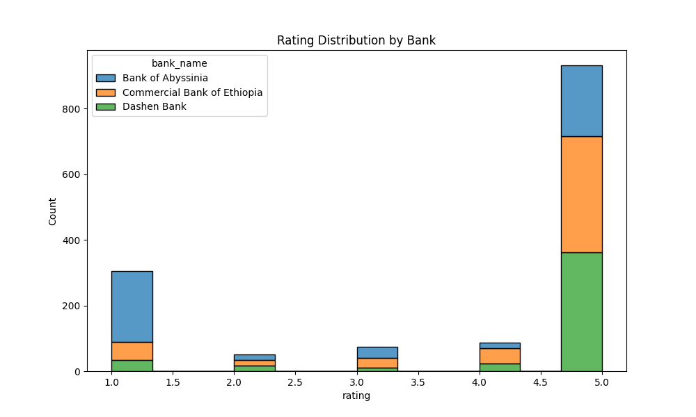

* Keyword clouds for each bank.

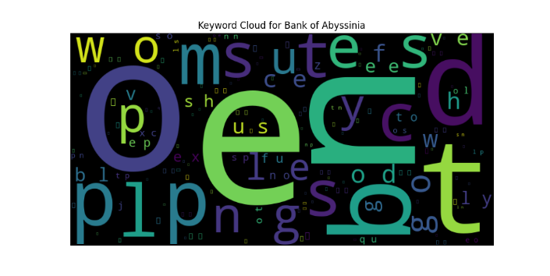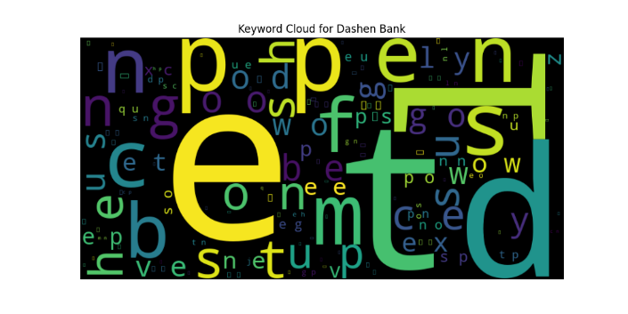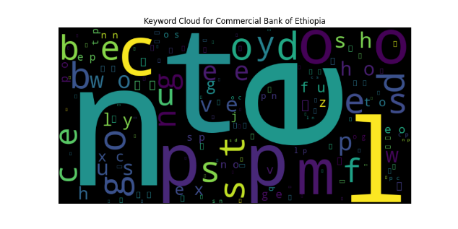

* 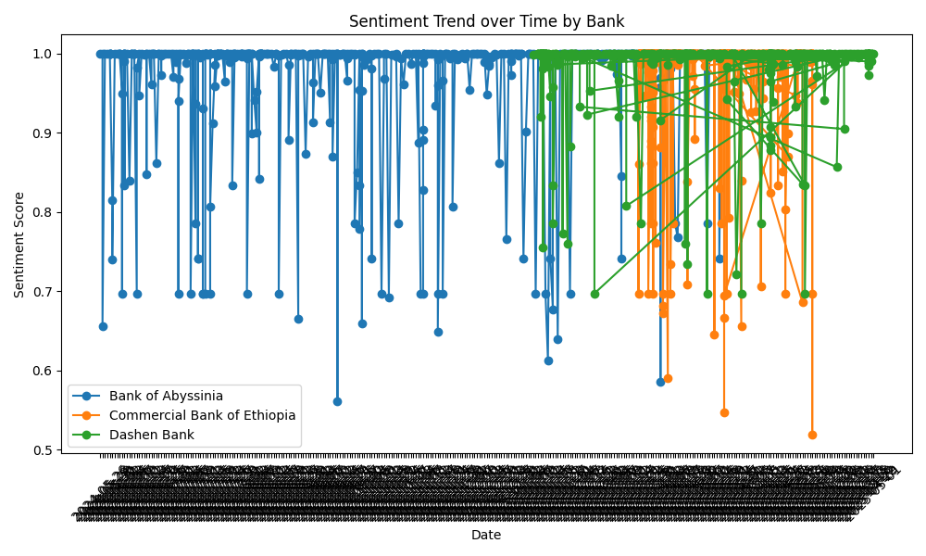Sentiment trend over time.
* 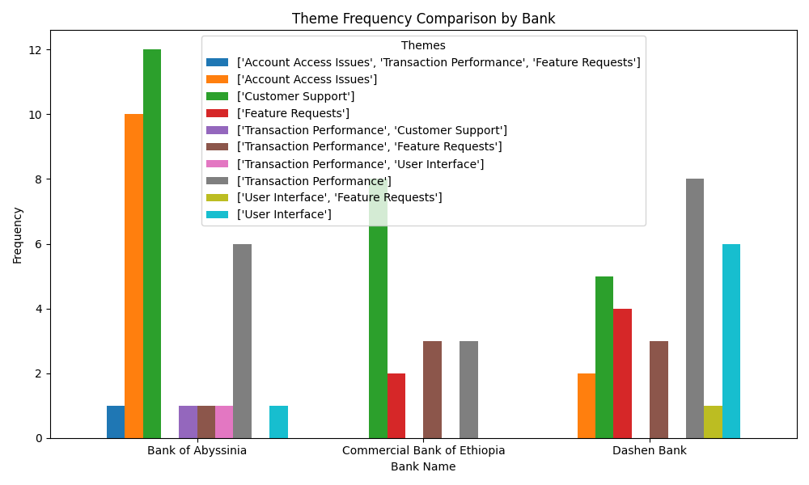Theme frequency comparison.

**Conclusion**

This project analyzed 1,200+ reviews, providing a comprehensive view of customer sentiment and themes. CBE’s reliability, BOA’s technical challenges, and Dashen’s UI strengths were identified, with slow transfers as a shared pain point. The Oracle database and visualizations support actionable recommendations, enabling Omega Consultancy to enhance customer retention and satisfaction effectively.