

**Electric Car Acceleration Sub-System**

**ECE 303 - 061: ECE Laboratory – Fall 2018**

**Instructor: Christopher Peters**

**Written By: Yonatan Carver**

**Farhan Muhammad**

**Date: 12/03/2018**

**Table of Contents**

|  |  |  |  |
| --- | --- | --- | --- |
| **Lab** | **Date** | **Page** | **Objective** |
| 1 | 09/24/2018 | 3 | Equipment Automation |
| 2 | 10/01/2018 | 6 | DC Motor Characterization |
| 3 | 10/08/2018 | 8 |  |
| 4 | 10/15/2018 | 10 | Data Acquisition and Emergency Shutdown Systems |
| 5 | 10/22/2018 | 12 |  |
| 6 | 10/29/2018 | 14 | Load Cell and Calibration |
| 7 | 11/05/2018 | 16 | Finishing the Testbed |

**Lab 1 - Equipment Automation**

**Objective**

The primary focus of this series of experiments is to write MATLAB scripts to automate the measurement equipment in the lab, namely the arbitrary waveform generator (AWG), digital multimeter (DMM), and the oscilloscope. The goal is to estimate the value of a resistor by sweeping the DC voltage out of the AWG and measuring the current, using the DMM, at that voltage, measured using the oscilloscope.

Firstly, the output voltage on the AWG will be changed manually and the data will be recorded from the DMM. In order to capture more data points more efficiently, scripts will be written for the equipment to estimate the value of the resistor. Afterwards, the process will be repeated using MATLAB to automate the voltage sweep and data recording. Finally, the oscilloscope will be tested to automate generating a signal of varying duty cycle and recording the corresponding on-times.

**Equipment List**

* BNC to BNC cable
* BNC to 2-alligator clip cable
* (2) banana-jack to alligator clip cables
* (1) 2 kΩ resistor
* HP Digital multimeter (DMM)
* HP Waveform generator (AWG)
* HP Oscilloscope

**Procedure**

The first experiment measures the current for a sweep of DC voltages manually set on the AWG. The voltage is swept from 0 to 10V in 1V increments. Both the voltage and current are recorded in order to cross-check the value of the resistor used.

For the second part of the experiment, the process is automated using MATLAB’s USB commands. Both the AWG and DMM are set up using MATLAB to sweep the DC voltage from 0 to 10V in 0.1V increments and record the corresponding readings.

The third part of the experiment connects the AWG to the oscilloscope. Periodic pulse signals of known amplitude and varying duty cycle are automatically generated using MATLAB’s USB commands. The duty cycle is swept from 20% to 80% and back down to 20% in 5% increments, and the corresponding on-times are recorded.

Finally, the data from all the experiments are plotted using MATLAB and linear regression is applied to each set of data to compare experimental results with best fit estimates.

**Deliverables**

1. Plot of Current vs. Applied Voltage for manually swept data set and accompanying best fit line.
2. Plot of Current vs. Applied Voltage for automatically swept data set and accompanying best fit line.
3. Plot of On-Time vs. Duty Cycle for automatically swept data set and accompanying best fit line.

**Results**

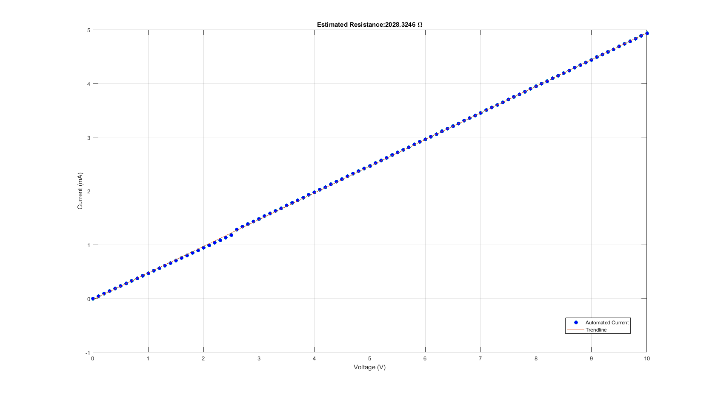

Figure 2: Voltage vs. Current - Automatic Measurement

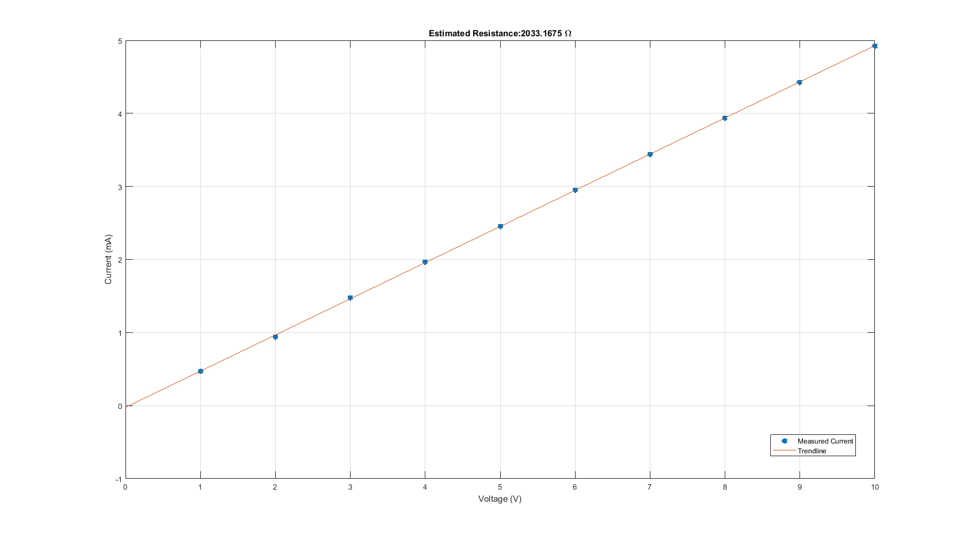

Figure 1: Voltage Vs. Current - Manual Measurement

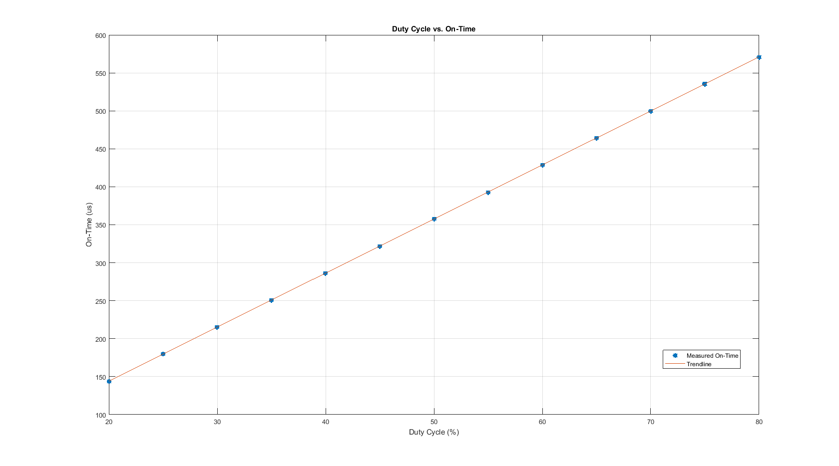

Figure 3: Duty Cycle vs. On Time - Automatic Measurement

**Lab 2 – DC Motor Characterization**

**Objective**

The primary focus of this experiment is to write a MATLAB script to automate the sweep of a DC voltage signal from the arbitrary waveform generator (AWG) which is supplied to an Arduino and used to generate a PWM signal of proportional duty cycle, which causes a wheel attached to a DC Motor to rotate. The goal of this experiment is to generate, using automation, the RPM vs. duty cycle characteristic plot of a DC motor using the Arduino as a PWM source.

**Equipment List**

* HP Oscilloscope
* HP Arbitrary Waveform Generator (AWG)
* Power Supply
* Arduino Mega 2560
* DC Motor with wheel
* H-bridge
* (2) Banana jack-to-alligator clip cables
* (3) BNC to Alligator clip cables
* Optical counter

**Procedure**

First, the H-bridge is set up and tested to ensure it is functioning correctly by connecting it to the motor and performing a test run using input voltage from the AWG. The optical counter is also connected properly, and its output is connected to the oscilloscope. Next, the Arduino is connected to the system. The voltage from the AWG is connected to an input pin of the Arduino, and one of its output pins is connected to the H-bridge. The AWG output is automated to sweep from 0 VDC to 5 VDC in 0.1 V increments each with a duration of 5s, using MATLAB’s USB commands. The resulting signal is sent to the Arduino, which is programmed to adjust an output PWM signal with duty cycle based on the input voltage.

The resulting PWM signal sent to the DC motor causes the motor to accelerate over time until it reaches a 100% duty cycle at 5V. The corresponding RPM of the motor is recorded in MATLAB using two methods. The first is by measuring the pulse frequency of the optical counter via the oscilloscope every 5s. The second is by programming the Arduino to initiate an interrupt that manually counts the number of rising edges from the pulses for a second and then reset the counter. Using serial communication with MATLAB, the pulse count is sent to MATLAB every fifth second and is recorded within the MATLAB code. Once the voltage sweep is finished, the two frequencies are plotted against the corresponding DC voltage inputs in MATLAB for comparison and analysis.

**Deliverables**

1. MATLAB and Arduino code
2. Plot of RPM (optical sensor pulse frequency) vs. AWG voltage, with a linear fit to the data
3. Plot of RPM (using the counter approach) vs. AWG voltage, with a linear fit to the data
4. Plot of combined graphs for comparison

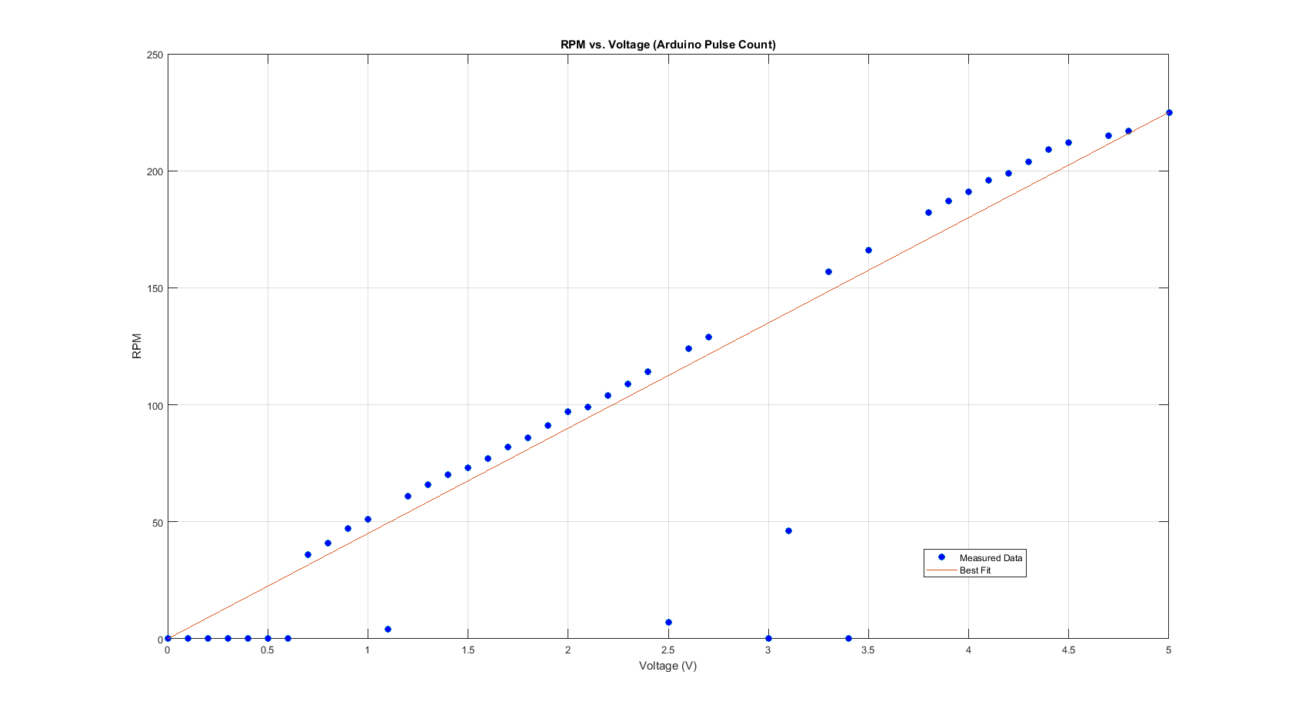**Results**

Figure 4: RPM vs. Voltage

**Lab 4 – Data Acquisition and Emergency Shutdown Systems**

**Objective**

The main goal of this lab is to devise a data acquisition system, using a secondary Arduino board, which collects RPM counts from the main controller, monitors the performance of the main motor as well as some characteristics of the battery, and initiates an emergency shutdown protocol based on certain triggers when normal functionality threshold values for the overall system are exceeded which triggers the main controller to use a relay to forcefully shutdown the system.

**Equipment List**

* Arduino Mega 2560
* Water Level Sensor
* DHT11 Temperature & Humidity Module
* R, B, W LEDs
* Passive Buzzer
* Relay Switch

**Procedure**

First, the circuitry for the sensors is built and connected to the DAQ. This consists of the water level and temperature sensors which are connected to two analog input pins of the Arduino board, as well as the three LEDs and passive buzzer which are connected to digital output pins. Optimal threshold values for the two sensors are determined experimentally and used to program the Arduino to trigger the alarm whenever these values are exceeded. Each of the three states of the DAQ (normal operation, low coolant level, and high battery temperature) are represented by the white, blue, and red LEDs respectively. While the system is under normal condition, no alarm is triggered and only the white LED is on. If at any point, the water level or temperature goes beyond the threshold then the white LED turns off and the corresponding LED turns on (possibly both). This also triggers the buzzer to turn on and emit an audible alarm.

Serial communication is used to communicate between the two Arduino boards as the main controller sends the DAQ the RPM count every second. This RPM count, along with water level and temperature readings are sent from the DAQ to the monitor, using serial communication again, to display the readings. The two Arduino boards are also connected through a digital pin. Whenever the alarm is triggered, the DAQ sends a digital high signal to the main controller which triggers it to open the relay and force the motor to perform the emergency shutdown.

**Deliverables**

1. Arduino code
2. Fully integrated and functional DAQ that –
   1. Implements a temperature sensor
   2. Implements a water level sensor
   3. Implements three different colored LEDs (white for normal operation, blue for low coolant, red for high temperature)
   4. Sends an audible alarm if a high temperature or low coolant level exists
   5. Receives RPM count from main controller
   6. Communicates with the main controller to shut down the motor upon sensor alarm
   7. Uses a relay to perform the emergency shutdown protocol
   8. Displays sensor information and RPM count

**Results**

There are no results to report and plot in this lab, however the fully integrated system was tested under several conditions and proper functionality was demonstrated. Through experimental observation and sensor threshold calibration, the water level sensor was determined to activate the alarm whenever its reading decreased below an analog input value of 280. And the temperature sensor was determined to activate the alarm at readings above 30℃.

**Lab 4 – Data Acquisition and Emergency Shutdown Systems**

**Objective**

The main goal of this lab is to devise a data acquisition system, using a secondary Arduino board, which collects RPM counts from the main controller, monitors the performance of the main motor as well as some characteristics of the battery, and initiates an emergency shutdown protocol based on certain triggers when normal functionality threshold values for the overall system are exceeded which triggers the main controller to use a relay to forcefully shutdown the system.

**Equipment List**

* Arduino Mega 2560
* Water Level Sensor
* DHT11 Temperature & Humidity Module
* R, B, W LEDs
* Passive Buzzer
* Relay Switch

**Procedure**

First, the circuitry for the sensors is built and connected to the DAQ. This consists of the water level and temperature sensors which are connected to two analog input pins of the Arduino board, as well as the three LEDs and passive buzzer which are connected to digital output pins. Optimal threshold values for the two sensors are determined experimentally and used to program the Arduino to trigger the alarm whenever these values are exceeded. Each of the three states of the DAQ (normal operation, low coolant level, and high battery temperature) are represented by the white, blue, and red LEDs respectively. While the system is under normal condition, no alarm is triggered and only the white LED is on. If at any point, the water level or temperature goes beyond the threshold then the white LED turns off and the corresponding LED turns on (possibly both). This also triggers the buzzer to turn on and emit an audible alarm.

Serial communication is used to communicate between the two Arduino boards as the main controller sends the DAQ the RPM count every second. This RPM count, along with water level and temperature readings are sent from the DAQ to the monitor, using serial communication again, to display the readings. The two Arduino boards are also connected through a digital pin. Whenever the alarm is triggered, the DAQ sends a digital high signal to the main controller which triggers it to open the relay and force the motor to perform the emergency shutdown.

**Deliverables**

1. Arduino code
2. Fully integrated and functional DAQ that –
   1. Implements a temperature sensor
   2. Implements a water level sensor
   3. Implements three different colored LEDs (white for normal operation, blue for low coolant, red for high temperature)
   4. Sends an audible alarm if a high temperature or low coolant level exists
   5. Receives RPM count from main controller
   6. Communicates with the main controller to shut down the motor upon sensor alarm
   7. Uses a relay to perform the emergency shutdown protocol
   8. Displays sensor information and RPM count

**Results**

There are no results to report and plot in this lab, however the fully integrated system was tested under several conditions and proper functionality was demonstrated. Through experimental observation and sensor threshold calibration, the water level sensor was determined to activate the alarm whenever its reading decreased below an analog input value of 280. And the temperature sensor was determined to activate the alarm at readings above 30℃.

**Lab 4 – Data Acquisition and Emergency Shutdown Systems**

**Objective**

The main goal of this lab is to devise a data acquisition system, using a secondary Arduino board, which collects RPM counts from the main controller, monitors the performance of the main motor as well as some characteristics of the battery, and initiates an emergency shutdown protocol based on certain triggers when normal functionality threshold values for the overall system are exceeded which triggers the main controller to use a relay to forcefully shutdown the system.

**Equipment List**

* Arduino Mega 2560
* Water Level Sensor
* DHT11 Temperature & Humidity Module
* R, B, W LEDs
* Passive Buzzer
* Relay Switch

**Procedure**

First, the circuitry for the sensors is built and connected to the DAQ. This consists of the water level and temperature sensors which are connected to two analog input pins of the Arduino board, as well as the three LEDs and passive buzzer which are connected to digital output pins. Optimal threshold values for the two sensors are determined experimentally and used to program the Arduino to trigger the alarm whenever these values are exceeded. Each of the three states of the DAQ (normal operation, low coolant level, and high battery temperature) are represented by the white, blue, and red LEDs respectively. While the system is under normal condition, no alarm is triggered and only the white LED is on. If at any point, the water level or temperature goes beyond the threshold then the white LED turns off and the corresponding LED turns on (possibly both). This also triggers the buzzer to turn on and emit an audible alarm.

Serial communication is used to communicate between the two Arduino boards as the main controller sends the DAQ the RPM count every second. This RPM count, along with water level and temperature readings are sent from the DAQ to the monitor, using serial communication again, to display the readings. The two Arduino boards are also connected through a digital pin. Whenever the alarm is triggered, the DAQ sends a digital high signal to the main controller which triggers it to open the relay and force the motor to perform the emergency shutdown.

**Deliverables**

1. Arduino code
2. Fully integrated and functional DAQ that –
   1. Implements a temperature sensor
   2. Implements a water level sensor
   3. Implements three different colored LEDs (white for normal operation, blue for low coolant, red for high temperature)
   4. Sends an audible alarm if a high temperature or low coolant level exists
   5. Receives RPM count from main controller
   6. Communicates with the main controller to shut down the motor upon sensor alarm
   7. Uses a relay to perform the emergency shutdown protocol
   8. Displays sensor information and RPM count

**Results**

There are no results to report and plot in this lab, however the fully integrated system was tested under several conditions and proper functionality was demonstrated. Through experimental observation and sensor threshold calibration, the water level sensor was determined to activate the alarm whenever its reading decreased below an analog input value of 280. And the temperature sensor was determined to activate the alarm at readings above 30℃.

**Lab 6 – Load Cell and Calibration**

**Objective**

The main goal of this lab is to add a component to simulate the accelerator foot pedal of the system by using a load cell. The reading from the load cell will then be amplified and the resulting signal will be sent to the main controller which will then be mapped and used to vary the PWM signal that is sent to the main motor of the wheel. First, the load cell will be calibrated using an Arduino test script. The resulting calibration factor will then be stored in the main Arduino’s internal EEPROM and will be loaded and initialized upon startup for the rest of the project.

**Equipment List**

* Arduino Mega 2560
* Analog Wheatstone Bridge Load Cell
* HX711 Breakout Module

**Procedure**

First, the circuit for the load cell is set up and the load cell, amplifier, and Arduino are connected as shown below in Figure 1. Next, an Arduino script is written to measure the weight applied on the load cell and calibrate the readings by using known weights and adjusting the calibration factor to return the desired values.

Figure 5: Circuit for Load Cell

Once the load cell is properly calibrated, it is added to the code for the main controller where the input from the load cell is constrained within a desired range of values. The resulting values are then mapped to output the PWM signal that will drive the wheel of the system. The functionality to set the desired maximum value of the load cell is added to the preexisting MATLAB GUI. This is done by adding a field in the GUI to reassign the calibration factor, which is sent from the GUI to the DAQ, and then to the main controller.

Finally, the EEPROM is added to the main controller such that it stores the user desired maximum RPM and calibration factor in specific addresses. The EEPROM functionality will include two Arduino functions, one that will read in the stored values and assign them accordingly upon startup and the another that will update the EEPROM addressed upon receipt of new values from the GUI. The EEPROM is set up using the EEPROMex library which allows a more user-friendly method of storing large values without concern for maximum space of each register in the EEPROM.

**Deliverables**

1. Arduino code
2. Integration of load cell and amplifier
3. Calibration system for reading weights in grams, settable from the GUI
4. Sensitivity parameter that maps load cell weight to motor speed by adjusting PWM signal
5. Functions that store and retrieve calibration and sensitivity parameters from EEPROM

**Results**

The base calibration factor acquired from experimenting with the given weights resulted in a value of -6266660. This factor was applied and tested using several different weights and the results were accurate to the nearest gram. The reading obtained from the calibrated load cell was constrained within a range of 0 to 100, where 100 is the initial maximum allowed weight and is subject to modification if desired. This range is then mapped to a range of 0 to 255 which represents the PWM signal that will be sent as output to the wheel motor to vary the motor RPM. The functionality of the EEPROM was also tested under several conditions which showed to successfully store, load, and update the calibration factor and maximum RPM values. A safety check was added to set the variables to the base values in the event that the EEPROM does not load properly.

**Lab 7 – Finishing the Testbed**

**Objective**

The main goal of this lab is two add two additional functionalities to the existing fully operational test bed. The list of options includes:

* RFID card reader-for security purposes
* LCD screen (with button to toggle display of different data)
* Remote operation with IR transmitter and sensor for speed control and system start/stop
* 4-Digit, 7-segment display for RPM display
* Accelerometer used to shut down system in case of excessive tilt or vibration

For this project, the 7-segment display and Accelerometer were chosen to be implemented.

**Equipment List**

* Existing Test Bed
* 4-Digit, 7-Segment Display
* GY-521 Module

**Procedure**

The 7-segment display is set up and tested first. It is connected to the DAQ Arduino using the pinout diagram shown below in Figure 1, and is programmed to update and display, in real time, the current RPM that is received by the DAQ from the main controller via serial communication. Each digit of the 7-segment display needs to be programmed and updated individually, so a function to breakdown the incoming RPM value into its separate digits and display them in the corresponding position of the 7-segment is written.

Figure 6: 4-Digit, 7-Segment Display Pinout

Next, the accelerometer is set up and tested using the GY-521 module. The breakout board for the module is connected to the main controller using the diagram shown below in Figure 2. This module requires the built-in “Wire” library in Arduino to initiate I2C communication. The module measures acceleration and tilt in the XYZ planes individually and sends the data through the communication channel to the Arduino where it is read and programmed to initiate the emergency shutdown protocol if any of the planes registers an excessive acceleration or tilt that crosses the set threshold values.

Figure 7: GY-521 Module Pinout

**Deliverables**

1. Arduino code
2. Full integration and functional system

**Results**

The 7-segment display updates each digit separately and so it was programmed to update from left to right. Due to circuit switching limitations, a small delay needed to be added in between the update of each digit in order to prevent short circuits. This delay was determined to be 4ms through repeated experiments.

The GY-521 module showed to have a high sensitivity to small changes in movement of the system. Small vibrations and tilts would result in large changes in the readings, so the thresholds for the movements were set to be relatively high; -8000 to 8000 for the X and Y planes, and 3000 to 19000 for the Z plane. These values were based on the initial, non-zero values that were being returned by the component even when it was stationary.