**ECES-352**

**Homework #2**

**Solutions**

Reading: In Signal Processing First, Appendix A on Complex Numbers; and Ch. 2 on Sinusoids.

Your homework is due at the beginning of class each Tuesday. See syllabus for late policy.

**Problem 1**

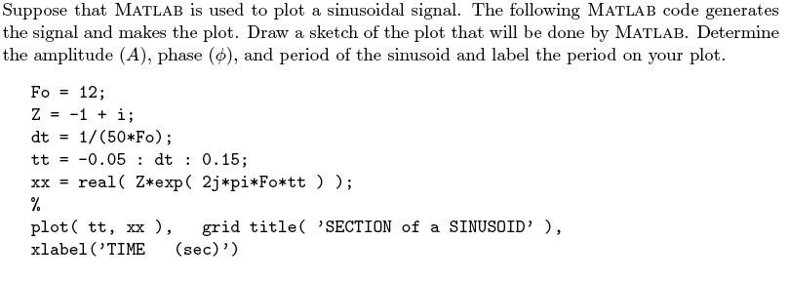

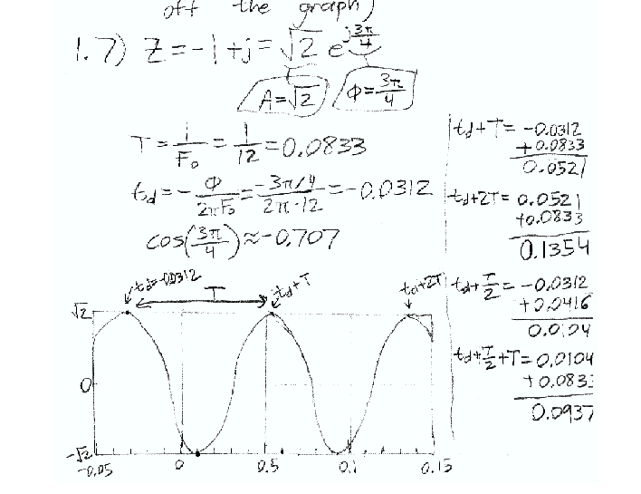

**Problem 2**

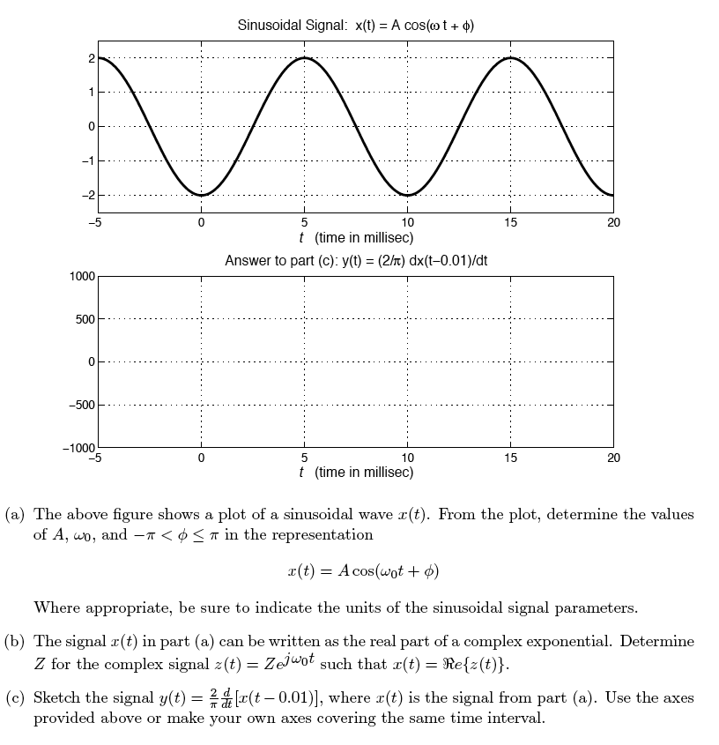

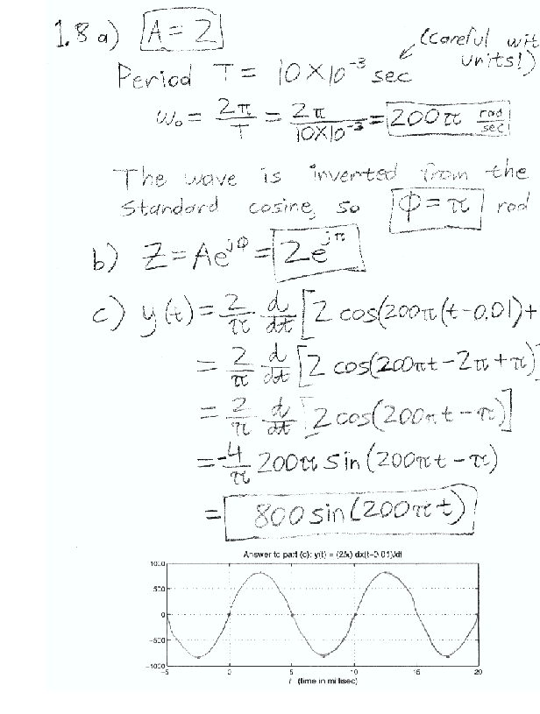

**Problem 3**

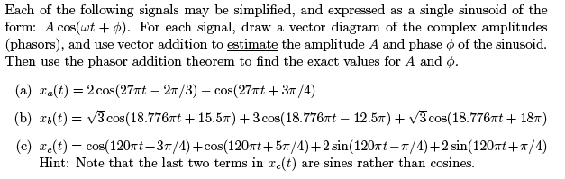

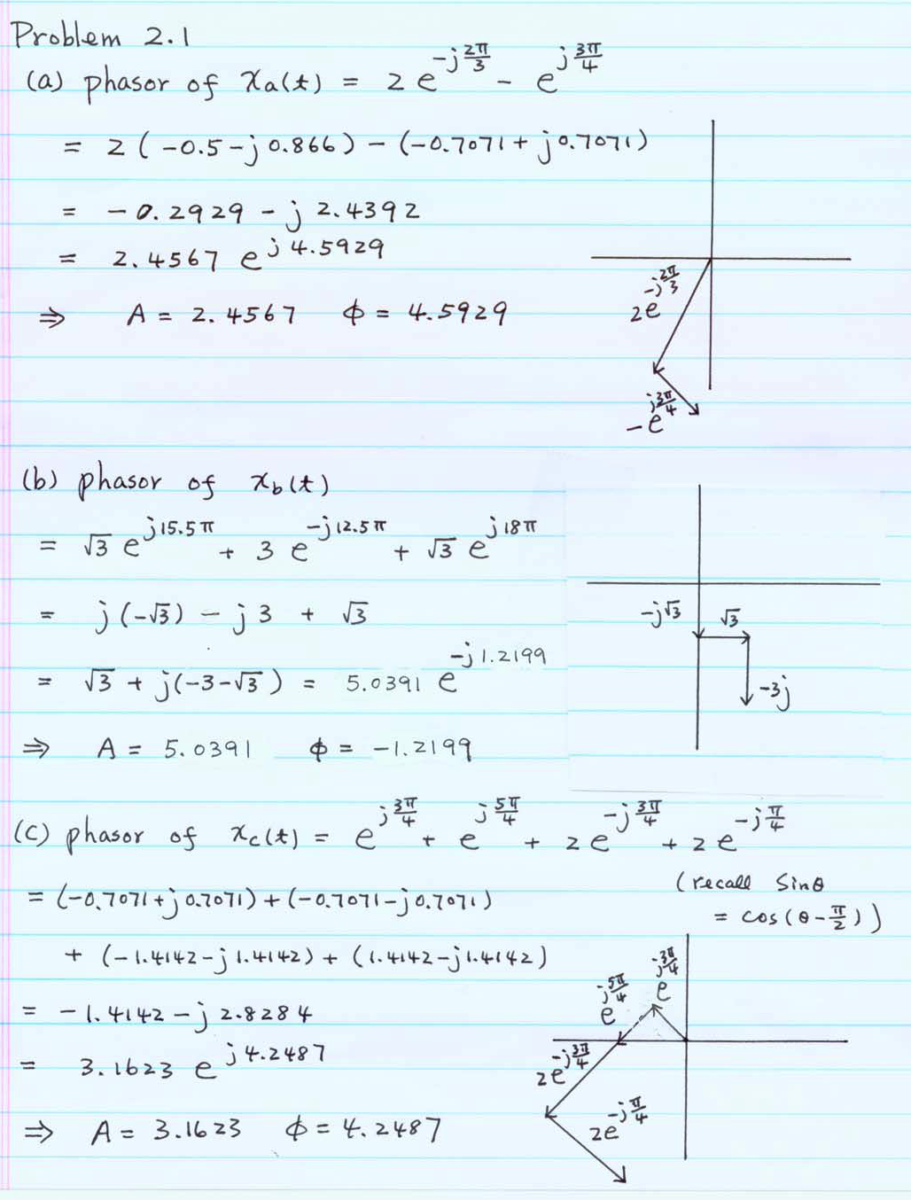

**Problem 4**

