**Problem 1**

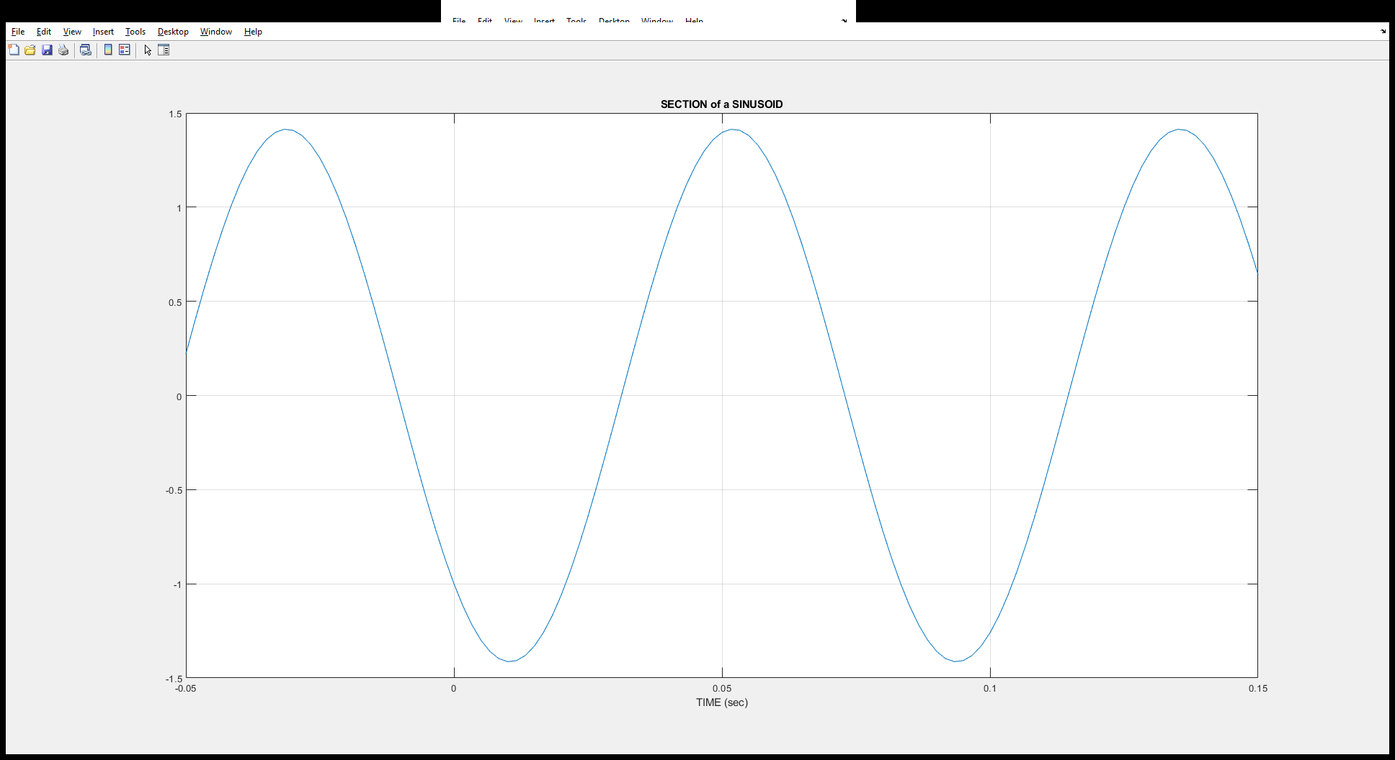

A = $1.1435$

ϕ = $-ω * t_{d}=\frac{2π}{T}*t_{d}=\frac{2π}{0.0834}*-0.0317=-2.3882$

T = 0.0834

**Problem 2**

1. A = 2
$$ω_{0}= -\frac{ϕ}{t_{d}}=-\frac{π}{5}$$

$$ϕ=\frac{2π}{T}*t_{d}=\frac{2π}{10}*5=π \\ x\left(t\right)=2\cos\left(-\frac{π}{5}t+π\right)$$

$z\left(t\right)=Ze^{\left(jω_{o}t\right)}$ $$=2*\left(e^{-j\frac{π}{5}t}e^{jπ}\right)$$

2. 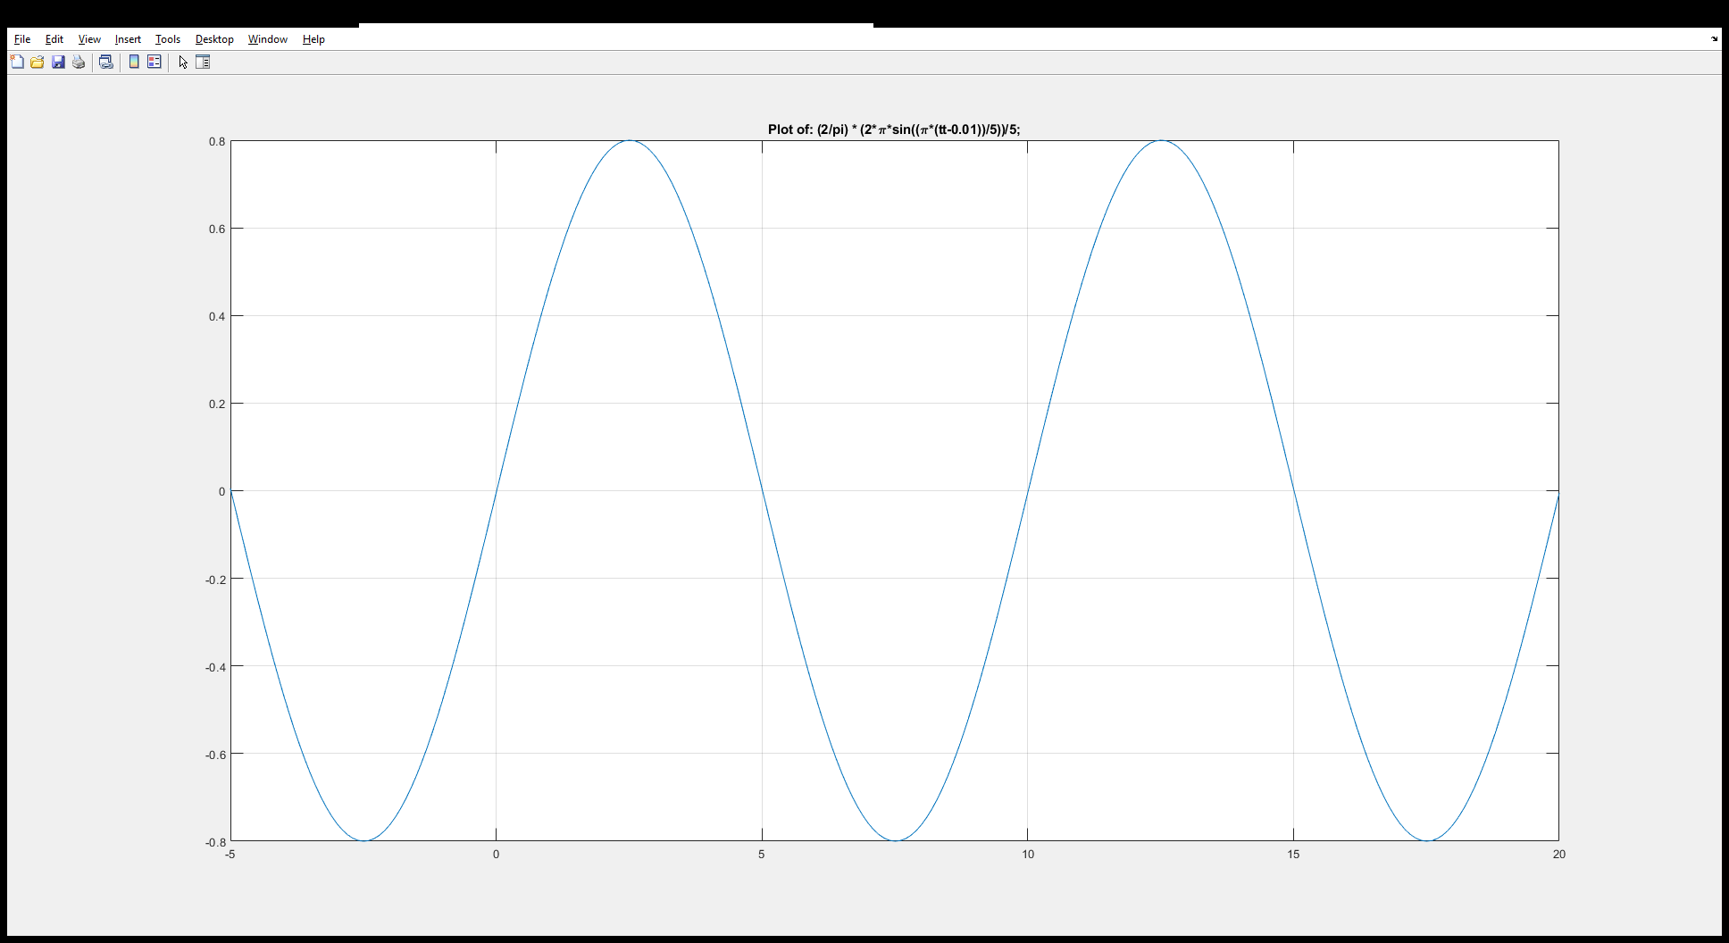

**Problem 3**

1. xa(t)

xa = 2 * cos(27 * pi * tt - (2*pi)/3) - cos(27 * pi * tt + (3*pi)/4);

xxa = real( 2 * (exp(1j * 27 * pi * tt)*(exp(-1j * (2 * pi)/3))) - (exp(1j * 27 * pi * tt)*exp(1j * (3 * pi)/4)) );

xa1 = 2 * (exp(-1j * (2 * pi)/3));

xa2 = -1 * exp(1j * (3 * pi)/4);

xa1 Z = X + jY Magnitude Phase Ph/pi Ph(deg)

-0.5 -0.866 1 -2.094 -0.667 -120.00

xa2 Z = X + jY Magnitude Phase Ph/pi Ph(deg)

-0.7071 0.7071 1 2.356 0.750 135.00

xa1 + xa2 Z = X + jY Magnitude Phase Ph/pi Ph(deg)

-1.207 -0.1589 1.218 -3.011 -0.958 -172.50

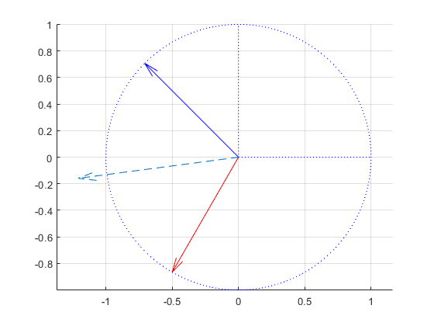

1. xb(t)

xb = sqrt(3) * cos(18.776 * pi * tt + 15.5 * pi) + 3 * cos(18.776 * pi * tt - 12.5 * pi) + sqrt(3) * cos(18.776 * pi * tt + 18 * pi);

xxb = real( sqrt(3) * (exp(1j * 18.776 * pi * tt)*exp(1j * 15.5 * pi)) + 3 * (exp(1j * 18.776 * pi * tt) * exp(-1j * 12.5 * pi)) + sqrt(3) * (exp(1j * 18.776 * pi * tt) * exp(1j * 18 * pi)) );

xb1 = sqrt(3) * exp(1j * 15.5 * pi);

xb2 = 3 * exp(-1j * 12.5 * pi);

xb3 = sqrt(3) * exp(1j * 18 * pi);

xb1 Z = X + jY Magnitude Phase Ph/pi Ph(deg)

-6.365e-15 -1.732 1.732 -1.571 -0.500 -90.00

xb2 Z = X + jY Magnitude Phase Ph/pi Ph(deg)

-7.366e-16 -3 3 -1.571 -0.500 -90.00

xb3 Z = X + jY Magnitude Phase Ph/pi Ph(deg)

1.732 -3.818e-15 1.732 -0.000 -0.000 -0.00

xb1 + xb2 + xb3 Z = X + jY Magnitude Phase Ph/pi Ph(deg)

1.732 -4.732 5.039 -1.220 -0.388 -69.90

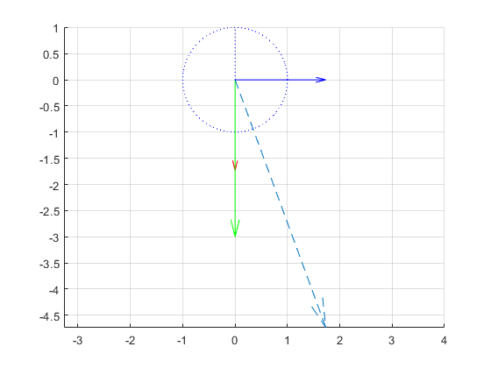

1. x­c(t)

xc = cos(120 * pi * tt + (3*pi)/4) + cos(120 * pi * tt + (5*pi)/4) + (2 * sin(120 * pi * tt - pi/4)) + (2 * sin(120 * pi * tt + pi/4));

xxc = -real( ...

( exp(1j * 120 * pi * tt) * exp(1j * 3*pi/4) ) + ...

( exp(1j * 120 * pi * tt) * exp(1j * 5*pi/4 ) ) + ...

( 2 * (-exp(1j * 120 * pi * tt) * exp( -1j * 3*pi/4 ) ) ) + ...

( 2 * (exp(-1j * 120 * pi * tt) * exp( 1j * -pi/4 ) ) ) ...

);

xc1 = exp(1j * 3*pi/4);

xc2 = exp(1j * 5*pi/4);

xc3 = 2 * exp( -1j * 3*pi/4 );

xc4 = 2 * exp( 1j * -pi/4 );

xc1 Z = X + jY Magnitude Phase Ph/pi Ph(deg)

-0.7071 0.7071 1 2.356 0.750 135.00

xc2 Z = X + jY Magnitude Phase Ph/pi Ph(deg)

-0.7071 -0.7071 1 -2.356 -0.750 -135.00

xc3 Z = X + jY Magnitude Phase Ph/pi Ph(deg)

-1.414 -1.414 2 -2.356 -0.750 -135.00

xc4 Z = X + jY Magnitude Phase Ph/pi Ph(deg)

1.414 -1.414 2 -0.785 -0.250 -45.00

xc1 + xc2 + xc3 + xc4 Z = X + jY Magnitude Phase Ph/pi Ph(deg)

-1.414 -2.828 3.162 -2.034 -0.648 -116.57

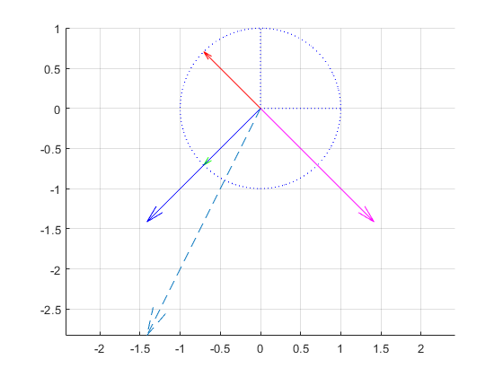

**Problem 4**

1. 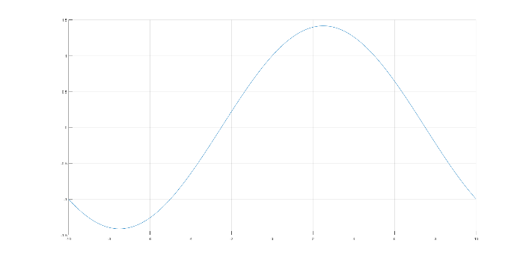ω0 = 0.1π

1 period included in -10 < t < 10

**Problem 5**

$x\left(t\right)=1+\cos\left(300πt+\frac{π}{2}\right)+0.6\cos\left(2\left(300π\right)t+\frac{π}{5}\right)$

$y\left(t\right)=2x\left(t\right)+10\cos\left(250π\left(t-0.002\right)\right)$

**Problem 6**

1. Dc component: -2.5

ω = π

$x\left(t\right)= -2.5+7.5\sin\left(πt\right)$ $$x\left(t\right)= -2.5+7.5\cos\left(πt-\frac{π}{2}\right)$$

$@-π, 3.75 e^{-j\frac{π}{2}}$ $$@ 0, -2.5 \\ @π, 3.75e^{j\frac{π}{2}}$$

1. @ frequency 4 Hz, peak @ 2251.8

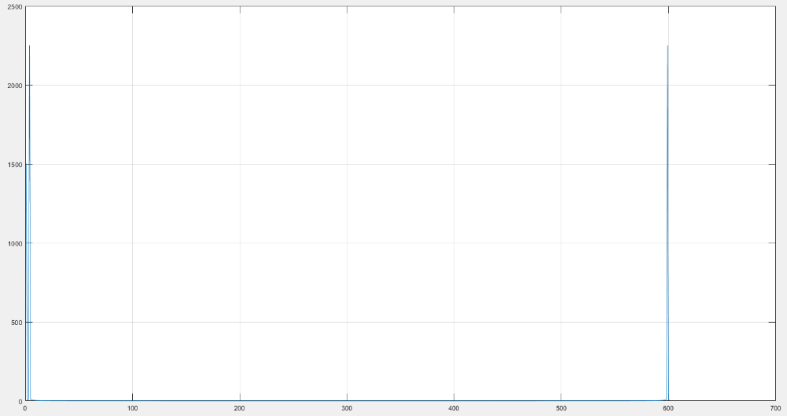@ frequency 600 Hz, peak @ 2251.8