**ECES-352**

**Winter 2019**

**Homework #3**

Reading: In Signal Processing First, Chapter 3 on Spectrum Representation.

Your homework is due at the beginning of class each Tuesday. See syllabus for late policy.

**Problem 1**

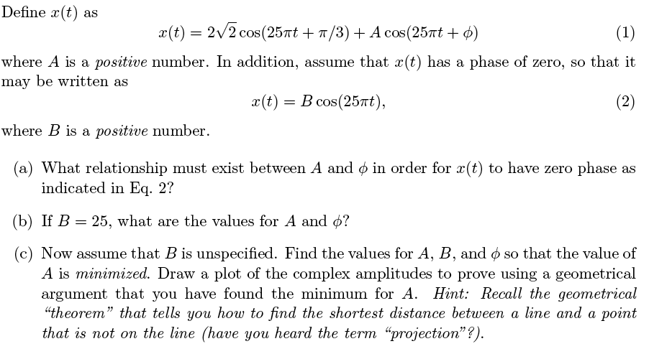

**Problem 2**

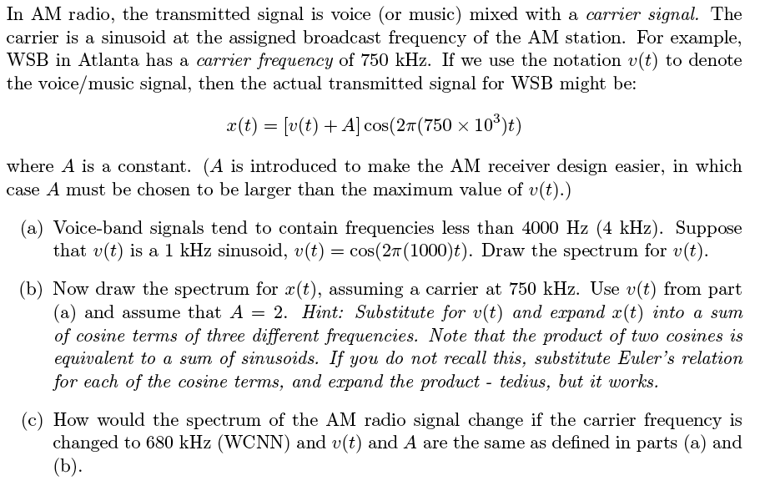

**Problem 4**

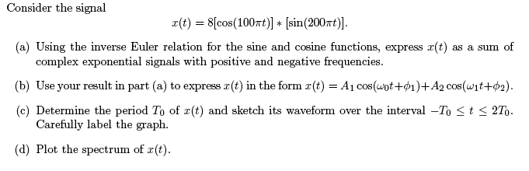

**Problem 5**

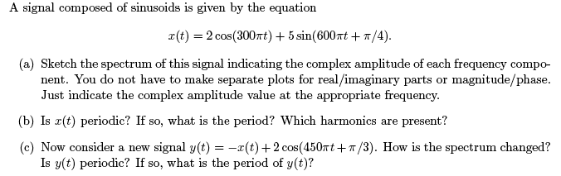

**Problem 6**

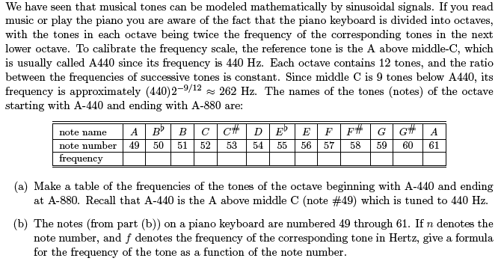

Problem 7

