**Problem 1**

(a)

**Problem 2**

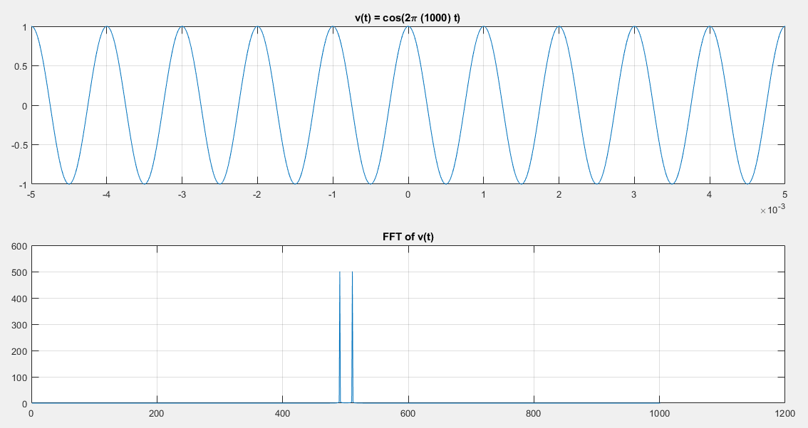(a)

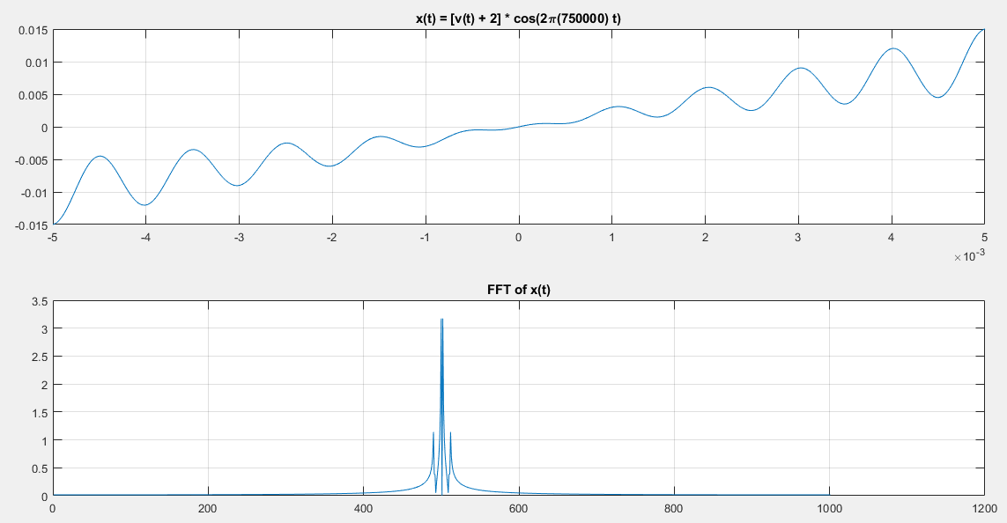(b)

(c) The spectrum does not change as the carrier frequency is changed.

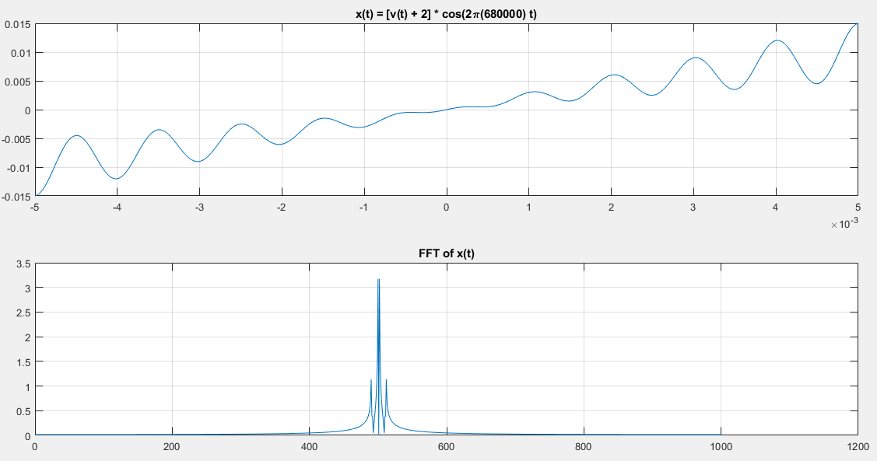

**Problem 4**

(a)

$$x\left(t\right)=8\left[\cos\left(100πt\right)\right]*\left[\sin\left(200πt\right)\right] \\ =8\left[\frac{1}{2} \left(e^{j100πt}+e^{-j100πt}\right)\right]*\left[\frac{1}{2j}\left(e^{j200πt}-e^{-j200πt}\right)\right] \\ =\left(4e^{j100πt}+4e^{-j100πt}\right)*\left(\frac{1}{2j}e^{j200πt}-\frac{1}{2j}e^{-j200πt}\right)$$

(b)

$$x\left(t\right)=8\cos\left(100πt+0\right)*\cos\left(200πt+\frac{π}{2}\right)$$

(c)

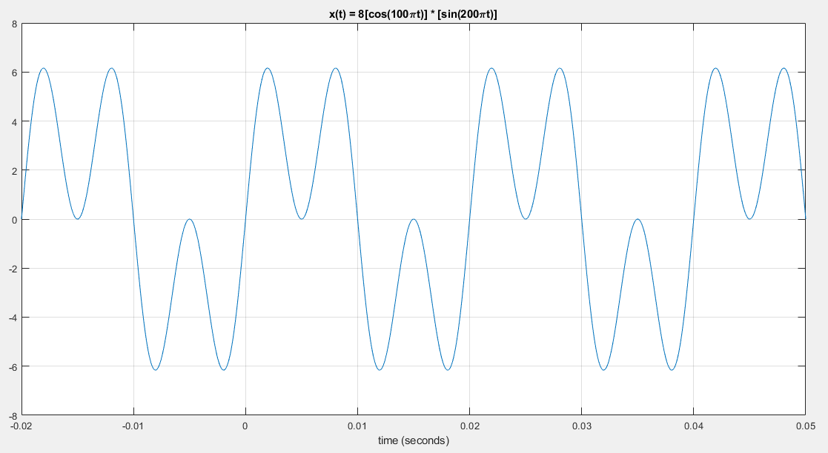

(d)

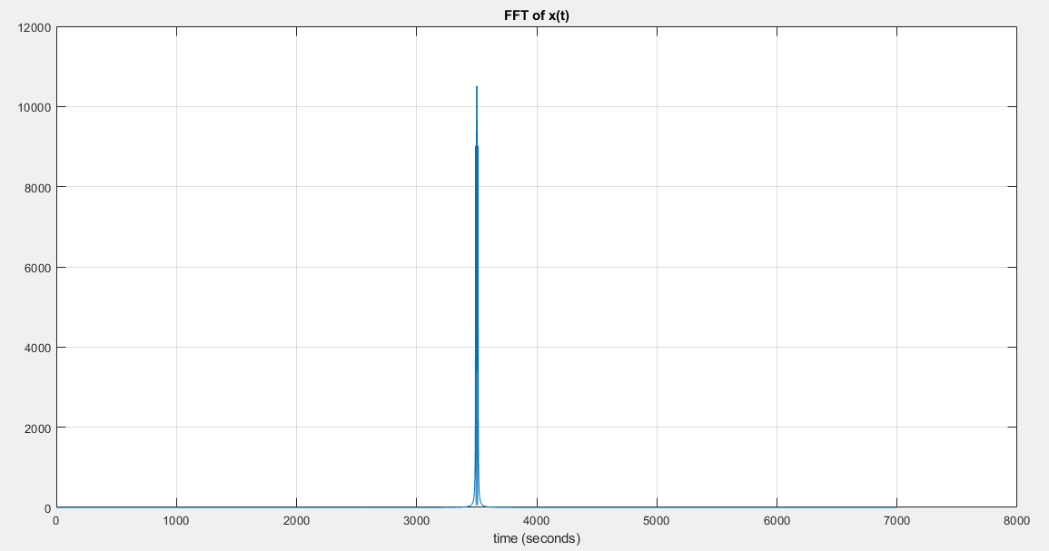

**Problem 5**

(a)

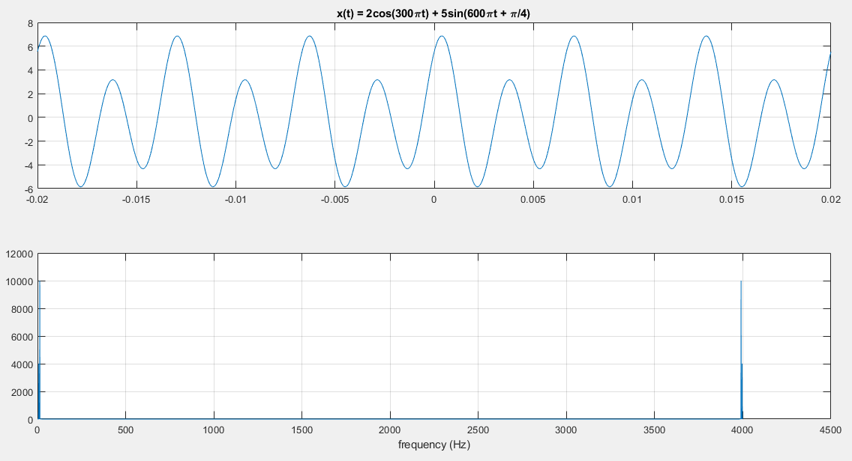

(b) x(t) is periodic with period 0.0067. There are harmonics at:

|  |  |
| --- | --- |
| **Frequency (Hz)** | **Power** |
| 7 | 10002 |
| 13 | 4006 |
| 3990 | 4006 |
| 3996 | 10002 |

(c) The frequency spectrum has not changed. y(t) is periodic with period 0.0133.

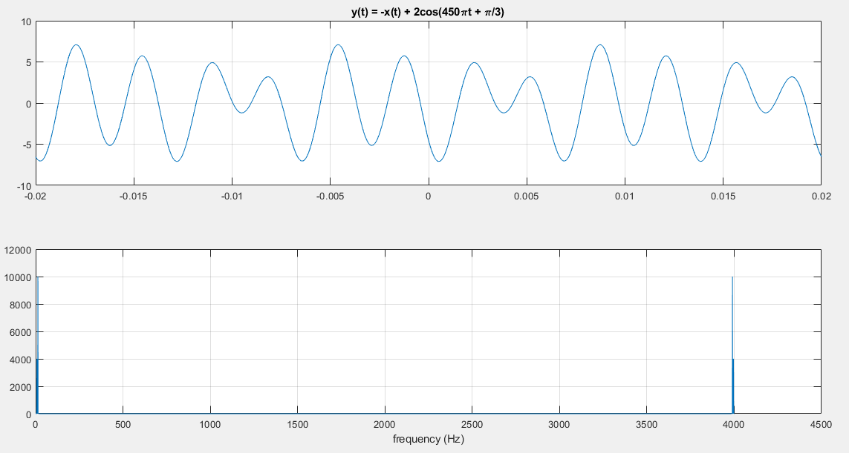

**Problem 6**

(a)

|  |  |  |
| --- | --- | --- |
| Note name | Note number | frequency |
| A | 49 | 440 |
| Bb | 50 | 466.16 |
| B | 51 | 493.88 |
| C | 52 | 523.25 |
| C# | 53 | 554.37 |
| D | 54 | 587.33 |
| Eb | 55 | 622.25 |
| E | 56 | 659.25 |
| F | 57 | 698.46 |
| F# | 58 | 739.99 |
| G | 58 | 783.99 |
| G# | 60 | 830.61 |
| A | 61 | 880 |

(b)

$$f_{n}=\left(440Hz\right)*2^{\frac{n}{12}}$$ fn = frequency of note n

n = steps away from 49 (440Hz) (i.e. for note 50, n=1)

**Problem 7**

$b_{k}=6+2*\sum{a_{k}}$

$b_{k}=3+\sum{a_{k}}$