**ECES-352**

**Winter 2019**

**Homework #4**

**Reading: Chapter 3 on Spectrum Representation and beginning of Chapter 4 on Sampling.**

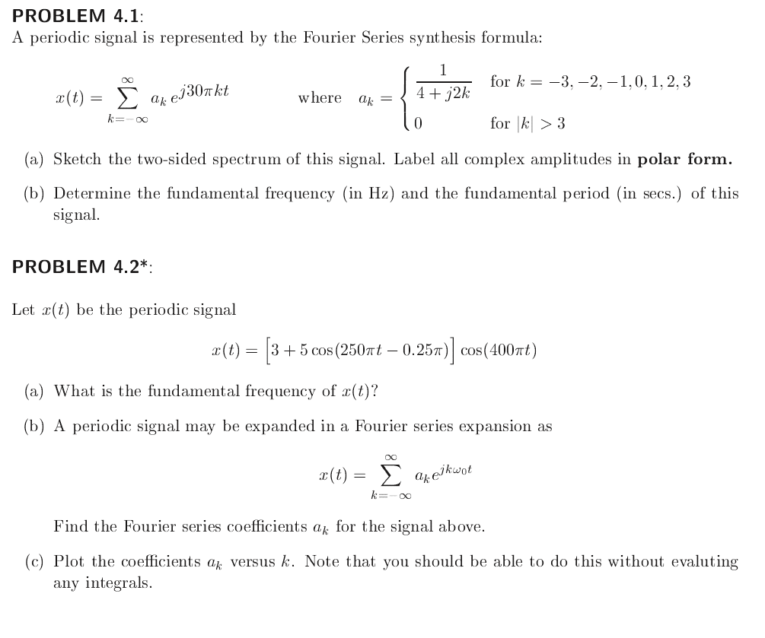

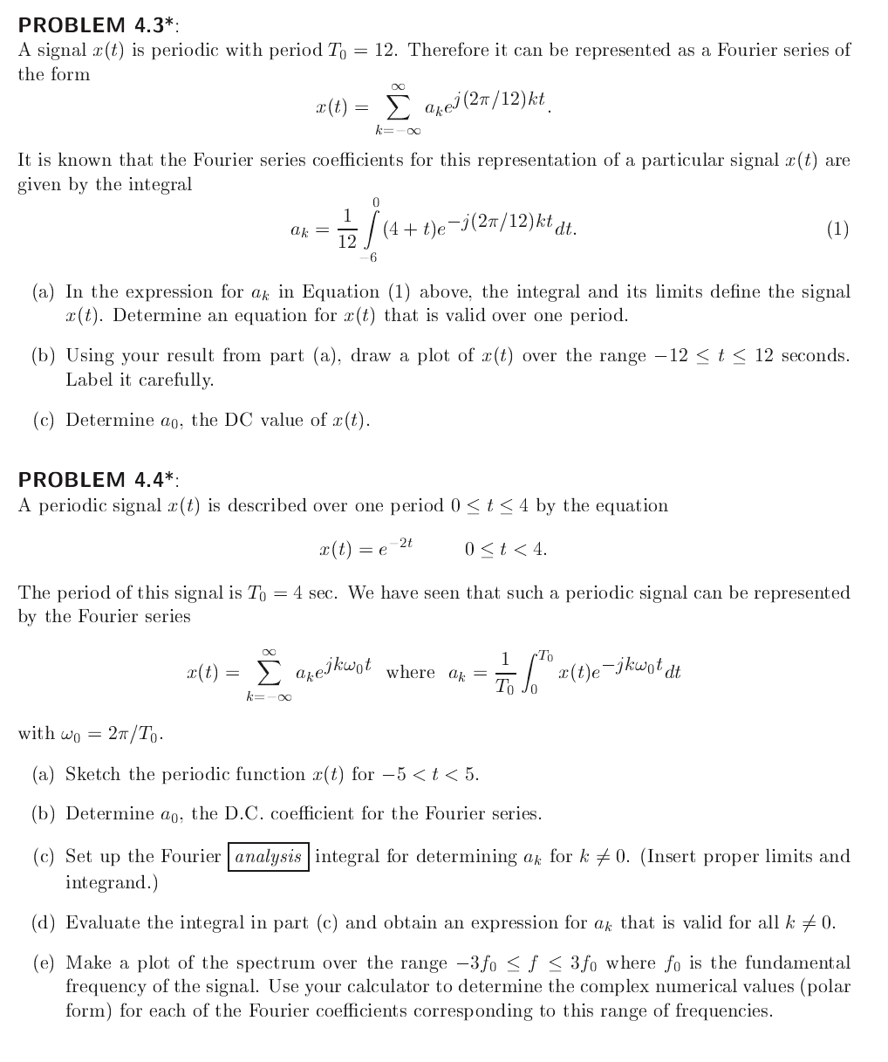

**PROBLEM 4.5**

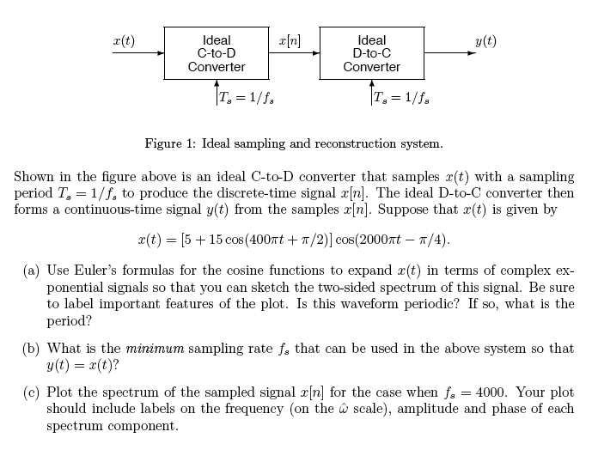**PROBLEM 4.6**

