**Problem 4.1**

**a) Sketch the two-sided spectrum of this signal. Label all complex amplitudes in polar form**

$$k= -3, \frac{1}{4-j6}e^{-j90πt}=\frac{1}{7.2e^{-j0.983}}e^{-j90πt} \\ k= -2, \frac{1}{4-j4}e^{-j60πt}=\frac{1}{5.66e^{-j0.785}}e^{-j60πt} \\ k= -1, \frac{1}{4-j2}e^{-j30πt}=\frac{1}{4.47e^{-j0.464}}e^{-j30πt}$$

$$k= 0, \frac{1}{4} \\ k= 1, \frac{1}{4+j2}e^{j30πt}=\frac{1}{4.47e^{j0.464}}e^{j30πt}$$

$$k= 2, \frac{1}{4+j4}e^{j60πt}=\frac{1}{5.66e^{j0.785}}e^{j60πt} \\ k= 3, \frac{1}{4+j6}e^{j90πt}=\frac{1}{7.2e^{j0.983}}e^{j90πt}$$

**b) Determine the fundamental frequency (in Hz) and the fundamental period (in secs. Of this signal.**

$$f_{0}=30π \\ T_{0}=\frac{1}{30π}$$

**Problem 4.2**

**a) What is the fundamental frequency of x(t)?**

$$x\left(t\right)=3\cos\left(8\left(50π\right)t\right)+5\cos\left(5\left(50π\right)t-0.25π\right)\cos\left(8\left(50π\right)t\right)$$

$$ω_{0}=50π \\ ω_{0}=\frac{2π}{T_{0}}, T_{0}=\frac{2π}{50π}=0.04$$

**b) A periodic signal may be expanded in a Fourier series expansion as $x\left(t\right)=\sum_{k=-∞}^{∞}{a_{k}e^{jkω_{0}t}}$. Find the Fourier series coefficients ak for the signal above.**

$$a_{k}=\frac{1}{T_{0}}\int_{0}^{T_{0}}{x\left(t\right)e^{-jkω_{0}t}dt}$$

$$a_{k}=\frac{1}{0.04}\int_{0}^{0.04}{x\left(t\right)e^{-jkω_{0}t}dt} \\ a_{k}=\frac{1}{2}A_{k}e^{jϕ_{k}}$$

**c) Plot the coefficients ak versus k. Note that you should be able to do this without evaluating any integrals**

**Problem 4.3**

**a) In the expression for ak in Equation (1) above, the integral and its limits define the signal x(t). Determine an equation for x(t) that is valid over one period.**

$$a_{k}=\frac{1}{12}\int_{0}^{12}{\left(4+t\right)e^{-j\left(\frac{2π}{12}\right)kt}dt}$$

**b) Using your result from part (a), draw a plot 9f x(t) over the range -12 <= t <= 12 seconds. Label it carefully.**

**c) Determine a0, the DC value of x(t).**

$$a_{0}=\frac{1}{12}\int_{0}^{T_{0}}{(4+t)dt}$$

**Problem 4.4**

**a) Sketch the periodic function x(t) for -5 <= t <= 5**

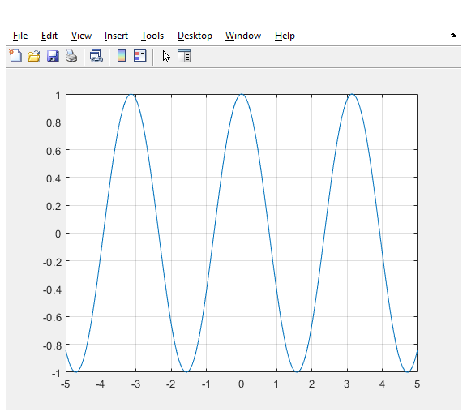

**b) Determine a0, the DC coefficient for the Fourier series.**

$$a_{0}=\frac{1}{4}\int_{0}^{4}{\left(e^{-2t}\right)dt}$$

**c) Set up the Fourier analysis integral for determining ak for k != 0**

$$a_{k}=\frac{1}{4}\int_{0}^{4}{\left(e^{-2t}\right)e^{-jk\frac{π}{2} t}dt}$$

**d) Evaluate the integral in part (c) and obtain an expression for ak that is valid for all k != 0**

**e) Make a plot of the spectrum over the range -3f0 <= f <= 3f0 where f0 is the fundamental frequency of the signal.**

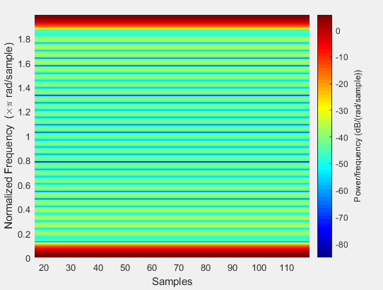

**Problem 4.5**

**a) Use Euler’s formulas for the cosine functions to expand x(t) in terms of complex exponential signals so that you can sketch the two-sided spectrum of the signal. Is the waveform periodic? What is the period?**

$$x\left(t\right)=5\cos\left(2000πt-\frac{π}{4}\right)+15\cos\left(400πt+\frac{π}{2}\right)\cos\left(2000πt-\frac{π}{4}\right) \\ =5\left(\frac{1}{2}\left(e^{j2000πt-\frac{π}{4}}+e^{-j2000πt-\frac{π}{4}}\right)\right)+15\left(\frac{1}{2}\left(e^{j400πt+\frac{π}{2}}+e^{-j400πt+\frac{π}{2}}\right)\left(e^{j2000πt-\frac{π}{4}}+e^{-j2000πt-\frac{π}{4}}\right)\right)$$

$$=5+15\left(\frac{1}{2}e^{j\frac{π}{2}}\left(e^{j400πt}+e^{-j400πt}\right)\right)\left(\frac{1}{2}e^{-j\frac{π}{4}}\left(e^{j2000πt}+e^{-j2000πt}\right)\right)$$

$$ω_{0}=400π=\frac{2π}{T_{0}}$$

$$T_{0}=\frac{2π}{400π}=0.005 \\ f_{0}=\frac{1}{0.005}=200$$

**b) What is the minimum sampling rate fs that can be used in the above system so that y(t) = x(t)?**

$$f_{s} must be at least= 2*f_{0}+\left(a little\right)to avoid aliasing (Nyquist rate)$$

**c) Plot the spectrum of the sampled signal x[n] for the case when fs = 4000.**

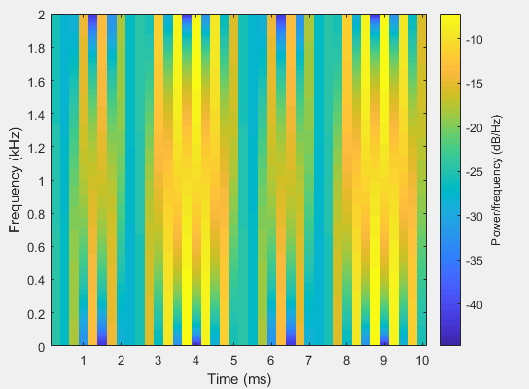

**Problem 4.6**

**a) Draw the spectrum @ fsi = 10000 samples/sec**

