**ECES-352**

**Winter2014**

**Homework #5**

Reading: Chapter 4 on Sampling

**PROBLEM 1**

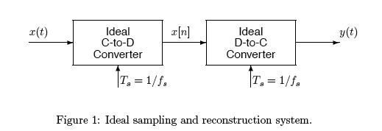

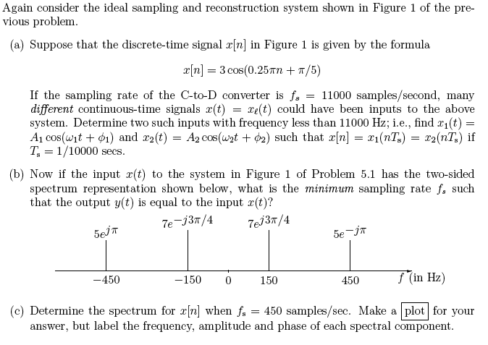

**PROBLEM 2**

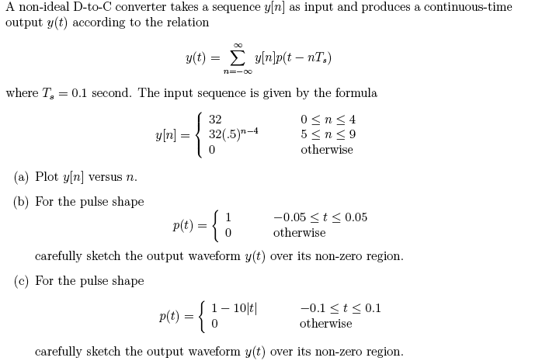

**PROBLEM 3**

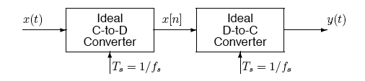

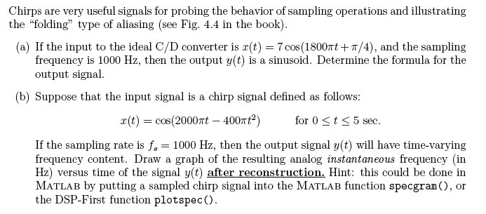

**PROBLEM 4**

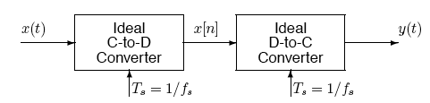

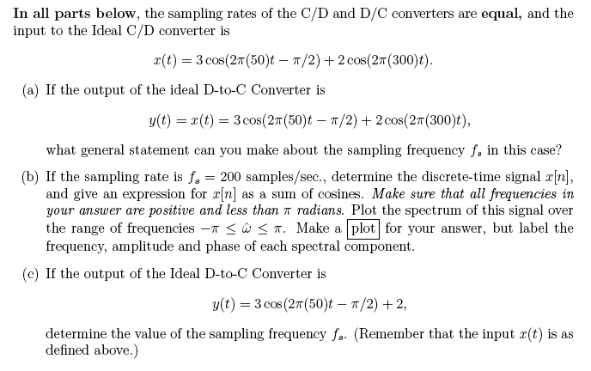

**PROBLEM 5**

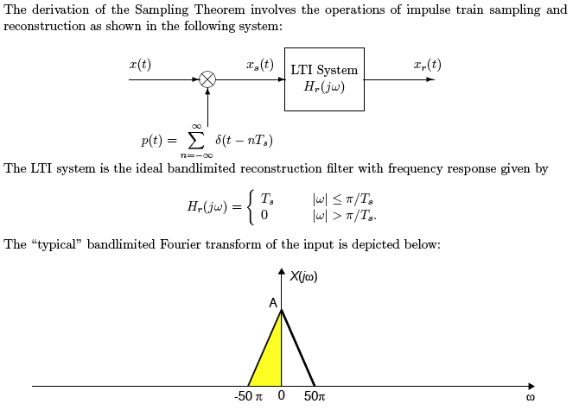

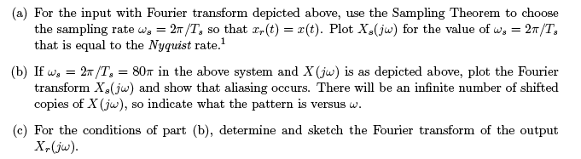

**PROBLEM 6**

1. Determine the DTFT of the following signals:
2. x[n]= δ[n-3]
3. x[n]= ½ δ[n+1] + δ[n] + ½ δ[n-1]
4. x[n]=(1/4)n-3 u[n-3]
5. x[n]=u[n+3]-u[n-4]
6. Consider a radix-2 16-point FFT. Please answer the following questions assuming a butterfly-type decimation-in-time implementation discussed in class.
7. How many butterfly stages are required?
8. How many butterflies per stage are required?
9. How many 2-pt butterflies are required in total?
10. Assuming a decimation-in-time FFT, what is the sequential order of the input samples to compute the fft?
11. Extra credit: What is the sequential order of input samples for decimation-infrequency?