**ECES-352**

**Winter 2019**

**Homework #6**

Reading: Chapter 5 on FIR Filters

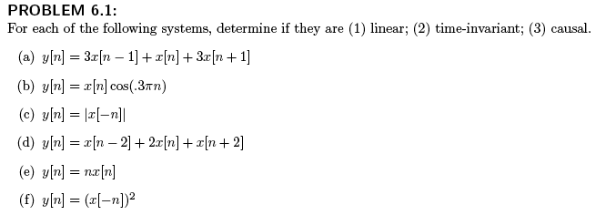

**PROBLEM 6.2**

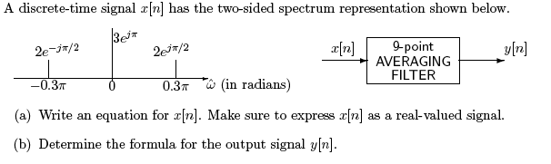

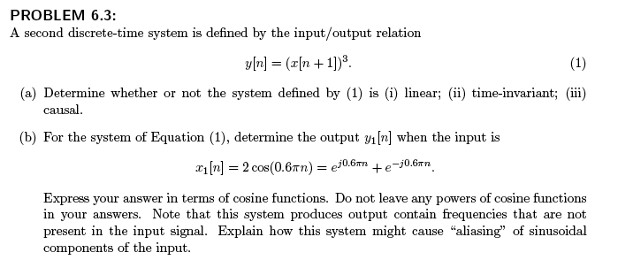

**PROBLEM 6.4**

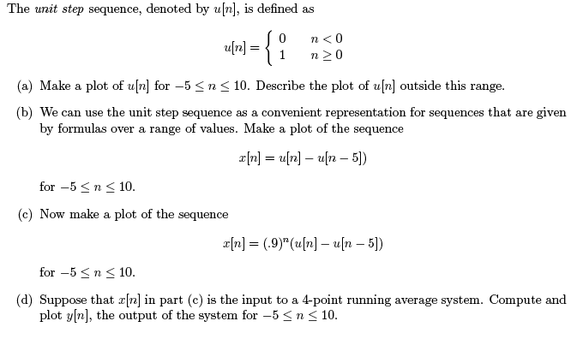

**PROBLEM 6.5**

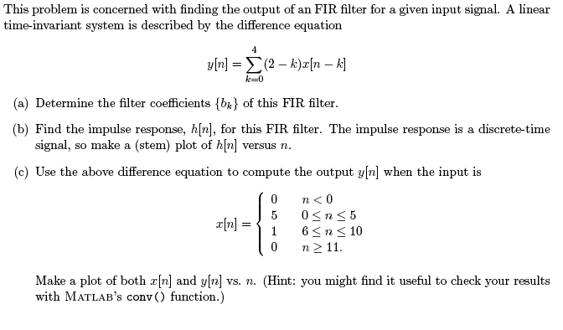

**PROBLEM 6.6**

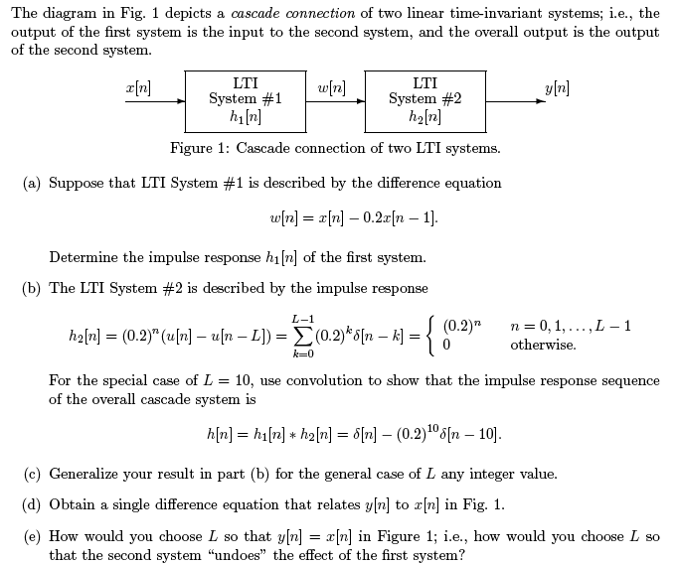

**PROBLEM 6.7**

