**Problem 7.1**

a)

$$y\left[n\right]={\left(Ae^{jϕ}e^{jωn}\right)}^{3}=A^{3}e^{j3ϕ}e^{j3ωn}$$

b) The angular frequency is tripled so we cannot convert the output, y[n], into the form $y\left[n\right]=H(ω)Ae^{jϕ}e^{jωn}$

**Problem 7.2**

a) time invariant

b)

$$y\left[ω\right]=x\left[ω\right]e^{jω}-2x\left[ω\right]+x\left[ω\right]e^{-jω} \\ \frac{y\left[ω\right]}{x\left[ω\right]}=e^{jω}+e^{-jω}-2 \\ H\left[ω\right]=2\left(\frac{e^{jω}+e^{-jω}}{2}\right)-2=2\left(\cos\left(ω\right)-1\right)$$

c)

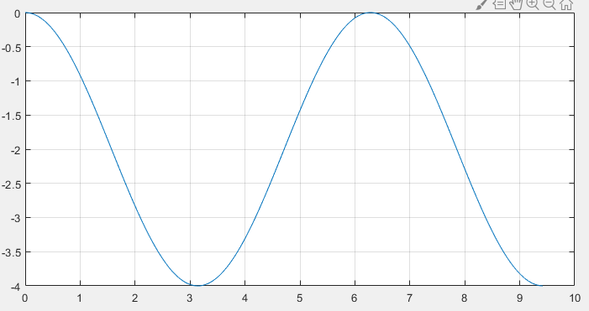

Magnitude response

Phase response

d)

$$y\left[n\right] @ e^{j0.25π}=2\left(\cos\left(e^{j0.25π}\right)-1\right)e^{j0.25π}$$

$$y\left[n\right] @ e^{-j0.25π}=2\left(\cos\left(e^{-j0.25π}\right)-1\right)e^{-j0.25π}$$

$$y_{1}\left[n\right]=-0.585e^{j0.25π}-0.585e^{-j0.25π}=-1.17\cos\left(0.25π\right)$$

e)

$$y_{2}\left[n\right]=2\left(\cos\left(1+cos\left(0.25π\left(n-1\right)\right)\right)-1\right)$$

**Problem 7.3**

b) $H_{1}\left(ω\right)=1-e^{jω}$

c)

$$H_{2}\left(ω\right)=\frac{1}{1-e^{-jω}}\left(1-e^{-jω10}\right)$$

d)

$$h_{1}\left[n\right]*h_{2}\left[n\right]=\left(δ\left[n\right]-δ\left[n-1\right]\right)*h_{2}\left[n\right] \\ =h_{2}\left[n\right]=h_{2}\left[n-1\right]=u\left[n\right]-u\left[n-10\right]-u\left[n-1\right]+u\left[n-11\right] \\ \left(u\left[n\right]-u\left[n-1\right]\right)-\left(u\left[n-10\right)-u\left[n-11\right]\right)=δ\left[n\right]-δ[n-10]$$

e)

$$H\left(z\right)=1-z^{-10}=1-e^{-jω10}$$

f)

$$H_{1}\left(ω\right)H_{2}\left(ω\right)=\left(1-e^{-jω}\right)\left(1-e^{-jω10}\right)=1-e^{-jω10}=H(ω)$$

**Problem 7.4**

a)

$$H\left(e^{jω}\right)=\frac{Y_{1}\left(e^{jω}\right)}{X_{1}\left(e^{jω}\right)}=e^{-jω}-e^{-j2ω} \\ Y_{1}\left(e^{jω}\right)=X_{1}\left(e^{jω}\right)e^{-jω}-e^{-j2ω}\left(e^{jω}\right) \\ Y_{1}\left(n\right)=x_{1}\left(n+1\right)-x_{1}\left(n+2\right)$$

b)

$$H_{2}\left(e^{jω}\right)=1+e^{-j2ω} \\ H_{3}\left(e^{jω}\right)=2e^{-jω}+2e^{-j2ω}$$

c)

$$H\left(e^{jω}\right)=H_{1}\left(e^{jω}\right)×H_{2}\left(e^{jω}\right)×H_{3}\left(e^{jω}\right) \\ =\left(e^{-jω}-e^{-j2ω}\right)\left(1+e^{-j2ω}\right)\left(2e^{-jω}+2e^{-j2ω}\right) \\ =2e^{-j2ω}-2e^{-j6ω}$$

d)

$$\frac{Y_{1}\left(e^{jω}\right)}{X_{1}\left(e^{jω}\right)}=2e^{-j2ω}-2e^{-j6ω} \\ Y\left(e^{jω}\right)=2e^{-j2ω}×e^{jω}-2e^{-j6ω}×e^{jω} \\ =2x\left(n-2\right)-2x(n-6)$$

**Problem 7.5**

a)

$$\left(1+e^{-jω}\right)\left(1-e^{j\frac{π}{3}}e^{-jω}\right)\left(1-e^{-j\frac{π}{3}}e^{-jω}\right)$$

$$=\left(1+e^{-jω}\right)\left[1-\left(e^{j\frac{π}{3}}+e^{-j\frac{π}{3}}\right)e^{-jω}+e^{-j2ω}\right] \\ =1-2e^{-jω}+2e^{-j2ω}-e^-j3ω$$

b)

$$h\left[n\right]=δ\left[n\right]-2δ\left[n-1\right]+2δ\left[n-2\right]-δ[n-3]$$

c)

$$\left(1-e^{-jω}\right)=0 \\ \left(1-e^{\frac{jπ}{3}}e^{-jω}\right)=0 \\ \left(1-e^{-\frac{jπ}{3}}e^{-jω}\right)=0$$

$$\left(e^{jω}-e^{\frac{jπ}{3}}\right)=0$$

$$e^{jω}=e^{\frac{jπ}{3}}→ω=\frac{π}{3}$$