**ECES-352**

**Winter 2019**

**Homework #8**

Reading: Chapter 9 on Z-transform

**Problem 8.1**

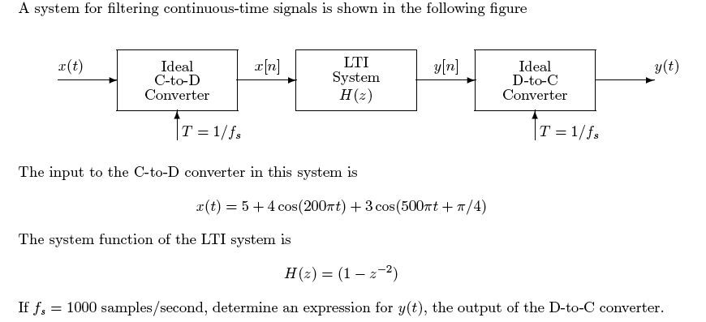

**Problem 8.2**

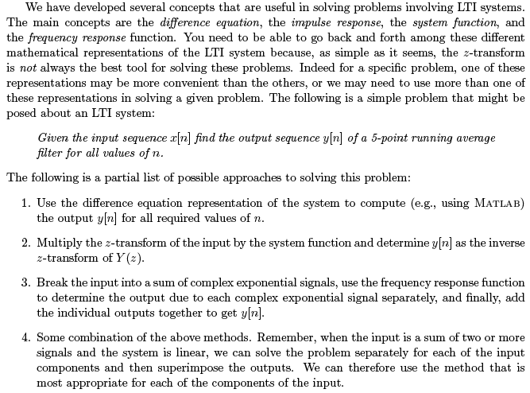

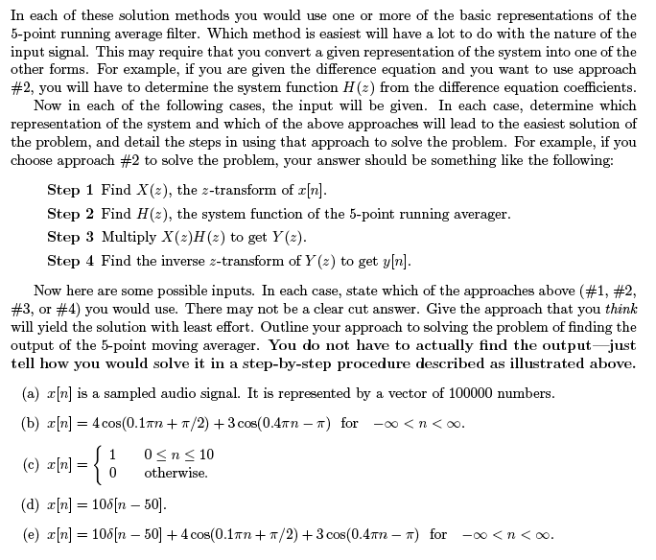

**Problem 8.3**

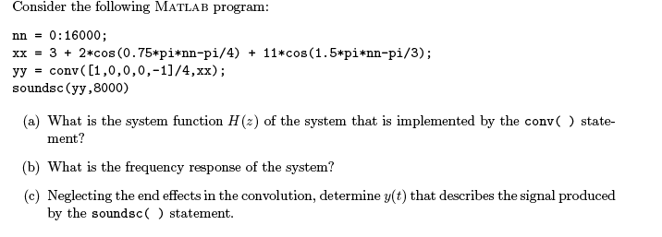

**Problem 8.4**

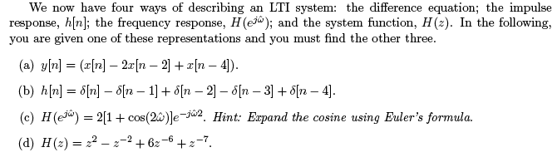

**Problem 8.5**

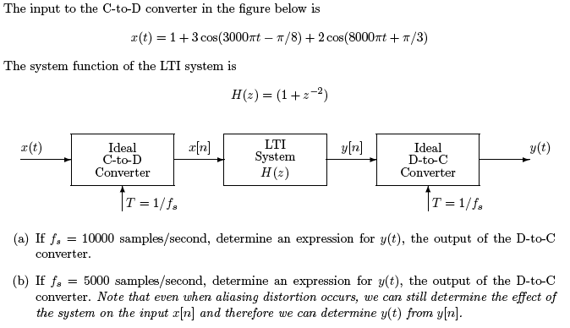

**Problem 8.6**

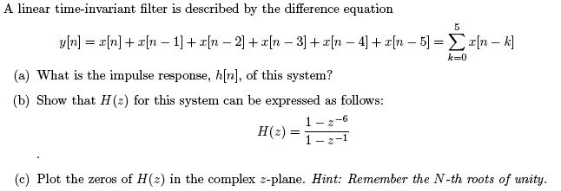

**Problem 8.7**

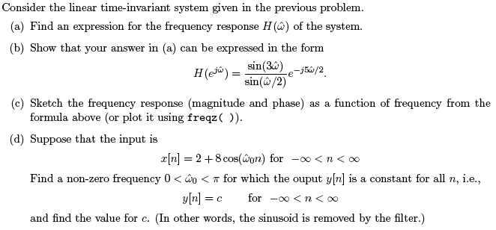

**Problem 8.8**

