Jonah Rubino, Yoni Carver

ECES 435 - Dr. Matthew Stamm

Assignment #1

**Question 1**

See attached pages X-X for the gamma correction code for this part of the experiment.

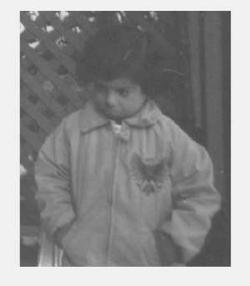

**Figure 1: Image read only through *imread* command**



**Figure 2: Gamma corrected image with γ = 2**

When the image is subjected to a gamma correction where the gamma value is set to 2, all of the pixels increase in value which means they will get darker. For this image, a gamma value of two turns the image completely black.



**Figure 3: Gamma corrected image with γ = 2**

When gamma is set to a number between 0 and 1, it causes the value of each pixel to decrease as they are being raised to a decimal exponent. When this image is subjected to a gamma value of .75, the values become so low they only show white.

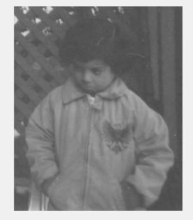

**Figure 4: Gamma corrected image with γ = 1**

When the image is subjected to a gamma equal to 1, it doesn’t enhance the image in any way. The image seen in figure 4 is the same as the image seen in figure 1.

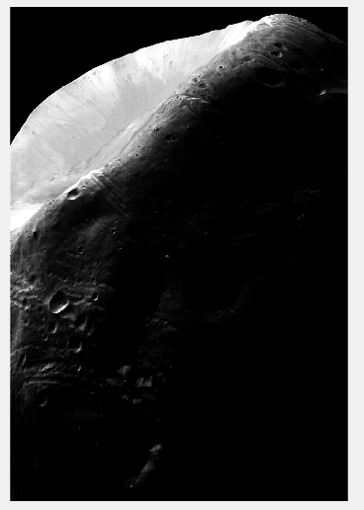

**Figure 5: Image read through MATLAB *imread* command**

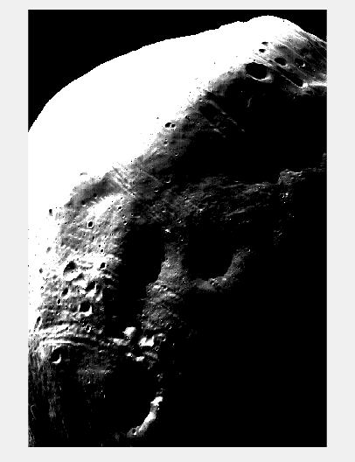

**Figure 6: Gamma corrected image with γ = .72**

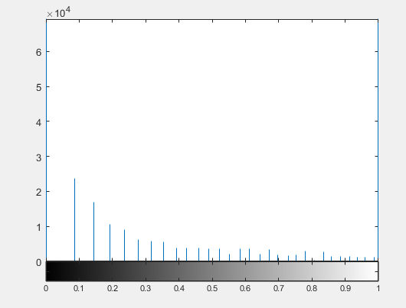

**Figure 7: Pixel value histogram for gamma corrected image**

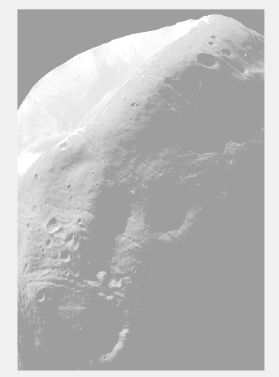

**Figure 8: Image read through the MATLAB *histeq* command**

When comparing figure 8 to figure 6, the image shown by the histeq command is better to enhance the image. More detail can be seen in this image in all areas. The image enhanced by gamma correction does show more detail in the lower part of the moon than the original image. However, the upper part has too light of pixels that become lighter with a less than one gamma. However, the bottom area of the moon is too dark to use any gamma greater than 1. Gamma being set to .72 shows the most detail it can, with showing a bit of the upper half of the image. Since this code is rudimentary, it is recommended to use the built in MATLAB command for a more detailed image.