**Part 1 – Verifying an Image’s Source Using JPEG Quantization Tables**

1. What are the camera manufacturer and camera model reported in the metadata tags (Exif) for each image?
2. Does each image have metadata tags specifying the camera manufacturer and model?
3. What are the luminance and chrominance quantization tables for each image?
4. Do these quantization tables match the camera reported in each image's metadata?
5. If not, does JPEGsnoop report that these quantization tables match those used by any image editing software?
6. Furthermore, if JPEGsnoop doesn't find a match between the quantization tables and the metadata tags, does this mean that the image's origin has been falsified? Why or why not?

If JPEGsnoop doesn’t find a match between the quantization tables and metadata tags, this does not mean that the image was falsified. It is possible that the metadata tags have been removed or that there is no entry in the built-in database that matches. It is possible that someone may have opened or re-saved the original image using a program or editor that removes the header data without editing any piece of the original image.

*imageOrigin1.jpg*

1. Canon PowerShot A75
2. Yes, metadata tags specify camera manufacturer and model

*** Marker: DQT (xFFDB) ***

Define a Quantization Table.

Precision=8 bits

Destination ID=0 (Luminance)

DQT, Row #0: 1 1 1 2 3 6 8 10

DQT, Row #1: 1 1 2 3 4 8 9 8

DQT, Row #2: 2 2 2 3 6 8 10 8

DQT, Row #3: 2 2 3 4 7 12 11 9

DQT, Row #4: 3 3 8 11 10 16 15 11

DQT, Row #5: 3 5 8 10 12 15 16 13

DQT, Row #6: 7 10 11 12 15 17 17 14

DQT, Row #7: 14 13 13 15 15 14 14 14

Approx quality factor = 92.96 (scaling=14.08 variance=5.28)

----

Precision=8 bits

Destination ID=1 (Chrominance)

DQT, Row #0: 4 4 5 9 15 26 26 26

DQT, Row #1: 4 4 5 10 19 26 26 26

DQT, Row #2: 5 5 8 9 26 26 26 26

DQT, Row #3: 9 10 9 13 26 26 26 26

DQT, Row #4: 15 19 26 26 26 26 26 26

DQT, Row #5: 26 26 26 26 26 26 26 26

DQT, Row #6: 26 26 26 26 26 26 26 26

DQT, Row #7: 26 26 26 26 26 26 26 26

Approx quality factor = 88.24 (scaling=23.52 variance=21.42)

*** Embedded JPEG Thumbnail ***

Precision=8 bits

Destination ID=0 (Luminance, typically)

DQT, Row #0: 9 6 5 9 13 22 29 35

DQT, Row #1: 6 6 8 11 15 33 34 30

DQT, Row #2: 8 7 9 13 22 33 39 31

DQT, Row #3: 8 9 12 16 28 49 45 34

DQT, Row #4: 10 12 21 32 39 61 58 42

DQT, Row #5: 13 19 31 36 45 58 63 51

DQT, Row #6: 28 36 44 49 58 68 66 55

DQT, Row #7: 41 52 54 55 62 56 57 54

----

Precision=8 bits

Destination ID=1 (Chrominance, typically)

DQT, Row #0: 9 9 12 20 15 26 79 79

DQT, Row #1: 9 10 12 10 26 26 79 79

DQT, Row #2: 12 12 10 10 26 79 79 79

DQT, Row #3: 20 10 10 26 79 79 79 79

DQT, Row #4: 15 26 26 79 79 79 79 79

DQT, Row #5: 26 26 79 79 79 79 79 79

DQT, Row #6: 79 79 79 79 79 79 79 79

DQT, Row #7: 79 79 79 79 79 79 79 79

1. No, quantization tables do not match
2. No, no reported image editing software

*imageOrigin2.jpg*

1. Minolta Co., Ltd. DiMAGE S304
2. Yes, metadata tags specify camera manufacturer and model

*** Marker: DQT (xFFDB) ***

Define a Quantization Table.

OFFSET: 0x000047B5

Table length = 132

----

Precision=8 bits

Destination ID=0 (Luminance)

DQT, Row #0: 1 1 4 5 6 5 2 5

DQT, Row #1: 1 2 6 5 1 2 8 5

DQT, Row #2: 1 1 2 1 1 8 3 6

DQT, Row #3: 1 1 1 1 6 2 8 12

DQT, Row #4: 1 2 5 1 7 10 10 12

DQT, Row #5: 4 6 2 10 11 8 10 11

DQT, Row #6: 5 3 10 9 7 7 9 10

DQT, Row #7: 5 6 4 6 9 9 10 9

Approx quality factor = 94.65 (scaling=10.71 variance=62.00)

----

Precision=8 bits

Destination ID=1 (Chrominance)

DQT, Row #0: 1 1 9 9 9 9 9 9

DQT, Row #1: 2 9 9 9 2 9 9 9

DQT, Row #2: 4 1 9 2 6 9 9 9

DQT, Row #3: 2 6 5 4 9 9 9 9

DQT, Row #4: 2 9 9 9 9 9 9 9

DQT, Row #5: 9 9 9 9 9 9 9 9

DQT, Row #6: 9 9 9 9 9 9 9 9

DQT, Row #7: 9 9 9 9 9 9 9 9

Approx quality factor = 94.92 (scaling=10.16 variance=47.37)

1. Yes, the quantization tables match
2. n/a

*imageOrigin3.jpg*

1. Canon PowerShot SD400
2. Yes, metadata tags specify camera manufacturer and model

*** Marker: DQT (xFFDB) ***

Define a Quantization Table.

OFFSET: 0x00001E0D

Table length = 132

----

Precision=8 bits

Destination ID=0 (Luminance)

DQT, Row #0: 1 1 2 2 3 3 7 14

DQT, Row #1: 1 1 2 2 3 5 10 13

DQT, Row #2: 1 2 2 3 8 8 11 13

DQT, Row #3: 2 3 3 4 11 10 12 15

DQT, Row #4: 3 4 6 7 10 12 15 15

DQT, Row #5: 6 8 8 12 16 15 17 14

DQT, Row #6: 8 9 10 11 15 16 17 14

DQT, Row #7: 10 8 8 9 11 13 14 14

Approx quality factor = 92.73 (scaling=14.53 variance=19.39)

----

Precision=8 bits

Destination ID=1 (Chrominance)

DQT, Row #0: 4 4 5 9 15 26 26 26

DQT, Row #1: 4 4 5 10 19 26 26 26

DQT, Row #2: 5 5 8 9 26 26 26 26

DQT, Row #3: 9 10 9 13 26 26 26 26

DQT, Row #4: 15 19 26 26 26 26 26 26

DQT, Row #5: 26 26 26 26 26 26 26 26

DQT, Row #6: 26 26 26 26 26 26 26 26

DQT, Row #7: 26 26 26 26 26 26 26 26

Approx quality factor = 88.24 (scaling=23.52 variance=21.42)

*** Embedded JPEG Thumbnail ***

Precision=8 bits

Destination ID=0 (Luminance, typically)

DQT, Row #0: 9 6 8 8 10 13 28 41

DQT, Row #1: 6 6 7 9 12 19 36 52

DQT, Row #2: 5 8 9 12 21 31 44 54

DQT, Row #3: 9 11 13 16 32 36 49 55

DQT, Row #4: 13 15 22 28 39 45 58 62

DQT, Row #5: 22 33 33 49 61 58 68 56

DQT, Row #6: 29 34 39 45 58 63 66 57

DQT, Row #7: 35 30 31 34 42 51 55 54

----

Precision=8 bits

Destination ID=1 (Chrominance, typically)

DQT, Row #0: 9 9 12 20 15 26 79 79

DQT, Row #1: 9 10 12 10 26 26 79 79

DQT, Row #2: 12 12 10 10 26 79 79 79

DQT, Row #3: 20 10 10 26 79 79 79 79

DQT, Row #4: 15 26 26 79 79 79 79 79

DQT, Row #5: 26 26 79 79 79 79 79 79

DQT, Row #6: 79 79 79 79 79 79 79 79

DQT, Row #7: 79 79 79 79 79 79 79 79

1. No, the quantization tables do not match
2. No, no reported image editing software

*imageOrigin4.jpg*

1. Minolta Co., Ltd. DiMAGE S304
2. No, metadata tags do not specify camera manufacturer and model

*** Marker: DQT (xFFDB) ***

Define a Quantization Table.

OFFSET: 0x000047B5

Table length = 132

----

Precision=8 bits

Destination ID=0 (Luminance)

DQT, Row #0: 4 3 11 14 17 15 8 14

DQT, Row #1: 2 6 17 16 4 6 24 15

DQT, Row #2: 4 3 7 3 4 22 10 18

DQT, Row #3: 3 5 4 4 17 6 23 34

DQT, Row #4: 4 6 16 5 22 29 29 34

DQT, Row #5: 11 19 6 29 32 24 28 32

DQT, Row #6: 16 10 31 26 22 20 28 28

DQT, Row #7: 16 19 14 18 26 27 29 28

Approx quality factor = 83.81 (scaling=32.39 variance=477.61)

----

Precision=8 bits

Destination ID=1 (Chrominance)

DQT, Row #0: 4 5 28 28 28 28 28 28

DQT, Row #1: 6 28 28 28 6 28 28 28

DQT, Row #2: 13 5 28 7 18 28 28 28

DQT, Row #3: 6 18 16 13 28 28 28 28

DQT, Row #4: 7 28 28 28 28 28 28 28

DQT, Row #5: 28 28 28 28 28 28 28 28

DQT, Row #6: 28 28 28 28 28 28 28 28

DQT, Row #7: 28 28 28 28 28 28 28 28

Approx quality factor = 84.00 (scaling=32.00 variance=450.51)

1. Yes, the quantization tables match
2. No reported image editing software but JPEGsnoop indicates that it is uncertain if the image is processed or original

*imageOrigin5.jpg*

1. Sony DSC-V1
2. Yes, metadata tags specify camera manufacturer and model

*** Marker: DQT (xFFDB) ***

Define a Quantization Table.

OFFSET: 0x00001887

Table length = 132

----

Precision=8 bits

Destination ID=0 (Luminance)

DQT, Row #0: 1 1 1 1 2 3 4 5

DQT, Row #1: 1 1 1 2 2 5 5 4

DQT, Row #2: 1 1 1 2 3 5 6 4

DQT, Row #3: 1 1 2 2 4 7 6 5

DQT, Row #4: 1 2 3 4 5 9 8 6

DQT, Row #5: 2 3 4 5 6 8 9 7

DQT, Row #6: 4 5 6 7 8 10 10 8

DQT, Row #7: 6 7 8 8 9 8 8 8

Approx quality factor = 96.06 (scaling=7.87 variance=0.69)

----

Precision=8 bits

Destination ID=1 (Chrominance)

DQT, Row #0: 1 1 2 4 8 8 8 8

DQT, Row #1: 1 2 2 5 8 8 8 8

DQT, Row #2: 2 2 4 8 8 8 8 8

DQT, Row #3: 4 5 8 8 8 8 8 8

DQT, Row #4: 8 8 8 8 8 8 8 8

DQT, Row #5: 8 8 8 8 8 8 8 8

DQT, Row #6: 8 8 8 8 8 8 8 8

DQT, Row #7: 8 8 8 8 8 8 8 8

Approx quality factor = 96.02 (scaling=7.97 variance=0.33)

*** Embedded JPEG Thumbnail ***

Precision=8 bits

Destination ID=0 (Luminance, typically)

DQT, Row #0: 16 11 10 16 24 40 51 61

DQT, Row #1: 12 12 14 19 26 58 60 55

DQT, Row #2: 14 13 16 24 40 57 69 56

DQT, Row #3: 14 17 22 29 51 87 80 62

DQT, Row #4: 18 22 37 56 68 109 103 77

DQT, Row #5: 24 35 55 64 81 104 113 92

DQT, Row #6: 49 64 78 87 103 121 120 101

DQT, Row #7: 72 92 95 98 112 100 103 99

----

Precision=8 bits

Destination ID=1 (Chrominance, typically)

DQT, Row #0: 17 18 24 47 99 99 99 99

DQT, Row #1: 18 21 26 66 99 99 99 99

DQT, Row #2: 24 26 56 99 99 99 99 99

DQT, Row #3: 47 66 99 99 99 99 99 99

DQT, Row #4: 99 99 99 99 99 99 99 99

DQT, Row #5: 99 99 99 99 99 99 99 99

DQT, Row #6: 99 99 99 99 99 99 99 99

DQT, Row #7: 99 99 99 99 99 99 99 99

1. No, the quantization tables do not match
2. GIMP,IrfanView, idImager, FastStone Image Viewer, NeatImage, Paint.NET, Photomatix, XnView

*imageOrigin6.jpg*

1. Sony Cybershot U
2. Metadata shows that there is a subsamp match to the Sony Cybershot U camera

*** Marker: DQT (xFFDB) ***

Define a Quantization Table.

OFFSET: 0x00000014

Table length = 67

----

Precision=8 bits

Destination ID=0 (Luminance)

DQT, Row #0: 8 6 5 8 12 20 26 31

DQT, Row #1: 6 6 7 10 13 29 30 28

DQT, Row #2: 7 7 8 12 20 29 35 28

DQT, Row #3: 7 9 11 15 26 44 40 31

DQT, Row #4: 9 11 19 28 34 55 52 39

DQT, Row #5: 12 18 28 32 41 52 57 46

DQT, Row #6: 25 32 39 44 52 61 60 51

DQT, Row #7: 36 46 48 49 56 50 52 50

Approx quality factor = 74.75 (scaling=50.51 variance=0.81)

*** Marker: DQT (xFFDB) ***

Define a Quantization Table.

OFFSET: 0x00000059

Table length = 67

----

Precision=8 bits

Destination ID=1 (Chrominance)

DQT, Row #0: 9 9 12 24 50 50 50 50

DQT, Row #1: 9 11 13 33 50 50 50 50

DQT, Row #2: 12 13 28 50 50 50 50 50

DQT, Row #3: 24 33 50 50 50 50 50 50

DQT, Row #4: 50 50 50 50 50 50 50 50

DQT, Row #5: 50 50 50 50 50 50 50 50

DQT, Row #6: 50 50 50 50 50 50 50 50

DQT, Row #7: 50 50 50 50 50 50 50 50

Approx quality factor = 74.74 (scaling=50.52 variance=0.19)

1. No
2. Adobe Photoshop 7.0, Apple Quicktime, Digital Photo Professional, IJG Library, MS Paint, MS Visio, ZoomBrowser EX, GIMP, IrfanView, idImager, FastStone Image Viewer, NeatImage, Paint.NET, Photomatix, XnView

**Part 2**

The histogram values for Z’ and Z’’ should be different after any form of image compression. The reason for this is because compression will save the most important bits, which tend to be around the middle of the image. The values of Z’’ should be lower than that of the uncompressed image. Compression can be lossless, but the values calculated for Z’ can show small differences.

For “blockArtifacts1.tif” the attached code, *compressdetect*, determined that this image has a history of compression. The code determined the K value was .4029. The histogram for Z’ and Z’’ can be seen in figure 1. For “blockArtifacts2.tif”, the code determined that this image has no history of compression. The code determined the K value was 0.0925 which is below the threshold. The histogram for Z’ and Z’’ can be seen in figure 2. For “blockArtifacts3.tif”, the code determined that this image has a history of compression. The code determined the K value was .3566. The histogram for Z’ and Z’’ can be seen in figure 3.

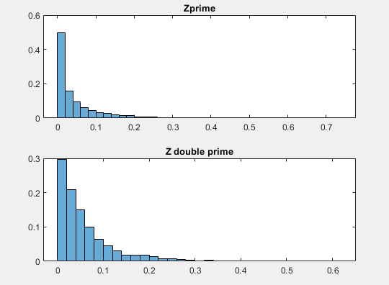

**Figure 1: Histogram plot for Z’ and Z’’ of blockArtifacts1.tif**

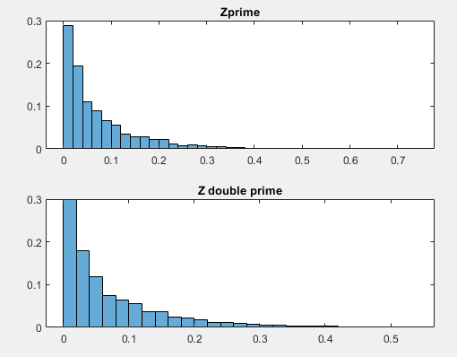

**Figure 2: Histogram plot for Z’ and Z’’ of blockArtifacts2.tif**

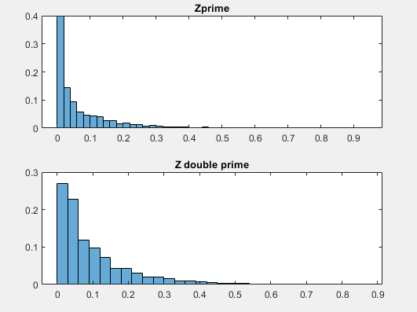

**Figure 3: Histogram plot for Z’ and Z’’ of blockArtifacts3.tif**

%ECES 435 Assignment #4

%Jonah Rubino Yoni Carver

%The purpose of this code is to determine if an imagehas a history of image

%compression by way of the Fan and De Quieroz method

function detection = compressdetect(image)

imd = im2double(image); %converts image to a double

[r,c]= size(imd); %gets size of image

r = r/8; % gets the number of 8x8 rows

c = c/8; %gets the number of 8x8 columns

shape = reshape(imd,8,r, 8, c); %creates the 8x8 blocks

blocks = permute(shape, [1 3 2 4]); %concatenates the blocks to form the image made of 8x8 blocks

%calculates the Z' values

for j = 1:c-1

for i = 1:r-1

A = blocks(4,4,i,j);

B = blocks(4,5,i,j);

C = blocks(5,4,i,j);

D = blocks(5,5,i,j);

Zprime(i,j) = abs(A-B-C+D);

end

end

%calculates the Z'' values

for j = 1:c-1

for i = 1:r-1

E = blocks(8,8,i,j);

F = blocks(8,1,i,j+1);

G = blocks(1,8,i+1,j);

H = blocks(1,1,i+1,j+1);

Zdprime(i,j)= abs(E-F-G+H);

end

end

%Plot the normalized Histogram of Z' and Z''

subplot(2,1,1)

H1 = histogram(Zprime,'Normalization', 'probability');

title('Zprime')

hold on

subplot(2,1,2)

H2 = histogram(Zdprime,'Normalization', 'probability');

title('Z double prime')

hist1 = H1.Values;

hist2 = H2.Values;

K = 0;

for i = 1: length(hist2)

K = K + abs(hist1(i) - hist2(i)); %calculate the Strength value

end

disp(K)

if K > 0.25 %checks the threshold value to see if there was compression

output = 1;

else

output = 0;

end

if output == 1

detection = 'There is evidence of JPEG compression'; %output if K is larger than thresh hold

else

detection = 'There is no evidence of JPEG compression'; %%output if K is not larger than thresh hold

end