# Notes about Old RTL:

## Code that we saw in the diff with the fresh game install:

1. Positions - From testing, it does not change anything? worked the same for me without this

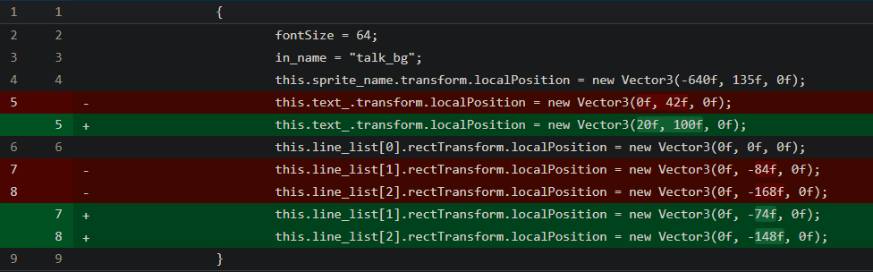

1. Alignment - Changes the alignment of the built in **UnityEngine.UI.Text**. Only "sticks" the text to the right. Looks like it is not compatible with **<center:1>**

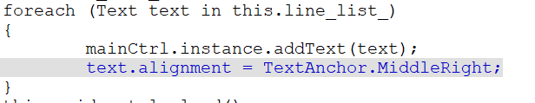

1. Reverse String - From testing, does not change anything? All you had to do, is write in reverse inside scenario file (שלום 🡺 םולש), and built in **UnityEngine.UI.Text** will render it fine. Did not need this code.

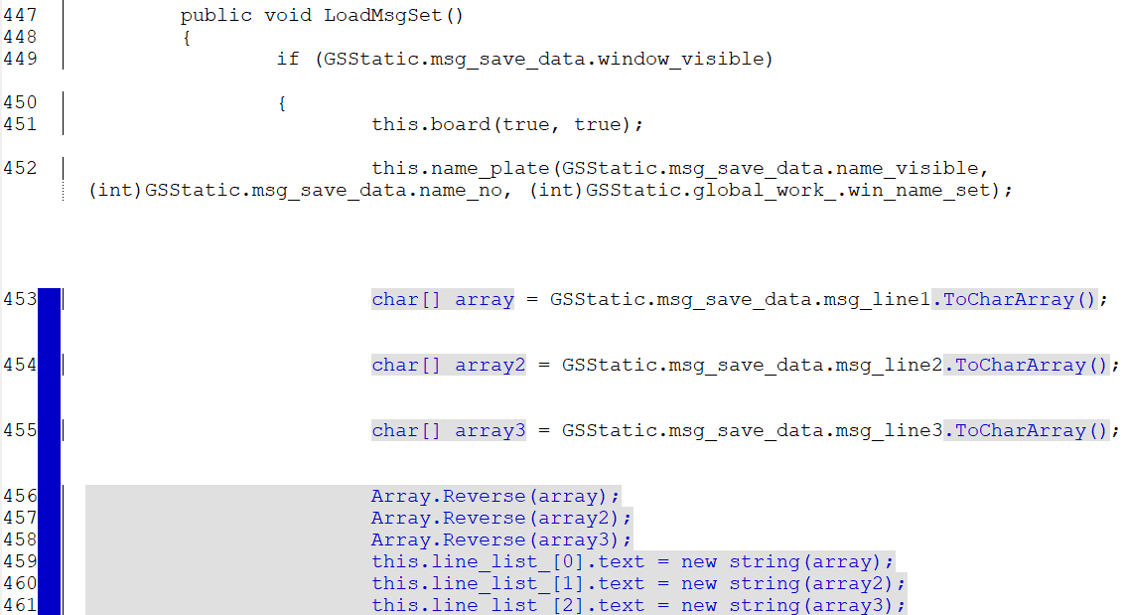

My Test (that did not change anything... no Date was shown...):

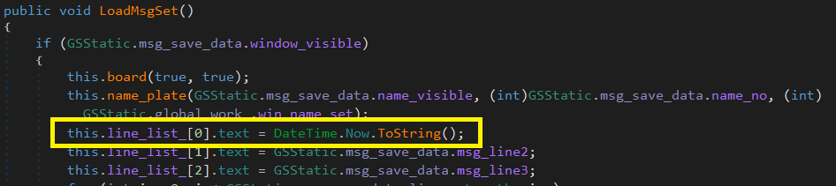

## Conclusion:

Only “2. Alignment” is relevant... putting the text to the right... all the other did not help/are not needed.

It did point me to the right place, as it seem that **this.line_list_[0..2].text** is the common Text component for all text scenarios (but not other, like inside his evidence case which will need more work to find)

# My solution

## Code

Like we discussed, the Text Animation code seems to be repeated across the whole game and not in one place, so it seems too much complex. And we should be focused on the **UnityEngine.UI.Text** and change it there.

From testing, a simple reverse will not work as there are tags inside (“<abc>שלום</abc>” 🡺 “>cba/<םומלש>cba<”) so I had to write helper functions, to replace only the text inside the tags.

Also, to not reverse if already reverse, I added a junk tag to the start to tell us if the text was changed (by others, like said Animations from all over). And with that, now the RTL typing animation work correct. But see edge cases bellow.

And the last trick was to do it under LateUpdate() which comes after Update() where I suspected all animations occurred.

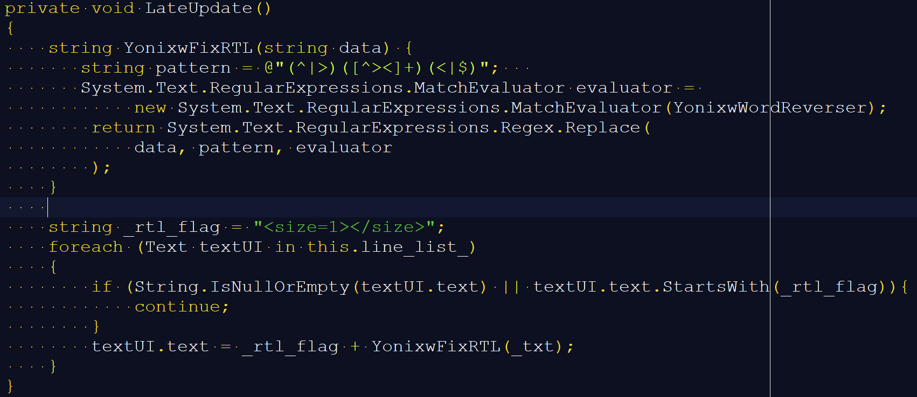

And:

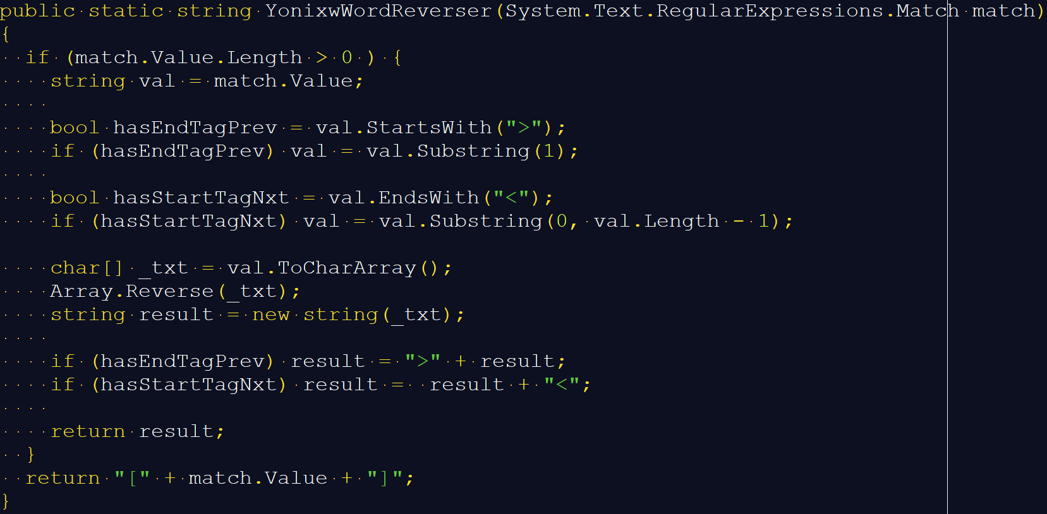

# Implications and Edge Cases of my way

* You write mostly normal in the scenario file (at least in Notepad++)



* Since we found out no real RTL reverse happened before in code, now that we DO reverse Hebrew, we will need to add this code in other software, like the “preview for translator” software you showed in the zoom
* Some numbers and symbols need to be reversed in the scenario file (it could probably be fixed with more code…)



* <center:1> will not work, as it assumes the text is on the left side. But that is about text align, and not because my way of reverse.
  + Solve by either removing or change to <center:**0**>

And:

* All solution did not solve that evidence case items (me and the old solution. Probably the code for it somewhere else)

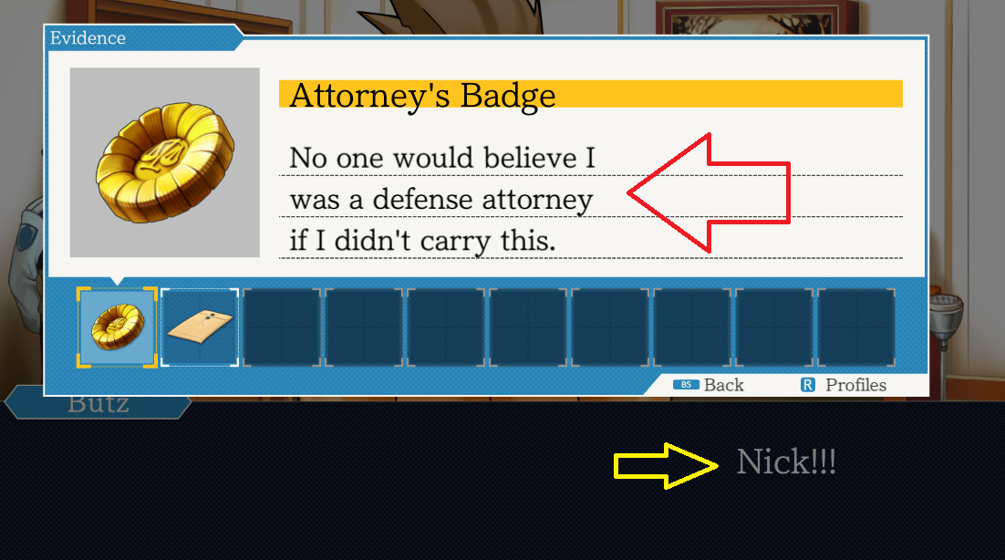

# Other notes:

* <b> is new line (no changed by me/old, but weird that it is not “bold”)