# V2 (Oct 20 – Nov 8, 2023)

How it works:

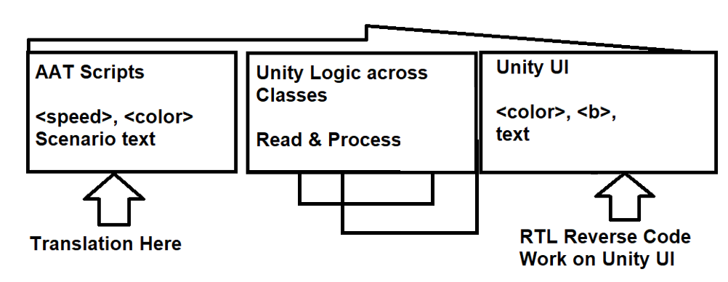

* Better RTL with reverse ui tag support
  + Number + Time kept the same

|  |  |
| --- | --- |
| RTL without <color> tag reverse | Version 2 - fixed |
| Image |  |

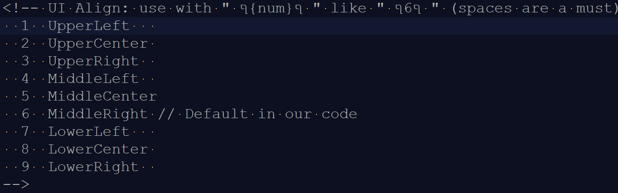

* Align code: "~{num}~" to allow center problem fix and menu left align
  + Need to manually remove AAT tag <center:1>
* Live config refresh (F5), but will affect only lines after
* Config file with features
  + Open debug console (might work only on windows)
    - Manually with F4
  + debugLines – fast iteration for text adjustments
    - does not support animation and AAT tags – only unity UI tags
  + replaces
    - Rules – Good for recurring characters like **(** and **)** 
      * Sometimes need tricks
    - Exact – Good for word that not in scene files
  + UI labels search names to process, so not hardcoded
* Debug Console
  + Might make background music lag, because it synced on scene start only.
  + Actions (F6)
    - Allow copy of values for debug (console can only show English)
  + List of dynamically loaded files to give hint what need changing