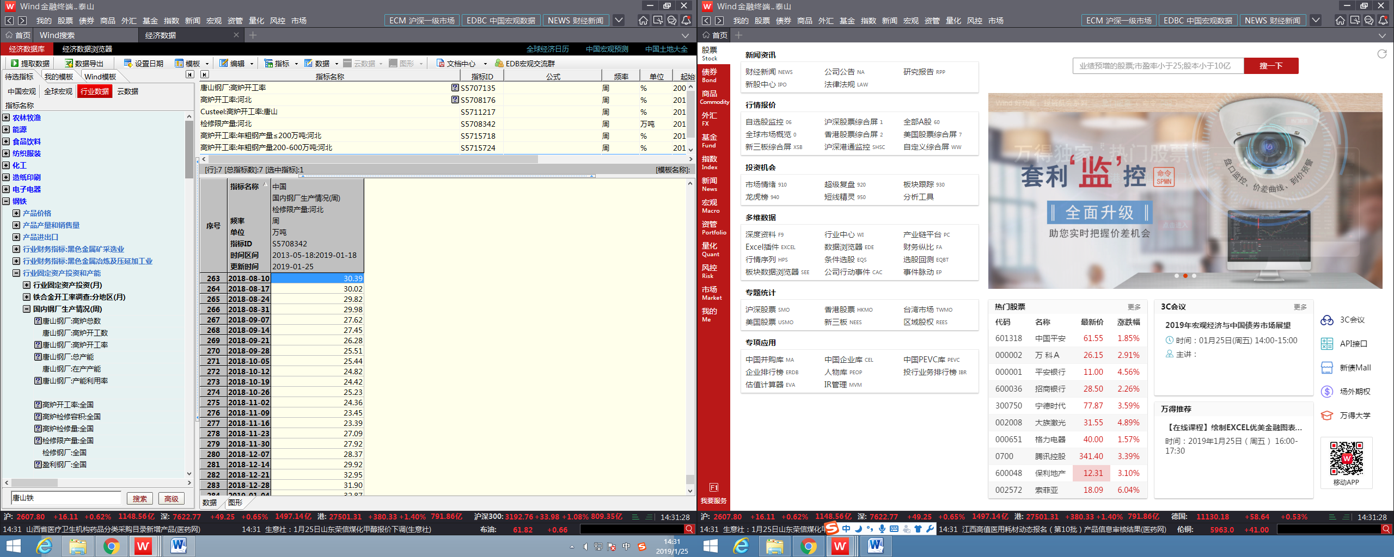

Industry data > Steel & Iron > Industry fixed assets investment and production capacity > Domestic steelworks production situation