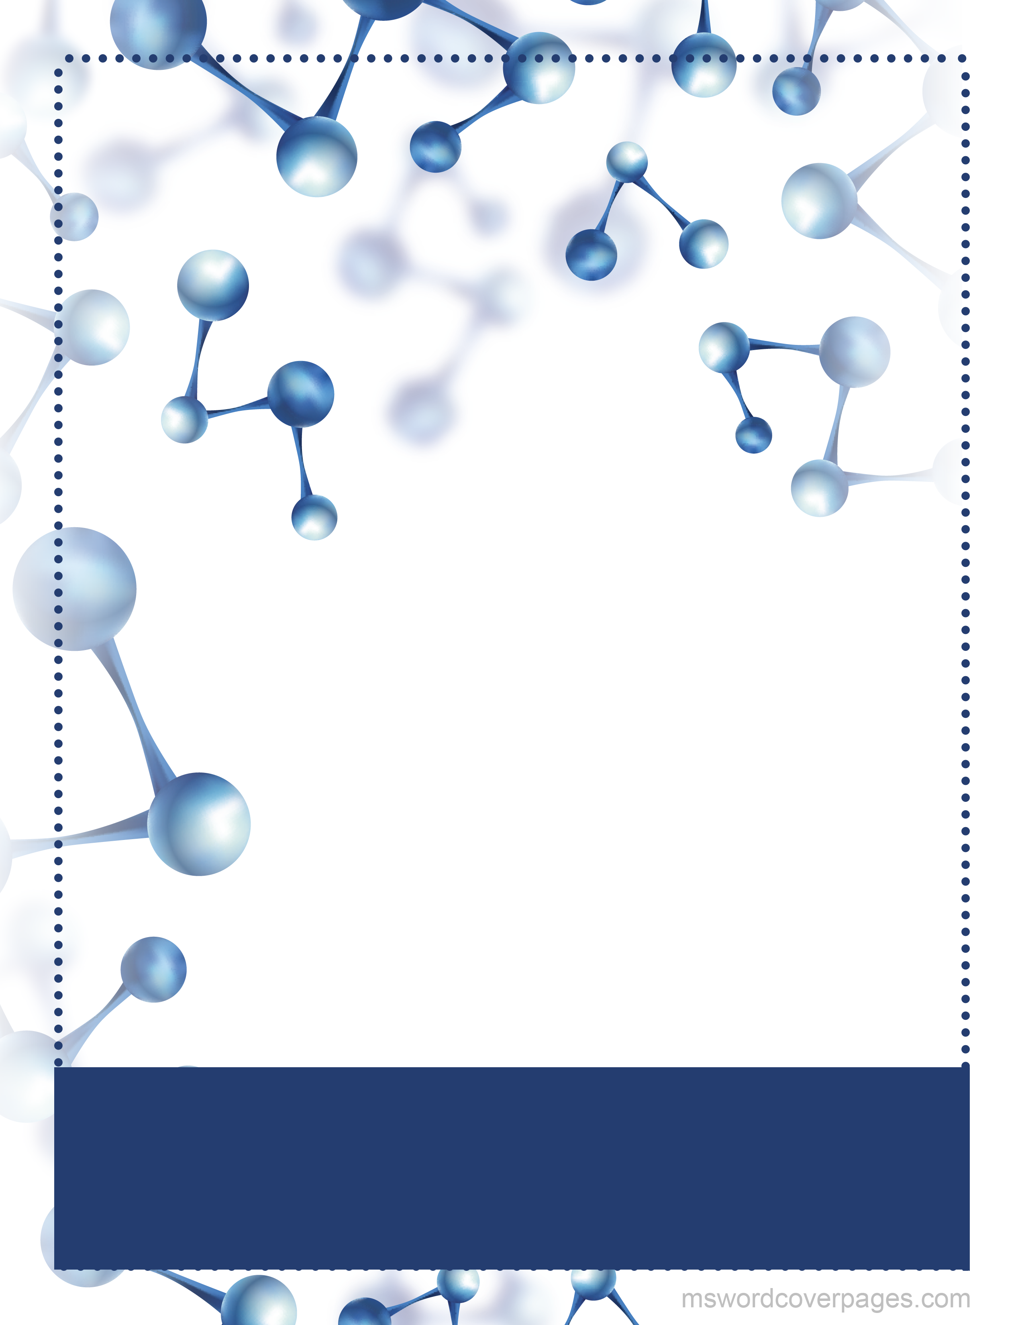­

20230

Markdown

Markdown syntax guide

John Gruber

EDITION