**Carrying the objective by the player**

In the Character create a boolean in header file

***UPROPERTY(BlueprintReadOnly, Category = "Gameplay" )***

***bool bIsCarryingObjective;***

We need to check if the overlap of the PickupActor is the character. So do the following to PickupActor.cpp file.

include the character header file in the top

***#include "FPSObjectiveCharacter.h"***

Then do the following in the Overlap function

***AFPSObjectiveCharacter* OverlapChar = Cast<AFPSObjectiveCharacter>(OtherActor);***

***if (OverlapChar)***

***{***

***OverlapChar->bIsCarryingObjective = true;***

***Destroy();***

***}***

Now fpsobjective should destroy as the player overlaps it.

To see if the boolean changes or not, we can do a print string in blueprints in the editor like normal ways. The boolean we created in cpp called bIsCarryingObjective will be accessible from blueprints.

**Creating UI Widgets**

Create Widget blueprint to display text "Object carried"

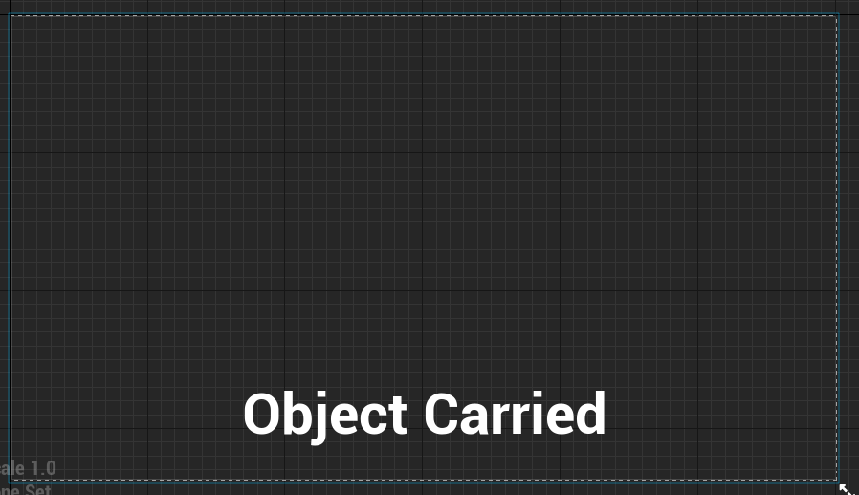

Create HUD. We can create a HUD from FPS HUD already in the project. (No need to create new)

Add following BP

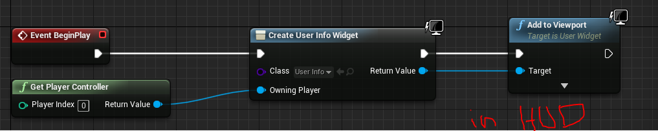

Create a GameMode derived from FPS Game Mode just like HUD and set the hud.

Set the GameMode in world settings

In the widget create binding to the text and add following BP to the function.

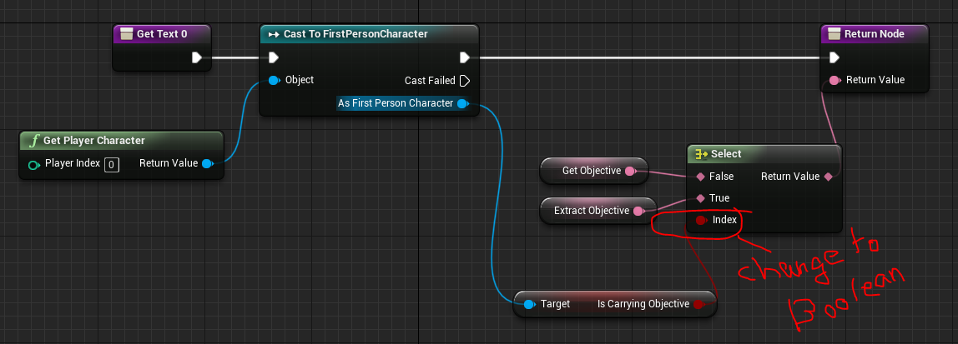

Exercise:

More objectives to level. Objective can be collected only if player is not carrying one.