**Adding AI obstacle**

* Simple AI to guard objective
* AI will see and listen for noises
* Distraction mechanics by bouncing projectile on wall

Create a character C++ class for AI

Name it FPSAIGuard

Its driven by AI so we can delete SetupPlayerInputComponent method from C++ and header files

Copy resources into the content folder in windows explorer

Create a character BP from FPSAIGuard cpp class.

Select the mesh and pick idle animation in details panel

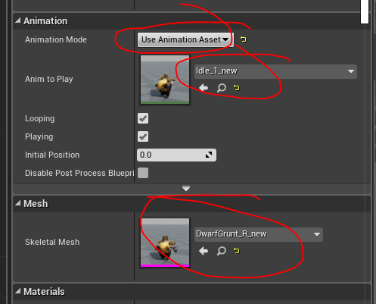

**AI sight**

Now we will create pawn sensing component to see the player and sense the noise from projectile.

Add following to header file of AIGuard

UPROPERTY(VisibleAnywhere, Category = "Components")

UPawnSensingComponent* PawnSensingComp;

Need forward decleration so add the following to the start of header file

class UPawnSensingComponent;

got to C++ file to instantiate the variable. So add the following in constructor

PawnSensingComp = CreateDefaultSubobject<UPawnSensingComponent>(TEXT("PawnSensingComp"));

Add include file

#include "Perception/PawnSensingComponent.h"

Since we are running AI for first time we need to add the AI module.

So we need to go to the **Build.cs** file and add the “AIModule” into PublicDependencyModuleNames

PublicDependencyModuleNames.AddRange(new string[] { "Core", "CoreUObject", "Engine", "InputCore",**"AIModule"**, "HeadMountedDisplay" });

Drag in the character into the level to see the character.

When we open the character we should be able to see the pawn sensing component added.

Select Pawnsensing component and adjust the cone and the sensing

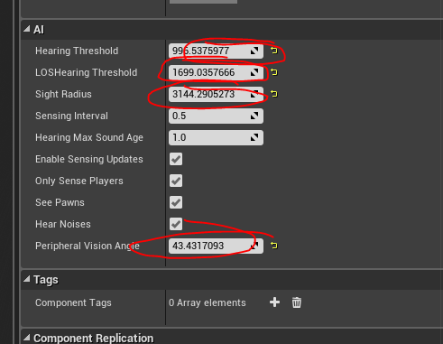

Now we need to bind to the sight of pawn sensing.

For this add the following to constructor.

PawnSensingComp->OnSeePawn.AddDynamic(this, &AFPSAIGuard::OnPawnSeen);

**OnPawnSeen** will not work because function not declared. So declare the function on header file.

void OnPawnSeen();

Function requires some parameters. To get those right click on **OnSeenPawn** in the constructor and go to definition. You will be taken to **FSeePawnDelegate OnSeePawn;** Right click on **FSeePawnDelegate** and go to definition. You will be taken to **DECLARE_DYNAMIC_MULTICAST_DELEGATE_OneParam( FSeePawnDelegate, APawn*, Pawn );** We can see it has only one parameter. Now declare the **OnPawnSeen** function as follows.

UFUNCTION()

void OnPawnSeen(APawn* SeenPawn);

Create implementation as

void AFPSAIGuard::OnPawnSeen(APawn * SeenPawn)

{

}

To test we will draw debug sphere when AI sees the player. To add it we need to include debug sphere first. So add the following.

#include "DrawDebugHelpers.h"

Add the following code to the method **OnPawnSeen** method

if (SeenPawn == nullptr)

{

return;

}

DrawDebugSphere(GetWorld(), SeenPawn->GetActorLocation(), 32.0f, 12, FColor::Yellow, false, 10.0f);

Debug sphere should be created every half second. It is set in pawn sensing component

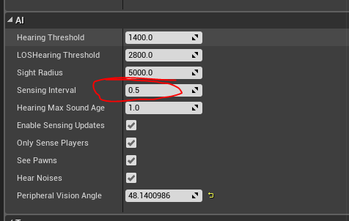

**AI hearing sense**

Go to constructor of AIGuard and add as follows.

PawnSensingComp->OnHearNoise.AddDynamic(this, &AFPSAIGuard::OnNoiseHear);

We have to create OnNoiseHear. We need to find the parameters. So right click on OnHearNoise and go to definition and in the definition right click on the delegate and go to definition to find the parameters. So create a function declaration in header file as follows.

UFUNCTION()

void OnNoiseHear(APawn* NoiseInstigator, const FVector& Location, float Volume);

**There is a default variable in every actor called Instigator.**

**(To check, right click on instigator and go to definition).**

**So we give a different name called “NoiseInstigatior”.**

create the implementation as follows.

void AFPSAIGuard::OnNoiseHear(APawn * NoiseInstigator, const FVector& Location, float Volume)

{

DrawDebugSphere(GetWorld(), Location, 32.0f, 12, FColor::Green, false, 10.0f);

}

Now we need to create a noise emitter in the character class.

Go to FPSObjectiveCharacter header file and add the following.

UPROPERTY(VisibleAnywhere, BlueprintReadOnly, Category = "AI")

UPawnNoiseEmitterComponent* NoiseEmitterComponent;

Forward decleration required. So add the following to the start.

class UPawnNoiseEmitterComponent;

Now go to C++ file and add the following to the constructor.

NoiseEmitterComponent = CreateDefaultSubobject<UPawnNoiseEmitterComponent>(TEXT("NoiseEmitter"));

Include the appropriate header file as follows

#include "Components/PawnNoiseEmitterComponent.h"

Now go to the character BP and add the following bp to create noise on every tick.

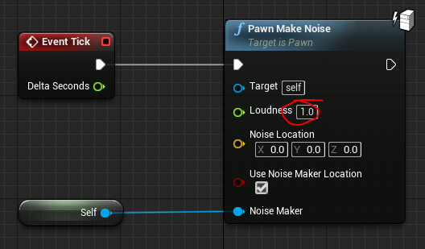

It should be creating green spheres when we are behind the character

Now we need to add noise to every hit of the projectile. For that go to C++ of the projectile and add the following code to the **OnHit** method.

**MakeNoise(1.0f, Instigator);**

Move destroy to the end after the **MakeNoise** method.

Now go to the FPSCharacter C++ file and add the following code to the **OnFire** method inside the **else** part of the third nested **if** statement.

**ActorSpawnParams.Instigator = this;**

Program should be working now. The delay in appearing of the sphere can be adjusted by changing the sensing interval in the settings of pawn sensing component in the character bp.

