**Problem statement:**

Write an application that manages lab assignments for students at a given discipline.

The application will store:

• students: <studentID>,<name>,<group>

• assignment: <studentID>,<description>, <deadline>, <grade>

**Student lab assignments – Feature list**

|  |
| --- |
| **F1. Add** a student. |
| **F2. Remove** a student. |
| **F3. Update** a student. |
| **F4. Search** a student. |
| **F5. Print** a student. |
| **F6. Add** an assignment. |
| **F7. Remove** an assignment. |
| **F8. Update** an assignment. |
| **F9. Search** an assignment. |
| **F10. Print** an assignment. |
| **F11. Create** a statistic. |
| **F12. Create** the database. |

**Iteration plan**

|  |  |
| --- | --- |
| **Iteration** | **Planned features** |
| I1 | **Create** an early working version of the program. |
| I2 | **Make** tests and manage exceptions. |
| I3 | **Make** a file repository. |

**Running scenario**

|  |  |  |  |
| --- | --- | --- | --- |
|  | **User** | **Program** | **Description** |
| **1.** |  | options() | Prints main menu. |
| **2.** | 1 | menuItem[0].show() | Prints the first sub menu. |
| **3.** | 1 | addStudent | Inputs the idd, name, group of a student. |
| **4.** | The user inputs idd, name, group | s=Student(idd,name,group)  sRepo.add(s) | Adds the student to the student repository lists. |
| **5.** | f | Options() | Goes back to main menu. |
| **6.** | 2 | menuItem[1].show() | Prints the second sub menu. |
| **7.** | 1 | addAssignment | Inputs the idd, description, deadline, grade of the assignment. |
| **8.** | The user inputs idd, description, deadline, grade | a=Assignment(idd,description, deadline, grade)  aRepo.add(a) | Adds the assignment to the  assignment repository lists. |
| **9.** | f | Options() | Goes back to the main menu. |
| **10.** | 3 | menuItem[2].show() | Prints the third sub menu. |
| **11.** | 1 | printFinal() | Prints the database, the student and the assignment concatenated in a nice print. |
| **12.** | f | Options() | Goes back to the main menu. |

**Use Case Diagram**

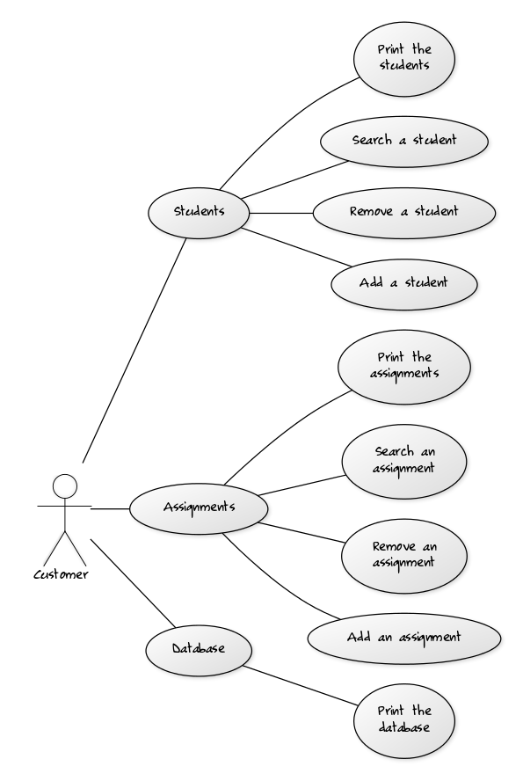

Class diagrams

**Domain**

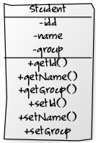 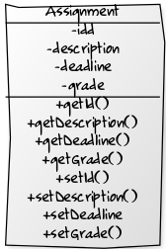 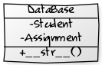

**Repository**

