UNIVERSITY OF COMPUTER STUDIES, YANGON
2025–2026 ACADEMIC YEAR

Project Report On
ANIME INDUSTRY ANALYTICS SYSTEM
Semester IX
DATA AND KNOWLEDGE MINING (IS-212) PROJECT
Submitted By
YKPT-22425 Yoon Thiri Aung
September, 2026 B.C.Sc.(SE)

Table of Contents

Acknowledgement
Chapter 1 3
Introduction 3
1.1 Project Background 3
1.2 Objectives of the project 3
1.3 Scope of the project 3
1.4 Overview of the Methodology………………………………………………3
1.5 Benefit of the project 3
Chapter 2 4
DATA PREPARATION AND PREPROCESSING 5
2.1 Dataset and Data Statistics 5
2.2 Data Preprocssing 5
2.2.1 Handing Missing Values………………………………………………...5
2.2.2 Data Transformation……………………………………………………..5
2.2.3 Feature Selection………………………………………………………...5
2.2.4 Data Normalization……………………………………………………...5
2.3 Data Visualization……………………………………………………………….5
Chapter 3 5
APPLIED METHODOLOGIES AND MINING 5
3.1 Descriptive Mining 5
3.2 Modeling 5
3.2.1 Applied Methodologies /Algorithms…..………………………………...5
3.2.2 Model Set up..…….……………………………………………………..5
3.2.3 Baseline Model……………………………………………..…………...5
3.2.4 …………………………………………………………………………...5
Chapter 4 6
evaluation 6
4.1 Performance Metrics 6
4.2 Comparison of Experiment Results/Model Comparison 6
4.2.1 Evaluation Analysis……………………………………………………...6
4.2.2 ROC Curve and AUC……………………………………………………6
4.2.3 Cross Validation ………………………………………………………...6
4.2.4 Findings………………………………………………………………….6
Chapter 5 7
Conclusion 7
5.1 Advantages of using this project 7
5.2 Disadvantages of using this project/ Limitation 7
REFERENCE

List of Figures

Figure 2.1 Distribution of score (left) and rank (right) 5
Figure 2.2 — Distribution of Engagement signals 7
Figure 2.3 — Average number of episodes by anime type……………………………8
Figure 2.4 — Average number of durations by anime type……………………………
Figure 2.5 — Top-10 genre release-count trend, 2010–2025………………………….
Figure 3.1 — Genre ↔ Theme Co-occurrence…………………………………………
Figure 3.2 — Top producer + genre association rules for the Balanced_High outcome.
Figure 3.3— Top studios + genre association rules for the Balanced_High outcome….
Figure 3.4 — Silhouette score across candidate cluster counts k = 8..40, identifying k = 32 as the objectively best choice…………………………………………………….
Figure 3.5 — Genre audience-demand (median MAL members) trend with 3-year Holt-Winters forecast………………………………………………………………..
Figure 4.2 — Confusion Matrix for XGBoost on the Held-Out ($\ge 2024$) Test Set.

Lists of Tables
Table 2.1 — Data dictionary for key attributes used throughout the analysis 11
Table 2.2 — Composition of the engineered balanced_score metric. 11
Table 2.3a — High raw score but low reach: balanced_score drops these titles sharply relative to their raw score. 11
Table 2.3a — High raw score but low reach: balanced_score drops these titles sharply relative to their raw score. 11
Table 3.1 — 2026–2028 genre audience-demand (median members) forecast. 11
Table 4.1 — Performance Metrics on the Held-Out Test Set (>2024) 11
Table 4.2 — 2023–2025 backtest of the audience-demand (median members) Holt-Winters forecast. 11

Chapter 1

Introduction
Japanese animation is an extremely high-risk commercial industry, where initial commitments must be made years before consumers even see the finished product. Behind every major TV anime series or film is a consortium of corporate investors—known as a production committee—responsible for making key creative decisions, such as contracting animation studios, selecting source material, and determining the thematic direction. These commitments come with significant financial risks: if an animated series fails to attract an audience, it becomes difficult to recoup costs through long-tail secondary channels such as global streaming rights, character merchandise, and music releases. The digital cataloging platform archives a vast amount of metadata on works and records of audience engagement signals, providing an opportunity for systematic analysis of market dynamics. Based on historical data from MyAnimeList, this project has established an end-to-end data mining framework designed to evaluate how pre-production attributes, narrative patterns, and evolving genre trends interact to drive audience engagement and commercial impact.

Project Background
In the anime industry, productions are rarely funded by a single studio; instead, they are typically financed through a “production committee” (seisaku iinkai)—a consortium comprising manga publishers, television stations, streaming platforms, music companies, and merchandise manufacturers. Each participating party contributes a fixed amount of funding upfront to cover the multi-million-dollar animation production budget, in exchange for commercial development rights within their specific business sectors. Given the long capital recovery cycle and the fact that revenue is spread across multiple commercial channels, the financial viability of an animated film depends on its ability to generate substantial downstream revenue through sources such as minimum-guaranteed streaming licensing, international copyright sales, theatrical distribution, and branded merchandise. However, since budgeting and production are completed long before any audience feedback becomes available, committee members face significant financial risks in the absence of any pre-release consumer validation.
At the same time, as the largest community-driven anime database and streaming platform, MyAnimeList (MAL) has accumulated more than a decade’s worth of structured, publicly searchable metadata on tens of thousands of titles—including genre, theme, production companies, producers, release dates, and various community engagement metrics (popularity, number of members, favorites, and user-submitted scores). This metadata precisely reflects the kind of market information that production committees want to understand before making investment decisions: which production companies consistently generate high engagement; which combinations of genres and themes have historically succeeded in attracting large audiences; and how demand for specific genres has changed over the past decade.
This project explicitly treats animation production as a financial and strategic decision-making issue and has built a data mining pipeline based on MAL metadata to support that decision-making process. Rather than simply asking “what content is popular,” this project focuses on the practical challenges that production committees actually face: Given a specific production company, a combination of genres and themes, and a release window, what insights does historical data offer regarding possible outcomes?

Objectives of the project
The primary objectives of this project are:
- To discover high-yield studio–genre–theme configurations and producer partnerships using FP-Growth association rule mining to guide studio-matching and content-strategy decisions.
- To extract latent narrative archetypes from synopsis text using TF-IDF, TruncatedSVD, and K-Means clustering, statistically validating their relationship with standard genre tags.
- To construct a hybrid content-based recommender system combining plot embeddings and genre-theme vectors for audience discovery and comparable-title scoping.
- To develop a pre-release machine learning classifier to predict audience success probability using strictly pre-broadcast production variables.
- To forecast near-term genre-level release volume and audience demand using Holt-Winters exponential smoothing models.
  - Overview / Scope of the project
The project covers the end-to-end pipeline from raw data acquisition through descriptive analytics, predictive modeling, and presentation. The scope includes:
- Data Collection: Retrieving anime metadata (titles, genres, themes, studios, producers, source material, airing information, images, and trailer links) from the Jikan API.
- Data Cleaning and Preprocessing: Filtering to core commercial anime formats, handling missing values, standardizing categorical text (studio/producer/genre naming variants), transforming stringified list columns, and cleaning synopsis text.
- Descriptive Mining: Genre trend analysis, studio and source-material performance benchmarking, seasonal-release analysis, association rule mining (FP-Growth) over genres, themes, producers, and studios, and unsupervised NLP clustering of synopsis text.
- Predictive Mining: A content-based hybrid recommender system, a pre-release anime success classifier, and Holt-Winters time-series forecasts of genre-level release volume and audience demand.
The scope is intentionally bounded to titles classified under the TV, Movie, ONA, and OVA formats released primarily between 2010 and 2026, since these formats represent full-scale, narratively complete commercial productions comparable across the analysis. Explicit adult content is excluded, as it is not relevant to the mainstream industry-investment framing of this project.
  - Overview of the Methodology
The project follows a structured data mining workflow:
- Data Collection: Anime metadata, including studios, producers, genres, themes, airing details, and audience engagement metrics, are gathered from MyAnimeList using the open Jikan REST API.
- Data Preprocessing: The raw extraction is refined by filtering core commercial formats, handling missing values, parsing serialized categorical lists, standardizing entity names, and cleaning synopsis text.
- Feature Engineering: A debiased composite success metric (balanced_score) is formulated by combining percentile ranks of critical score, member reach, favorites, and popularity and studio/producer/theme/genre categories are consolidated to a manageable top-N vocabulary to control dimensionality.
- Pattern Mining and Storyline Clustering: The FP-Growth algorithm identifies frequent association rules that span across studios, producers, and genres. Unsupervised natural language processing clustering methods (TF-IDF, truncated SVD, and K-Means) classify plot summaries into different story archetypes and validate them statistically by comparing them with standard genre labels.
- Predictive Modeling and Recommendation: Machine learning classifiers (including XGBoost, random forests, decision trees, and logistic regression) are used to predict pre-release success. A content-based hybrid recommendation system matches similar films, while the Holt-Winters exponential smoothing method is used to forecast demand for various film genres in the near term.
- Model Evaluation: System components are validated using standard classification metrics (accuracy, precision, recall, F1-score, and ROC-AUC), clustering metrics (silhouette score and Cramér's V), and time-series backtesting (MAE, RMSE, and MAPE).
  - Benefit of the project
This project is intended to provide the following benefits:
- Informed Decision Support: By evaluating historical release patterns, the project replaces intuition-driven greenlighting with quantitative evidence, helping committees evaluate which studio, genre, and thematic combinations historically drive market success.
- Bias-Corrected Evaluation: The engineered balanced_score addresses critical distortions in community data by combining critical score, audience reach, user favorites, and popularity, ensuring titles are judged on commercial scale rather than niche review extremes.
- Actionable Industry Insights: The use of FP-Growth association rules and performance benchmarking uncovers interpretable studio specializations and high-yield producer partnerships, directly informing content strategy and studio-matching decisions.
- Pre-Release Risk Mitigation: The predictive machine learning pipeline evaluates a concept's likelihood of high audience success using strictly pre-broadcast attributes, aiding stakeholders in early-stage risk assessment before capital is locked in.
- Scalable and Reusable Pipeline: The data collection, cleaning, and modeling architecture is designed to integrate new seasonal records continuously, allowing stakeholders to track shifting anime audience trends over time.
Overall, this project delivers a practical, data-driven framework that supports anime production planning by combining rigorous predictive modeling with actionable market intelligence.

Chapter 2
DATA PREPARATION AND PREPROCESSING
This chapter introduces the dataset used in this project, as well as the preprocessing steps performed prior to descriptive mining and predictive modeling. It describes the statistical characteristics of the extracted anime records and the filtering process, and explains how the raw metadata was cleaned, transformed, and engineered to support association rule mining, plot clustering, and viewer success rate prediction.

2.1 Dataset and Data Statistics
The dataset for this project is obtained from MyAnimeList (MAL) via the open Jikan REST API [1], which provides structured anime metadata including titles, genres, themes, studios, producers, source materials, airing details, scores, community engagement metrics, images, and synopsis text. This dataset is open, publicly accessible, and serves as an empirical record of commercial anime performance and audience response.
Preliminary data extraction yielded a total of 19,547 raw animation records covering 33 attributes. To ensure that the analysis focused on commercial works that were complete in both scope and narrative, the raw dataset was filtered to retain only core release formats (TV, film, ONA, and OVA). The data was further refined by excluding explicit adult content, filtering out short promotional clips based on duration thresholds for specific formats, and removing entries lacking valid ratings, vote counts, or synopsis. This multi-stage filtering process ultimately produced a consistent final working dataset comprising 8,227 records, which was used throughout all descriptive analysis and predictive modeling phases of this project.
Data Dictionary — Key Attributes
Attribute | Meaning
mal_id, title / title_english / title_japanese / title_synonym | MyAnimeList ID, Romanized, English, Japanese, and alternative titles for the same anime.
type | Delivery format: TV, Movie, ONA, or OVA (after filtering).
source | Origin material: Manga, Light novel, Original, Game, Web manga, Visual novel, Web novel, 4-koma manga, Novel, Other/Unknown, etc.
genres / themes / demographics | MAL-assigned classification tags (list-valued); demographics indicates an intended audience segment such as Shounen, Shoujo, Seinen, or Josei.
studios / producers | The animation studio(s) that produced the anime and the production-committee member companies (list-valued).
episodes / duration_minutes | Number of episodes and per-episode (or per-film) runtime in minutes
score / scored_by / rank | MAL's official weighted community score , the number of users who submitted a score, and the rank derived from that score.
members / favorites / popularity | Total users who added the title to any list (Watching, Completed, Dropped, Plan to Watch), users who marked it a favorite, and MAL's own popularity rank.
season / year / broadcast_day | Release season, release year, and day-of-week of broadcast.
synopsis_clean | The show synopsis after HTML tags, MAL boilerplate, and source attributions were stripped.
balanced_score | The engineered, bias-corrected success metric introduced in this project.
Table 2.1 — Data dictionary for key attributes used throughout the analysis.
2.2 Data Preprocessing
2.2.1 Handling Missing Values
To address the issue of incomplete attributes in the raw data, a systematic process for handling missing values was implemented, ultimately resulting in a fully prepared working dataset containing 8,227 records.
During the initial cleaning phase, the “broadcast_day” and “year” fields were directly interpolated by extracting the day of the week and the year of release from the “aired_from” timestamp, as both are deterministic functions of the provided broadcast date. The “licensors” attribute (with a missing value rate of 77%) was excluded because licensing arrangements vary by regional distributor, and this attribute does not affect upstream production attributes as much as major studios or production companies do. Similarly, since the “aired_to” and the derived “season_is_derived” metrics are not essential for evaluating market outcomes, they were excluded. Missing values for the number of episodes were imputed by calculating the median number of episodes within each anime type (TV, movie, ONA, OVA), for example, the median for movies is 1 episode, while for TV series it is 13 episodes.
The “duration” field requires special care. This field is entered as a free-text string (e.g., “24 minutes per episode”) and is then parsed into a numeric “duration_minutes” column using a regular expression that captures hours, minutes, and seconds separately. Upon checking the parsed values, 456 suspicious, extremely short ONA entries (less than 1 minute) were identified. These entries almost certainly consist of promotional clips, opening and closing sequences, or commercials, rather than full-fledged short animations. Rather than adopting a single, universal threshold, this approach employs minimum duration thresholds tailored to different type of anime —Movies ≥ 15 minutes, TV series ≥ 3 minutes, ONA ≥ 1 minute, and OVA ≥ 10 minutes. This approach preserves legitimate short-form works within each format (short theatrical movies, short TV series, and short OVAs) while filtering out low-quality promotional content. Combined with the removal of explicit adult content (Rx – hentai), these criteria filtered out invalid entries before the results were modeled.
For the “score” and “scored_by” fields, data missing primarily stems from two causes: first, occasional errors during API scraping; and second, some titles in the MyAnimeList database lack official ratings altogether due to insufficient votes. Because both attributes—and the composite “balanced_score” derived from them—form the ground truth for audience performance, rows missing either field were completely removed rather than imputed with fabricated scores.
The “demographics” tag is absent for most entries; this reflects a structural catalog property rather than missing data, as general-audience titles are rarely assigned demographic labels by community contributors. Therefore, missing “demographic” values were preserved as informative categories labeled "Unspecified" rather than imputed artificially.
After dropping the above described score/scored_by/synopsis-null rows, the dataset finalized at 8,227 complete entries. Across these remaining rows, nulls in producers and studios accounted for less than 7%. High-visibility titles meeting defined thresholds (members > 10,000, score > 8.0, or popularity in the top 1,500) were verified and completed using domain reference sources, while any remaining unassigned categorical entries were imputed with an explicit "Unknown"/"Other" category flag to ensure seamless encoding during feature processing.
2.2.2 Data Transformation
Several multi-tag classification fields (genres, themes, studios, prdocuers, demographics, etc.,) are stored as string representations of Python lists (e.g., “[‘Action’, ‘Adventure’]”). These fields are parsed into native Python list objects using `ast.literal_eval`, thereby establishing the format required for downstream list expansion and multi-hot encoding. The raw “synopsis” field contains HTML tags, template markers (such as [Written by MAL Rewrite]), and source attributions. This text is sanitized through a regular expression cleaning pipeline, which includes stripping tags, removing content within metadata brackets, and normalizing spaces, thereby generating the “synopsis_clean” attribute. Finally, an entity standardization process resolves inconsistencies in spelling and punctuation across studios, producers, genres, and themes. By combining automatic string matching implemented with `difflib.SequenceMatcher` with manual review, near-duplicate naming variants are mapped to their canonical forms. This normalization process prevents fragmented tracking records from occurring during association rule mining and performance aggregation.
2.2.3 Feature Selection and Engineering
MyAnimeList does not display a simple arithmetic mean of user ratings. Instead, it publishes a Bayesian-adjusted weighted score, calculated as:
Weighted Score = (v ÷ (v + m)) × S + (m ÷ (v + m)) × C
where “S” is the title's raw average user score, “v” is the number of users who scored it, “m” is the minimum number of votes required for a fully calculated score (50, at the time of writing), and “C” is the mean score across the entire MAL database [2].
Although this calculation formula prevents low-rated works from distorting the rankings by dragging down the average score of the library, weighted ratings alone cannot measure true commercial success. A niche series might earn extremely high ratings thanks to a small group of loyal fans, yet still fail to reach a broader audience. Conversely, a mainstream production might end up with only mediocre ratings simply because it reaches millions of casual viewers—who, naturally, tend to be more critical in their ratings.
To correct for this, a single composite balanced_score was engineered for this project, defined as:
balanced_score = 0.40 × score_pct + 0.25 × members_pct + 0.20 × favorites_pct + 0.15 × popularity_pct
Component | What it captures | Transform used
score (40%) | Critical / audience reception | Percentile rank among rated titles
members (25%) | Total reach — everyone who ever added the title to any list | Percentile rank of log1p(members)
favorites (20%) | Depth of fan enthusiasm — users who loved it enough to favorite it | Percentile rank of log1p(favorites)
popularity (15%) | MAL's own popularity rank | Percentile rank of −popularity
Table 2.2 — Composition of the engineered balanced_score metric.
Each component was converted to a percentile rank on a uniform 0–1 scale to prevent metrics with high variability—such as the number of members—from having an excessive impact on the composite score. To address a severely right-skewed distribution, both the number of members and the number of favorites were log1p-transformed prior to ranking. A minimum threshold of 100 members was set to eliminate outliers with zero visibility. Among the final 8,227 works, the mean of `balanced_score` has a mean of 0.500 and a standard deviation of 0.260, and correlates at r = 0.845 with raw score on the scored subset — meaning it broadly agrees with critical reception while still meaningfully re-ranking titles whose raw score is not representative of their actual audience reach.
Table 2.3 illustrates this adjustment directly. High-rated niche titles drop significantly due to limited viewership (Table 2.3a), whereas mass-market franchises with mediocre review scores rise substantially due to broad commercial reach (Table 2.3b).
Title | score | members | popularity rank | favorites | balanced_score
Zhe Tian Movie: Bei Guan Zhan Wang Teng | 7.69 | 760 | 16,529 | 0 | 0.370
You Shou Yan 3rd Season | 7.93 | 1,131 | 14,925 | 8 | 0.461
Wu Dong Qian Kun 6th Season | 7.92 | 1,580 | 13,539 | 5 | 0.467
Table 2.3a — High raw score but low reach: balanced_score drops these titles sharply relative to their raw score.
Title | score | members | popularity rank | favorites | balanced_score
Ousama Game The Animation | 5.08 | 269,007 | 1,056 | 522 | 0.514
Diabolik Lovers | 5.18 | 375,821 | 738 | 1,905 | 0.555
One Punch Man 3 | 4.76 | 447,981 | 599 | 7,453 | 0.568
Yakusoku no Neverland 2nd Season | 5.24 | 1,005,653 | 193 | 4,506 | 0.592
Boruto: Naruto Next Generations | 5.97 | 936,027 | 217 | 7,453 | 0.646
Table 2.3b — Low-to-mid raw score but very high reach: balanced_score raises these titles sharply relative to their raw score.
2.3 Data Visualization
Visual inspection guided data cleaning, verified distributional properties, and contextualized historical market dynamics across the 8,227 records.
2.3.1 Numeric Column Distributions
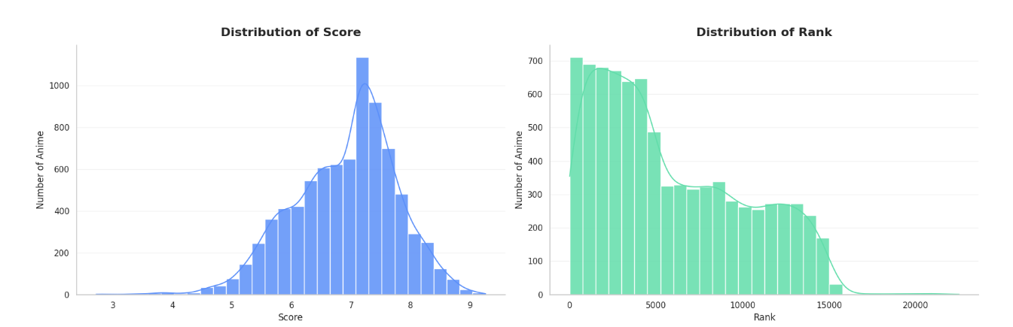
Figure 2.1 Distribution of score (left) and rank (right)
Raw user scores approximate a bell curve centered around 7.0–7.5, reflecting community rating tendencies toward completed titles. Rank directly mirrors this distribution with a pronounced tail.
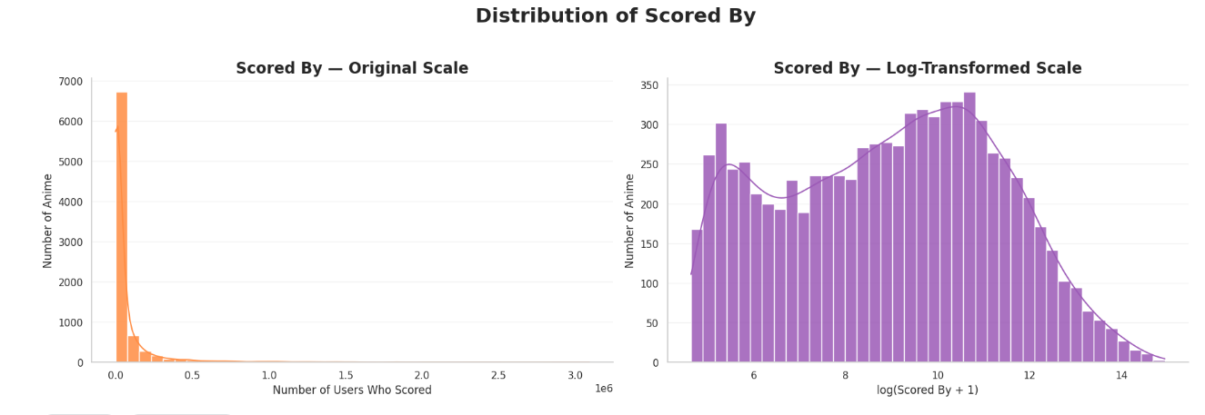
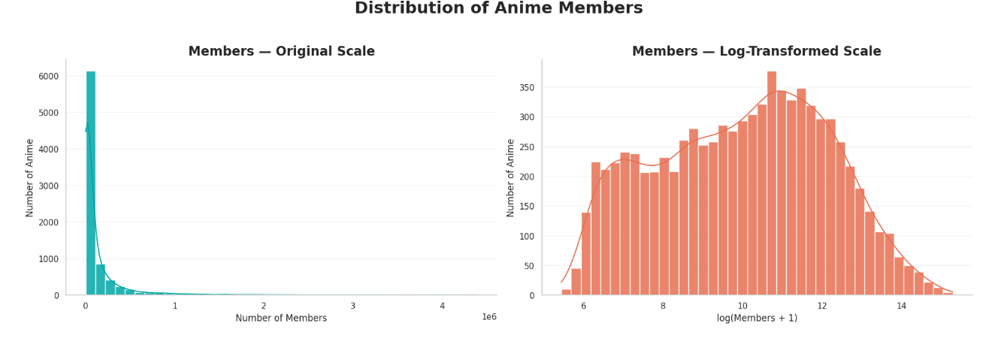
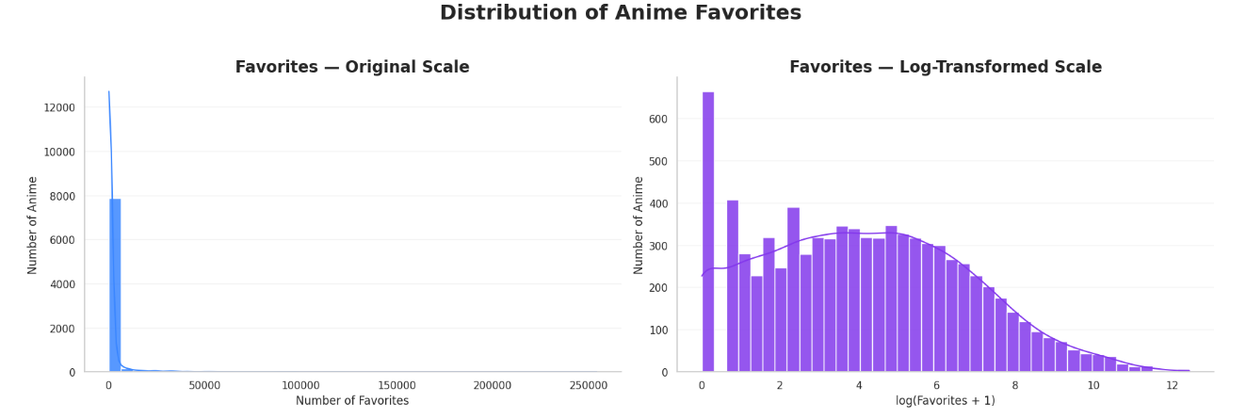
Figure 2.2 — Distribution of Engagement signals
Engagement signals (members, scored_by, and favorites) are heavily right-skewed on linear scales due to power-law audience distribution. Applying a log(1+x) transformation reveals unimodal distributions, validating log-scaling for feature engineering.
2.3.2 Structural Format Differences
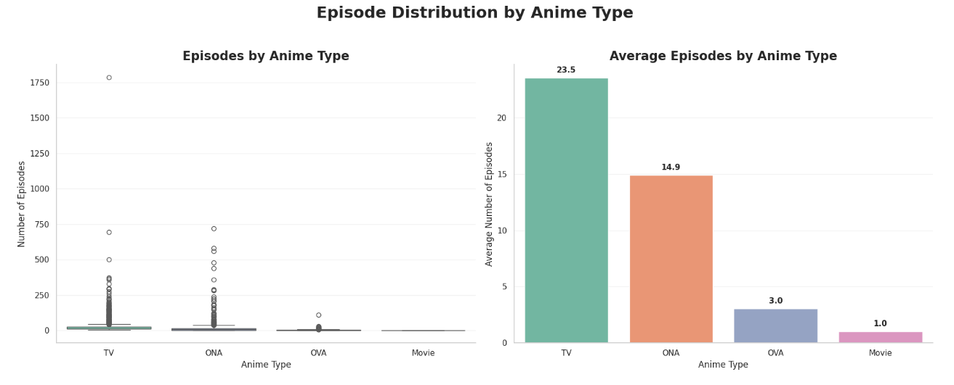
Figure 2.3 — Average number of episodes by anime type
Figure 2.3 illustrates the structural runtime differences across delivery formats, with TV productions leading at an average of 23.5 episodes due to seasonal broadcast runs, followed by ONAs at 14.9 episodes with substantial variance. In contrast, OVAs average just 3.0 episodes for direct-to-video releases, and Movies remain fixed at 1.0 episode as standalone theatrical works. These systematic disparities justify the decision to impute missing episode counts using format-specific medians rather than a uniform database-wide average.
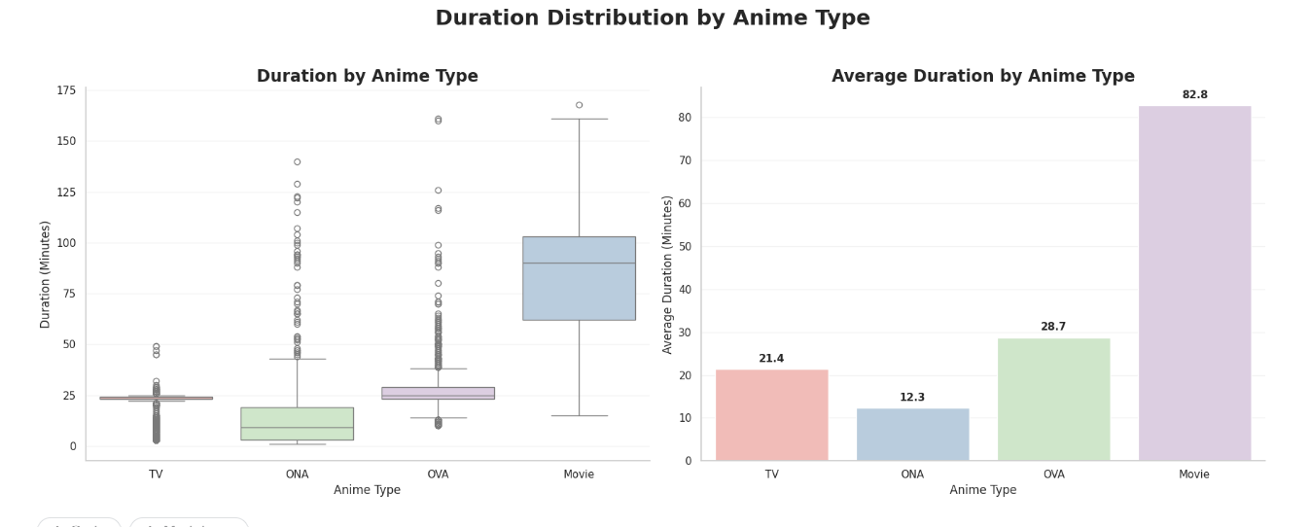
Figure 2.4 — Average number of durations by anime type
This shows distinct duration patterns across formats: Movies average 82.8 minutes, OVAs average 28.7 minutes, TV episodes cluster tightly around 21.4 minutes to match broadcast slots, and ONAs average the shortest at 12.3 minutes with broad variance. These systematic runtime splits validate applying format-specific minimum duration thresholds to filter out promotional clips while retaining legitimate short-form anime.
2.3.3 Genre Trend Over Time
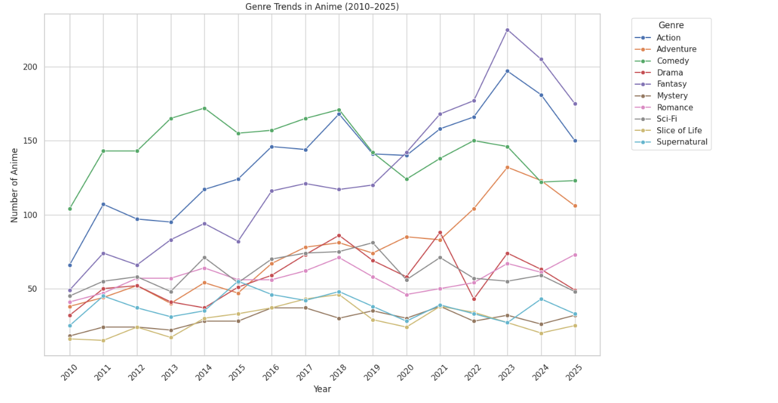
Figure 2.5 — Top-10 genre release-count trend, 2010–2025
Figure 2.7 tracks the annual release volume by genre from 2010 to 2025, revealing a marked shift in the industry’s focus. Comedy dominated releases in the 2010s but has shown a steady decline since 2018; at the same time, fantasy and action genres have surged in popularity, becoming the leading genres, with both peaking in 2023 at nearly or over 200 releases each. Medium-sized genres such as romance, science fiction, and adventure experienced moderate fluctuations in release volume, while mystery, slice-of-life, and supernatural genres consistently remained at the lowest levels. The downward trend across all genres after 2023 reflects the cutoff point of the data collection rather than an actual market contraction.

Chapter 3

APPLIED METHODOLOIES AND MINING
This chapter applies descriptive and predictive data mining techniques to a cleaned dataset to explore four main research questions regarding data-driven animation investment:
RQ1: Common combinations of genres, themes, and production entities that lead to a statistically significant increase in market success rates.
RQ2: High-return production entities, studio capabilities, and long-term partnerships.
RQ3: Unsupervised discovery of latent narrative prototypes through synopsis texts to supplement the platform’s genre classification system. Section 3.1 introduces methods for descriptive pattern discovery through FP-Growth association rule mining and natural language processing-based clustering.
Section 3.2 details predictive modeling, including content-based recommendations, pre-release success classification, and exponential smoothing for demand forecasting.

3.1 Descriptive Mining
Descriptive mining identifies intrinsic structures and co-occurrence patterns within a catalog without the need to define specific target variables. This section analyzes which creative elements co-occur, which production entities specialize in specific genres, and whether unstructured plot synopsis texts can capture thematic signals beyond metadata tags.
3.1.1 Association Rule Mining (FP-Growth)
To address RQ1 and RQ2, association rule mining was applied to uncover non-random couplings among genres, themes, studios, producers, and commercial outcomes.
Algorithmic Formulation and Transaction Encoding
To identify common combinations of production choices and their commercial outcomes, we applied the FP-Growth algorithm to 8,227 anime records. Each work was modeled as a transaction, containing classification tokens representing genre, theme, production company, and producer, as well as outcome labels discretized based on `balanced_score`: `
`Balanced_High` (≥ 75th percentile),
`Balanced_Mid` (40th to 75th percentile), and
`Balanced_Low` (< 40th percentile).
Rule Mining Configurations and Findings
Four transaction spaces were evaluated:
- Genre ↔ Theme Co-occurrence
After analyzing the genre and theme transaction baskets, clear structural co-occurrence relationships were identified, with definitional correspondences being the most prominent. For example, Theme_Team Sports $\rightarrow$ Genre_Sports (confidence 100%, lift 22.62) and Theme_Detective $\rightarrow$ Genre_Mystery (confidence 99.40%, lift 12.73) , which confirms the reliability of the catalog annotations. In addition to the baseline classifications, strong narrative associations were also identified: Theme_Psychological $\rightarrow$ Genre_Suspense achieved a high lift value of 16.52 (confidence 66.32%), indicating that psychological themes are systematically concentrated within suspense narratives rather than scattered across conventional dramas. Furthermore, Rules 2 and 5 captured a bidirectional cluster linking adventure, wuxia, fantasy, historical, and action genres, outlining a recurring prototype for historical wuxia productions. Finally, established industry tropes are reflected in the following strong associations: female idol themes with music, harem and eroticism, and military sci-fi with mecha.
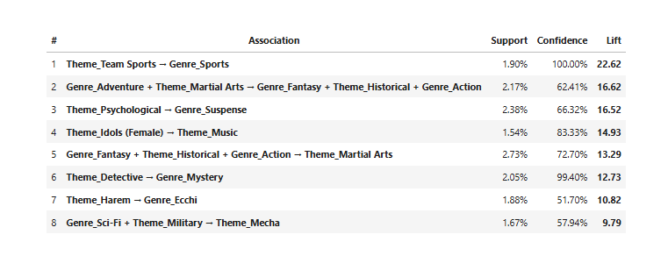
Figure 3.1 — Genre ↔ Theme Co-occurrence
2. Producer Strategy and Commercial Outcomes
Association rule mining reveals that leading producers achieve high balanced success when paired with specific genres and themes.
- Aniplex strongly associates with high success when combined with Supernatural, Fantasy, Action, Romance, or School content.
- Shueisha drives high success primarily when paired with Action or School categories.
- Dentsu shows a strong link to high success when producing Action anime.
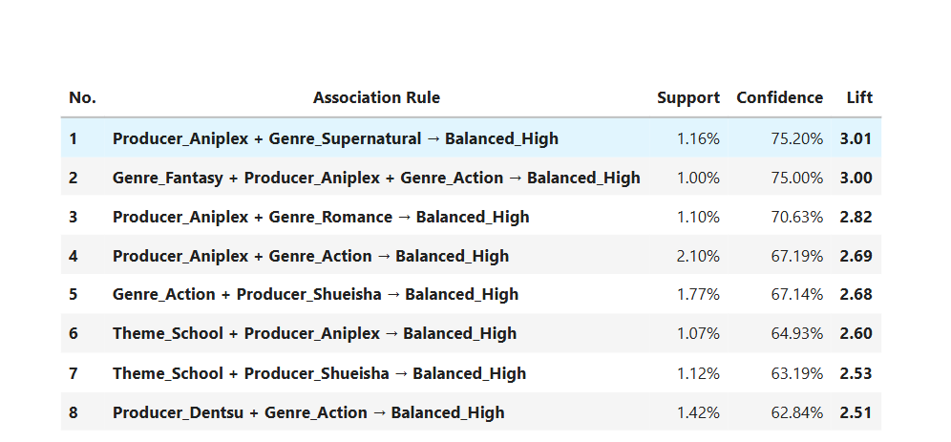
Figure 3.2 — Top producer + genre association rules for the Balanced_High outcome.
- Studio Specialization and Outcome Linkages
Top studios consistently achieve high balanced success when producing within their proven genre competencies.
- A-1 Pictures and Bones drive the strongest success in Action, each achieving over 65% confidence and lifts exceeding 2.6.
- Madhouse strongly associates with high success when paired with Drama (lift 2.26, confidence 56.58%).
- J.C.Staff shows a reliable link to high performance in Comedy (lift 1.78, confidence 44.44%).
- Toei Animation consistently converts to high success within Adventure and Action productions.
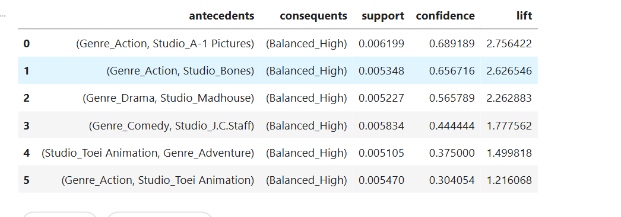
Figure 3.3— Top studios + genre association rules for the Balanced_High outcome.
3.1.2 Producer–Studio Collaboration Dynamics
To address Research Question 2 (RQ2), combinations of production companies and animation studios with at least five collaborative works were aggregated based on their average balanced_score.
The best-performing collaborations were primarily driven by the continuity of series and the sustained support of production committees:
- Collaborations between Studio Bind and Frontier Works, TOHO Animation, Hakuhodo DY, and KADOKAWA: These collaborations consistently maintained top scores (0.935–0.961) across 5 to 6 works, largely due to the support of the *Reincarnated as Unemployed* production committee.
- David Production and Medicos Entertainment: With an average balanced score of 0.956 across 8 collaborative works and over 1 million members, this success is primarily driven by *JoJo’s Bizarre Adventure*.
- Studio Ghibli and Dentsu: With 6 theatrical films, the average composite score is 0.941, and the number of members is approximately 848,000.
- CloverWorks, Toho Animation, Shogakukan-Shueisha, and TV Tokyo: 5 to 6 collaborative works, with an average composite rating ranging from 0.931 to 0.939, driven primarily by highly anticipated adaptations such as *Spy x Family*.
- White Fox and Memory-Tech: 7 co-produced works, with an average rating of 0.931 and approximately 908,000 subscribers, centered around *Re:Zero*.
Overall, title-level inspection reveals that these top pairs rarely collaborate across diverse slates; rather, they tend to work together repeatedly across multiple popular seasons, cours, and continuations of a single proven franchise.
3.1.3 Synopsis Text Mining and Narrative Clustering (SVD + K-Means)
To address RQ3, we performed unsupervised text mining on the raw plot synopsis texts from 6,798 valid records to determine whether natural language can capture underlying narrative prototypes without relying on genre labels. We vectorized the plot summaries using the TF-IDF algorithm (after removing English stopwords) and performed dimension reduction using truncated singular value decomposition (TruncatedSVD, i.e., latent semantic analysis) to preserve the sparsity of the matrix without the need for mean centering. In the L_2-normalized 30-dimensional SVD space, we scanned the range of candidate cluster sizes from k = 8 to k = 40 and determined that k = 32 was the optimal configuration, achieving a peak contour score of 0.1488. For unstructured plot summaries, lower absolute contour scores are common, as narrative tropes across different works tend to naturally overlap.
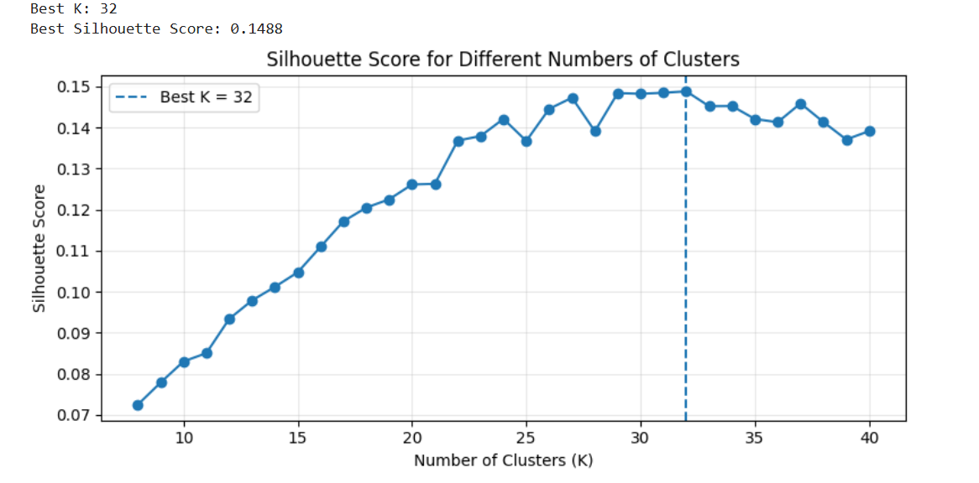
Figure 3.4 — Silhouette score across candidate cluster counts k = 8..40, identifying k = 32 as the objectively best choice
Recovered Storyline Archetypes
Inspecting dominant TF-IDF keywords and top genre distributions across the 32 clusters confirmed distinct, human-interpretable storyline patterns:
- Franchise & Mascot Clusters: Highly specific clusters isolated major legacy properties purely from text, such as Cluster 0 (n = 57, Pokémon: "satoshi", "pikachu", "region"), Cluster 16 (n = 121, One Piece: "luffy", "straw", "crew", "island"), and Cluster 20 (n = 46, Doraemon: "nobita", "doraemon", "shizuka", "gadget").
- Fantasy & Sci-Fi Archetypes: High-fantasy court tropes grouped into Cluster 1 (n = 225: "magic", "kingdom", "princess", "witch"), while cultivation and xianxia narratives formed Cluster 19 (n = 224: "sect", "emperor", "heaven", "li", "qin"). Galactic war narratives formed Cluster 18 (n = 295, predominantly Sci-Fi: "earth", "space", "alien", "zeon", "war"), and demonic conflict formed Cluster 27 (n = 206: "demon", "demon lord", "hero").
- School, Club, & Romance Settings: School life split into distinct sub-genres, including large general high-school comedy/romance (Cluster 9, n = 468: 'high', 'high school', 'student' ), after-school clubs (Cluster 8, n = 174: "club", "members"), student councils (Cluster 31, n = 82: 'council', 'student council', 'student', 'president', 'academy'), and pure romance/drama (Cluster 21, n = 197: "love", "feelings", "relationship").
- Specialized Sub-Genres: Distinct clusters captured competitive sports teams (Cluster 13, n = 220: "soccer", "baseball", "tournament"), detective procedural mysteries (Cluster 17, n = 186: "detective", "conan", "police", "case"), idol performance groups (Cluster 22, n = 155: "idol", "music", "band"), and martial arts tournaments (Cluster 25, n = 102).
3.2 Predictive mining
Predictive mining develops forward-looking models to support investment decisions: discovering similar titles through hybrid matching, classifying pre-release commercial success, and forecasting genre demand.
3.2.1 Content-Based Hybrid Anime Recommendation
To support project scoping and comparative benchmarking, a content-based recommender blends two complementary representations:
- Storyline Similarity: Cosine similarity computed over an $L_2$-normalized 100-component TruncatedSVD embedding fit on TF-IDF synopsis vectors, capturing narrative arcs and latent tropes.
- Genre and Theme Similarity: Cosine similarity computed over combined multi-hot encoded genre and theme vectors via MultiLabelBinarizer.
For each query, both similarity vectors are min-max scaled to [0, 1] before computing the final weighted score:
Similarity_hybrid = 0.6 * Similarity_story+ 0.4*Similaritygenre_theme
Storyline carries the dominant 60% weight so the engine prioritizes narrative structure over shared superficial tags. The recommender supports fuzzy matching across primary, English, Japanese, and synonym titles (e.g., resolving 進撃の巨人 to Shingeki no Kyojin).
3.2.2 Anime Success Classification
This task evaluates whether a title's market reception can be anticipated pre-production using strictly pre-release metadata: studio, genres, themes, source material, format, and synopsis text embeddings. Post-release metrics (e.g., member counts, review scores, popularity ranks) were omitted to prevent data leakage.
Dataset and Splitting Strategy
The modeling dataset was restricted to completed titles released from 2010 onward (n = 6,659). To mirror real-world forecasting and prevent temporal leakage, records were partitioned chronologically:
- Training Set (<= 2022): 5,165 titles (77.6%)
- Validation Set (<=2023): 480 titles (7.2%)
- Held-Out Test Set (> 2023 />=2024): 1,014 titles (15.2%)
The target variable (is_success_b) was framed as a binary flag set to 1 if a title's balanced_score met or exceeded the 75th percentile of the training distribution (0.6946). Defining the threshold exclusively on the training split prevents target leakage into later periods. The positive class remained stable across all subsets: 25.0% in training (1,292 / 5,165), 24.6% in validation (118 / 480), and 23.4% in testing (237 / 1,014), eliminating the need for artificial resampling.
Feature Engineering (FeatureBuilder)
A custom FeatureBuilder pipeline constructed a 108-dimensional feature matrix. To ensure strict separation between splits, all vocabularies, historical aggregations, text transformers, and medians were fitted exclusively on the training partition:
- Categorical Identifiers: One-hot encodings for top genres (n = 25), top themes (n = 20), top studios (n = 30,>= 10$ titles), demographics, source materials, delivery types, age ratings, and airing seasons.
- Historical Track Records: Historical mean “balanced_score” mapped across studios (studio_hist_balanced) and source material types (source_hist_balanced), imputing unseen categories with the training set global mean.
- Production Metadata: Imputed episode counts and durations (via training medians), release year, studio/producer list lengths, and total tag counts.
- Narrative Storyline Embeddings: A fresh TF-IDF vectorizer (3,000 unigrams/bigrams, domain stop-words filtered) coupled with TruncatedSVD to produce a 20-dimensional storyline embedding (story_svd_0 to story_svd_19).
An explicit leakage audit confirmed zero post-release engagement metrics were retained in the final 108 features.
Modeling
Four distinct algorithms were implemented to benchmark linear against non-linear decision boundaries:
- Logistic Regression (Baseline): Serves as the parametric baseline. Standardized via StandardScaler (Z-score scaling fit on the training split) and configured with max_iter=2000 to guarantee convergence.
- Decision Tree: A non-linear tree classifier parameterized with max_depth=8 and min_samples_leaf=5 to constrain tree complexity.
- Random Forest: An ensemble bagging model trained with 400 estimators, max_depth=10, and min_samples_leaf=5 to limit individual tree variance.
- XGBoost: A gradient-boosted decision tree architecture built with 400 boosting rounds, max_depth=4, a conservative learning rate of 0.05, and sub-sampling ratios of 0.8 for rows and feature columns (colsample_bytree=0.8).
Proposed Model
The proposed model is XGBoost, chosen for its ability to capture complex non-linear interactions across structured pre-release features while iteratively minimizing prediction error.
XGBoost achieved the strongest overall performance (accuracy 0.789, precision 0.539, F1-score 0.601), providing the best protection against costly false positives in greenlighting decisions. Feature importance analysis revealed that historical studio track record, source material background, and specific genre-theme pairings are the primary drivers of commercial success. Furthermore, the 20-component SVD synopsis embeddings confirmed that latent narrative tropes contribute essential predictive signal beyond metadata tags alone.
Adopting XGBoost provides a unified approach to prediction and interpretation, delivering reliable pre-release classification alongside actionable insights into the key production factors driving market performance.
3.2.3 Genre Trend Forecasting (Damped Holt-Winters)
To project audience engagement shifts and inform production greenlighting timelines, an additive Exponential Smoothing model with a damped trend was applied to the historical annual audience demand (median MyAnimeList members, 2010–2025) across key volatile genres (Romance, Ecchi, Girls Love, Supernatural, Suspense, and Mystery).
1. Historical Backtesting (2023–2025)
Models were trained on historical records through 2022 to generate out-of-sample forecasts for 2023, 2024, and 2025. Projections were benchmarked against observed audience figures using Mean Absolute Error (MAE), Root Mean Squared Error (RMSE), and Mean Absolute Percentage Error (MAPE).
2. Forward Horizon Forecasting (2026–2028)
Following backtesting validation, models were refit on the complete historical window (2010–2025) to project 3-year audience demand trajectories across the 2026, 2027, and 2028 production cycles.
Genre | 2026 forecast | 2027 forecast | 2028 forecast | Trend
Ecchi | 139,427 | 139,630 | 139,792 | Slight increase
Romance | 93,981 | 93,401 | 92,934 | Slight decrease
Girls Love | 87,589 | 86,579 | 85,574 | Decrease
Supernatural | 41,848 | 40,279 | 38,923 | Decrease
Mystery | 34,624 | 32,553 | 30,492 | Decrease
Suspense | 46,250 | 34,719 | 23,245 | Sharp decrease
Table 3.1 — 2026–2028 genre audience-demand (median members) forecast.
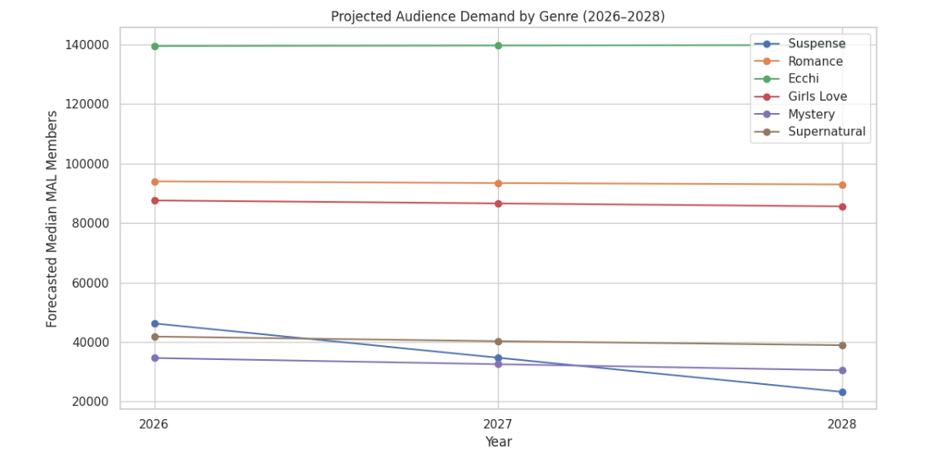
Figure 3.5 — Genre audience-demand (median MAL members) trend with 3-year Holt-Winters forecast
As shown in Figure 3.5, Ecchi maintains the highest projected demand ceiling at approximately 140,000 median members, while Romance and Girls Love remain relatively stable above 85,000 members. In contrast, Suspense exhibits the sharpest contraction over the forecast horizon, dropping to approximately 23,000 median members by 2028.

Chapter 4

EVALUATION
This chapter presents the quantitative and qualitative evaluation results for the predictive and analytical systems developed in Chapter 3: the pre-release success classifiers, the unsupervised NLP storyline clustering and content-based recommender, and the time-series forecasting models.
4.1 Evaluation Framework and Metrics
Because each analytical component serves a distinct objective, tailored evaluation criteria were implemented:
- Success Classification: Evaluated on the held-out test split (>=2024$,n = 1,014) across four complementary metrics to balance class skew (~23.4% positive):
  - Accuracy: Overall correctness across both classes.
  - Precision: Share of predicted successes that achieved actual top-quartile performance, measuring reliability against false positives.
  - Recall: Share of actual successful titles identified by the model, measuring sensitivity against false negatives.
  - F1-Score: Harmonic mean of precision and recall.
  - ROC-AUC: Threshold-independent ranking capability separating hits from lower-tier titles.
- Storyline Clustering: Evaluated internally via mean silhouette coefficients across candidate k partitions, and externally through a Chi-square test of independence and Cramér's V against platform genre tags.
- Content-Based Recommender: Assessed via qualitative spot-checks, verifying query disambiguation, franchise cohesion, and cross-genre thematic retrieval.
- Time-Series Forecasting: Evaluated over an out-of-sample backtest window (2023–2025) using Mean Absolute Error (MAE), Root Mean Squared Error (RMSE), and Mean Absolute Percentage Error (MAPE).

4.2 Success Classification Performance
4.2.1 Model Comparison on Held-Out Test Data (>= 2024)
All four classifiers were trained on pre-2023 historical records (n = 5,165) using 108 pre-release features and evaluated on the held-out test set (n = 1,014).

Model | Accuracy | Precision | Recall | F1 | ROC-AUC
Logistic Regression (baseline) | 0.709 | 0.432 | 0.776 | 0.555 | 0.824
Decision Tree | 0.649 | 0.385 | 0.835 | 0.527 | 0.766
Random Forest | 0.725 | 0.452 | 0.831 | 0.585 | 0.845
XGBoost | 0.789 | 0.539 | 0.679 | 0.601 | 0.840
Table 4.1 — Performance Metrics on the Held-Out Test Set (>2024)
Ensemble architectures clearly separated from the linear baseline and the single Decision Tree:
- XGBoost delivered the highest overall accuracy (0.789), precision (0.539), and F1-score (0.601), effectively mitigating false-positive risk in pre-production greenlighting.
- Random Forest yielded the highest ROC-AUC (0.845) and strong recall (0.831), trading precision (0.452) to capture a wider net of potential hits.
- Logistic Regression established a competitive linear baseline (ROC-AUC 0.824), confirming that pre-release features encode genuine predictive signal.
- Decision Tree achieved high recall (0.835) but suffered from poor precision (0.385) and an uncompetitive ROC-AUC (0.766), reflecting individual tree instability.
4.2.2 ROC Curve Analysis
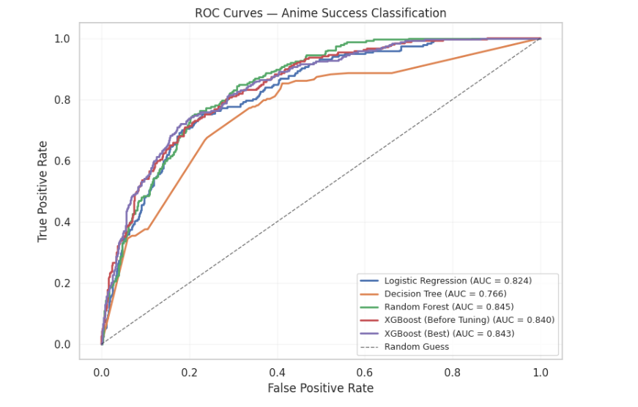
Figure 4.1 — Receiver Operating Characteristic (ROC) curves across all models
The ROC curves illustrate clear diagnostic separation. Random Forest (0.845) and XGBoost (0.840) maintain strong sensitivity across low false-positive rates, running nearly parallel throughout the curve. Logistic Regression (0.824) demonstrates solid linear separability, while the single Decision Tree (0.766) underperforms across all threshold boundaries.
4.2.3 Cross-Validation and Confusion Matrix Analysis
To evaluate generalization stability beyond aggregate metric scores, the champion XGBoost model was evaluated across its prediction error distribution on the held-out test split (n = 1,014).
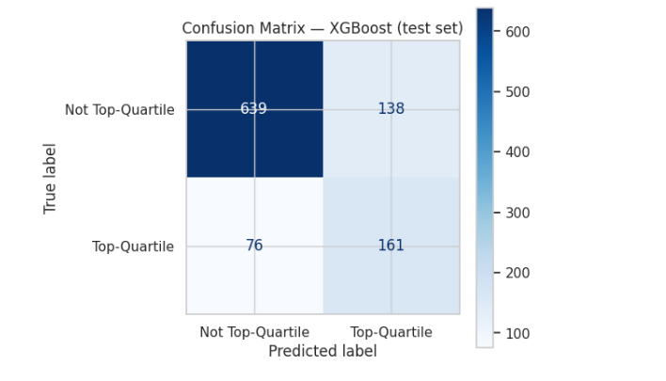
Figure 4.2 — Confusion Matrix for XGBoost on the Held-Out ($\ge 2024$) Test Set.
As shown in Figure 4.2, the confusion matrix breaks down predictions across the binary classes (Not Top-Quartile vs. Top-Quartile):
- True Negatives (TN = 639): Correctly classified non-top-quartile titles, successfully screening out 82.2% ($639 / 777$) of commercially underperforming concepts.
- False Positives (FP = 138): Titles incorrectly flagged as potential hits, yielding an operational precision of 53.8% ($161 / 299$).
- False Negatives (FN = 76): High-performing titles missed by the model, reflecting an error rate of only 7.5% across the full test cohort.
- True Positives (TP = 161): Successfully predicted top-quartile successes, capturing 67.9% ($161 / 237$) of all actual commercial hits.

4.3 Storyline Clustering and Recommender Validation
4.3.1 Statistical Validation of Text Clusters
The 32-cluster SVD synopsis solution was evaluated against catalog genre labels to determine whether latent text features capture valid structural patterns without redundantly mirroring metadata tags:
- Chi-Square Test: Decisively rejected the null hypothesis of independence (chi_square = 10,372.3, p < 0.001), confirming that text-derived storyline clusters reliably correspond to underlying genre classifications rather than emerging as arbitrary noise.
- Cramér's V: Yielded 0.180 (with all genres included), indicating a moderate association on the standard 0–1 scale. This confirmed that the synopsis embeddings successfully capture real genre structures while retaining non-redundant narrative nuances that static metadata tags miss, justifying the use of SVD storyline components in subsequent predictive and recommendation tasks.
4.3.2 Qualitative Evaluation of the Hybrid Recommender
The hybrid engine (60% 100-component SVD storyline similarity, 40% binarized genre/theme similarity) was assessed through targeted spot-checks across diverse genres:
- Franchise & Narrative Cohesion: Querying Fullmetal Alchemist: Brotherhood surfaced preceding franchise installments alongside dark fantasy military narratives (Hai to Gensou no Grimgar).
- Cross-Genre Psychological Mapping: Querying Death Note retrieved complex psychological and supernatural thrillers (Serial Experiments Lain, Mirai Nikki: Redial) rather than generic action or supernatural series, confirming the storyline component's influence.
- Multilingual Query Resolution: Title searches successfully resolved across alternate English, Japanese (進撃の巨人 $\rightarrow$ Shingeki no Kyojin), and synonym records, with unindexed queries reliably triggering "no title found" fallback handling.
- Unmatched search terms cleanly return a "no title found" message.
4.4 Forecasting Evaluation
To evaluate forecast accuracy, additive Holt-Winters models with damped trends were trained on data through 2022 and backtested against observed values over the 2023–2025 holdout window.
Genre | MAE | RMSE | MAPE | Accuracy interpretation
Romance | 29,603 | 30,323 | 35.89% | Best
Ecchi | 30,080 | 47,660 | 41.75% | Relatively good
Girls Love | 47,681 | 48,735 | 72.31% | Weak
Supernatural | 42,353 | 44,285 | 79.16% | Weak
Suspense | 61,448 | 61,873 | 182.41% | Very poor
Mystery | 44,930 | 44,971 | 291.01% | Very poor
Table 4.2 — 2023–2025 backtest of the audience-demand (median members) Holt-Winters forecast.
The backtest demonstrates strong performance for high-volume, stable categories, with Romance and Ecchi achieving the lowest error rates across all metrics. Conversely, MAPE degrades heavily for niche genres like Suspense (182.41%) and Mystery (291.01%). This inflation is a structural property of MAPE, which divides errors by small actual values, exaggerating percentage error when baseline audience sizes are low. Because the absolute errors (MAE and RMSE) for Mystery and Suspense remain comparable to Supernatural and Girls Love, MAE and RMSE serve as the primary reliable benchmarks for low-volume genres.

Chapter 5

Conclusion

This project utilized metadata from MyAnimeList to develop an end-to-end data mining pipeline designed to evaluate the production quality of anime works from an investment decision-making perspective. The pipeline encompassed automated data collection, target engineering for bias correction, association rule mining, text-based plot clustering, hybrid recommendation, pre-release classification, and demand forecasting. Empirical results confirm that a production company’s capabilities, committee partnerships, and the alignment of genre and theme can provide strong, learnable signals of commercial success even before a work is released.
5.1 Advantages of this project
- Bias-Corrected Success Metric: The balanced_score discounts high-scoring niche titles with small audiences, ensuring evaluations reflect genuine commercial reach.
- Actionable Association Mining: FP-Growth rules deliver clear strategic insights into studio genre competencies and high-performing producer partnerships.
- Statistically Validated NLP Clustering: The 32-cluster SVD synopsis representation is statistically validated (chi_square = 10,372.3, Cramér's V = 0.180), capturing authentic genre structures alongside non-redundant narrative tropes.
- Leakage-Free Predictive Modeling: Evaluated on a strict chronological split using strictly pre-release features to ensure realistic, out-of-sample performance benchmarks.
- Modular and Reproducible Pipeline: Modular preprocessing, vectorization, and modeling workflows allow seamless updates as new anime seasons air.

5.2 Limitation of this project
- Absence of Financial Data: Because platform metadata excludes production and marketing budgets, the framework evaluates audience reception and engagement rather than direct financial ROI.
- Lack of Source Material and Sequel Linkages: The dataset does not track prior manga sales ranks or explicit prequel-sequel chains, preventing the model from quantifying pre-existing adaptation pull or franchise carryover effects.
- Sample Attrition from Missing Data: Requiring complete synopsis and rating fields reduced the dataset from 11,500 to 8,227 titles, inherently excluding unrated, newly announced, or niche promotional works.
- Qualitative Recommender Validation: Evaluation of the hybrid recommender relies on qualitative query verification rather than formal ranking metrics (e.g., NDCG@K, franchise recall).
- Volatile Niche Time-Series Trajectories: Damped Holt-Winters forecasting performs reliably on mainstream genres with stable release patterns, but exhibits high percentage error (inflated MAPE) on low-volume, high-variance categories like Suspense and Mystery.

References
[1] Jikan API, “Jikan — Unofficial MyAnimeList API,” [Online]. Available: [https://docs.api.jikan.moe/](https://docs.api.jikan.moe/).
[2] J. Han, J. Pei, and Y. Yin, “Mining Frequent Patterns without Candidate Generation,” in Proc. ACM SIGMOD, 2000, pp. 1–12.
[3] S. Deerwester et al., “Indexing by Latent Semantic Analysis,” JASIS, vol. 41, no. 6, 1990, pp. 391–407.
[4] H. Cramér, Mathematical Methods of Statistics, Princeton University Press, 1946.
[5] C. C. Holt, “Forecasting Seasonals and Trends by Exponentially Weighted Moving Averages,” Int. J. Forecast., vol. 20, no. 1, 2004, pp. 5–10.
[6] T. Chen and C. Guestrin, “XGBoost: A Scalable Tree Boosting System,” in Proc. 22nd ACM SIGKDD, 2016, pp. 785–794.

