NeoHealth: A Multi-Factor Fuzzy Approach to Newborn Health Risk Assessment
Yoon Nwe Htun | Khin Thida Hnin | Tha Pyay Win
University of Information Technology | University of Information Technology | Faculty of Computer Systems and Technologies
Yangon, Myanmar | Yangon, Myanmar | University of Information Technology
yoonnwehtun@uit.edu.mm | khinthidahnin@uit.edu.mm | Yangon, Myanmar
 |  | thapyaywin@uit.edu.mm

Abstract— Newborn health risks can develop rapidly, while early information is often uncertain or incomplete. NeoHealth addresses this challenge through an interpretable, web-based assessment system that considers multiple aspects of newborn health rather than relying on a single clinical indicator. Using fuzzy logic, the system evaluates APGAR components alongside gestational age, birth weight, maternal and delivery-related conditions, and family disease history to estimate an overall risk level. The assessment is presented as low, moderate, or high risk, together with clear explanations, confidence information, visual summaries, saved records, and downloadable reports. By transforming complex and overlapping health factors into understandable results, NeoHealth demonstrates the potential of fuzzy reasoning to improve preliminary risk awareness and support informed decision-making. The system is designed for educational and decision-support purposes and is not a substitute for professional medical diagnosis, clinical evaluation, or treatment.
Keywords— newborn health assessment, neonatal risk, fuzzy logic, Mamdani inference, APGAR score, decision-support system, healthcare informatics.

Introduction
Newborn health assessment is important for identifying potential risks during the early stage of life. The neonatal period is highly sensitive, and timely evaluation can support appropriate care and monitoring. Newborn health may be influenced by several factors, including APGAR score, gestational age, birth weight, maternal age, delivery type, delivery complications, and family disease history. However, interpreting these factors can be challenging because medical conditions often involve uncertainty.
Conventional assessment methods commonly rely on fixed ranges or clinical judgment. Although these methods are essential in medical practice, rigid classifications may not fully represent gradual changes in health risk. For example, a newborn with a moderately low APGAR score, slightly low birth weight, or near-preterm gestational age may not clearly belong to a single risk category. Therefore, a computational approach capable of handling imprecise information while producing interpretable results can be beneficial.
Fuzzy logic is suitable for this problem because it represents input values using linguistic terms such as low, normal, moderate, and high. Rather than assigning each factor to one fixed category, it allows gradual membership across multiple categories. A fuzzy inference system can combine related factors through decision rules and generate an understandable risk output.
This project, titled “A Multi-Factor Fuzzy Approach to Newborn Health Risk Assessment,” introduces NeoHealth, a web-based system that estimates newborn health risk using multiple neonatal and maternal factors. It evaluates immediate condition, birth-related factors, and family-history information before producing an overall risk classification. NeoHealth also provides visual charts, explanations, confidence information, assessment history, and downloadable PDF reports.
NeoHealth demonstrates an interpretable and user-friendly approach to preliminary newborn health-risk assessment. It is intended for educational decision support and does not replace professional medical diagnosis, clinical judgment, or treatment.

Related Work
J. Hong, K. Crawford, K. Jarrett, T. Triggs, and S. Kumar (2024) investigated the relationship between the five-minute Apgar score and adverse neonatal outcomes using a population-based cohort of 941,221 term singleton births in Queensland, Australia. The study found that lower five-minute Apgar scores were associated with higher risks of neonatal death and severe neurological disorders. The outcomes show the importance of the Apgar score in the short-term assessment of the condition of the newborn. This study did not suggest a fuzzy decision-support system integrating the Apgar components with other maternal, delivery and family-history factors as well [1].
N. Moftian, T. S. Soltani, K. Mirnia, A. Esfandiari, M. S. Tabib, and P. R. Hachesu (2023) identified clinical risk factors associated with early-onset sepsis in preterm infants. The study implemented the fuzzy Delphi technique to reach consensus among experts on the risk factors of premature babies and maternal health. The identified factors included low birth weight, low one-minute Apgar score, prematurity, maternal urinary tract infection, premature rupture of membranes, and so on. Although the fuzzy Delphi method was effective in handling the uncertainty of expert assessments, the study only considered early-onset neonatal sepsis and did not consider a generalized fuzzy inference system for assessing overall newborn health risk [2].
F. Kermani, M. R. Zarkesh, M. Vaziri, and A. Sheikhtaheri (2023) developed a web-based case-based reasoning system to predict neonatal survival and length of stay in neonatal intensive care units. The system employed a K-nearest-neighbour approach and previously collected neonatal cases to determine similarities between new patients and historical cases. The methodology is based upon a clinical data-set and a data-centric K-nearest-neighbor technique. The proposed system, however, does not employ machine learning or historical training data and instead applies predefined fuzzy membership functions and interpretable IF–THEN rules [3].
A. A. Sobowale et al. (2020) proposed a fuzzy clinical decision-support system for monitoring preterm infants in neonatal intensive care units. The system used temperature, heart rate and respiratory rate as input parameters with low, medium and high fuzzy membership levels. A total of 27 IF–THEN rules were used to classify the neonate’s condition as normal, abnormal, or critical. However, the attention was mainly focused on ongoing surveillance of vital signs and exclusion of wider aspects such as gestational age, birth weight, complete Apgar components, maternal health, delivery problems or family medical history [4].
The existing studies apply clinical factors and fuzzy reasoning to specific neonatal outcomes, such as mortality, sepsis, survival, and abnormal vital signs. In contrast, the proposed system combines neonatal, maternal, delivery, and family-history factors using hierarchical fuzzy inference. It provides interpretable risk scores for preliminary assessment and is not intended to replace professional medical diagnosis.

System overview
NeoHealth is a web-based newborn health risk assessment system that applies fuzzy logic to newborn, maternal, delivery-related, and family-history factors. It provides an interpretable preliminary assessment using information available at or shortly after birth.
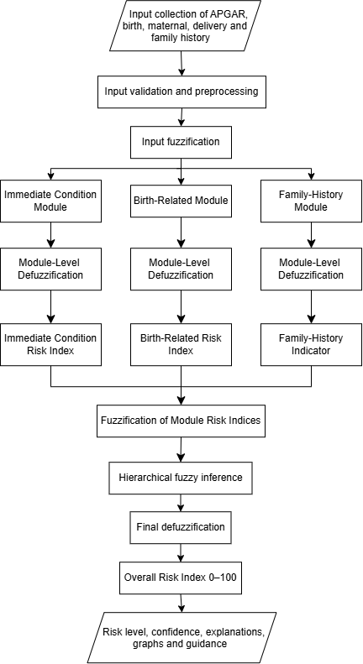
Fig. 1. Overall workflow of the NeoHealth hierarchical fuzzy newborn health risk assessment system
As shown in Fig. 1, the assessment begins with the collection of the five APGAR components—Appearance, Pulse, Grimace, Activity, and Respiration—together with gestational age, birth weight, maternal age, delivery type, delivery complications, and family disease history. The inputs are then validated and preprocessed. During this stage, the total APGAR score is calculated, birth weight is standardized in grams, and categorical inputs are converted into the representations required by the fuzzy inference engine.
The preprocessed inputs are fuzzified and processed through three modules: the Immediate Condition Module, Birth-Related Module, and Family-History Module. The Immediate Condition Module evaluates the APGAR score and delivery-complication status. The Birth-Related Module evaluates gestational age, birth weight, maternal age, and interactions between related birth factors. The Family-History Module evaluates the reported family disease and affected family member to produce a general family-history indicator.
Each module applies fuzzy IF–THEN rules and produces an index from 0 to 100. The Immediate Condition Risk Index, Birth-Related Risk Index, and Family-History Indicator are then passed to the hierarchical fuzzy inference layer [5]. After final defuzzification, the system generates an Overall Risk Index ranging from 0 to 100. The result is classified as low, moderate, or high risk and is presented with a confidence level, explanations, membership-function graphs, and user-oriented guidance.

System Methodology

Input Collection and Preprocessing
NeoHealth collects newborn, maternal, delivery, and family-history data through a web form. Inputs include the five APGAR components, gestational age, birth weight, maternal age, delivery type, delivery complications, and family disease history. The system validates and standardizes these values before fuzzy processing.
The APGAR score is calculated as:
APGAR = Appearance + Pulse + Grimace + Activity + Respiration
In APGAR, each component ranges from 0 to 2, giving a total score of 0 to 10 [6].
Birth weight is converted to grams.
Preterm birth is defined as birth before 37 completed weeks, while low birth weight is defined as a birth weight below 2,500 g [7].

Fuzzification
Fuzzification converts numerical inputs into linguistic categories such as low, normal, moderate, and high. NeoHealth uses triangular and trapezoidal membership functions [8].
- Trapezoidal functions

It is used for APGAR score, Gestational age, Birth weight, Maternal age, Delivery-complication status, Family-history indicators.

$$\begin{aligned}μ\left(x;a,b,c,d\right)=\left\{\begin{matrix}0 & \text{if} x<a \\ \frac{x-a}{b-a} & \text{if} a≤x≤b \\ 1 & \text{if} b≤x≤c \\ \frac{d-x}{d-c} & \text{if} c≤x≤d \\ 0 & \text{if} x>d\end{matrix}\right.\#\left(1\right)\end{aligned}$$

A trapezoidal function is defined by four points: a, b, c, and d. Membership increases from 0 to 1 between a and b, remains 1 between b and c, and decreases to 0 between c and d. This allows stable clinical ranges and gradual boundary transitions to be represented.
- Triangular functions
They are used for categories centered on a representative value.
$$\begin{aligned}μ\left(x;a,b,c\right)=\left\{\begin{matrix}0, & x<a \\ \frac{x-a}{b-a}, & a≤x≤b \\ \frac{c-x}{c-b}, & b<x≤c \\ 0, & x>c\end{matrix}\right.\#\left(2\right)\end{aligned}$$

Modular Risk Assessment
NeoHealth evaluates three modules:
- Immediate Condition Risk
- Birth-Related Risk
- Family-History Risk
Each module produces a risk index from 0 to 100.
Immediate Condition Risk = $F_{IC}$(APGAR score, Delivery-complication status)
Birth-Related Risk = $F_{BR}$ (Gestational age, Birth weight, Maternal age, Delivery type, Delivery-complication status) [9]
Family-History Risk = $F_{FH}$ (Family disease status, Affected family member)

Mamdani Fuzzy Inference System (FIS)
NeoHealth uses Mamdani fuzzy inference with IF-THEN rules. Crisp clinical inputs (e.g., APGAR score, Gestational Age) are converted into fuzzy membership degrees using input membership functions [10].
For Fuzzy Operator AND, the minimum membership value is used. For Fuzzy Operator OR, the maximum membership value is used [11].
$$\begin{aligned}μ_{A∩B}\left(x\right)=\min\left(μ_{A}\left(x\right),μ_{B}\left(x\right)\right)\#\left(3\right)\end{aligned}$$
$$\begin{aligned}μ_{A∪B}\left(x\right)=\max\left(μ_{A}\left(x\right),μ_{B}\left(x\right)\right)\#\left(4\right)\end{aligned}$$

Example Rule: IF the APGAR score is low AND gestational age is preterm, THEN the risk is high.
- Rule Evaluation: The AND condition takes the minimum membership values:
$$α=\min\left(μ_{\text{Low}}\left(\text{APGAR}\right),μ_{\text{Preterm}}\left(\text{GestationalAge}\right)\right)\left(5\right)$$
- Implication: The consequent membership function $μ_{Risk}\left(z\right)$ is clipped at height $α_{k}$ for each rule k.
$$\begin{aligned}μ_{C_{k}^{'}}\left(z\right)=\min\left(α_{k},μ_{\text{Ris}{\text{k}}_{\text{k}}}\left(z\right)\right)\#\left(6\right)\end{aligned}$$

- Aggregation: Once the fuzzy outputs are evaluated, they are aggregated using the max-min composition method. The output represents low, moderate, or high risk.
$$\begin{aligned}μ_{\text{aggregated}}\left(z\right)=\max_{k=1,…,m}\left(\min\left(α_{k},μ_{\text{Ris}{\text{k}}_{\text{k}}}\left(z\right)\right)\right)\#\left(7\right)\end{aligned}$$

Defuzzification:

The fuzzy output is converted into a numerical risk index using the discrete centroid method. The result ranges from 0 to 100.
$$\begin{aligned}\text{Final Risk Index} \left(z^{*}\right)=\frac{\sum_{i=1}^{n}{\left(z_{i}⋅μ\left(z_{i}\right)\right)}}{\sum_{i=1}^{n}{μ\left(z_{i}\right)}}\#\left(8\right)\end{aligned}$$
  - Hierarchical Risk Combination
Final Risk = $F_{H}$(Immediate Condition Risk, Birth-Related Risk, Family-History Risk)
The final score is classified as:
- Low Risk: $0≤\text{Risk}<30$
- Medium Risk: $30≤\text{Risk}<70$
- High Risk: $70≤\text{Risk}≤100$
  - Result Explanation and Report Generation
NeoHealth displays the final risk level, APGAR breakdown, module indices, contributing factors, rule traces, confidence information, and charts. Results may be saved to private history or exported as a PDF report. This methodology supports flexible, interpretable risk assessment by handling uncertain inputs and gradual clinical boundaries.

System Design and implementation

System Architecture
NeoHealth is a web browser-based application that uses Flask to integrate the assessment interface, fuzzy inference engine, PostgreSQL database, visualization functions, and PDF generator. Flask receives HTTP requests, validates and standardizes the input data, calculates the APGAR score, and sends the processed inputs to the fuzzy engine. The engine generates the module risks, final risk classification, confidence information, contributing factors, and activated rules. Flask then displays the results and stores the assessment record in PostgreSQL.

Web Interface Implementation
The NeoHealth web interface provides registration, login, newborn assessment, result presentation, and assessment-history functions. The assessment form divides the required information into separate sections so that newborn, maternal, delivery-related, and family-history data can be entered in a structured sequence.
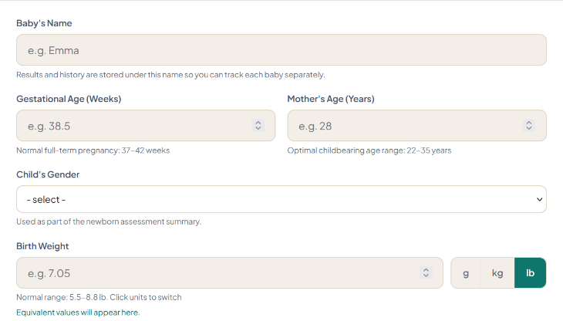
Fig. 2. Newborn and maternal information entry interface
Fig. 2 shows the newborn and maternal information section. The baby’s name is used to identify saved assessments in the user’s history. Gestational age and maternal age are entered in weeks and years, respectively, while the child’s gender is recorded as part of the assessment summary. Birth weight may be entered in grams, kilograms, or pounds through the unit-selection control. The selected weight is subsequently converted into grams before fuzzy processing. Reference ranges and equivalent weight values are displayed to assist the user during data entry.
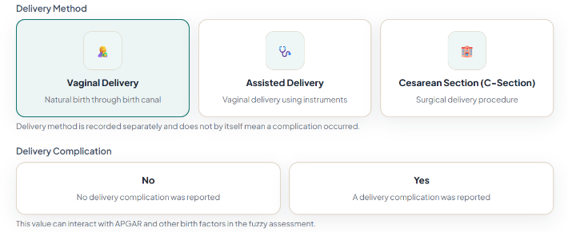
Fig. 3. Delivery method and delivery-complication selection interface
Fig. 3 presents the delivery-information section. The user selects vaginal delivery, assisted delivery, or cesarean section as the delivery method. Delivery complications are recorded separately using a binary selection. This separation prevents the system from automatically interpreting a particular delivery method as a complication. During fuzzy processing, the reported complication status may interact with the APGAR result and other birth-related factors.
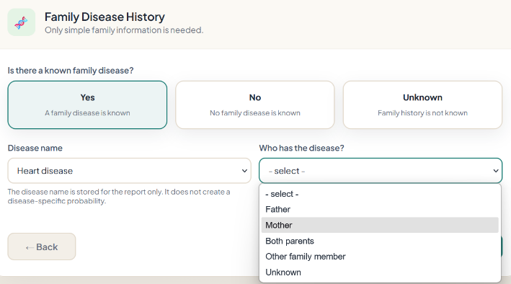
Fig. 4. Family disease-history entry interface
The family disease-history interface is shown in Fig. 4. The user first indicates whether family disease information is known, absent, or unknown. If a known disease is selected, the interface displays additional fields for the disease name and affected family member. The affected person may be identified as the father, mother, both parents, another family member, or unknown. The disease name is included in the assessment summary and report, whereas the reported family relationship contributes to the Family-History Risk module. Providing an unknown option also prevents missing family information from being interpreted automatically as the absence of disease.

Fuzzy Engine Integration
The fuzzy engine is implemented independently from the Flask route handlers. It accepts a standardized input structure and returns a structured result that can be used by the result page, database, charts, and PDF generator.
The engine first executes the Immediate Condition Risk, Birth-Related Risk, and Family-History Risk modules. Each module performs fuzzification, rule evaluation, output aggregation, and centroid defuzzification. The three module indices are then supplied to the hierarchical inference stage to calculate the final risk index.
The returned result contains
$$\begin{aligned}R=\{R_{IC},R_{BR},R_{FH},R_{F},L,C,E,G\}\#\left(9\right)\end{aligned}$$
where $R_{IC}$, $R_{BR}$, and $R_{FH}$ represent the three module indices; $R_{F}$ is the final risk index; L is the risk level; C contains confidence information; E contains the contributing factors and activated rules; and G represents the generated guidance.
This result structure allows all output components to use the same inference result without repeating the fuzzy calculation.

Database and User Record Management
PostgreSQL provides persistent storage for user accounts and assessment records. Database operations are implemented using Flask-SQLAlchemy, while Flask-Migrate manages schema creation and subsequent database changes. The database functions cover three connected processes: assessment storage, user access control, and retrieval of previous results.
Example Rule: IF the APGAR score is low AND gestational age is preterm, THEN the risk is high.
- PostgreSQL Data Storage
The User and Assessment models have a one-to-many relationship. Each assessment stores submitted inputs, calculated risk outputs, JSON-compatible explanations, timestamps, and the fuzzy algorithm version. Database transactions use commit and rollback to prevent incomplete records and preserve data integrity.
- User Authentication and Access Control
The authentication functions include registration, login, logout, and session management. User passwords are stored as password hashes rather than plain text. After successful login, the user identifier is maintained in the active session and associated with newly created assessment records. Protected routes require an authenticated session, and the ownership of an assessment is verified before its information is returned. An assessment can be accessed only when its stored user identifier matches the identifier of the authenticated user. This prevents users from viewing assessment records belonging to other accounts.
- Assessment History and Retrieval
The /assessments route displays the authenticated user’s saved records, including the assessment date, newborn’s name, final risk index, and risk category. The /assessments/<id> route retrieves the complete assessment details only after verifying record ownership. These details include the original inputs, APGAR breakdown, module indices, final result, contributing factors, activated rules, confidence information, and guidance. Stored result snapshots preserve previous outcomes even when the fuzzy rules or membership functions are later modified, supporting consistent historical review and traceability across different fuzzy algorithm versions.

Experimental Results
The experimental evaluation of NeoHealth examined the behavior of its fuzzy inference framework, the consistency of the generated risk classifications, input-processing functions, and supporting web application features. Four representative cases were selected to cover low, moderate, high, and borderline-risk conditions. The cases were evaluated separately by the Immediate Condition, Birth-Related, and Family-History modules before their outputs were combined to obtain the final risk assessment.

Immediate Condition Risk
Table I Immediate condition risk Results
Case | APGAR Score | Delivery Complication | Immediate Risk
C1 | 10 | No | 19.44
C2 | 7 | Yes | 63.14
C3 | 3 | Yes | 80.56
C4 | 8 | No | 19.44
Table I shows that immediate risk increases when a low APGAR score is combined with delivery complications. C1 and C4 had low risk, C2 had moderate risk, and C3 had the highest risk. This table is included to demonstrate how these two factors jointly affect the newborn’s immediate condition.
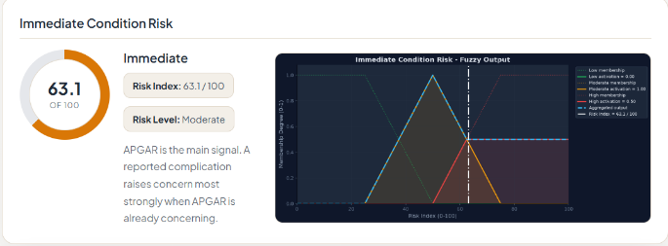
Fig. 5. Immediate-condition fuzzy output for Case C2
Fig. 5 shows that Case C2 obtained an immediate-risk index of 63.1, classified as moderate, due to its intermediate APGAR score and delivery complication. The overlapping moderate- and high-risk memberships demonstrate fuzzy inference behavior by producing a gradual risk transition rather than an abrupt classification.

Birth-Related Risk
Table II Birth-Related Risk Results
Case | Gestatio  -nal  Age | Birth  Weight | Mater-nal  Age | Delivery  Type | Comp-li-  cation | Birth-Related  Risk
C1 | 39 weeks | 3.20 kg | 28 | Vaginal | No | 19.44
C2 | 36 weeks | 2.40 kg | 31 | Assisted | Yes | 53.06
C3 | 32 weeks | 1.60 kg | 40 | Cesarean | Yes | 68.98
C4 | 37 weeks | 2.45 kg | 35 | Vaginal | No | 37.70
Table II shows that birth-related risk increases with prematurity, low birth weight, advanced maternal age, and delivery complications. C1 had the lowest risk, while C3 had the highest. This table demonstrates how multiple birth factors jointly determine the risk level.
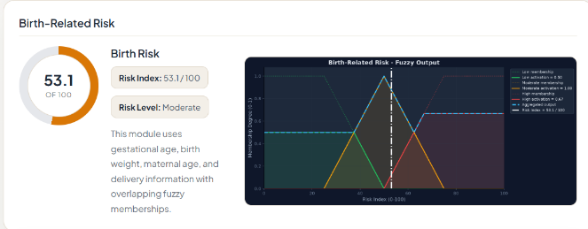
Fig. 6. Birth-related fuzzy output for Case C2
Fig. 6 shows that Case C2 obtained a moderate birth-related risk index of 53.1. The overlapping low, moderate, and high memberships demonstrate fuzzy inference behavior by combining multiple birth factors and allowing a gradual transition between risk levels.

Family-History Risk
Table III Family-History Risk Results
Case | Family Disease  Status | Affected  Family Member | Family-History  Risk
C1 | No | None | 19.44
C2 | Unknown | Not specified | 35.89
C3 | Yes | Both parents | 80.56
C4 | Yes | Other family member | 41.72
Table III shows that family-history risk increases with the number and closeness of affected family members. C1 had the lowest risk, while C3 had the highest because both parents were affected. This table describes how family-disease information affects the newborn’s risk assessment.
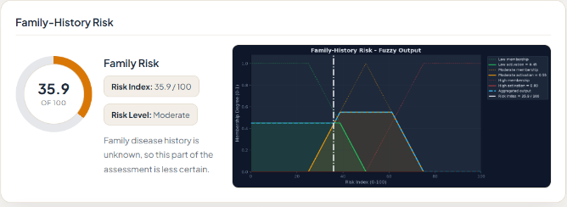
Fig. 7 Family-history fuzzy output for Case C2
Fig. 7 shows that Case C2 obtained a moderate family-history risk index of 35.9 because its family-disease information was unknown. The overlapping low and moderate memberships demonstrate fuzzy inference behavior by representing uncertainty through a gradual transition instead of a fixed classification.

Final Risk Assessment
Table IV Final Combined -Risk Assessment
Case | Immediate  Risk | Birth-Related  Risk | Family-History  Risk | Final Risk | Risk Level
C1 | 19.44 | 19.44 | 19.44 | 19.44 | Low
C2 | 63.14 | 53.06 | 35.89 | 67.01 | Moderate
C3 | 80.56 | 68.98 | 80.56 | 72.53 | High
C4 | 19.44 | 37.70 | 41.72 | 40.16 | Moderate
Table IV combines the three module outputs to determine the final risk level. C1 was classified as low, C3 as high, and C2 and C4 as moderate due to different contributing factors. This table demonstrates how multiple risks are integrated into one overall assessment.
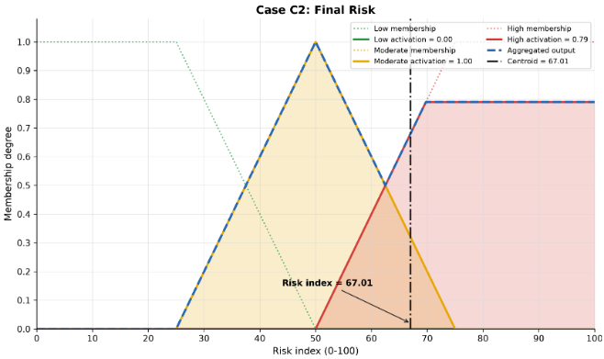
Fig. 8 Aggregated fuzzy output and centroid defuzzification for Case C2
Fig. 8 shows that Case C2 obtained a final risk index of 67.01 after combining all module outputs. The overlapping moderate- and high-risk memberships demonstrate fuzzy inference behavior, while centroid defuzzification converts the aggregated output into a single moderate-risk result.

Limitations and Future Work
Although NeoHealth provides an interpretable approach to preliminary newborn health-risk assessment, the current implementation has several limitations.
- Dependence on Input Accuracy: The reliability of the generated risk level depends on the completeness and correctness of user-provided information. Missing or inaccurate inputs may reduce assessment reliability.
- Rule-Base Limitations: The fuzzy rules represent a selected set of factor interactions and may not cover every uncommon condition, complex clinical scenario, or combination of neonatal complications.
- Limited Outcome Prediction: The system estimates a general level of health risk rather than predicting a specific diagnosis, complication, treatment requirement, or clinical outcome.
The system can be extended through real-time monitoring, additional clinical variables, data-driven optimization, clinical validation, and integration with existing healthcare information systems.
- IoT & Real-Time Monitoring: Connect with neonatal ICU sensors (e.g., continuous pulse oximeters, vitals monitors) for dynamic, time-series risk tracking.
- Expanded Clinical Variables: Add specialized modules for maternal intrapartum complications, cord blood gas analysis, and lab biomarkers (e.g., bilirubin, CRP).
- Self-Tuning & Optimization (ANFIS): Integrate Adaptive Neuro-Fuzzy Inference Systems (ANFIS) or Genetic Algorithms to learn and automatically optimize membership function parameters and rule weights directly from real-world hospital datasets.
- Mobile and Multilingual Support: A responsive mobile application and multilingual interface could improve accessibility for healthcare workers and users in different regions.

Conclusion
NeoHealth is an interpretable framework for preliminary newborn health-risk assessment using hierarchical Mamdani fuzzy inference and centroid defuzzification. It evaluates Immediate Condition, Birth-Related Factors, and Family History, reducing rule complexity while handling uncertainty more effectively than rigid thresholds. The system provides understandable risk levels, explanations, confidence information, visual summaries, assessment history, and downloadable reports without requiring training data. However, it is intended only for educational decision support, not medical diagnosis or treatment. Future clinical validation and real-time physiological data could improve its reliability and practical use.

References
- J. Hong, K. Crawford, K. Jarrett, T. Triggs, and S. Kumar, “Five-minute Apgar score and risk of neonatal mortality, severe neurological morbidity and severe non-neurological morbidity in term infants—An Australian population-based cohort study,” The Lancet Regional Health—Western Pacific, vol. 44, Art. no. 101011, 2024, doi: 10.1016/j.lanwpc.2024.101011.
- N. Moftian, T. S. Soltani, K. Mirnia, A. Esfandiari, M. S. Tabib, and P. R. Hachesu, “Clinical risk factors for early-onset sepsis in neonates: An international Delphi study,” Iranian Journal of Medical Sciences, vol. 48, no. 1, pp. 57–69, 2023, doi: 10.30476/IJMS.2022.92284.2352.
- F. Kermani, M. R. Zarkesh, M. Vaziri, and A. Sheikhtaheri, “A case-based reasoning system for neonatal survival and LOS prediction in neonatal intensive care units: A development and validation study,” Scientific Reports, vol. 13, Art. no. 8421, 2023, doi: 10.1038/s41598-023-35333-y.
- A. A. Sobowale, O. M. Olaniyan, O. Adetan, O. Adanigbo, A. Esan, A. T. Olusesi, W. B. Wahab, and O. A. Adewumi, “Implementation of a clinical decision support systems-based neonatal monitoring system framework,” International Journal of Advanced Computer Science and Applications, vol. 11, no. 9, pp. 372–377, 2020, doi: 10.14569/IJACSA.2020.0110944.
- S. M. Dolan and C. Moore, “Linking family history in obstetric and pediatric care: Assessing risk for genetic disease and birth defects,” Pediatrics, vol. 120, suppl. 2, pp. S66–S70, Sep. 2007, doi: 10.1542/peds.2007-1010E.
- American Academy of Pediatrics Committee on Fetus and Newborn and American College of Obstetricians and Gynecologists Committee on Obstetric Practice, “The Apgar score,” Pediatrics, vol. 136, no. 4, pp. 819–822, Oct. 2015, doi: 10.1542/peds.2015-2651.
- World Health Organization, “Preterm and low birth weight infants.” Accessed: Aug. 28, 2026. [Online]. Available: WHO—Preterm and low birth weight infants.
- L. A. Zadeh, “Fuzzy sets,” Information and Control, vol. 8, no. 3, pp. 338–353, Jun. 1965, doi: 10.1016/S0019-9958(65)90241-X.
- I. Rodrigues, H. Soares, G. Rocha, and I. Azevedo, “Impact of advanced maternal age on neonatal morbidity: A systematic review,” J. Mater-Fetal Neonatal Med., vol. 36, no. 2, Art. no. 2287981, 2023, doi: 10.1080/14767058.2023.2287981.
- E. H. Mamdani and S. Assilian, “An experiment in linguistic synthesis with a fuzzy logic controller,” Int. J. Man-Machine Studies, vol. 7, no. 1, pp. 1–13, Jan. 1975, doi: 10.1016/S0020-7373(75)80002-2
- C.-C. Lee, “Fuzzy logic in control systems: Fuzzy logic controller—Part I,” IEEE Trans. Syst., Man, Cybern., vol. 20, no. 2, pp. 404–418, Mar./Apr. 1990, doi: 10.1109/21.52551.

