Exploring Vital Signs and Medications

Yoon Choi, Kelvin Encarnacao, Zhao Zhang

# **Introduction**

Patient clinical notes are an important piece of information that we can use to analyze the health data. Our objective in this paper is to determine whether we can gain insights from the dataset in regard to vital signs/physical exam readings and medication across the dataset as a whole and across the dataset at a patient level. We got the data from Kumar et al. paper, extracted relevant information for the health data analysis, and finally created charts and figures to analyze it.

# **Methods**

We were given dataset in XML format from Kumar et al. paper titled “Creation of a new longitudinal mix of clinical narratives.” The dataset is a mix of free texts and tags. With the data in our hands, we analyzed the vital signs / physical exam readings through the free-text portions and the medications through the xml tagged portion. Our group decided the most efficient method for parsing and analyzing the dataset was to use Python as our programming language and write scripts that iterate through all the relevant information.

For analyzing vital signs / physical exam readings (question 1), we --- (TO BE DONE BY ZHAO).

For analyzing medications (questions 2-5), we converted the XML tags to a single CSV file utilizing Python’s csv library. Putting all medication information in a single CSV file allowed for easier data parsing later on which saved both time and effort [1] . The relevant headers for the columns in the CSV file was patient_id, visit_id, medication_id, start, end, time, text, type1, type2, and comment. Patient_id and visit_id are integers that are split by ‘-‘ from the name of each XML file. For example, patient_id and visit_id would be 100 and 01, respectively, if the file name was 100-01.xml. This way we are able to determine the patient and the separate visit to the doctors. The rest of the headers are the same as from the medication tags. The output process was a simple iterative function that took each row in the CSV file and outputting relevant results in a dictionary, which was later put in another separate CSV file for easier analysis. All rows that didn’t match the criteria for each related question were skipped. The most important thing for us to understand was that each row has medication_id that started with ‘DOC’ or ‘M’, which we will call as row in ‘**first category**’ and row in ‘**second category**’, respectively. This information is important because the first category encompasses the second category and also has less information. The second category has more information but usually contain the same information with each other if they are encompassed by the same first category.

For analyzing ------- (question 6), we --- (to be done by kelvin).

# 2.1 Question 1:

Explained in detailed by Zhao.

# 2.2 Question 2a: Freq. Distribution of the Medications Taken

This method returns a list of tuples where first element of the tuple is a medication name, and the second element is a frequency of the medication. We loop through only the rows that fit the second category (medication_id starts with 'M’ as stated in the methods section) in medication.csv. This is because the ones from the first category does not have the 'text' field which indicates the medication name. We utilize the list 'intermerdiate_medicines' to store 'text' field from each row in the second category until the next row's medication_id starts with 'DOC' (first category), which then we will flush out the elements in the list. This means that this method doesn't double-count the medication name for the frequency if they are 1) the same name and 2) under the same first category. However, this does not prevent from double-counting if they are from different first category. This means double-counting of the same medications is possible even if the only difference between the first category is the time. However, we left it as is because we believe time is an important aspect of the medication frequency due to the possibility of getting on/off the drugs from before/during/after the DCT.

# 2.3 Question 2b: Freq. Distribution of the Medications Categories Taken

This method returns a list of tuples where first element of the tuple is a medication category, and the second element is a frequency of the medication category. We loop through only the rows that fit the first category (starts with 'DOC') in medication.csv. This is because the ones from the first category encompasses the ones from the second category that follows after. If we counted both rows in the first category as well as the rows in the second category, we will definitely be double counting the frequency and thus inflate our resulting frequency distribution (we safely skipped over the second category because the first category rows encompasses the second category rows that follow). We store the 'type1' and 'type2' field from each row without regard to which type it is. We disregarded the different types and simply aggregated them together because the medicines with two types still mean that the medicines are within the bounds of these two and we cannot ignore one another since it doesn't mean the first type is more important than the second type or vice-versa.

# 2.4 Question 3 and 4: 10 Individuals taking the Greatest / Least Number of Medication Types

These methods return a list of tuples where first element of the tuple is a patient_id and the second element is a frequency of the medication types for the said patient. Similar to question 2b, we loop through only the rows that fit the first category (starts with 'DOC') in medication.csv. This is because the ones from the first category encompasses the ones from the second category that follows after. For each patient, we aggregate the type1 and type2 field of the rows as long as we haven't counted the medication type inside the patient's medication type taken. After we gathered all the medication types from a patient, we simply count the number of them and thus we get our result. We put sections for question 3 and 4 together because they are similar, and we can obtain results from simply sorting by second element of the tuple either ascending or descending.

# 2.5 Question 5: Freq. Distribution of the Medications Taken

This method returns a list of tuples where first element of the tuple is a patient_id and the second element is a frequency of the medication for the said patient. We loop through only the rows that fit the second category (starts with 'M') in medication.csv. This is because the ones from the first category does not have the 'text' field that indicates the medications taken by the said patient. Similarly with question 2a, we utilize the list 'intermerdiate_medicines' to store 'text' field from each row in the second category until the next row's medication_id starts with 'DOC' (first category), which then we will flush out the elements in the list. This means that this method doesn't double-count the medication if they are the same name and under the same first category but does not prevent from double-counting if they are from different first category. This means double-counting of the same medications is possible even if the only difference between the first category is the time. However, we left it as is because time is an important aspect of the medication frequency due to the possibility of getting on/off the drugs from before/during/after the DCT. Then, similarly with question 4, after we have gathered all the medication names from a patient, we simply count the number of them and thus we get our result.

# 2.6 Question 6: Freq. Distribution of the Medications Taken

Explained in detailed by Kelvin.

Each of the functions that returned dictionaries as outputs were saved to CSV files using the custom python module named csvModule. This allowed for an easier graph creation and more intuitive result of our analysis. We also created a custom python module named printModule in order to get a sense of our data representative. The final data analysis was done under Excel.

# **Results**

# 3.1 Question 1 Result:

Explained in detailed by Zhao.

# 3.2 Question 2a Result: Freq. Distribution of Medications Taken

Figure 1 below represents the frequency distribution of medications taken. There were a lot of medication in our returned result, so we are showing the top ten medications in the figure 1. As we can see from the graph, aspirin is the most frequent medication with the frequency of around 1200, with Lipitor and lisinopril in the second and third place with the frequency of around 1000-1100.

There doesn’t seem to be a dramatic difference in the frequency of the medications taken from one another. Rather, the differences are slight and very gradual. It is important to note that the most frequent medicine is aspirin is correlated with CAD, which stands for coronary heart disease.

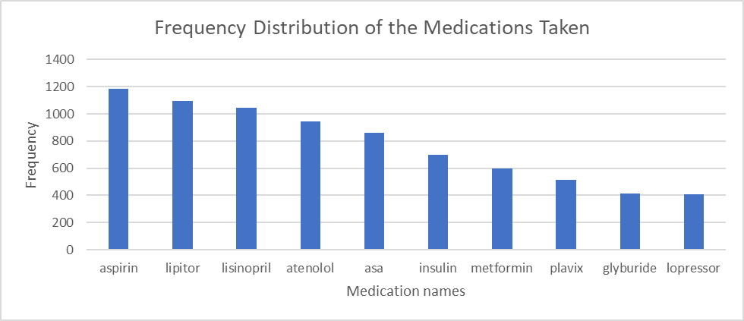

Figure 1: Frequency Distribution of the Medications Taken

# 3.3 Question 2b Result: Freq. Distribution of the Medications Categories Taken

Figure 2 below represents the frequency distribution of medication categories taken. We returned all the medication categories as there were only 18 from our results. As we can see from the graph, beta blocker is the most frequent medication category with the frequency of around 2250, with statin and aspirin in the second and third place with the frequency of a little north of 2000. After that, the frequency of the categories of medications taken sort of fiddles out.

One thing to note is that three of the top five medication types are CAD, which stand for coronary artery disease. This seems to suggest that there are a lot of patients visiting the doctors for CAD than one might have expected. However, this is far from surprising because heart disease is “the leading cause of death for men, women, and people of most racial and ethnic groups in the United States” [2].

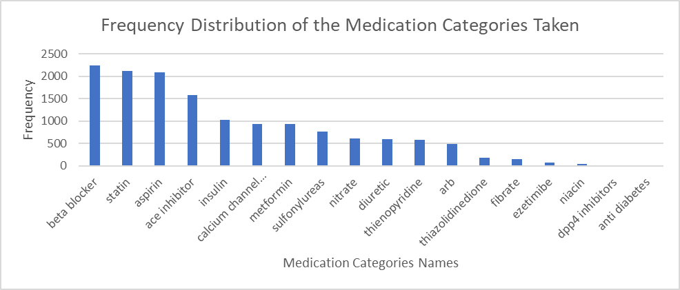

Figure 2: Frequency Distribution of the Medication Categories Taken

# 3.4 Question 3 Result: Individuals taking the Greatest Number of Medication Types

|  |  |
| --- | --- |
| patient_id | num of medication types |
| 125 | 13 |
| 216 | 13 |
| 281 | 13 |
| 400 | 13 |
| 100 | 12 |
| 106 | 12 |
| 115 | 12 |
| 156 | 12 |
| 177 | 12 |
| 184 | 12 |
| 196 | 12 |
| 202 | 12 |
| 237 | 12 |

Below table displays individuals taking the greatest number of medication types. Using our methods as described from the methods section, there weren’t 10 individuals cut off, but rather four patients with 13 medication types and nine patients with 12 medication types, bringing the individuals taking the greatest number of medication types to thirteen patients in the table shown.

# 3.5 Question 4 Result: Individuals taking the Least Number of Medication Types

|  |  |
| --- | --- |
| patient_id | num of medication types |
| 176 | 2 |
| 160 | 3 |
| 142 | 4 |
| 174 | 4 |
| 246 | 4 |
| 251 | 4 |
| 259 | 4 |
| 307 | 4 |
| 318 | 4 |
| 326 | 4 |
| 369 | 4 |

Below table displays individuals taking the least number of medication types. Using our methods as described from the methods section, there weren’t 10 individuals cut off, but rather one patient with 2 medication types, one patient with 3 medication types, and nine patients with 4 medication types, bringing the individuals taking the least number of medication types to eleven patients in the table shown.

# 3.6 Question 5 Result: 10 Individuals taking the Least Number of Medications

|  |  |
| --- | --- |
| patient_id | num of medication |
| 174 | 3 |
| 176 | 3 |
| 251 | 3 |
| 246 | 4 |
| 259 | 4 |
| 264 | 4 |
| 307 | 4 |
| 119 | 5 |
| 275 | 5 |
| 326 | 5 |

Below table displays individuals taking the least number of medications. Using our methods as described from the methods section, there were three patients with 3 medications, four patients with 4 medications, and three patients with 3 medications, bringing the individuals taking the least number of medications to ten patients in the table shown.

# 3.7 Question 6 Result:

Explained in detailed by kelvin.

# Limitations

First of all, double-counting of the same medications is possible for the frequency questions even if the only difference between the medications is ‘time’. This is due to the fact that tags whose medication_id starts with 'DOC' differ from one another only by the 'time' field while medication tags inside are identical. However, we must see this not only as limitations, but also by design, because time is an important aspect of the medication frequency due to the possibility of getting on/off the drugs from before/during/after the DCT.

Secondly, we constructed the frequency results based on their relevant strings, so if the 'text' field had any discrepancies from the representatives due to spelling errors or long strings, the medicine didn't match well enough to contribute to the frequency. For example, we couldn't make sense of 'dilt (30mg TID)' from 114-04.xml so we left them out. This could mean that we were missing some relevant medicines. However, our dataset was large enough to justify filtering through the anomalies and we are confident that we had enough data to make a proper analysis.

# Conclusions

There are various information available through patient clinical notes dataset that we can use for health data analysis.

# Bibliography

1. Bibliography here.

# Bibliography

1. *docs.python.org*. (n.d.). Retrieved from https://docs.python.org/3/library/csv.html
2. Centers for Disease Control and Prevention. [Underlying Cause of Death, 1999–2018](http://wonder.cdc.gov/ucd-icd10.html). CDC WONDER Online Database. Atlanta, GA: Centers for Disease Control and Prevention; 2018. Accessed March 12, 2020.