**Problem:**  
Ever faced the problem developer spending time to do their test by redeploying WAR, stopping and starting up the tomcat?

Have wish that your changes are reflected immediately after the change, be it java classes for server programs ?

**Solution:**  
1) Build a unit test.   
2) Switch to Spring boot / Play.   
3) Get JRebel, but who am I joking with.  
4) Use DCEVM/hotswap.

**To use DCEVM:**

1. Install Java 7 and above.
2. Download hotswap. <https://github.com/HotswapProjects/HotswapAgent/releases>
3. Download DCEVM (use the full release). <https://github.com/dcevm/dcevm/releases>
4. Install DCEVM, by running *java –jar dcevm-0.2-win.jar,* Choose the java version and update it. Install both **DCEVM** and **altjvm**. Don’t bother it’s for development!

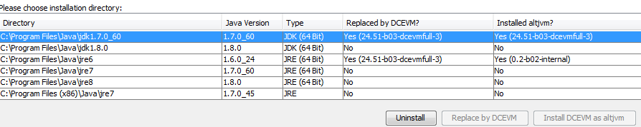

* 1. You can test if had been setup by running *java –version* command. The “Dynamic Code Evolution” will appear.

**TO USE TOMCAT**

1. In catalina.bat, add the option (use export for linux)

*set JAVA_OPTS=-XXaltjvm=dcevm -javaagent:c:\SelfProject\researchDevelopment\dcevm_hotswap\hotswap-agent.jar -Xdebug*

1. Start tomcat and all classes replace will be auto deploy.

**TO USE TOMCAT WITH ECLIPSE**

1. Start up eclipse and create a Dynamic WEB project.
   1. Click File->New->Others
   2. Choose Dynamic WEB project
2. Install eclipse and install tomcat on it.
   1. Click File->New ->Others
   2. Choose Server->Server and click Next
   3. Install Tomcat 7.0/Tomcat 6.0.
      1. Click Next
      2. Click on Installed JRE. Click Add to point to your DCEVM replaced JRE. Choose the added JRE and click OK.
      3. Choose the JRE: that have just been installed.
      4. Choose the directory that your Tomcat has already reside in ur pc, or download from Eclipse market.
      5. Click Next
      6. Make sure the project in 5) points are included to tomcat
      7. Click Finish
3. Under the Server tab(you can open in Window->Show View->Server). Double click on the Tomcat create on Step 6.
   1. Click Open Launch Configuration
   2. Choose Arguments tab and add *-XXaltjvm="dcevm" -javaagent:c:\<folder path>\hotswap-agent.jar* into the VM argument. (Optional: Add memory). Click Apply and OK.

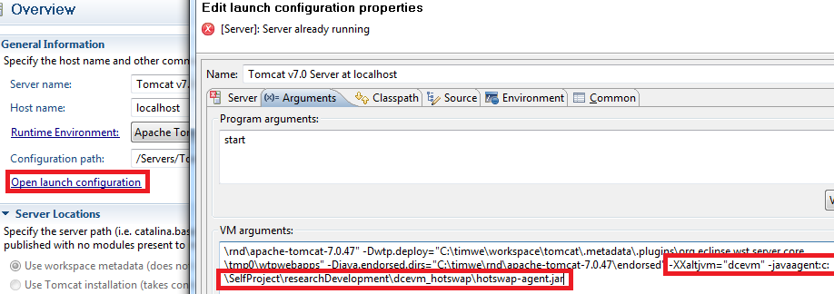

* 1. Make sure publishing selected choice is “Automatically publish when resources change”
  2. Select the Modules tab and disable the auto Reload.

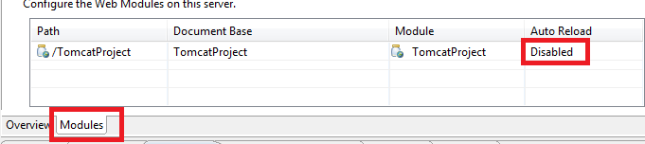

* 1. File -> Save the configurations.

1. Setup your Dynamic WEB Project .
2. Run as debug mode.
   1. Notice in console, HOTSWAP AGENT will appear in the console.
   2. Make any changes and it’ll appear.

--You may notice that when you’re adding even method, it will be reflected. Awesome?

**Issues:**

1. Current hotswap only works for Java version 1.6(some problems with 20.X) and above.
2. Web.xml does not reflect until java is updated.
3. Only works on eclipse.
4. Working only for debug mode.
5. If the program get bloated, this will slow down n crash.