R Notebook

1. Mortality on Quebec.

xWide = read.table(paste0("https://www.stat.gouv.qc.ca/statistiques/", "population-demographie/deces-mortalite/", "WeeklyDeaths_QC_2010-2020_AgeGr.csv"), sep = ";", skip = 7, col.names = c("year", "junk",  
"age", paste0("w", 1:53)))  
xWide = xWide[grep("^[[:digit:]]+$", xWide$year), ]

## Warning in grep("^[[:digit:]]+$", xWide$year): input string 47 is invalid in  
## this locale

## Warning in grep("^[[:digit:]]+$", xWide$year): input string 50 is invalid in  
## this locale

## Warning in grep("^[[:digit:]]+$", xWide$year): input string 59 is invalid in  
## this locale

x = reshape2::melt(xWide, id.vars = c("year", "age"),  
measure.vars = grep("^w[[:digit:]]+$", colnames(xWide)))   
x$dead = as.numeric(gsub("[[:space:]]", "", x$value))   
x$week = as.numeric(gsub("w", "", x$variable))  
x$year = as.numeric(x$year)  
x = x[order(x$year, x$week, x$age), ] #convert the ‘week’ variable to time  
newYearsDay = as.Date(ISOdate(x$year, 1, 1))   
x$time = newYearsDay + 7 * (x$week - 1)  
x = x[!is.na(x$dead), ]  
x = x[x$week < 53, ]  
  
plot(x[x$age == "Total", c("time", "dead")], type = "o", log = "y") # we get bigger spikes in the past with the flue vaccine. So these are often elderly people who have all sorts of other health problems.

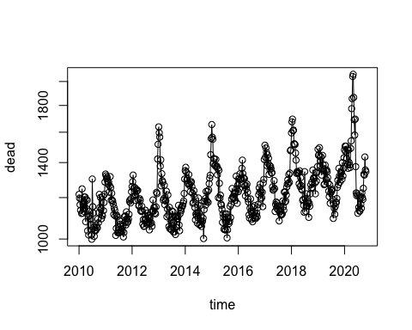

xWide2 = reshape2::dcast(x, week + age ~ year, value.var = "dead")   
Syear = grep("[[:digit:]]", colnames(xWide2), value = TRUE)  
Scol = RColorBrewer::brewer.pal(length(Syear), "Spectral")   
matplot(xWide2[xWide2$age == "Total", Syear], type = "l",  
lty = 1, col = Scol)  
legend("topright", col = Scol, legend = Syear, bty = "n",  
lty = 1, lwd = 3)

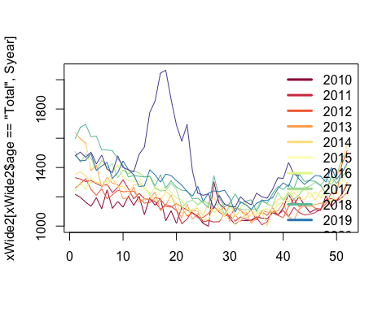

xWide3 = reshape2::dcast(x, week + age ~ year, value.var = "dead")  
Syear = grep("[[:digit:]]", colnames(xWide3), value = TRUE)  
Scol = RColorBrewer::brewer.pal(length(Syear), "Spectral")   
matplot(xWide3[xWide3$age == "0-49 years old", Syear], type = "l",  
lty = 1, col = Scol)  
legend("topright", col = Scol, legend = Syear, bty = "n",  
lty = 1, lwd = 3)

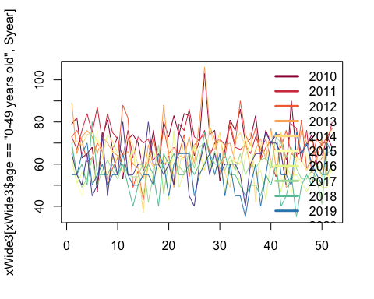

xWide4 = reshape2::dcast(x, week + age ~ year, value.var = "dead")  
Syear = grep("[[:digit:]]", colnames(xWide4), value = TRUE)  
Scol = RColorBrewer::brewer.pal(length(Syear), "Spectral")   
matplot(xWide3[xWide4$age == "70 years old and over", Syear], type = "l",  
lty = 1, col = Scol)  
legend("topright", col = Scol, legend = Syear, bty = "n",  
lty = 1, lwd = 3)

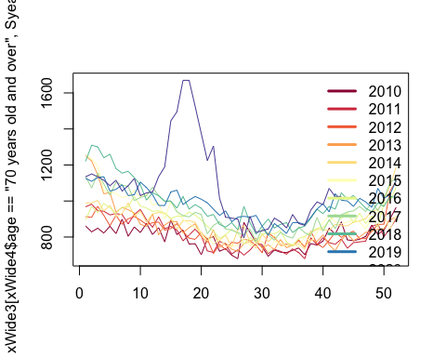

Divide the data into pre and post covid, add extra dates to data so that INLA will create forecasts.

dateCutoff = as.Date("2020/3/1")  
xPreCovid = x[x$time < dateCutoff, ]  
xPostCovid = x[x$time >= dateCutoff, ]  
toForecast = expand.grid(age = unique(x$age), time = unique(xPostCovid$time),  
dead = NA)  
xForInla = rbind(xPreCovid[, colnames(toForecast)],toForecast)  
xForInla = xForInla[order(xForInla$time, xForInla$age),]

xForInla$timeNumeric = as.numeric(xForInla$time)  
xForInla$timeForInla = (xForInla$timeNumeric - as.numeric(as.Date("2015/1/1")))/365.25   
xForInla$timeIid = xForInla$timeNumeric  
xForInla$sin12 = sin(2 * pi * xForInla$timeNumeric/365.25)  
xForInla$sin6 = sin(2 * pi * xForInla$timeNumeric *  
2/365.25)  
xForInla$cos12 = cos(2 * pi * xForInla$timeNumeric/365.25)   
xForInla$cos6 = cos(2 * pi * xForInla$timeNumeric *2/365.25)  
xForInlaTotal= xForInla[xForInla$age == 'Total', ]   
xForInla_under50 = xForInla[xForInla$age == '0-49 years old',]  
xForInla_over70 = xForInla[xForInla$age == '70 years old and over',]  
library(INLA, verbose=FALSE)

## Loading required package: Matrix

## Loading required package: sp

## Loading required package: parallel

## Loading required package: foreach

## This is INLA_20.03.17 built 2020-10-27 02:19:26 UTC.  
## See www.r-inla.org/contact-us for how to get help.  
## To enable PARDISO sparse library; see inla.pardiso()

res = inla(dead ~ sin12 + sin6 + cos12 + cos6 +  
f(timeIid, prior='pc.prec', param= c(log(1.2), 0.5)) + f(timeForInla, model = 'rw2', prior='pc.prec', param= c(0.01, 0.5)),  
data=xForInla_over70,  
control.predictor = list(compute=TRUE, link=1), control.compute = list(config=TRUE),  
# control.inla = list(fast=FALSE, strategy='laplace'),  
family='poisson')  
qCols = paste0(c(0.5, 0.025, 0.975), "quant")   
rbind(res$summary.fixed[, qCols], Pmisc::priorPostSd(res)$summary[,qCols])

## 0.5quant 0.025quant 0.975quant  
## (Intercept) 6.78520154 6.777584946 6.79251442  
## sin12 0.06367217 0.056174012 0.07121581  
## sin6 0.01138859 0.004902564 0.01786384  
## cos12 0.11701052 0.109481282 0.12460255  
## cos6 0.01182356 0.005329866 0.01829595  
## SD for timeIid 0.04050370 0.036336243 0.04504260  
## SD for timeForInla 0.16066285 0.106910730 0.23982926

plot(x[x$age == "0-49 years old", c("time", "dead")], type = "o", log= "y",main = "Number of deaths under 50")

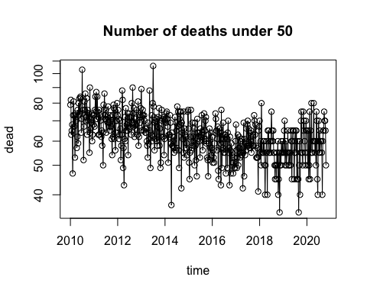

plot(x[x$age == "70 years old and over", c("time", "dead")], type = "o", log= "y",main = "Number of deaths over 70")

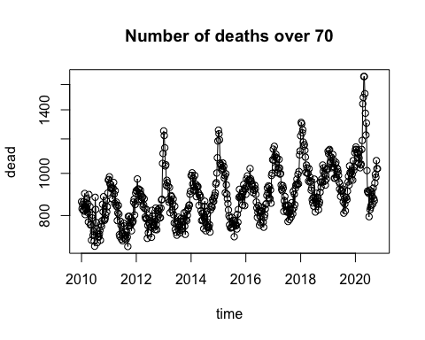

matplot(xForInlaTotal$time, res$summary.fitted.values[,  
qCols], type= "l", ylim = c(1000, 1800), lty = c(1,2, 2), col = "black", log = "y")  
points(x[x$age == "Total", c("time", "dead")], cex = 0.4,col = "red")

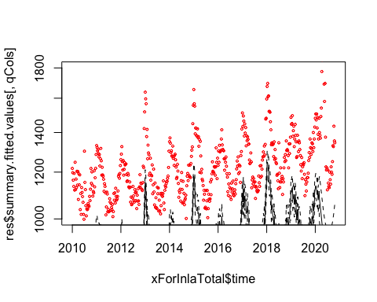

matplot(xForInlaTotal$time, res$summary.random$timeForInla[, c("0.5quant", "0.975quant", "0.025quant")], type = "l", lty = c(1, 2, 2), col = "black", ylim = c(-1, 1) *  
0.1) # this is after taking out seasonality

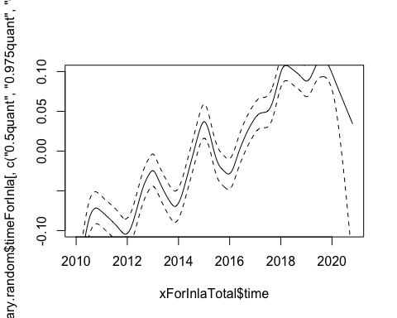

Take posterior samples of the intensity

# get posterior samples  
sampleList = INLA::inla.posterior.sample(30, res, selection = list(Predictor = 0)) # prdictors = 0 is samples of log(\lmabda(t)) turning that into a matrix   
sampleIntensity = exp(do.call(cbind, Biobase::subListExtract(sampleList,"latent"))) # and exponentiate it them to put them into natural sclae  
sampleDeaths = matrix(rpois(length(sampleIntensity), #generating deaths from poisson distribution  
sampleIntensity), nrow(sampleIntensity), ncol(sampleIntensity))

plot samples and real data

matplot(xForInlaTotal$time, sampleDeaths, col = "#00000010", lwd = 2, lty = 1, type = "l", log = "y") # graph of posterior samples  
points(x[x$age == "Total", c("time", "dead")], col = "red", cex = 0.5) # actual datas

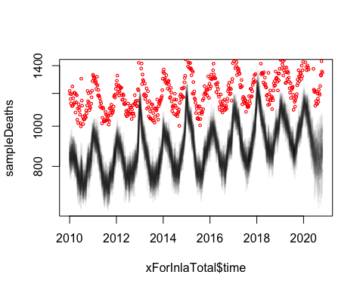

matplot(xForInlaTotal$time, sampleDeaths, col = "#00000010",  
lwd = 2, lty = 1, type = "l", log = "y", xlim = as.Date(c("2019/6/1",  
"2020/11/1")), ylim = c(1, 2.3) * 1000)  
points(x[x$age == "Total", c("time", "dead")], col = "red", cex = 0.5) # these red dots are real deaths after the covid.

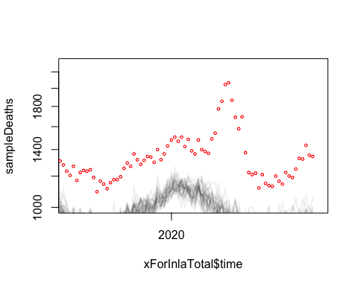 calculate excess deaths

xPostCovid_under50 = xPostCovid[xPostCovid$age == '0-49 years old', ] # this is number of deaths each week  
xPostCovidForecast_under50 = sampleDeaths[match(xPostCovid_under50$time, xForInla_under50$time), ]#5 posterior samples of what we would have expected.   
excessDeaths_under50 = xPostCovid_under50$dead - xPostCovidForecast_under50  
xPostCovid_over70 = xPostCovid[xPostCovid$age == '70 years old and over', ] # this is number of deaths each week  
xPostCovidForecast_over70 = sampleDeaths[match(xPostCovid_over70$time, xForInlaTotal$time), ]#5 posterior samples of what we would have expected.   
excessDeaths_over70 = xPostCovid_over70$dead - xPostCovidForecast_over70  
xPostCovidTotal = xPostCovid[xPostCovid$age == 'Total', ] # this is number of deaths each week  
xPostCovidForecast = sampleDeaths[match(xPostCovidTotal$time, xForInlaTotal$time), ]#5 posterior samples of what we would have expected.   
excessDeaths = xPostCovidTotal$dead - xPostCovidForecast

plot samples of excess deaths

matplot(xPostCovid_under50$time, xPostCovidForecast_under50, type = "l", ylim = c(1000, 2200), col = "black")  
points(xPostCovid_under50[, c("time", "dead")], col = "blue") # so what is the difference between red and the black that is the next graph # the black line represents the covid free world and red is actual death

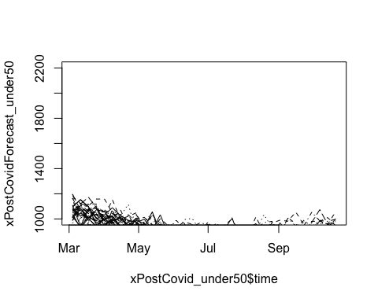

matplot(xPostCovid_under50$time, excessDeaths_under50, type = "l",lty = 1, col = "#00000030", main =" Excess death in Post-COVID under 50")

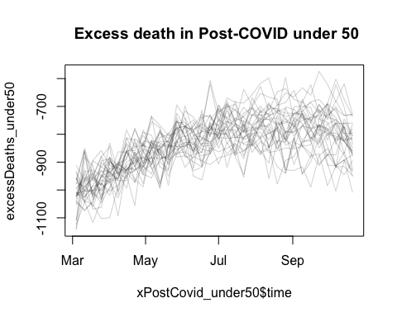

matplot(xPostCovid_over70$time, xPostCovidForecast_over70, type = "l", ylim = c(1000, 2200), col = "black")  
points(xPostCovid_over70[, c("time", "dead")], col = "blue") # so what is the difference between red and the black that is the next graph # the black line represents the covid free world and red is actual death

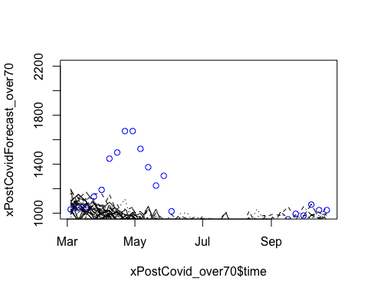

matplot(xPostCovid_over70$time, excessDeaths_over70, type = "l",lty = 1, col = "#00000030", main =" Excess death in Post-COVID over 70")

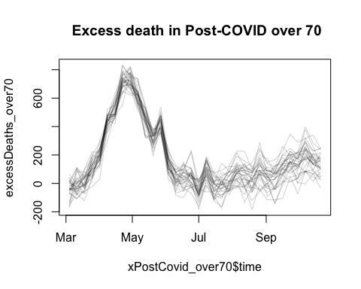

matplot(xPostCovidTotal$time, xPostCovidForecast, type = "l", ylim = c(1000, 2200), col = "black")  
points(xPostCovidTotal[, c("time", "dead")], col = "red") # so what is the difference between red and the black that is the next graph # the black line represents the covid free world and red is actual death

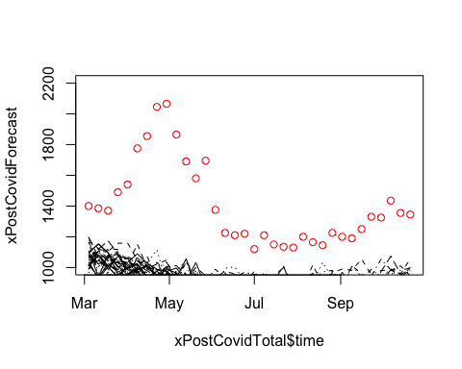

matplot(xPostCovidTotal$time, excessDeaths, type = "l",lty = 1, col = "#00000030")

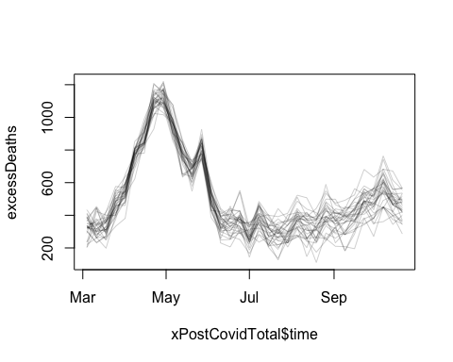

matplot(xPostCovidTotal$time, xPostCovidForecast, type = "l", ylim = c(1000, 2200), col = "black")  
points(xPostCovidTotal[, c("time", "dead")], col = "red") # so what is the difference between red and the black that is the next graph # the black line represents the covid free world and red is actual death



matplot(xPostCovidTotal$time, excessDeaths, type = "l",lty = 1, col = "#00000030")

