Hw4 Q2

Insu Yoon, 1003180933

Introduction

In this paper, we use the data from UK that number of cases of COVID-19 is related to what factors so that we will investigate that hypothesis

* Air pollution would positively influence in increase in COVID-19 cases
* The area with high unemployment results in more cases of COVID-19
* Ethnically minorities are more likely to get infected by COVID-19.

Method

$Y_{i}∼Poisson(E_{i}λ_{i}$)

$$log\left[λ_{i}\right]=μ+X_{i}β+U_{i}$$

$$U_{i}=BYM\left(σ^{2},τ^{2}\right)$$

$$θ_{1}=\sqrt{σ^{2}+τ^{2}}$$

$$θ_{2}=σ/\sqrt{σ^{2}+τ^{2}}$$

Prior distributions on $θ_{1}$ and $θ_{2}$

$Y_{i}$: Case count

$E_{i}$: expected count

$X_{i}$ is the vector that includes

* Pmmodelled25 refers to the concentration of fine particular matter in the health authority.
* Ethnicity refers to the percentage of ethnicity minorities
* Unemployment refers to the percentage of unemployment

## mean 0.025quant 0.5quant 0.975quant  
## (Intercept) 0.363934 0.2169813 0.3640466 0.6091025  
## Ethnicity 1.012085 1.0080907 1.0120831 1.0160997  
## modelledpm25 1.057811 0.9958948 1.0577659 1.1237733  
## Unemployment 1.119875 1.0593063 1.1198742 1.1838485  
## sd 1.342307 1.2951449 1.3408408 1.4002772  
## propSpatial 2.455652 2.1572621 2.4778800 2.6526043

Appendix

(load("../Hw4/data/England_shp.RData"))

## [1] "UK_shp"

UK_shp$logExpected = log(UK_shp$E)

## Loading required package: sp

# remove an island  
UK2 = UK_shp[grep("Wight", UK_shp$Name, invert = TRUE),  
 ]  
englandRes = diseasemapping::bym(cases ~ offset(logExpected) +  
 Ethnicity + modelledpm25 + Unemployment, prior = list(sd = c(0.5,  
 0.5), propSpatial = c(0.5, 0.5)), family = "poisson",  
 data = UK2)

exp(englandRes$parameters$summary)[, c(1, 3:5)]

## Warning in inla.model.properties.generic(inla.trim.family(model), mm[names(mm) == : Model 'bym2' in section 'latent' is marked as 'experimental'; changes may appear at any time.  
## Use this model with extra care!!! Further warnings are disabled.

save(englandRes, file = "../data/englandRes.RData")

casesCol = mapmisc::colourScale(UK2$cases, dec = -3, breaks = 12,  
 col = "Spectral", style = "quantile", rev = TRUE)  
Ecol = mapmisc::colourScale(UK2$E, breaks = casesCol$breaks,  
 col = casesCol$col, style = "fixed")  
pmCol = mapmisc::colourScale(UK2$modelledpm25, breaks = 9,  
 dec = 0, style = "quantile")  
ethCol = mapmisc::colourScale(UK2$Ethnicity, breaks = 9,  
 digits = 1, style = "quantile")  
uCol = mapmisc::colourScale(UK2$Unemployment, breaks = 12,  
 dec = 0, style = "quantile")  
rCol = mapmisc::colourScale(englandRes$data$random.mean,  
 breaks = 12, dec = -log10(0.25), style = "quantile")  
fCol = mapmisc::colourScale(englandRes$data$fitted.exp,  
 breaks = 9, dec = 1, style = "quantile")  
insetEngland1 = mapmisc::openmap(UK2, zoom = 3, fact = 4,  
 path = "waze", crs = CRS("+init=epsg:3035"))

## Warning in showSRID(uprojargs, format = "PROJ", multiline = "NO", prefer_proj = prefer_proj): Discarded datum Unknown based on GRS80 ellipsoid in CRS definition,  
## but +towgs84= values preserved

## Warning in spTransform(x, crsOut): NULL source CRS comment, falling back to PROJ  
## string

## Warning in wkt(obj): CRS object has no comment

library("raster")  
insetEngland = raster::crop(insetEngland1, extend(extent(insetEngland1),  
 -c(25, 7, 4, 9.5) * 100 * 1000))  
library("sp")  
mapmisc::map.new(UK2)

## Warning in wkt(obj): CRS object has no comment  
  
## Warning in wkt(obj): CRS object has no comment

mapmisc::insetMap(UK_shp, "topright", insetEngland, width = 0.4)

## Warning in wkt(pfrom): CRS object has no comment

## Warning in rgdal::rawTransform(projfrom, projto, nrow(xy), xy[, 1], xy[, : Using  
## PROJ not WKT2 strings

## Warning in spTransform(xsp, CRSobj = crs(mapOrig)): NULL source CRS comment,  
## falling back to PROJ string

## Warning in wkt(obj): CRS object has no comment

plot(englandRes$parameters$sd$posterior, type = 'l', xlim = c(0,1), ylim = c(0,2.5), xlab = "prop spatial", main = "Prior and Post distribution of sd")  
lines(englandRes$parameters$sd$prior, col = 'grey')  
legend("topright", lty=1, col= c("grey", "black"), legend = c("prior","posterior"), bty ="n")

plot(englandRes$parameters$propSpatial$posterior, type = 'l', xlim = c(0,1), ylim = c(0,2.5), xlab = "prop spatial", main = "Prior and Post distribution of spatial proportion")  
lines(englandRes$parameters$propSpatial$prior, col = 'grey')  
legend("topright", lty=1, col= c("grey", "black"), legend = c("prior","posterior"), bty ="n")

plot(UK2, col = casesCol$plot, add = TRUE, lwd = 0.2)  
mapmisc::legendBreaks("left", casesCol, bty = "n")

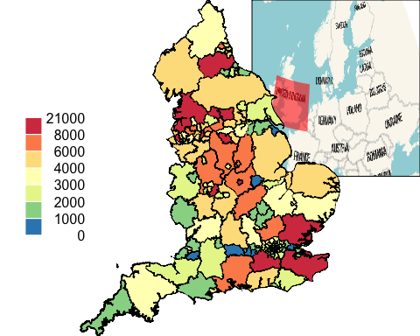

mapmisc::map.new(UK2)

## Warning in wkt(obj): CRS object has no comment  
  
## Warning in wkt(obj): CRS object has no comment

plot(UK2, col = Ecol$plot, add = TRUE, lwd = 0.2)  
mapmisc::legendBreaks("left", casesCol, bty = "n")

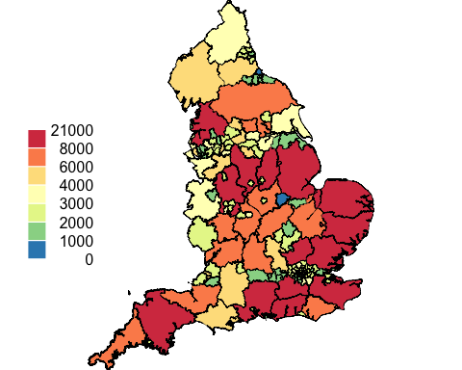

mapmisc::map.new(UK2)

## Warning in wkt(obj): CRS object has no comment  
  
## Warning in wkt(obj): CRS object has no comment

plot(UK2, col = pmCol$plot, add = TRUE, lwd = 0.2)  
mapmisc::legendBreaks("left", pmCol, bty = "n")

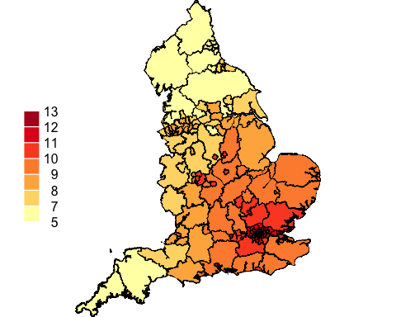

mapmisc::map.new(UK2)

## Warning in wkt(obj): CRS object has no comment  
  
## Warning in wkt(obj): CRS object has no comment

plot(UK2, col = ethCol$plot, add = TRUE, lwd = 0.2)  
mapmisc::legendBreaks("left", ethCol, bty = "n")

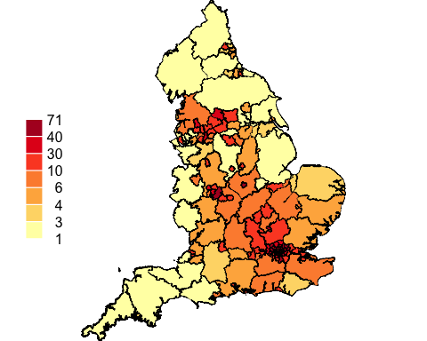

mapmisc::map.new(UK2)

## Warning in wkt(obj): CRS object has no comment  
  
## Warning in wkt(obj): CRS object has no comment

plot(UK2, col = uCol$plot, add = TRUE, lwd = 0.2)  
mapmisc::legendBreaks("left", uCol, bty = "n")

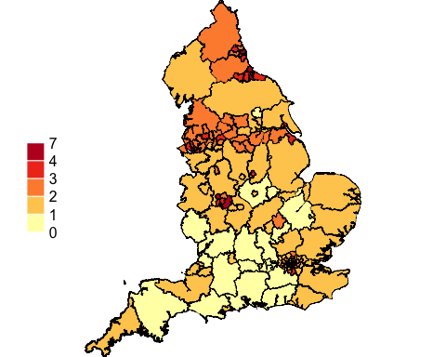

mapmisc::map.new(UK2)

## Warning in wkt(obj): CRS object has no comment  
  
## Warning in wkt(obj): CRS object has no comment

plot(UK2, col = rCol$plot, add = TRUE, lwd = 0.2)  
mapmisc::legendBreaks("left", rCol, bty = "n")

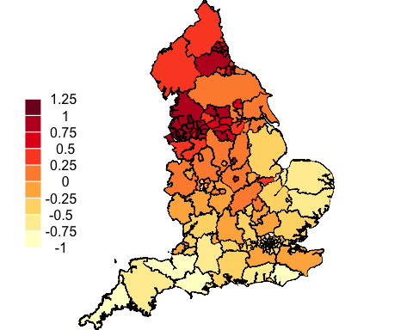

mapmisc::map.new(UK2)

## Warning in wkt(obj): CRS object has no comment  
  
## Warning in wkt(obj): CRS object has no comment

plot(UK2, col = fCol$plot, add = TRUE, lwd = 0.2)  
mapmisc::legendBreaks("left", fCol, bty = "n")

