유한요소법 과제

-Exercise 1.3.2(1)

By Exercise1.3.1, I have schemes of finite dimension method about Dirichlete problem and mixed problem. In any case, the matrix in the scheme is symmetric, diagonal dominant with positive diagonal elements and all entries of the matrix are real numbers. Thus the matrix is symmetric and positive definite. Thus I used conjugate gradient method to solve each linear equation.

1. Dirichlete Problem

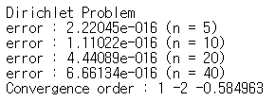

In this case, the maximum norm is very close to the machine epsilon for each n. Thus the convergence order is meaningless.

1. Mixed Problem using Backward Difference

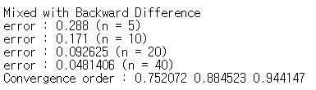

In this case, the boundary condition at x=1 is approximated by ($U_{n}$- $U_{n-1}$)/h=d where h=1/n and d=u’(1)=2. Thus the convergence order is 1. In the result, actual convergence order converges to 1 in each step.

1. Mixed Problem using Central Difference

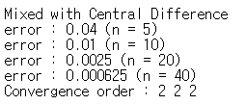

In this case, the boundary condition at x=1 is approximated by ($U_{n}$- $U_{n-1}$)/ $h^{2}$ =d/h+f(1)/2. Thus the convergence order is 2. In the result, every actual convergence order is exactly 2 because the maximum error appears at x=1 for each n.

If the boundary value u(1) is excluded when the maximum error is calculated, then the result is follow :

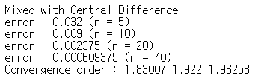

In this case, actual convergence order converges to 2 in each step.