유한요소 Midterm Take Home Exam(1)

1. About code

To be convenient for obtain errors and convergence orders for given levels, I define a function FEM_Dirichlet whose output is the error of the solution obtained by F.E.M. However, this function solves only Dirichlet Problem whose domain is rectangle with uniform mesh. The inputs of the function FEM_Dirichlete are (exact solution u, p, boundary condition g, given data f, domain, level, int choice, char* ch), where f=-div(p grad(u)). Here, the input domain is a 2 by 2 matrix whose 1st row is the x-axis interval and the 2nd row is the y-axis interval. The last two inputs are included to save the result of solutions as m-files to plot the corresponding graph. If choice==1, then the function saves a m-file whose name is ch where ch is of the form “****.m”. Otherwise, the function just returns the error.

When I first used this function, there are some compile errors in the given code. It seems that there are some problems of constructors and destructors of the classes FVector and FMatrix. Thus I deleted the word “static” on the 178th line, which is in the definition of the function CG.

1. 3 by 3 stiffness matrix $A_{k11}$ where p=1+x+2 $y^{2}$ and k=2

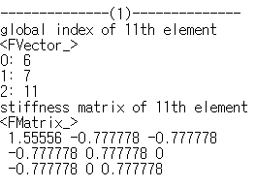

1. F(i), i=4,5,6,7 where p=1+x+2 $y^{2}$, f=-(1+4y) and k=2

There are two different ways of interpretation for F(i)’s.

First, F(i) is the value about the i-th node in the global numbering of nodes. In this case, the result is as follow:

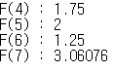

Second, F(i) is the value about the i-th unknown node contained in $\text{Ω}$ as the same order of the matrix (2.86) in Chapter2_Variational Formulation, p30. Then F (4), F (5), F (6) and F (7) are the values about the 12th,13th,14th and 16th nodes in the global numbering of nodes respectively. In this case, the result is as follow:

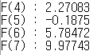

1. Solve the problem –div(p grad(u))=F where p=1+x+2 $y^{2}$,u=x(1-x)y(1-y) and g=0 (Dirichlet condition on $∂$ Ω).

Computing –div(p grad(u)), we obtain F=2(1+x+ $y^{2})$ (x- $x^{2}$ +y- $y^{2})$-(1-2x)(y- $y^{2}$)-4(x- $x^{2}$)(y- $2y^{2}$). Then the errors for levels (2,3,4,5,6) and the convergence orders are as follow:

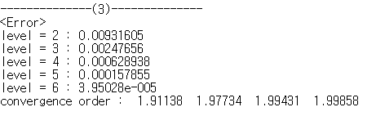

This result shows that convergence orders go to 2 as level is increasing.

1. Solve the problem –div(p grad(u))=F where p=1, u=1+x+9y , f=0 and g=1+x+9y (Dirichlet condition on $∂$ Ω).

Note that the exact solution u is a linear function. The errors and convergence orders are as follow:

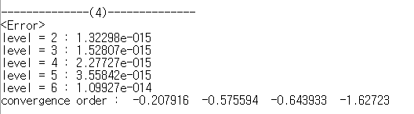

In this case, all errors are very close to the machine epsilon and so convergence orders are meaningless. In fact, the solution $u_{h}$ obtained by F.E.M is exactly equal to the exact solution u in H1 norm sense. To prove it, denote $a_{h}(v,w)$ = $\sum_{T}{\int_{T}{∇v∇w}}$ where T is a triangular element ($a_{h}\left(v,w\right)=a(v,w)$:= $\int_{Ω}{∇v∇w}$). Also, denote $\left\|.\right\|$ as the $H^{1}$-norm. Then the variational formula of this problem is to find u satisfying $a_{h}\left(u,v\right)=\left(f,v\right)=0$ where $(f,v)=\int_{Ω}{fv}$ for every v in $H_{0}^{1}$ ( $Ω).$ Let $V$ be the vector space spanned by {$φ_{h}$} where $φ_{h}$ is a Lagrange basis function. By Poincare’s Inequality, there is $α$ >0 such that $α{\left\|w\right\|}^{2}≤{a\left(w,w\right)=a}_{h}\left(w,w\right)$ for every w in $H^{1}(Ω)$. Also, there is C>0 such that $a_{h}(w,v)≤C\left\|w\right\|\left\|v\right\|$ for every w, v in $H^{1}(Ω)$. Since $a_{h}\left(u,φ_{h}\right)=0$ and ${ a}_{h}\left(u_{h},φ_{h}\right)=0, { a}_{h}\left({u-u}_{h},φ_{h}\right)=0$ for every $φ_{h} in V$.

Then $α{\left\|{u-u}_{h}\right\|}^{2}≤a_{h}\left({u-u}_{h},{u-u}_{h}\right)=a_{h}\left({u-u}_{h},u\right)-a_{h}\left({u-u}_{h},u_{h}\right)≤a_{h}\left({u-u}_{h},u-φ_{h}\right)≤C\left\|{u-u}_{h}\right\|\left\|u-φ_{h}\right\|$.

Thus $\left\|{u-u}_{h}\right\|≤\frac{C}{α}\inf_{φ_{h}∈V}\left\|u-φ_{h}\right\|.$ Since u is linear, there is $φ∈V$ such that $u=φ.$ Hence, $\left\|{u-u}_{h}\right\|=0.$

1. The graph of solution $u_{h}$ of Problem 3

To draw solutions of 3, I saved these solutions as m files to use MATLAB.

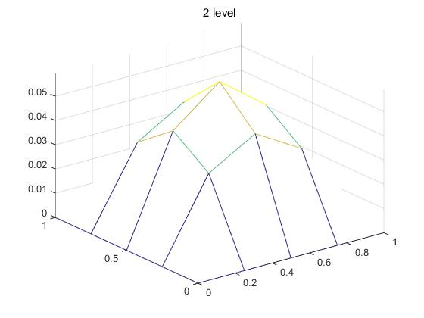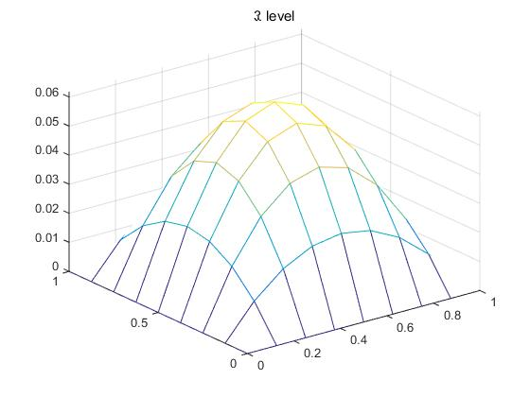

[level =2] [level =3]

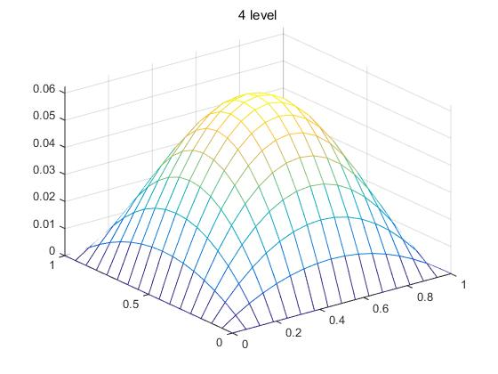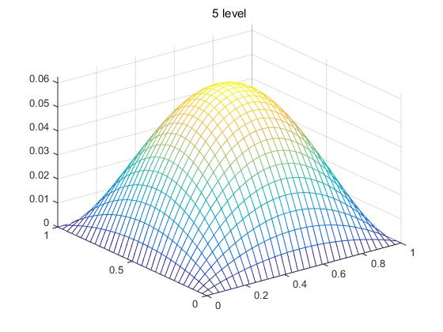

[level =4] [level =5]

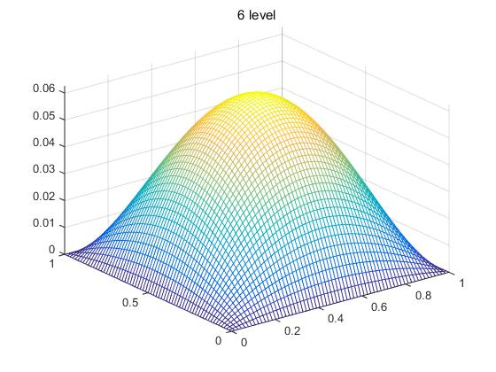

[level=6]

1. Solve the problem –div(p grad(u))=F where p=1+xy, u= $e^{x+3y}$, g= $e^{x+3y}$ (Dirichlet condition on $∂$ Ω) and Ω=[0,1]*[0,1]

Compute –div(p grad(u)), then we obtain F= ${-10(1+xy)e}^{x+3y}-(3x+y)e^{x+3y}$. Then the errors for levels (2,3,4,5,6) and the convergence orders are as follow:

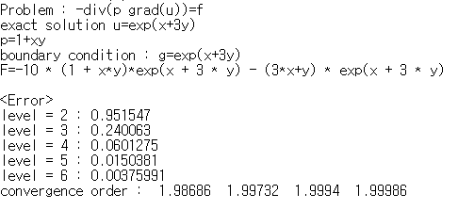

Note that I used nonlinear exact solution u to observe convergence orders and to obtain errors which are not close to the machine epsilon by using the fact in the problem 4. The result in this problem is similar to that of the problem 1. That is, the convergence orders go to 2 as the levels are increasing.

I also plotted graphs of the solutions for each level.

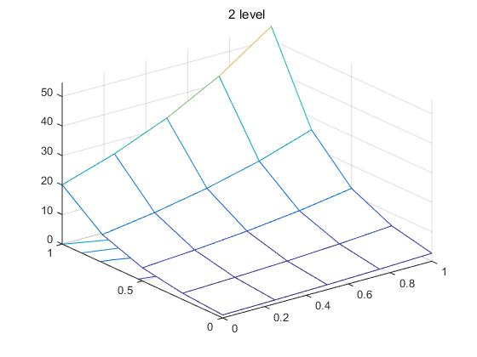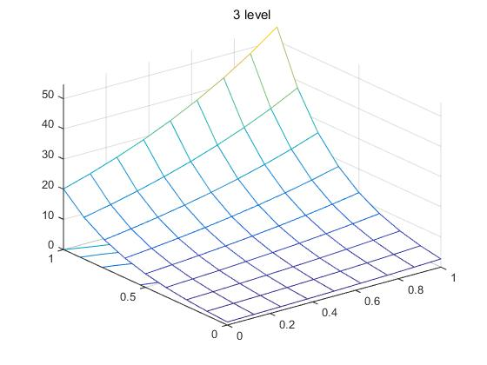

[level =2] [level =3]

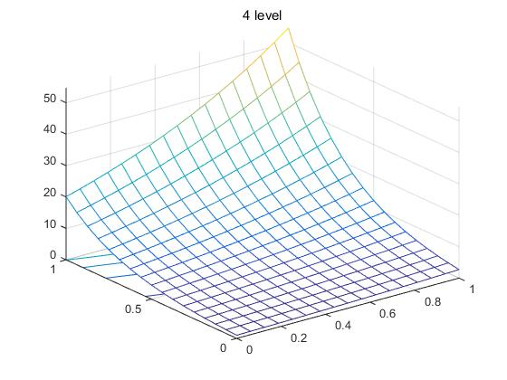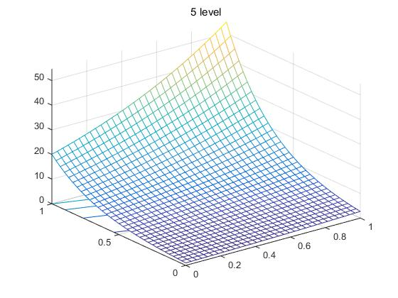

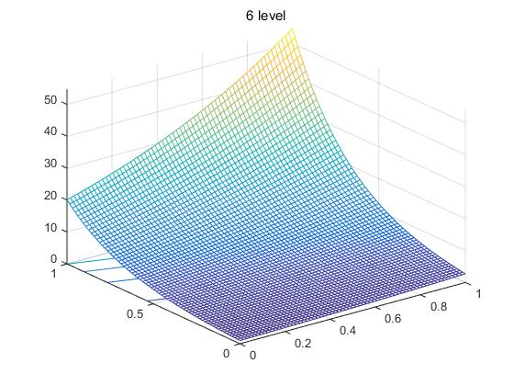 [level =4] [level =5]

[level=6]