유한요소 Midterm Take Home Exam(2)

The problem is to solve a partial differential equation on an L-shape. Here, the equation is given as

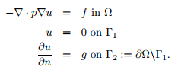

Here, u= ${(x^{2}+y^{2})}^{γ/2}$, p=1+x+2 $y^{2}$ and g can be obtained by partial differentiating u. I tested the code for three cases when 1. $γ$ is an positive integer, 2. $γ≥2$ and 3. $γ<2$

1. $γ$ is a positive integer

Note that is $γ$ is even, then u is infinitely differentiable. I tried some cases when $γ=2,3,4,5,6$. The result is as follow:

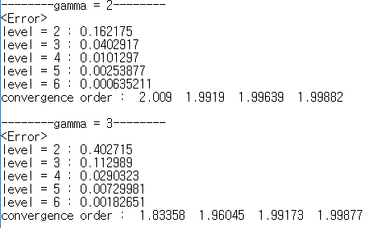

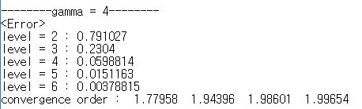

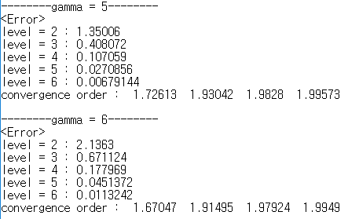

The result shows that every convergence order of each case goes to 2 as levels are increasing. Moreover, as gamma is increasing, the corresponding errors in low levels are too big to be ignore.

Note that if $γ≥2$, then the gradient of u has no singularity in the domain, but if $γ<2$, then the gradient of u has a singularity at the origin. Thus I expected that the convergence order for $γ≥2$ may be near 2.

$γ≥2$

I tried some cases when $γ$ =2.3, 3.4, 2.5.

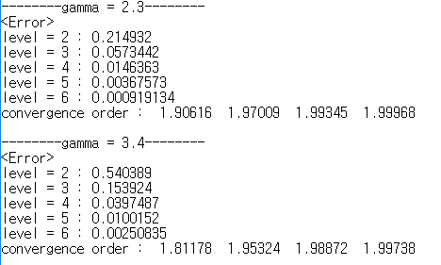

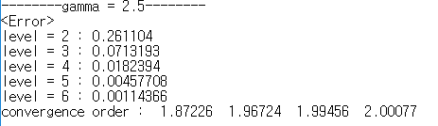

As I expected, each convergence order goes to 2 as levels are increasing.

$γ<2$

At the first time when I tested $γ$ in random, the convergence order does not go to 2 but it goes to near $γ$. Thus I tried 19 case when $γ$ is k\*0.1 where k = 1, 2, ….., 19 to observe how the convergence orders change. Moreover, I plotted a graph about $γ$ and the convergence order for the last level. The result for some cases is as follow:

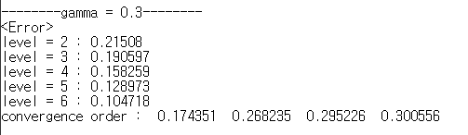

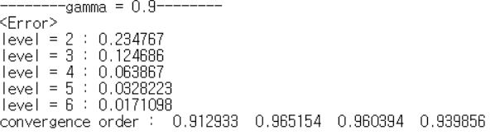

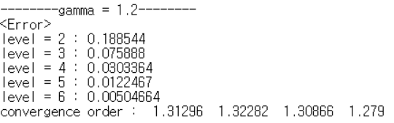

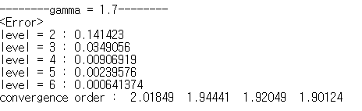

It seems that as $γ$ is close to 2, the convergence order goes to 2 and when $γ$ is sufficiently small, the convergence order is close to $γ$. The graph about $γ$ and the convergence order is given by

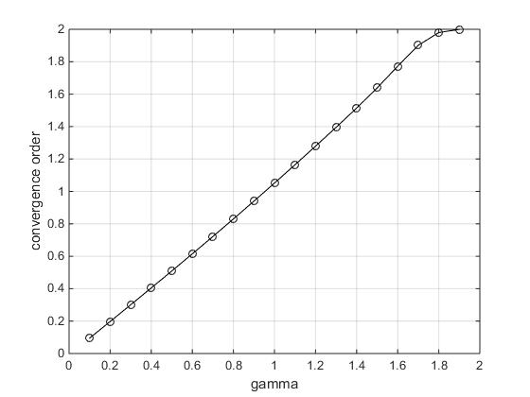

1. Conclusion

If $γ≥2$, then u is an $H^{1}$ function and so the convergence order is 2. If $γ<2$, then $\frac{∂}{∂x}\left(u\right)=γx{(x^{2}+y^{2})}^{n}$ and $\frac{∂}{∂y}\left(u\right)=γy{(x^{2}+y^{2})}^{n}$ where n= $1-\frac{γ}{2}$ and -1<n<0. Thus u is not an $H^{1}$ function because these partial derivatives are not integrable near the origin. Thus the order of convergence is close to $γ$ as the graph is shown.