유한요소 P1-nonconforming

Our problem is to solve the Dirichlet problem in the domain [-1 1]*[-1 1] of an elliptic equation given by −∇ · p∇u = f in Ω where p=1+x+2 $y^{2}$ and the exact solution is u=x(1-x)y(1-y).

1. About the code in P1_nonconforming.cpp

Since the grids of the discretized domain do not correspond to the nodes of the same discretized domain in P1_nonconforming space, I defined another variables grid_coordN and grid_indexP which are the variables coordN and indexP in the P1_conforming code to use the function Make_realP_and_DF.

1. Results

The error and convergence order of each level are as follow.

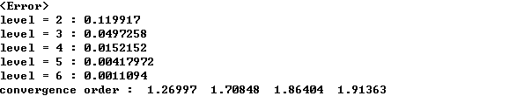

The result shows that the convergence orders seem to converge to near 2. However, the convergence orders are not good comparing the convergence orders in P1_conforming code. I think that the solutions have somewhat bad convergence orders because p=1+x+2 $y^{2}$ vanishes at the boundary, so there exist no positive numbers p1 and p2 such that p1<p<p2 in the domain [-1 1]*[-1 1]. Thus the coerciveness is not guaranteed in the variational formula, so the approximated solution may not be well approximated to the exact solution.

However, when p=1 is trivial with the same exact solution, the results are as follow.

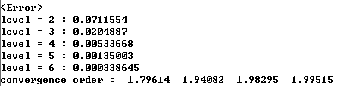

Then the solutions have better convergence orders than the case when p is vanishing at some points in the boundary.

Now the following figures are the graph of the approximated solutions when the levels are 3 and 5 respectively.

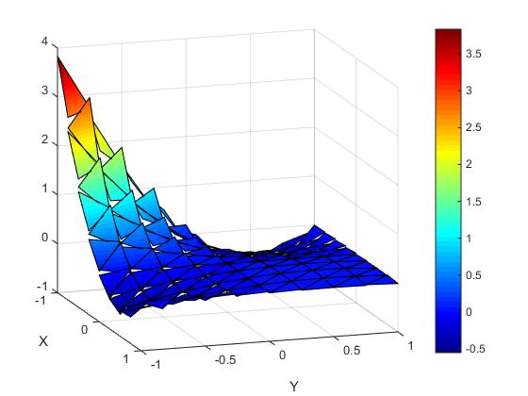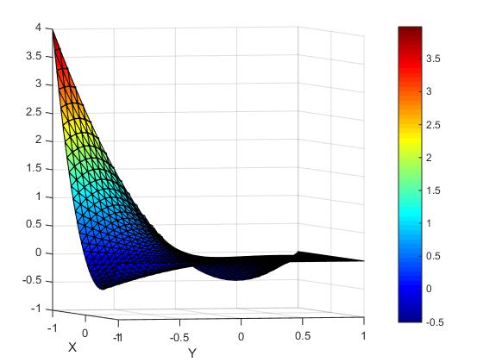

Since this solution is in P1-nonconforming space, the solution has discontinuity at each grid. Thus the discontinuity is easily observed when the level is low.