수치 해석학 과제1 – Exercise1.1.2

1. About code

I made the Assignment1 class to solve each exercise problems.

For exercise(1), there are 2 ways to express $e^{-x}-\left(1-x+\frac{1}{2}x^{2}\right)$. A function ‘double taylor (double x, int order)’ returns the value of Taylor expansion of order=order at the point x. Another function ‘double nested (double x, int order)’ returns the same calculation of Taylor expansion but the function uses a nested multiplication. A function ‘void Exercise1()’ solve the exercise (1). Here, to check that the two given double type variables are same, I made a function ‘bool doubleEqual (double a, double b)’ considering both absolute error and relative error.

For exercise (2) and exercise (3), I made functions ‘void Exercise2()’ and ‘void Exercise3()’ respectively. Here, I compared two data types (float, double) for machine epsilons.

1. Exercise (1)

I calculated the value at the point 4.5 The result is as follow:

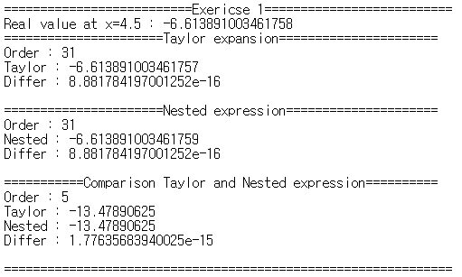

For both Taylor expression and Nested expression, the values are same to the exact value calculated by $e^{-x}-\left(1-x+\frac{1}{2}x^{2}\right)$ when the order is 31. The last order 5 is the smallest order when both Taylor expression and Nested expression have different values.

1. Exercise (2)

Note that the CPU of my computer is 64-bit

The machine epsilon of each data type is as follow:

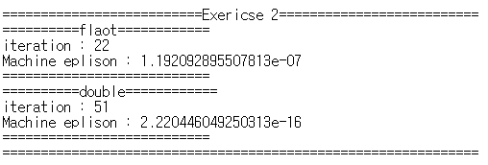

The machine epsilon of float type is for single precision and the machine epsilon of double is for double precision.

1. Exercise (3)

In Exercise (3), since the condition statement is changed, the result for float type is changed.

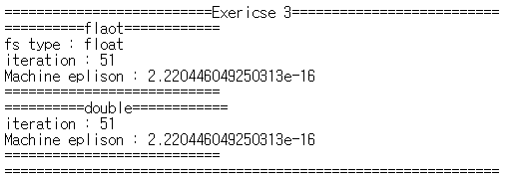

The condition statement of the code in Exercise3 is “fs+1.0<=1.0”. Here, the computer considers 1.0 as a double type constant. Thus, in Exercise3_modified, I changed this condition to “fs+1.0f<=1.0f” where 1.0f is a float type constant. Then the result is the same to Exercise (2).

